Assignment #1: Exploring Dikili Tash

Please visit the following website: <http://www.dikili-tash.fr/index_en.htm>

This website is the research page for the Dikili Tash archaeological project in northern Greece. Your assignment is to familiarize yourself with the Dikili Tash project by answering a series of questions that will help guide you through the history and archaeology of this little-known yet very important archaeological site.

Please answer **ALL QUESTIONS IN THE SPACE PROVIDED**. You may use point-form or full sentences.URL references are not required. This .docx file will allow you to type your answers into pre-set text boxes. Please do not alter the format of the document.Spend some time familiarizing yourself with the website by exploring the five section links: Presentation, Research, Chronology, Appendixes, and News.

Section 1: The Environment of Dikili Tash

1. Indicate on the map below the location of Dikili Tash (1pt).

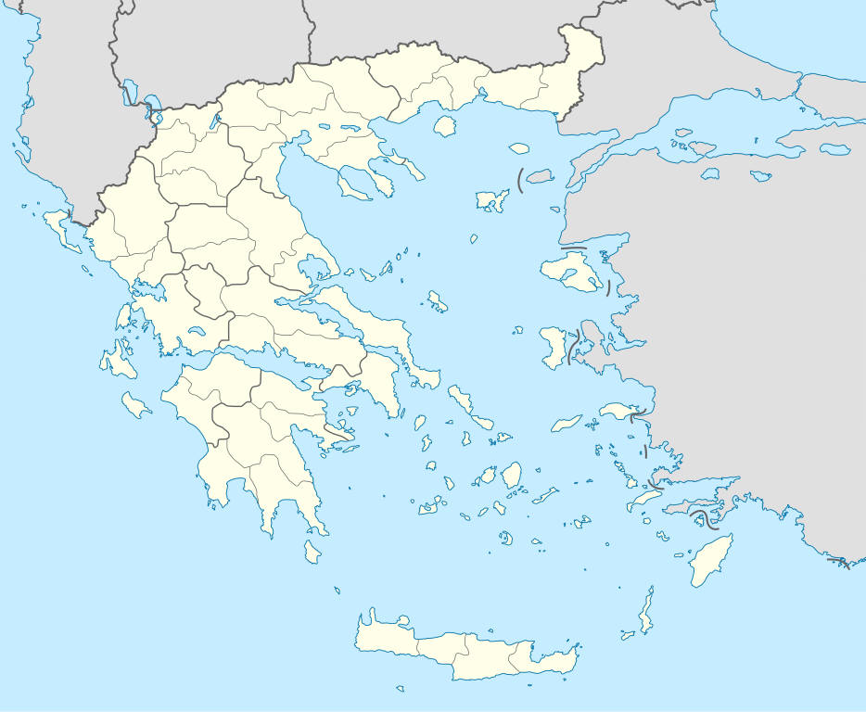

1. What is the specific name of the plain, administrative region, and regional unit in which Dikili Tash is situated? (hint: only one of these is on the website. You must determine the other two using outside sources) (3 pts).

South eastern part of the drama plain, Eastern Macedonia, Kavala Regional Unit

Pangee, Menikion, Phalakro, Lekani, Symbolon

Collective altitude range: 45 – 80 m/sea

1. Name the five mountain ranges surrounding Dikili Tash and their collective altitude range (3 pts)

Edges of a marshy plain

Access to different environments, resources, land to cultivate, and drinking water.

1. What part of the plain was occupied and why (be specific)? (2 pts)

Strategic advantage of being on the only passage around the marsh from the East

1. What advantage did Dikili Tash have over other nearby Neolithic sites, and why? (2 pts)

Section 2: Discovering Dikili Tash

Cyriaque d’Ancona between 1426-1430

1. Who is credited with discovering Dikili Tash and in what years? (2 pts)

Nearby spring

Roman Monument of Caius Vibius

1. What two archaeological features alerted researchers to this spot? (2 pts)
2. What material culture was first identified from Dikili Tash and where was it found? (2 pts)

Pot sherds from the tell in 1917-1918

1. Why is the nearby monolith partly destroyed? (2 pts)

Scraping the white marble dust gives the virtue of milk-giving to nurses

Section 3: Excavating Dikili Tash

The First Soundings (1920-1922)

The First Research Program (1961-1975)

The Second Research Program (1986-1996)

The Third Research Program (2009-ongoing)

1. Name the research programs associated with Dikili Tash and when they were conducted (2 pts)
2. Aside from pottery, what were some of the first objects discovered during excavations at Dikili Tash? (2 pts)

Anthropomorphic and zoomorphic Neolithic figurines

Two roman heroes

1. There are four letters superimposed on the plan map of the Dikili Tash excavation trenches. What year-range was each associated excavation trench investigated? (4 pts)

A: 1st Research Program

B: 3rd Research Program

C: 2nd Research Program

D: The First Soundings

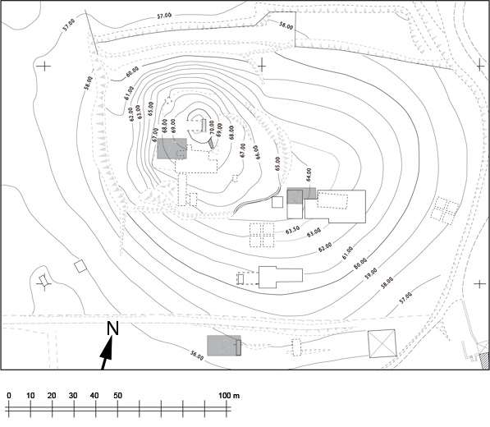

**A**

**D**

**C**

**B**

1. What did the results of the First Research Program (1961-1975) allow researchers to determine? What was their importance for understanding the archaeological record of the Balkans? (3 pts)

Allowed researchers to determine the general stratigraphic sequence and major occupation phases.

Prove that the end of the Neolithic period in Macedonia preceded the beginning of the Early Bronze Age as determined from the site of Troy

1. Geomorphological research was conducted during the Second Research Program (1986-1996). What did this research consist of and what did it provide? (4 pts)

Consisted of heavy machines to dig two small trenches on the periphery of the mound to take core samples

Provides the nature of geological substrate and the evolutions of the land

1. Experimental archaeology is also conducted at the site of Dikili Tash. On what two aspects of ancient lifeways has this research predominantly focused? (2 pts)

Functions of Ovens and Hearths

Construction techniques of the house and equipment

1. What is this excavated feature? What period does it date to? Describe the likely construction technique (2 pts)

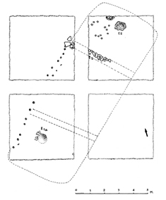

Big rectangular platform made of a layer of stones covered with clay.

Late Neolithic I

Wattle and Daub construction technique

1. What is this feature? (1 pt)

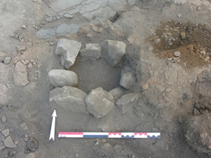

Posthole

1. What is this feature (include cultural association) and where is it located on the site? (2 pts)

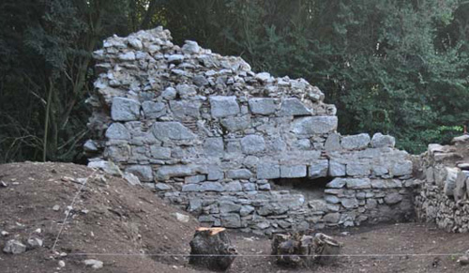

The ruins of a Byzantine tower built at the top of the Dikili Tash mound

Section 4: Artifacts from Dikili Tash

1. What is this and what period does it come from? (2 pts)

Late Bronze Age flint blade: the dotted line indicates its axis of insertion in a “tribulum”.


Stone Blade Tool from Late Bronze Age

1. What is this and what period does it come from? (2 pts)

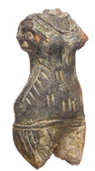

Fragment of anthropomorphic clay figure

Late Neolithic II

1. What is this and what period does it come from? (2 pts)

Bronze Dagger from the Bronze Age

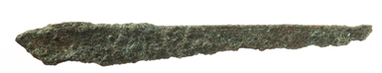

1. What is this artifact, what kind of decoration does it have, and what period is it from? (2 pts)

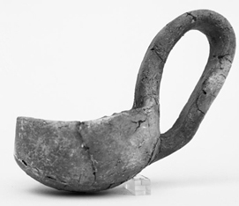

Cup with Raised Handle

Decorated with impressions

Early Bronze Age

Section 4: Interpreting and Understanding Dikili Tash

1. Why did Dikili Tash enjoy a long continuity of occupation? (1pt)

Necessary location for communication by land between the northern and southern parts of the plain.

1. Examine the following profile of the Dikili Tash tell. What are the five predominant cultural periods that investigators believe are responsible for creating the tell? What are tells and how are they formed? (6 pts)

**A**

**E**

**D**

**C**

**B**

Tells are artificial mounds that form from centuries of successive building remains.

Cultural Periods:

A: Byzantine, B: Late Bronze Age, C: Early Bronze Age, D: Late Neolithic II,   
E: Late Neolithic I

1. Around what year was Dikili Tash abandoned in the Bronze Age and what event did this abandonment correspond with in wider Greece?Use years BCE (2 pts)

Abandoned in 1200 BCE

Corresponds to the destruction of the Mycenaean palaces

1. When was Dikili Tash first occupied? Use years BCE (1 pt)

6500 BCE

Middle Bronze Age

1. There is no evidence for which Bronze Age Period on Dikili Tash? (1 pt)

ASSIGNMENT GRADE: /60