**Fossil Classifications**

* **Fossils and Subfossil** (younger) threshold of 11700 years  
  End of the last ice age on Earth
* **Hard and Soft body parts**:  
  Mineralized hard body parts, fossilize easier  
  Soft body parts need to be preserved to be fossilized  
   Rapid burial preserves the soft body, carapaces can protect it
* **Body Fossils**: Partial, completely fossilized dead organisms, most frequent
* **Trace Fossils**: Organism activities such as feeding or movement
* **Chemical Fossils** (Biomarkers): Chemical substances resulting from reaction between organisms and minerals/surrounding environment
* **Greek Rationalism**:  
  Xenophanes of Colophon (495-435 BC): First fossils in southern Italy, scientifically interpreted  
  Xanthus of Lydia (450 BC): New reports from Lesser Asia  
  Publius Ovidius Naso (43 BC – 18 AD): Black sea, exiled, writings on anchors of ancient ships  
  Lucius Apuleius (125-180 AD): First fossil fish in northern Africa
* **Glossopetrae**: Stoned Tongues, fell from the moon during eclipse  
  Dark ages, no science was developed at this time  
  Look like a large shark tooth
* **First Illustrated Fossils**:  
  George Bauer (1949-1555): Fossils as figured/incised stones, important guy, thoughts accepted without criticism  
  Christophorus Encelius (1513-1583): *On the Metallic Objects,* returns to antiquity interpretations that fossils are ancient life forms. First illustrated fossils
* **First Monographic Study on Fossils:**Conrad Gesner (1516-1565): *De Rerum Fossilium*, About the Fossil Objects, illustrations in a systemic way  
  Fossil in latin is an object dug up from the Earth, book contained many other general rocks and minerals
* **Paleontology and its Subdivisions**Micropaleontology: Microscopic debris of organisms  
  Paleoalgology: Vestiges of ancient algae  
  Palynology: Vestiges of reproductive organisms of higher plants (spores)  
  Paleobotany: Studies ancient plants  
  Vertebrate Paleontology: Organisms with skeletons  
  Invertebrate Paleontology: Organisms without skeletons
* **Related Sciences:**Paleoecology: Represents studies of ecology of ancient organisms and their relationships with the inorganic and organic components of their environment  
  Paleobiogeography: Studies the distribution in spaces of organisms, bio-provinces  
  Biostratigraphy: Distribution of fossils in space and time  
  Evolutionary Paleontology: Studies the evolutionary relationships between organisms

**Types of Fossilization**

* **Casual Fossilization Process:** Frequent, lower quality, soft tissues are rare  
  Permineralization, Carbonization, Recrystallization
* **Exceptional Fossilization Process:** Soft tissue constantly preserved  
  Congealment, Amber + Tar
* **Permineralization:** Fossils with porous internal structure  
  Pockets filled with fluids -> Critical mass -> Precipitate minerals  
  Petrification is both Permineralization and Lithification (rest of body)  
  Usually fractional, multiple stages of fluids form smaller rings of different minerals as the previous minerals harden
* **Recrystallization:** Mineral structure changes (aragonite -> calcite)  
  Frequent dissolved calcium carbonate in oceans, form limestone  
  Calcium Carbonate: Toxic for organisms, form shells by precipitating it  
   Usually in form of aragonite, not stable, when they die aragonite recrystallizes ..to more stable calcite
* **Moldic Preservation and Replacement:** Bottom of Sedimentary Basin  
  Scavengers destroy soft tissue, burial encloses the shell  
  Loose sediment turned into rigid sedimentary rock  
  Fluids circulate, aragonite -> calcite, dissolves and leaves nothing behind  
  Cast: External Part  
  Mold: Internal part  
  Replacement: Critical mass of fluids to form new minerals (inorganic pyrite)
* **Carbonization:** Frequent in plants and invertebrates  
  Bacterial decomposition reacts with CHON,NOSP are expelled leaving only C, H  
  C + H generate oil, natural gas, H expelled at high temperature  
  C crystallizes as graphite, extremely stable
* **Impregnation:** Sedimentary basins (tropical seas), concentration of Calcium Carbonate so high it precipitates from the sea water  
  Algaes, soft-tissued organisms covered in Calcium Carbonate  
  After death, soft tissues preserved by CaCO impregnating dead tissue
* **Congealment:** Frozen swamps in permafrost conditions  
  Organisms trapped inside, drown and are completely preserves
* **Dehydration, Dessication:** Dry, arid regions  
  Lose body fluids quickly and mummify, high temps preserve body, organs
* **Amber:** Most sophisticated, best preservation  
  Sticky natural resin, organism trapped inside
* **Tar Pits:** La Brea, Oil at surface creates toxic swamp with toxic gases  
  Organisms that get too close asphyxiate, fall in and perfectly preserved
* **Exceptional Preservation (Fossil Lagerstatten):**Skeletal parts remain in anatomical connection  
  Colour patterns are preserved  
  Non-mineralized parts are preserved
* **Hunsruck Shale – Germany:**Pyritization of marine fossils, no anoric sedimentary layer needed
* **Colour Patterns – Ukraine:**Unstable colour pigments decompose quickly due to substance in environment  
  Brachiopods have colours not present in molluscs  
  Preserves pattern, not the pigments themselves

**Other**

* **Clastic Rocks**: Sediments, transported by water, wind, ice, or gravity
* **Regional Metamorphism**: Large area, large-scale action of heat and pressure
* **Thermal Metamorphism:** Heat and pressure
* **Burial Metamorphism**: Sediments buried, heat and pressure to recrystallize
* Igneous rocks have no fossils, rare in metamorphic, mostly in sedimentary
* Most important condition of fossilization: Rapid burial

**Geological Time**

* Age of Earth: 4.6 billion years old
* **Nicolaus Steno:**Royal Society of London in 1660  
  Established first principles of stratigraphy from Tuscany, Italy  
  Two sequences by injection discontinuity, assumed Noah's Flood
* **1. Principle of Layer Superposition:**First layer is oldest, higher layers are younger  
  Possible for older rock outcrops to become insecure and fall onto layers of younger rocks (particularly in water basins
* **2. Principle of Successive Layer Formation:**Layers formed in succession, some fossils present, fossils take a long time  
  10000 layers in Tuscany, 5-6 years per layer, 50k years to form  
  First sign of split between science and the church
* **3. Principle of Original Layer Horizontality:**Sediments accumulated by the settling of suspended particles in a fluid  
  Originally layers were horizontal, folds are due to crustal movements
* **4. Principle of Lateral Layer Continuity:**Layers of river, layers are formed across the entire surface of the basin  
  Not true all the time  
  Originally deposited strata extend all directions until termination at end of basin  
  Used to find coal
* **Layers & Facies Terminations:**5 cases to demonstrate how layers are ordered in the Earth's crust  
  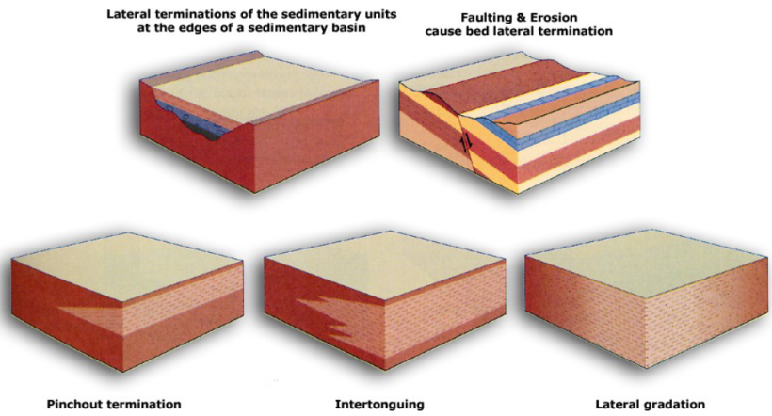
* **Georges Louis Leclerc – Compte de Buffon:**1774: First calculation of Earth's age based on experimental data  
  Result proved wrong, 70k years too young but still 10x biblical age of Earth  
  Ended influence of creationist ideas in science
* **Interpreting Stratigraphical Succession:**Desiccation Cracks (Mudcracks): Surface with strong evaporation  
  Ripple Marks: Narrow upwards, form small waves by the wind  
  Burrowings: Trace fossils from digging organisms  
  Use these layers to compare normal vs inverted stratigraphical successions
* **Correlation with Fossils:**Sir William Smith: First to use fossil ranges to correlate layers and successions  
  Intercontinental correlation, global timeline + scientific knowledge  
  Fossils with different stratigraphical ranges, narrow ones are better index fossils  
  Planktic species are paramount (ocean currents, long distances), endemic ones are useless
* **Stratigraphical Successions of Igneous Rocks:**Inclusions: Inclusions of older layers, lavaflow picks up detached older rocks  
  Cross-Cutting: Nearly parallel lines (dikes) cutting through older segments  
  Relative Age of Lavaflows (Sills): Lava cooking adjacent layers
* **Eons (Oldest to Youngest):  
  Hadean:** No rock record, can't be subdivided  
  **Archean:** Oldest rocks, highly subjective boundary  
  **Proterozoic:** Early fossils, longest, started continents moved on asthenosphere  
  **Phanerozoic**: Visible life forms, large size fossils  
   Defined by Agronomic Revolution, formation of burrowers leading to massive ..diversification of life forms on Earth  
   Evolution, shortly after is the first global predator (360 degree vision)  
   Cambrian Explosion
* **Phanerozoic Subdivisions (Oldest to Youngest):  
  Paleozoic:** Fossils look like Aliens  
   Cambrian: Whales  
   Ordovician: Ancient Welsh Tribes  
   Silurian: Ancient Welsh Tribes  
   Devonian: England, development of layers of rocks  
   Mississippian  
   Pennsylvanian: These two only recognized in NA, otherwise Carboniferous  
   Permian: Russian city in European mountains  
  **Mesozoic:** Flora and Fauna resembling modern life forms  
   Evolution of mammals, reptiles in wetter areas. Life Diversification  
   Ocean Conveyor pushing continents together for Pangaea  
   Triassic, Jurassic, Cretaceous  
  **Cenozoic:**   
   Ocean conveyor collapsed, large swamp, 95% of species died (great dying)  
   1m years later, restarted, life recovered  
   Also asteroid + extinction of dinosaurs  
   Eventual evolution of primates to take over  
   Paleogene, Neogene, Quaternary

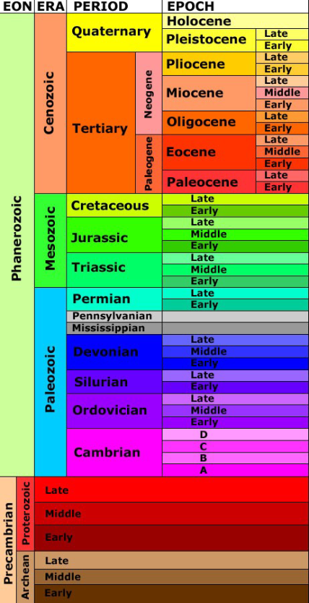

* **Radioactive Decay:** Unstable element spontaneously changes to stable state  
  Most elements transform over several steps: Radioactive decay series  
  Measure weight of parent and daughter isotope to calculate the age of mineral
* **Half-Life:** Time for half of atoms to decay to more stable daughter  
  Uranium 238 -> Lead 206 is the most relevant isotope pair, half life 4.5 b years

**Fossil Classification, Nomenclature**

* **Hierarchical Classification:** Linnaean classification based on Aristotlelian philosophy, organisms grouped by morphological similarities

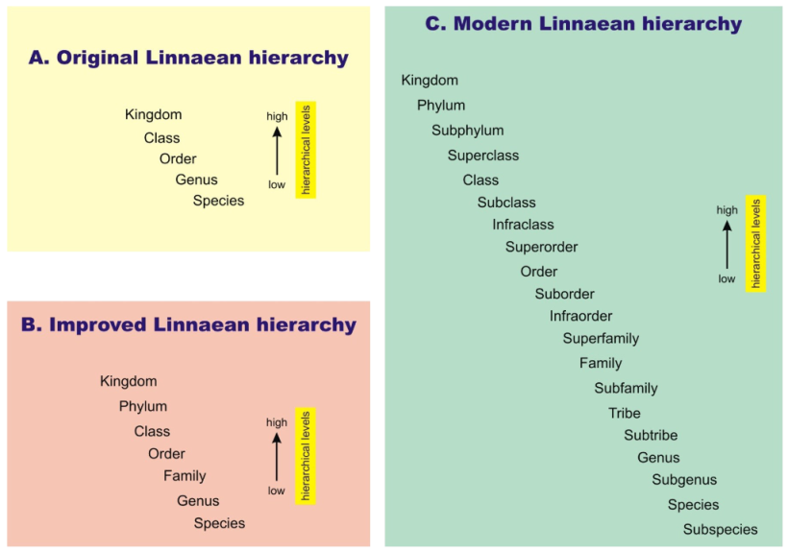

* **Kingdom Bacteria:** Simplest life forms in fossil record  
  Bacteria, Cyanobacteria as oldest fossils on Earth  
  Isolated or grouped together into large clusters, Stromatolites  
  Most diverse array of metabolic strategies
* **Kingdom Protista:** Mostly single celled, rarely colonial, rarely multicellular eukaryotic organisms  
  Eukaryotes defined nucleus in cytoplasm, many develop external protection or internal skeleton, some of the best fossil records  
  Sexual reproduction, high rate of evolution
* **Kingdom Fungi:** Rarely occur in fossil record, many species undiscovered  
  Extremely diverse, most frequent is fossilized plant roots (rhizoliths)
* **Kingdom Plantae:** Photosynthetic organisms, wide scale ecological adaptation  
  Land plants evolve after land colonization 400 mya  
  Woody tissue in continental plants w/ large size bodies (well-known fossils)  
  Evolved rapidly once roots were developed, exponential evolution
* **Kingdom Animalia:** Most evolved, most diverse, very high rate of evolution  
  Adapted to variety of environments (intelligence, flight, skeletons, vertebrates)  
  Homogenous aerobic heterotrophy (aerobic respiration)  
  Well-developed movement capabilities  
  Most develop a vertebral column

**Major Groups of Fossils**

* **Prokaryotes:** Kingdom Bacteria, mostly as stromatolites  
  Divisions Bacteriophyta and Cyanophyta  
  Very primitive organisms, vast array of metabolic strategies, mostly single-celled, rarely multicellularity (clustered)  
  Occur frequently in fossil record
* **Plant-like Protistans – Algae:  
  Rhodophyta**: Red algae, primitive, first multicellular, can be single-celled, photosynthetic, mostly marine, adapted to fresh waters  
  **Chlorophytes**:Green algae, single/multi cellular, photosynthetic, occur in terrestrial conditions w/ enough moisture in the soil  
  **Charophytes**:Only multicellular, ancestors of land plants, female reproductive organs calcified to protect egg, male organs not preserved  
  Good for studying algae evolution
* **Plantae:** Higher plants, complex morphological structure  
  First fossils w/ conquest of land, fungi -> algae -> molluscs -> arthropods -> fish  
  **Bryophtes**: short + narrow leaves, nutrients + respiration, seeded ferns (modern ferns have no seeds)  
  First land plants, very primitive, height of 5 cm
* **Plants –** **Palynology**Pollen: Small saclike structures dispersed in the air  
  Don't have mineralized parts, everything organic  
   Fossilize quickly when buried, organic matter changes colour  
   Changes particularly on heat, colour can tell heat of rock buried on, tell if ..particular rock can generate hydrocarbons (good for oil)
* **Animal-Like Protistans:**Never multicellular, single-cell predators  
  **Foraminifera**: Bearer of openings (open top), marine  
  Protect cell w/ mineralized test, can add additional chambers as it grows  
   Extremely diverse tests made of minerals, best fossil record  
  At first ventic (bottom of sea), very primitive movement  
  Eventually adapted to plantic, float freely in upper part of oceanic water  
  **Radiolarians**: Internal skeletons to support parts of cytoplast  
  Entirely marine, open oceanic basins  
  Precipitate organic silica, lots around volcanoes (pacific), use erupting silica to build their skeletons  
  **Ciliophorans, Choanoflagellates:** Single-cell marine, diverse in seas  
  Cup-like shape, organism lived inside with tentacles for feeding from opening  
  Evolved independently of different groups at least 8 times  
  Choanoflagellate: Almost identical to tissue cells within sponge mass (evolution)  
   Can't have evolved, sponges 600m years, choanoflagellate spore only 300k
* **Animalia: Invertebrates:  
  Sponges** (poriferans)  
  **Cnidarians** (corals and medusa): Colonis/solitary in oceans, after great dying  
   Primitive corals  
  **Lophophorates** (bryozoans, brachiopods): Organ to catch food  
   Bryozoans: Colonial, long fossil record, colonized brackish, some freshwaters  
   Brachiopods: Solitary, can cluster, soft body protected by 2 valves  
   attach to seafloor by organ between 2 valves, can be open/close,v long record  
  **Molluscs**: Protect soft body w/ shell of aragonite, calcite, variable morphology  
  **Arthropods**: Segmented appendages, body protected by carapace, variable morphology, evolve at high rates  
   Trilobites are particularly important  
  **Echinoderms**: Highest diversity, starfish, soft body protected by thicker test covered in small bits  
   After death, plates detached and rest disintegrates, rare to find all together  
  **Graptolites:** Extinct group, only occur as colonial organisms, started as benthic organisms, eventually became plants
* **Animalia: Chordates  
  Conodonts**: Chewing apparatus fossilize equally  
  Evolved to vertebrates, Haikouichthys is the earliest vertebrate  
   Ascidians/Tunicates: Microscopic pieces  
  Vertebrates: Fishes, reptiles, birds, mammals