**Emergence of Life on Earth**

* **Dominant Elements**: Carbon, Oxygen, Hydrogen, Nitrogen, Sulphur, Phosphorus
* **Petroleum Composition:** Persistence of carbon-based life forms can be tested by studying composition of substances from organic decay, transformation  
   - Hydrocarbons: Natural Gas, Petroleum, Bitumen, Waxes, formed after death  
   - Large amounts of Carbon in these hydrocarbons, followed by H, S, O
* Living matter dominated by water, life evolved in aquatic environment
* **Monomers, Polymers:** - Oldest fossils are bacteria and cyanobacteria - CHON(SP) elements easily combine to form simple inorganic monomers  
   Carbon Dioxide, Methane, Ammonia, Water, etc  
   - Higher molecular masses compared to elements that dominate terrestrial planets primordial atmospheres  
   - Major problem in understanding early chemical reactions was chemical character of the atmosphere  
   - Modern atmosphere (nitrogen, large amounts of O2) could not favour formation of larger organic molecules (because oxidizing)
* **Primordial Soup:** Alekxandr Ivanovich Oparin (1894-1989)  
   - 1930: First model primordial atmosphere was reducing  
   - Organic molecules accumulate on surface, dissolve in water, electricity in atmosphere + UV radiation from space + heat from Earth all combine
* **Miller and Urey Experiment:** 1953, simple monomers react to form complex molecules  
   - Started with mixture of gases (H2, N2, NH3, CH4, H2O)  
   - Added electrical discharges, ultraviolet radiation  
   - Obtained 7 amino acids: Glycine, Alanine, Formaldehyde, Hydrogen Cyanide, Acetylene, Cyanoacetylene
* **Polymers:** - Simple organic monomers form larger molecules  
   - Some large molecules are polymers, repeating of monomeric unit  
  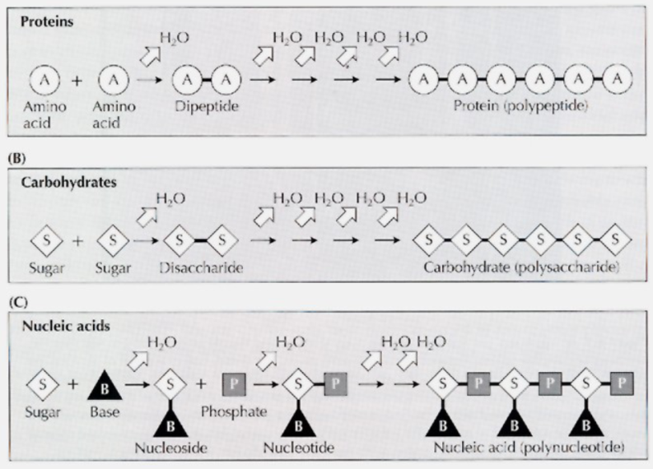  
   - Amino Acid: Dehydration Condensation (2 amino acid = dipeptide), form long chain known as protein (Polypeptide)  
   - Sugar: Two sugars form disaccharide, chain is polysaccharide (carbohydrates)  
   - Nucleic Acid: Sugar + Base = Nucleoside, add Phosphate = Nucleotide, chain of Nucleotides form a Polynucleotide = Nucleic Acid
* **Early Earth Events:**1. Early Crust Formation: Temperature difference between hot Earth and cold outer space, trapped heat inside, volcanoes common at surface  
  2. Early Atmosphere Formation: Gases from two sources: remnants of Solar System formation, new ones from volcanic phenomena  
  3. Ocean Formation: Early due to accumulation of water from vapour condensation.  
   Zircon minerals from Australia (4.4 bya, oldest minerals on Earth), require significant amounts of water (earliest oceans: 4.4 bya)  
  4. Catastrophic Meteorite Bombardment: Effects at surface of moon, Mercury, Mars. Not affected by tectonic plates, craters still visible unlike Earth  
   Infer this happened between 4.2 and 3.95 bya
* **Isua Formation:** 3.7-3.8 bya in southwestern Greenland  
   - Dark appearance: Deposited in reducing environment  
   - Small calcites: Molecular oxygen only existed in small amounts, layers of calcites could not form  
   - Formed in shallow marine environment  
   - Thin layers of graphite: Final process of organic matter, vestiges of primordial soup  
   - Living isolated organisms in primordial soup, created oxygen to form calcites  
   - Oldest Stromatolites found here, communities of prokaryotes, bacterias destroyed by fossilization
* **Earliest Isolated Bacteria, Cyanobacteria** - Cyanobacteria: slightly larger in fossil record, don’t differ much morphology  
   - Oldest fossils: Discovered in Apex Chert in Pilbara Craton of Western Australia  
   - **Apex Chert**: Rocks of conglomerates, transformed to chert through silification  
   - Earliest age of isolated cells: ~3.465 = 3.5 billion years  
   - Some cells = folded filament w/ cell-like C structures (modern iron bacteria)  
   - **Strelley Pool Chert**: Younger than Apex Chert by 10-15k years  
   Form chain-like structures, like modern purple bacteria  
   Prokaryotes in clustered form

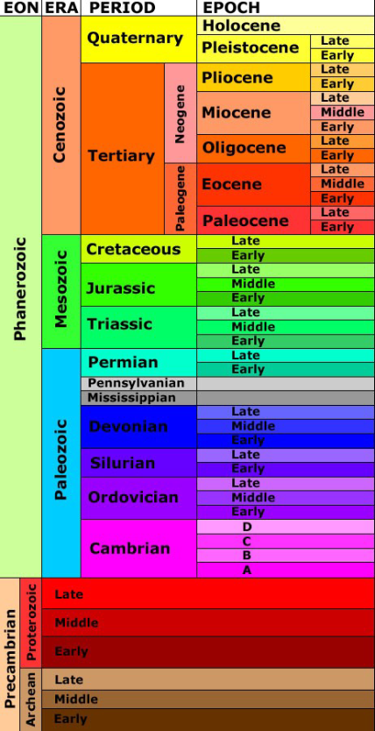

**Evolution of Multicellularity**

* **Stromatolites**- Circular fossils, Cryptozoon (hidden organisms)  
  - Schreiber Beach in late 50s, first noticed prokaryotes  
  - First Precambrian fossils (transmitted light microscopy)  
  - Prefer warmer waters, column-like structures between tidal zones  
  - Living stromatolites in Shark Bay  
  - Photosynthetic, only alive in upper portion, rest is dead rock (very old)  
  - By Neoarchean, achieved global domination, previously slow growth  
  - Predator by Phanerozoic, sharp decline to patchy distribution (mostly in toxic lagoons, toxic for gastropod predators)
* **Stromatolite Structure**- Growth Surface: (1mm), highest diversity, produce oxygen, some photosynthetic, don't need oxygen to grow  
  - Undermat: (1mm) non-oxygen making photosynthetic bacteria, anaerobic bacteria can still use oxygen when needed, less bacteria than growth surface  
  - Oxygen-Depleted Zone: (1-2cm) Populated by rare anaerobic bacteria  
  - Stromatolite Mass: Rest of the stromatolite, calcium carbonite, no living organisms in this portion

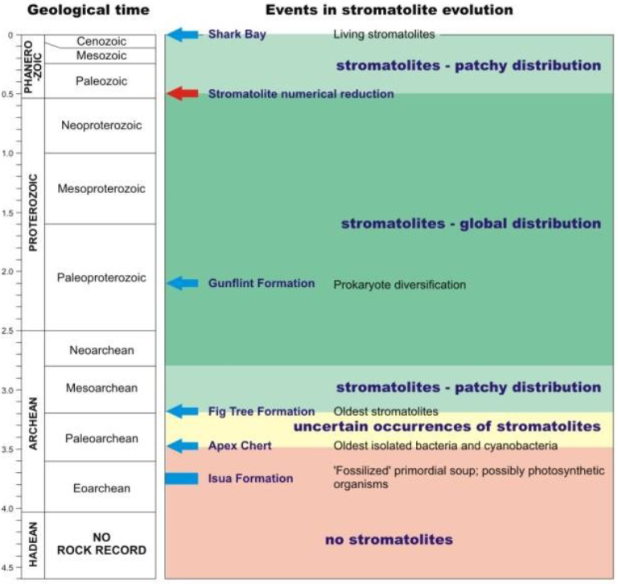

* **Banded Iron Formation (BIF)**- Another sediment in Isua formation  
  - Alternation of thin layers of iron oxides (hematite, magnetite, etc, Fe_O_)  
  - Formed during volcanic events, iron expelled and combined with dissolved oxygen from oceanic water  
  - Required free molecular oxygen  
  - Can tell Earth's atmosphere transformed from reducing to oxidizing (first mass extinction, organisms destroyed by their product)
* **Oldest Eukaryotes**- Biomarkers  
  - Toxic environment, prokaryotes clustered and formed larger organisms  
   Each Prokaryote to do one function (organelle)  
  - Evolved sexual reproduction, rapid evolution  
  - Fossils: Evolved 1.8 billion years ago  
  - Other records: Closer to 2.1 billion years ago
* **Bitter Springs Formation:** Australia  
  - First true eukaryote cells here, 1.0 bya  
  - Assigned to red algae (rhodophytes) and green algae (chlorophytes: Caryosphaeroides and Glenobotrydion)  
  - Some fossilized in process of cellular division, nucleus + membrane fossils  
  - Cell arrangement: Meiotic cell division  
  - Not found among the prokaryotes
* **Algal Multicellularity**- Bangiomorpha: Red algae  
   Filamentous thallus  
   Primitive holdfast attached to seafloor, rise up towards sunlight  
   1.2 bya (Proterozoic – Quaternary)  
  - Melanocyrillium  
   Similar to modern testate amoebas (earliest animals)  
   Vase looking mf, open top, cytoplast to catch food from opening  
   Organic, sometimes with agglutinated particles  
   0.8-0.9 bya (Upper Proterozoic – Quaternary)
* **Grand Canyon Findings**- CD Walcott  
  - Small black coal disks in carbon-rich shales, assumed flattened shell  
  - Know large single-cell planktonic algae  
  - Increase size, instead of multicellularity they just became single big cell  
  - As it got big, Snowball Earth happened  
  - South Africa: Isolate calcitic cells covered in openings from the Cryogenian period  
   Animals achieved multicellularity here to survive the cold  
   Sponge **Otavia** evolved in cryogenian, became extinct by the end of it.

**Ediacaran Fauna** - Southern Australia, impressions in fine sediments, multicellular

* **Parvancorina**:   
  - Shield-shaped front end, central axis with weak segmentation, up to 10 pairs of appendages, head shield facing the direction of water current (for feeding?)
* **Tribrachidium:**- Originally interpreted as single organism, now as holdfast for another organism. Disk-shaped w/ three raised arms, borders. Triradial symmetry
* **Dickinsonia:**- 1-100cm, resembles a flatworm, segmented head + tail. No internal organs. Tail only occurs in mature specimens
* **Charnia:**- Enigmatic, strong similarities with modern sea-pens. Bilateral symmetry (stem with matching fronds), feather shaped fronds with series of side branches
* **Spriggina:** - Resembles large swimming worm. Elongated "spine" with V-shaped muscle clusters on each side  
   - Hardened head of organic tissue, vestige of cephalic shield (beginning of cephalisation, who were the predators?)  
   - Resembles the first vertebrates, those don’t appear for a long time
* **Kimberella:**- Complex structure, three peripheral layers full of cavities. Central part has a slightly inflated structure. Center structure fossilizes, harder organic tissue  
  - Always found very well defined at one end, other end has no structure (horseshoe shape)  
  - Was a grazer, no structure at front as it was a siphon, need a muscle to do so  
  - Likely ancestor of molluscs, very rare
* **Vendia:  
  -** Bilateral symmetry. Head, lateral parts, tail, no eyes or mouths  
  - Impressions of internal cavity  
  - First ediacaran with internal cavities, invertebrates started here
* **Onega:**- Body architecture in 3 parts: Head, Body, Tail (similar to Trilobites)  
  - 50m years between Onega and Trilobites, maybe not an ancestor
* **General Symmetry:  
  -** Body cavities of oldest creatures form radial symmetries  
  - As we get closer to the present, body cavities form bilateral symmetries  
  - Arrange organisms stratigraphically, organisms start to coagulate into lineages

**Cambrian Life Diversification**

* **Earliest Shelly Animals**- Neoproterozoic of Namibia, SW Africa  
  - Cloudina: Calcitic, tubelike fossil. Discoveries were completely recrystallized.  
   Looks like a worm, but worms did not exist before the Precambrian.  
   Precipitated calcium carbonate like cnidarians, determined to be a coral first, but always has same morphology no matter where it is found, not a coral  
   Cloudina-like fossils in China, determined a sponge, extinct for long time, reappeared here
* **Precambrian/Cambrian Boundary**- Original: Boundary defined by animals with an exoskeleton, wrong idea  
  - Organisms began to dig in sediment, deeper in search of food, decomposing organic matter  
  **-** New group of organisms, new ecological niches, evolution took over  
  - Index Fossil: Trichophycuspedom (formerly Phycodespedum)  
  - Russophycus: Frequent above boundary, bilaterally symmetrical trace fossils
* **Tommotion Fauna Generalities**- Latouchella: Strange, gently coiled shell in one piece, gastropod-like  
  - Yochelcinoella: As above, with siphon on shell, is mollusk- Above two are first snails/brachiopods, first predators of stromatolites  
  - Shells are tubular, spinose, conical, plates or sclerites also occur  
  - Microcystis: Flanked with sclerites and legs beneath. Scales and sclerites with horns defend for carnivorous warms, inefficient against being swallowed hole  
  - Evolution of Tommotion Fauna had major impact, associated with strong reduction in stromatolite occurrences
* **North America – Main Tectonic Structures**- Canadian Shield: Strongest stretch in North America  
  - North American Platform: Shallow waters, stable around Canadian Shield  
   Surrounded by shallow depression basins  
  - Mobile Belts: Permanent source of earthquakes, extremely unstable, 4 in NA
* **Earth's Climate**- Seven-fold oscillation history in Late Precambrian-Phanerozoic interval  
  - Greenhouse: Warm and Humid  
  - Icehouse: Dry, Cold, Arid

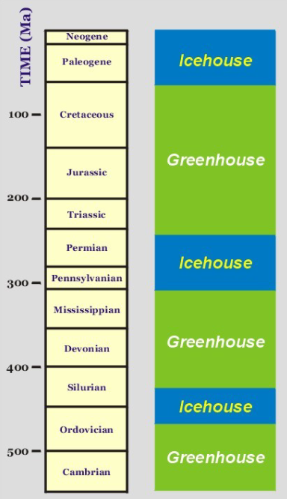

* **Sea Level Fluctuations  
  -** Not constant  
  - Major transgression initiated late Proterozoic after major Marinoan Glaciation  
  - Precambrian to Ordovician: Sauk Transgression, sea level increase  
  - Evolution needed to be fast
* **Intertidal Sedimentation**- Stromatolites were widespread in carbonate facies on both sides of the craton  
  - Insane tides and currents, every day would rise and recede across most of NA
* **Archaeocyathids** – First Reef Builders  
  - Calcareous sponges  
  - Cup-like structure, small size, two walls defining central cavity  
  - Walls contain intervalve (intervalum), full of septum (calcitic walls connecting the inner + outer walls), attach to seafloor with rootlike structures  
  - Calcitic, not flexible, totally covered in pores  
  - Needed resistance to currents  
  - Lived in new reefs, water energy carries small-size particles through pores, would eat and develop  
  - Very small reefs (2m in diameter, 50cm in height)
* **Trilobites**- Cambrian Explosion: massive life diversification  
  - Body can be divided into three obvious parts  
  - Originally very successful, new defensive strategy: Large size populations (cockroaches of paleozoic), two well-developed eyes to spot predators, first molting species with inflexible carapace  
  - Diverse through Cambrian and Ordovician  
   Cambropallus: Very large, 1 foot in length, dissuades predators by being big  
  - Died out when predators were too large and diverse (trilobites are primitive)  
  - At first, benthic at bottom of oceans, eventually planktic  
   Head and tail are almost equal to rotate body for water currents, thorax reduced to 2-3 segments, blind due to turbulent waters couldn’t see anyways
* **Burgess Shale**- Middle Cambrian  
  - Discovered by Walcott at beginning of 19th century in BC  
  - Fossils buried along continental slope, mobile belts surrounding NA, frequent earthquakes, underwater landslides, very rapid burial in anoxic conditions  
  - Chordate – Pikaia: Cephalocordate, like modern lancelet, small antennae on head with tapered tail for swimming. Full of V-Shaped muscles  
  - Opabinia: 5 eyes from head, irregular hole in head for probiscus mouth, predator to eat burrowers  
  - Anomalocaris: Most important predator, one meter in length, body covered in thick tissues, large eyes to spot prey, extremely efficient predator, global range and first major predator of Cambrian times  
   So efficient at hunting ate everything, resorted to cannibalism  
  - Wiwaxia: 3-5 cm in length, headless body covered by protective armor plates, long spines  
  - Hallucigenia:: Long wormlike organism with appendages on both top and bottom. First thought in turbulent waters, legs on back to flip upright, realized they were just spines  
  - Ayisheaia: Missing link to Onychophorids (segmented worms w/out other fossil records)

**Coral Evolution Events and Patterns**

* **Phylum Cnidaria**- Metazoans (multicellular organisms) organised in tissue-grade, no organs  
  - Characteristic feature: Nematocysts   
   Cells discharge poisonous substance, paralyze or kill prey
* **Body Architecture  
  -** Polyp Stage:  
   Sessile (fixed to sea bottom with root-like structure)  
   Asexual reproduction by budding  
   Frequent in reef environments  
  - Medusa Stage:  
   Jellyfish-like (free-dweller in the oceanic water column)  
   Sexual reproduction strategy
* **Classifications:** Hydrozoa, Scyphozoa, Anthozoa
* **Hydrozoa:** Marine and freshwater, hydroids/hydra exist, mostly polyp stage  
  - Hydrozoans lack a mineralized skeleton, rare in fossil record  
  - Evolutionary occurrence in Carboniferous
* **Scyphozoa:** Marine, mostly medusa  
  - Rare in fossil record, lack hard body parts, mostly water  
  - Evolutionary occurrence in Cambrian
* **Anthozoa:** Most of the fossil and living cnidarians (sea-pens, soft/stony corals)  
  - Evolved in the Cambrian, possibly late Proterozoic  
  - Exist only in the polyp stage, 2300 genera, over 6k species in fossil record
* **Subclass Zoantaria**- Stony corals, corallites  
  - 3 Major Orders: Tabulata, Rugosa, Scleractinia  
  - Tabulata, Rugosa: Ordovician-Permian  
  - Scleractinia: Triassic-Recent  
  - Between these orders: The Great Dying
* **Order Tabulata (Tabulates)**- Individuals (corallites) usually have no septa  
  - Horizontal plates (tabulae) occur within corallites as result of growth process  
  - Each hexagonal corallite groups together, grows to be very long  
  - No corallite today has their interior separated by horizontal plates
* **Order Rugosa (Tetracorals)**- Both solitary and colonial, name from wrinkled (rugose) aspect of corallites  
  - Tetracorals due to general arrangement of the septae  
  - Tabulae still exist in lower portion of corallite, can hardly be seen unless specimen is sectioned  
  - Mix both tabulae with longitudinal septae  
  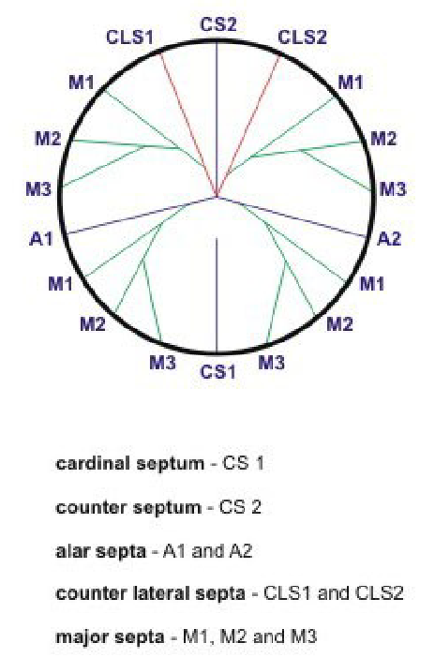  
  - Cardinal Septum: No attached septa, move vertically  
  - Counter Septum: Few lower order septae attached, angled from cardinal  
  - Most lower order septae attached to alar and counter laterals  
  - Resulting thickened calcareous structure in central portion of corallite is a columella
* **Order Scleractinia (Hexacorals)**- Evolved after the Great Dying  
  - No corals in sediments just above the Permian/Triassic boundary  
  - All corals of the Mesozoic and Cenozoic belong to this order  
  - Clearly separated between hermatypic and ahermatypic scleractinias function of the symbiosis with the photosynthetic algae zooxanthelae  
  - Septae are added successively and in sets at 60 degrees, 6 septae in a set  
  - Oldest set of septae are known as protoseptae, others metaseptae  
  