Assignment #2: Documenting the Athenian Agora

Please visit the following website: <http://www.agathe.gr/>

This website is the research page for the Athenian Agora Excavations in the center of Athens. Your assignment is to familiarize yourself with these excavations by answering a series of questions that will help guide you through the history and archaeology of this site. Emphasis in this assignment will be on the archaeological documentation generated by the field researchers. You can reach this documentation through the **Research** portal website above or directly here: <http://agora.ascsa.net/research?v=default>The search bar is your main tool. To search the entire database, make sure you search from **All Results** on the left side navigation bar. To reset the search function, search from the **Agora Excavations** tab.

Please answer **ALL QUESTIONS IN THE SPACE PROVIDED**. You may use point-form or full sentences.URL references are not required. This .docx file will allow you to type your answers into pre-set text boxes. Please do not alter the format of the document.Spend some time familiarizing yourself with the website by exploring the five section links: Overview, Guide, Democracy, Research, and Publications.

Section 1: Exploring the Agora and Artifacts of Politics (20 pts)

1. Indicate on the map below the location of the Athenian Agora (1pt).

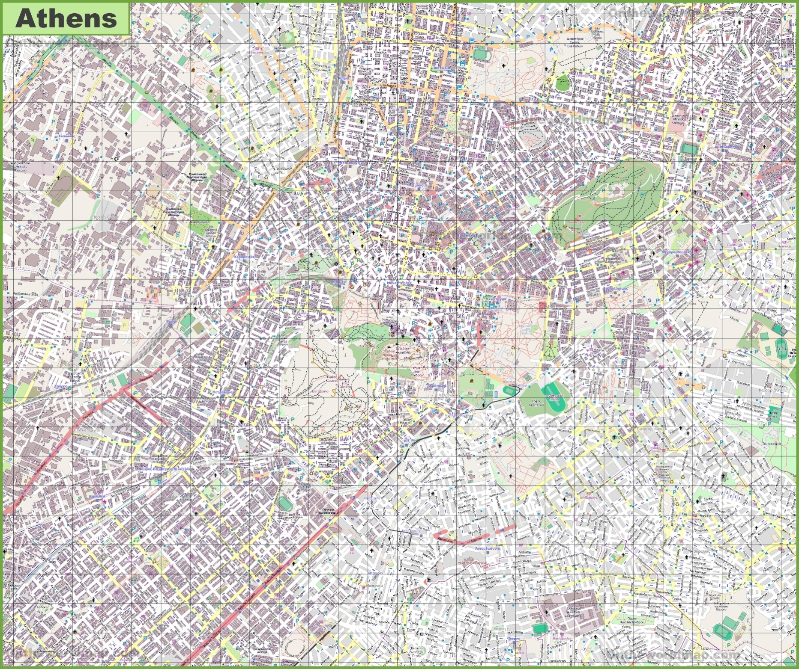

1. What are the fifth century BCE names of the buildings noted on the plan map below? If you search beyond the website for hints or clues, make sure you check your answer with the research page by searching for it in the search bar and confirming the names (5 pts).

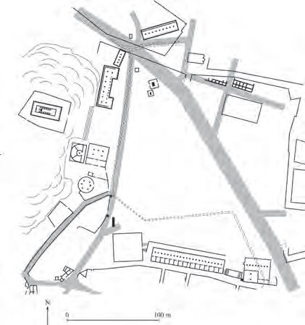

**5**

**4**

**3**

**2**

**1**

1. Stoa of Zeus

2. Hephaisteion

3. Heliaia

4. Mint + Holy Apostles

5. Lawcourt

1. What are the c. 200 AD names of the buildings noted on the plan map below? If you search beyond the website for hints or clues, make sure you check your answer with the research page by searching for it in the search bar and confirming the names (5 pts).

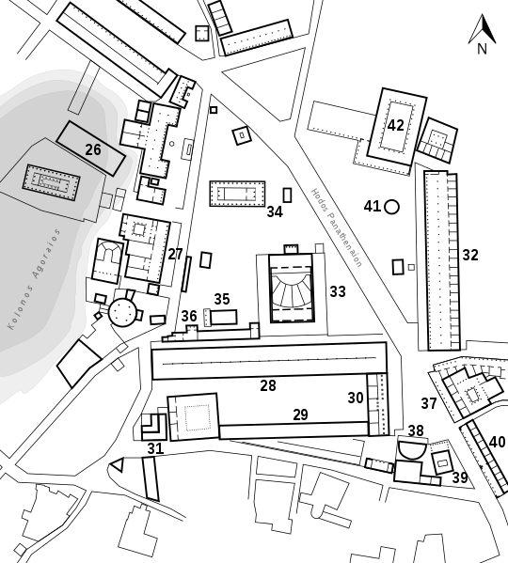

27. Metroon

32. Stoa of Attalos

33. Odeion

38. Nymphaion

42. Basilica

1. Search for the “Stoa of Attalos” and provide the function, patron, material, condition, and chronology (date of construction) of the building (2.5 pts)

Function: Commercial

Patron: Attalos II of Pergamon

Material: Conglomerate, Limestone, Pentelic Marble, Hymettian Marble

Condition: Fully Restored

Date of Construction: c. 150 BCE

1. Find the picture with Archive number 2003.01.0308. What archaeological feature is being photographed, where was it found, and what is inside it? (2.5 pts)

Photograph of a room with a ballot box in a building under the Stoa of Attalos. Contains a ballot box, the ballots in the photo have been replaced by copies.

1. Search for Agora Publication XXV. What is the topic of this publication? What are the artifacts detailed in this book? (2 pts)

The publication is a complete catalogue and discussion of sherds containing the names of candidates for ostracism. Begins with the history of ostracism in Athens and moves on to descriptions of the ostraka

1. Search for AO (Agora Object) 22. What is this object? What type of vessel did this originally come from (be specific)? (2 pts)

This is the Ostrakon of Themistokles Neokleos. One of the ostraka from Agora Publication XXV that nominates Themistokles Neokleos. It is the base of a kylix (formal drinking cup) with black glaze, inscribed on the bottom is the nomination.

Section 2: Reading Profiles (15 pts)

Archaeological profiles are designed to illustrate soil, sediment, and architectural stratigraphy as encountered during archaeological excavation. Sometimes profiles are observed in exposed excavation blocks and sometimes they’re reconstructed based on elevation data taken while excavating. Take your time and READ THESE PLANS CAREFULLY. These questions may be designed to trick you. Pay attention to the boundaries between soil and architectural levels.

1. Search for **DA (Agora Drawing) 4315. What is the name of this structure, and what are the names of the five cross section illustrations?**(2 pts)

Name: Metroon-Bouleuterion Complex

Sections: A-A, B-B, C-C, D-D, E-E

1. Keep DA 4315 open. Search for DA 12335. Illustrate on the map below where the cross-section profiles from DA 4315 are located on the plan drawing DA 12335. Compare the two illustrations and pay attention to the cross-section names. Please illustrate by inserting a thick line feature the full length of the cross section and giving it a bold colour (example provided).(5 pts)

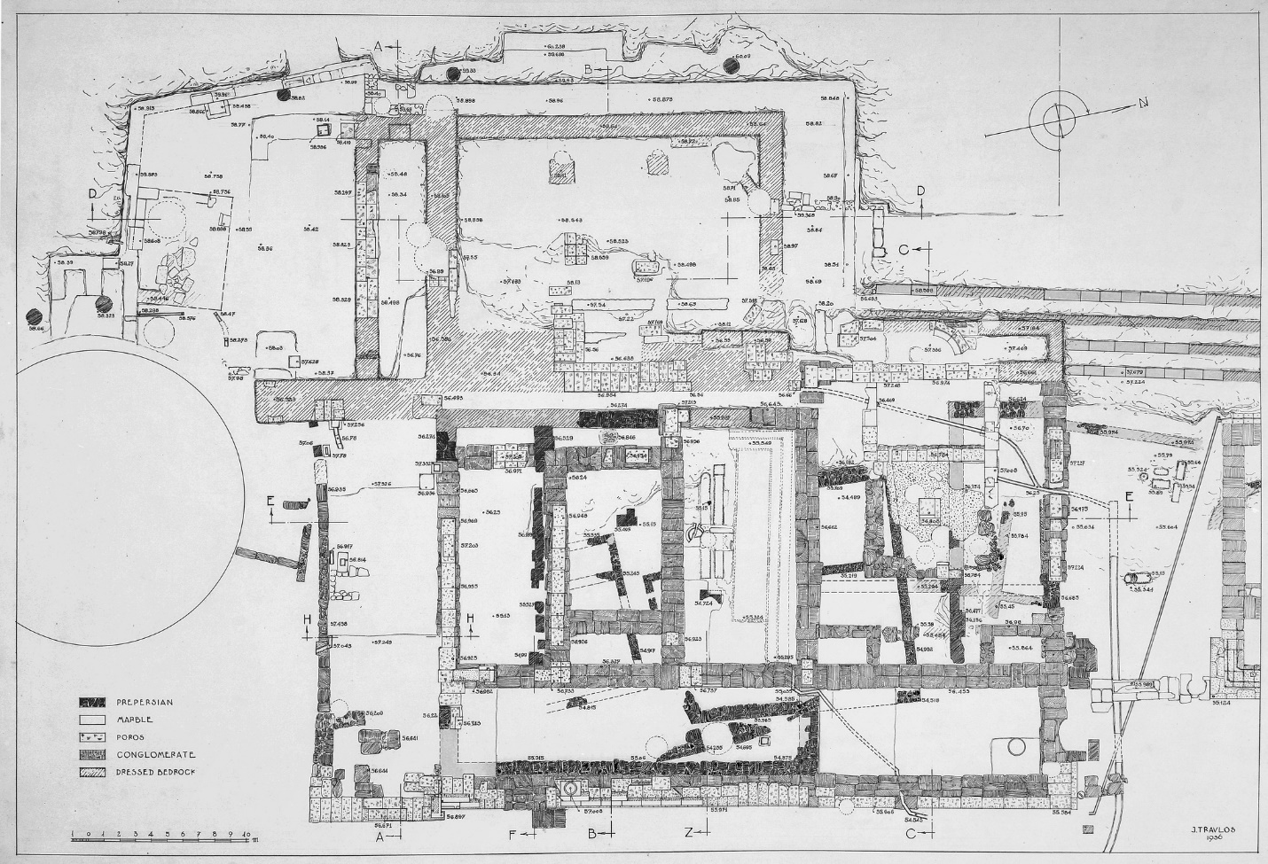

1. The complex illustrated by DA 12335 is hyphenated, indicating that two buildings are situated here. The newest structure is noted first. What is this monument, and what were its functions? (2 pts)

This monument is the Metroon, it functioned as the archive building where official records were kept. Also used as the temple to the mother goddess.

1. Search for DA 4319. These are segments of cross sections related to DA 12335.Answer the following questions: a. what layer is under the monument base in Section F-F? b. what layer is above the prehistoric grave in Section C-C? What infrastructural feature is common to all three sections? (3 pts)

Section F-F: Dug Bedrock

Section C-C: Gravel

Common Feature: Great Drain

1. Search for DA 5050. What feature is illustrated? What is the oldest deposit and what is the newest deposit? (3 pts)

Feature: The cross section of Well S 19:7

Oldest Deposit: Silt and mud

Newest Deposit: Collapsed bedrock and dumped fill

Section 3: Reading Notebooks (15)

You will be required to get information out of archaeological notebooks. Some of the terms you encounter will be specific archaeological jargon. Email with any questions or have a look through google. One term often encountered is ‘strosis’. This is another word for ‘layer’ or ‘stratigraphical layer’ or sometimes ‘floor level’.

The notebooks are scanned originals with embedded links that can take you to additional photos or plans or other notebook pages. Links to maps, however, appear mostly broken. The locations of the work described in the notebooks is derived from a grid-plan (Key Plan of the Sections) devised during early excavations at the Agora. It can be found by searching for “Image **2011.04.0332”. This is a plan of excavation areas listed with Greek letters (A, E, N’, OO, ∆, MΣ, BB, etc.) and separated by dashed lines. Use this plan to help understand what is being discussed in the notebooks.**

1. Search for Notebook Ω-10. Who is the author of this notebook, what section does it cover, and what year was it written? (3 pts)

Author: Colin N. Edmonson

Section: Ω

Year: 1957

1. Read pages 1803 and 1804 in notebook Ω-10. The work occurring from April 4th to 9th occurs in three different ‘sections’. What are they? (3 pts)

Sections Ω, AA, BB

1. Read pages 1803 and 1804 in notebook Ω-10. On April 8th, two features were identified: the first was a pebble mosaic floor. What was the second? If you follow the link to the picture of the feature, there is additional information. In what section was it found? What is it made of? (3 pts)

The second was a large stone pithos. It was found in section BB and was made of small stones and mortar.

1. Search for Notebook A-8. This notebook details finds from Section A. Find artifact P1315 from Section A 372 (87). What is this artifact (be specific)? In what context was it found? What period is it from? (3 pts)

Artifact: Black Figure Lekythos Fragment. Features the heads of four horse team, two heads reined in, the two behind lifted. The horse nearest forward was white.

Context: Rectangular Rockcut Shaft

Period: Greek

1. Search for Notebook H-5. This notebook details finds from Section H. Find artifact P2092 from Section H 354. What is this artifact (be specific)? In what context was it found? What period is it from? (3 pts)

Artifact: Plate Fragment with Makers Stamp. Broken on all edges, a bit of the circular groove left. A stamp in the center that reads: 'V I B I'. Made of a light reddish-buff clay with excellent red glaze.

Context: Dump in N. E. corner

Period: Roman

ASSIGNMENT GRADE: /50