**Minerals**

**Crystalline Network**

**Definition:**

* Any naturally formed chemical substance having a definite chemical composition (not necessarily fixed) and a characteristic crystal structure
* *A mineral cannot be broken into different mineral substances*

**Mineraloids:**

* Amorphous, naturally occurring substances
* Example: Opal, amorphous substance formed through the precipitation of silica

**Imperfections & Significance**

* Often present imperfections in form, colour, and properties
* The imperfections show us that they have an internal structure
* A bunch of example images in the slides

**The Crystalline Network**

* Able to begin developing models of the crystal structure  
  - Can be cubicle, with right angles
* Crystals: Fundamental units of matter organization, which have regular, repeating architecture (unit cell) reflecting the packing of atoms
* Exponential increase to magnification in microscopes in 1990s
* Galena minerals are cubical, has metallic luster reflecting light almost completely
* Extremely high magnification of a galena mineral surface reveal a regular, repeatable pattern consisting of an alternance of bright and dark spots (checkerboard, with lead and sulphur)
* Examples of ideal geometrical packing of ions and atoms:  
  - Tetrahedron  
  - Cubical  
  - Octahedron  
  *Geometrical bodies never have round surfaces*

**Importance:**

* Example: Diamond v Graphite, both are carbon atoms
* **Diamond**: All covalent bonds, very very strong, very homogenous due to the bonds (homogenous mineral)  
  - Deeper parts of the crust and mantle, huge pressure. Made it to the surface through massive volcanic events (does not happen anymore)
* **Graphite**: Lumpy, very weak, parallel planes of carbon. Planes covalently bonded form hexagons in a honeycomb pattern. The bonds between the planes are vanderwaal bonds (weaker than ionic)  
  - Formed in a variety of conditions  
  - Decomposition organic matter(C&H), H expelled at high temperature, leaving only carbon (graphite)

**Physical Properties**

* Can be used to recognize a mineral, although they cannot be sufficient

**Colour:**

* A huge variability in colour, the most deceiving physical property
* Some of the minerals have a well-defined colour when pure
* Impurities can significantly affect mineral colour

**Lustre:**

* Represents the qualitative expression of light reflection from a mineral  
  - Can be used in the description of the single minerals, or aggregates of minerals
* Most common descriptive terms for lustre: Metallic, Vitreous, Dull, Silky, Greasy

**Crystal Faces & Form:**

* Best examples to illustrate the crystal form are from thin sections
* **Euhedral**: Planar faces, corners are well-developed and angular (M)
* **Subhedral**: Consistency in general aspect, faces are not planar, corners are rounded (P)
* **Anhedral**: Irregular, not well-defined form (Q)

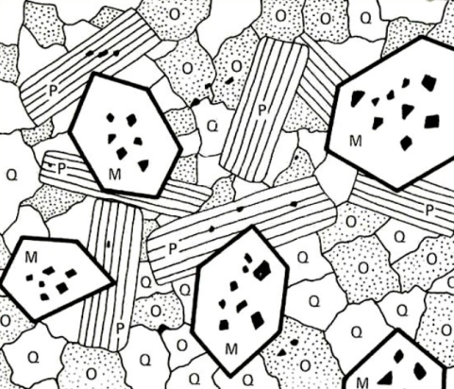

**Twinning:**

* A growth phenomenon
* Some minerals can put together portions of their crystal structure
* Can be defined as the symmetrical intergrowth of two or more crystals of the same substance
* Can be seen in both hand specimens and in thin sections
* Classifications: Simple Twins; Multiple (polysynthetic)
* Can be a diagnostic feature of some minerals (feldspar, staurolite)

**Transparency:**

* Transparent, Translucent, Opaque

**Mineral Toughness/Hardness:**

* Property referring to the force necessary to scratch the mineral's surface
* Strongly depends on the bonds in the crystal structure
* A relative hardness scale is used, *Mohs* hardness scale that goes from 1 (Talc) to 10 (Diamond)

**Classification**

**Native/Pure Elements**

* Free uncombined elements
* Metals: Au, Cu, Pt, Bi, Ag  
  - Dense, soft, opaque, malleable, ductile  
  - Massive, dendritic, wire-like
* Semimetals: Sb, As:  
  - Poor conductors  
  - Common in nodular masses
* Nonmetals: S, C  
  - Transparent to Translucent  
  - Do not conduct electricity  
  - Form distinct, large-sized crystals

**Sulfides and Sulfosates**

* Sulfides, minerals formed by metallic element + Sulfur  
  - Sulfur can be replaced by tellurium (tellurides) or arsenic (arsenides)  
  - Often present in metallic lusters (galena), and can be dense (galena, molybdenite, etc)  
  - Some are nonmetallic (opiment, realgar)  
  - Most frequent sulfide in nature is Pyrite (FeS2)  
  - Some sulfides are toxic (Realgar AsS, Orpiment As2S3) or radioactive
* **Sulfosalts** are mixed sulfides in which a semimetallic element is present together with a metallic one

**Oxides and Hydroxides**

* **Oxides** are compounds formed from various metallic elements and oxygen, in which the oxygen plays the role of an anion- Oxides occur in a variety of environments, often encountered in all three rock families

- Properties are extremely varied, habit and color are extremely variable

**Carbonates, Nitrates, Borates**

* Minerals that contain the radicals CO3 (carbonate), NO2 (nitrate), and BO3 (borate)- **Carbonates:**- Most common is Calcite (CaCO3)- Carbonate minerals are usually present as well-developed rhombohedral crystals

- Commonly present bright colours

**Sulfates, Chromates, Molybdates, Tungstates**

* Minerals in which the metallic elements are combined with the radicals SO4 (sulfate), CrO4 (chromate), MoO4 (molybdate), and WO4 (tungstate)  
  - **Sulfates**- The most common is gypsum (CaSO4)- Most of the occurrences are in evaporite rocks- Commonly they are soft, light minerals, present in pale colours

**Silicate Structure**

* One atom of silicon, covalently bonded to four atoms of oxygen. The oxygen atoms leave 1 valence electron

**Isolated Silicates/Tetrahedra (Nesosilicates)**

* Tetrahedra are linked by cations (eg: Fe (2+), Mg (2+))
* No shared electrons in the tetrahedra oxygen atoms
* Simplest structure, the most frequent minerals on Earth
* Examples:   
  - Topaz, Zircon (formed in a variety of environments, requires vast amount of water)  
  - **Olivine** (most frequent mineral on Earth)

**Single Chain Silicates/Tetrahedra (Inosilicates)**

* Single covalent chains, ionically bonded to each other by metals
* Chains of the silicates, those chains are ionically (weakly) bonded to each other by metal cations
* Tough in a direction perpendicular to the covalent chains, weak in the other direction with the ionic bonds
* Elongated prism shape due to this structure
* Cations can be Fe2+, Mg2+, Ca2+, etc

**Double Chain Silicates/Tetrahedra (Sorosilicates)**

* There are two or three shared oxygens in any Si-O tetrahedron
* The double chains are bonded by cations
* Very tough in a direction perpendicular to the chain structures, very weak in a direction parallel with them
* Relatively rare in nature, not rock-forming minerals

**Sheet Chain Silicates/Tetrahedra (Phyllosilicates)**

* Silica tetrahedra present three shared oxygen atoms
* Form a plane, the planes are bonded by cations
* Extremely tough in a direction perpendicular to the plane structure, extremely weak in a direction parallel to them
* **Biotite**: Very flaky, aka black mica, relatively frequent  
  - Black micas formed by the crystallization of the magmas from the deeper portions of the Earth  
  - White micas (**Muscovite**) form closer to the Earth's surface

**Framework Silicates/Tetrahedra (Tectosilicates)**

* All four oxygen atoms are bonded with covalent bonds
* The framework is three dimensional
* Covalent bonds everywhere, these structures are weirdly some of the most flexible minerals due to impurities that force the crystal structure to adapt
* **Quartz**: Very important, go through multiple rock cycles at the surface of the Earth under atmosphere, water, and biogenical forces, and remain intact  
  - One of the most stable minerals on Earth

**Ring Silicates/Tetrahedra (Cyclosilicates)**

* The ring silicates share two oxygen atoms in the Si-O tetrahedra to form rings of 3,4, or 6 tetrahedra
* Relatively rare minerals, do not occur in proportions greater than 1% of a rocks mass when they do occur

**Silicate Groups:**

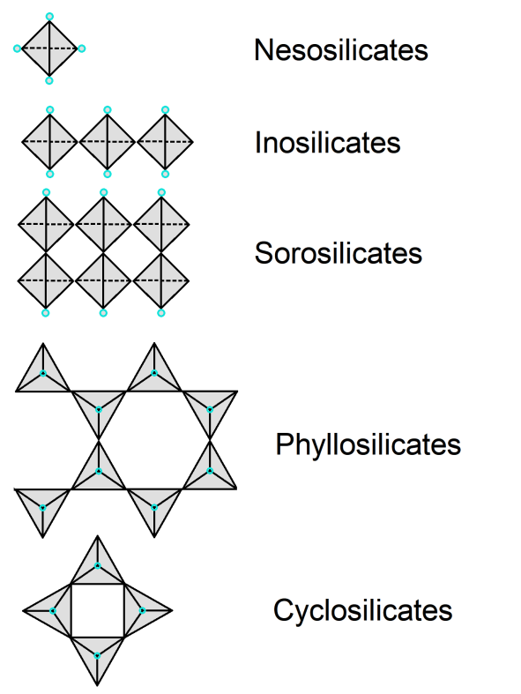

**Igneous Rocks**

**Major Groups**

* **Intrusive**: Magma cools and crystallizes within the Earth's crust  
  - Formed slowly within the Earth's interior, crystals have the time to grow and are obvious to the eye (pink granite has many flecks of colours)
* **Extrusive**: Magma cools and crystallizes at the surface of the Earth  
  - Process of cooling is very fast, the magma will crystallize in a matter of days, crystals don't have time to grow and remain small
* As magma moves towards the surface, it loses heat, certain elements in the magma begins to crystallize  
  - Three components: molten matter, crystals, liquids/gases  
  - Liquids were discovered due to the existence of diamonds, diamonds need water

**Igneous Classification**

**Phaneritic**

* Relatively large crystals in their mass
* Characterized by the fact that the crystals can be seen with the unaided eye or magnifier (such as hand lens)
* Indicative of slow cooling
* Examples: Granite, Granodiorite

**Aphanitic**

* Characterized by the presence of small-sized crystals, cannot be seen with the unaided eye
* Can be seen if you make a cross section through the rock and study with a microscope
* Indicative of rapid cooling
* Examples: Banded rhyolite, Basalt

**Glassy**

* Indicates the molten material crystallized very rapidly, no time for elements to arrange themselves into solid crystalline compounds
* Crystallization process lasts a few seconds
* Result is amorphous non-crystalline glass (extrusive)
* Examples: Obsidian, Snowflake obsidian

**Fragmental**

* Consist of pyroclastic material ejected as laval from a volcano, falls down at the Earth's surface as partly consolidated rocks
* Mixed characteristics, igneous and sedimentary
* Examples: Tuff

**Phaneritic Rock Textures**

* Textures are important as they can offer clues of significant importance for reconstructing the crystallization sequence
* Simply looking at the size of minerals, one can infer the process (heat, chemistry of the magma chamber)
* **Granular**  
  - Formed by a lot of minerals of almost the same dimensions
* **Porphyritic**- Big mineral chunks that are well-developed, set in a mass of very very small minerals (so small they don't let the light pass through them)- Process of slow cooling was somehow altered partway through after the bigger minerals were formed, heat was very rapidly lost, forming the "ground mass"/"matrix" of small minerals
* **Poikilitic**- Larger minerals that sit in what looks like a ground mass, however it is not a ground mass.- Light will not pass through, rotate it 90* and it will pass through depending- Two phases of crystallization, high melting point minerals (olivine in the examples) first start to form within the magma chamber, then the remaining molten matter became very homogeneous and became one single mineral.

|  |  |  |
| --- | --- | --- |
| Granular | Porphyritic | Poikilitic |

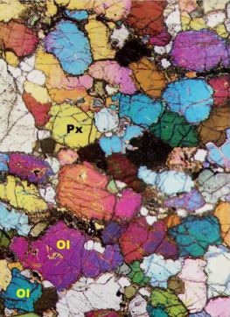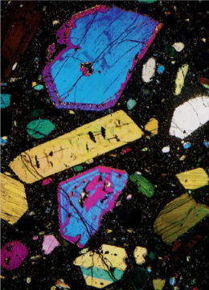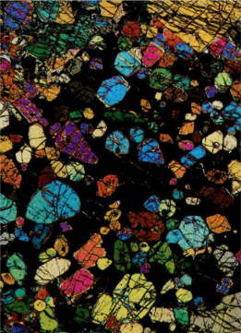

**Bodies of Intrusive Rocks**

* Batholith: largest body of intrusive rocks  
  - Magma chamber which solidified in the Earth's interior, then raised to the surface
* Stock: very large body of intrusive rocks  
  - Column shape, prismatic

**Igneous Bodies of Rocks**

* **Dike**: An obvious cut of a different rock through another body of rocks
* **Sill**: Parallel/horizontal layer of rocks between two layers of rocks. Layers originally adjacent, sill was injected between them.

**Extrusive Rocks**

* Process of cooling is very fast, the magma will crystallize in a matter of days, crystals don't have time to grow and remain small

**Volcanic Igneous Rocks**

* Journey of intrusive igneous rocks ends in the crust where they cool and crystallize
* Volcanic igneous rocks are further influenced by various volcanic processes, which can affect their form and texture
* **Lava Flows** (aphanitic igneous rocks)  
  Contain incandescent matter
* **Pyroclastic Flow** (fragmental igneous rocks)

Without incandescent matter

**Other Textures in Basaltic Lava**

* **Vesicular Basalt**: Vesicles are preserved gas cavities  
  - Inverted bubbly texture, lots of small holes

- Occurs in high viscosity lava flows, as they move (slow) they embed portions of atmosphere as bubbles

* **Pillow Basalts**: Basalt lava flows with bulbous appearance that form from underwater eruptions

- Large round chunks of rocks

- Magma from the core reaches the Earth's surface at the bottom of the ocean, very cold with colossal hydraulic pressure. Lava flow crystallizes almost instantly, creating pseudo-spherelike glassy rocks

**Volcanic Ash and Tuff**

* Particles expelled during volcanic eruptions, components of the pyroclastic flows (no molten matter)
* The volcanic ash falls and forms a very loose sediment, 1 meter of ash can be condensed into 1 cm
* The rock that forms from the concentration of the sediment is called Tuff

**Volcanic Bombs and Volcanic Breccia**

* Volcanic bombs are large-sized rock fragments, ejected during the volcanic eruptions
* Can be thrown 800-900 meters from the eruption (problem for nearby communities)

**Sedimentary Rocks**

* The clastic/detrital/siliclastic sedimentary rocks are composed predominantly of silicate fragments (many different ones) such as individual silicate minerals (quartz, feldspar) and rock (lithic) fragments  
  - **Clast**: Derived from a single mineral  
  - **Lithoclasts**: Clasts derived from 2 or more minerals  
  - **Bioclasts**: Fossils, vestiges of ancient life forms
* Clasts undergo weathering and erosion, transport, deposition, and lithification, to form a clastic rock
* The process can take several million years

**Clastic Rock Formation Cycle**

**Weathering and Erosion:**

* Weathering represents the physical and chemical alteration of rocks exposed to the atmospheric influences on the Earth's surface
* **Physical Weathering**: Bedrock is broken into smaller fragments, composition of the minerals remains unchanged  
  - Ex: A desert, by temperature and seasons
* **Chemical Weathering**: Water and dissolved ions react with solid rock to produce different compositions

**Transport:**

* Landslides and rockfalls
* **Eolian Transport**: transport media = wind  
  - Examples: Desert sand dunes, sandstorms, volcanic ash (krakatow circled the globe)
* **Glacier Transport**: transport media = ice  
  - Slowest kind of sediment transport
* - While a glacier advances, it detaches bigger particles from the ground  
  - Eventually it reaches an area with higher temperatures or an ocean, discharging sediment
* **Stream and River Transport**: TM = continental water  
  - Most of the sediments at the surface of the Earth are transported by streams and rivers
* **Wave and Current Transport**: TM = oceanic water

**Deposition:**

* Begins once a particle reaches the sedimentary basin, until it settles into the bottom of the basin
* The product of deposition is sediments, no cohesion

**Lithification:**

* Once the sediment starts the process of burial, transformation of a loose sediment into a rigid sedimentary rock
* **Compaction**: Reduction in volume of sediments resulting from weight of newly deposited sediments above
* **Cementation**: Precipitated minerals bind together the grains of a sediment, converting it into a sedimentary rock
* **Recrystallization**: formation of new crystalline mineral grains in a rock

**Metamorphic Rocks**

**Generalities:**

* Not molten and recrystallized
* Changes of the preexisting rocks during the metamorphic process are:
* **Textural**: Relative development of some minerals with respect to the others
* **Mineralogical**:Chemically reactive fluids travelling through rocks and fractures, coming in contact with existing minerals, changing their chemical composition
* **Both**:Most common

**Necessity of Changes:**

* Changes during the metamorphic process is due to rocks having the trend to remain in equilibrium with the surrounding environment
* Changes to the environment also change the rocks
* Example: Transformation from limestone into marble involves rock recrystallization under heat under many years

**Limits of Metamorphism**

* Metamorphic changes are made while the rocks remain under the solid state
* Doesn't always happen (migmatite, result from when metamorphosis between Granite and Gneiss fails)

**Importance of Metamorphic Rock Study**

* Metamorphic rocks exposed at the Earth's surface provide a window into different levels into the Earth's crust
* Allows for understanding of how the crust behaves and changes in different geologic environments
* Economic significance

**Types of Metamorphism**

* 8 main types, only cover 3 of them in this course
* **Barrovian/Regional Metamorphism**  
  - Metamorphism in the zone of the mountain ranges  
  - Metamorphism in the area between two plates (huge pressure)
* **Buchan/Contact Metamorphism**

- Deeper portions of the crust, when molten matter is injected (process of solidification is not linear, is fractional)

- Dominant rocks are marbles

* **Burial Metamorphism**

- A very thick pile of sediments, as more sediments are added, the older ones are buried and experience higher heat and pressure

**Metamorphic Rock Textures**

* Two processes to develop new textures:
* **Recrystallization**: Minerals change chemical+mineralogical composition, and size
* **Foliation**: Minerals realign, changing structures. Parallel alignment of minerals, layered appearance

**Grades of Metamorphism**

* Low Grade: You can tell it is still the original rock, a little transformed
* Medium Grade: The transformation is more apparent
* High Grade: You cannot practically recognize the original rock from which they formed (migmatite)

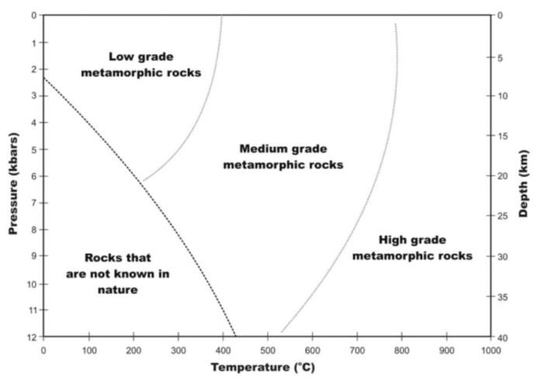

**Major Classes of Textures**

* **Foliated**: Contains nearly parallel strips of other minerals, present preferential orientation (*schistose*)
* **Non-Foliated** (Granoblastic): Don't have the strips

**Rock Cleavage**

* Describes the tendency of a rock to break along parallel or sub-parallel surfaces
* Reflects textural alignment of mineral grains, or subparallel arrangement of discontinuities
* As the rocks are buried, we see transitions as the minerals layer themselves

**Slaty Cleavage**

* Includes rocks with the lowest degree of transformation, shallow conditions
* Still recognize the original arrangement of the minerals, can frequently see fossils
* **Dominant type of cleavage**
* Low Grade Metamorphic Rocks

**Phyllite Cleavage**

* A tendency to lose the original foliation
* Originate through the metamorphic changes of the very fine sedimentary rocks
* More prominent metamorphic transformation
* Medium Grade Metamorphic Rocks

**Schistose Cleavage**

* Minerals rearrange themselves, almost cannot recognize the original rocks
* Schists are the most frequent of metamorphic rocks, formed through regional and burial metamorphism
* Dominant rocks of regional metamorphism
* Medium Grade Metamorphic Rocks

**Gneissic Foliation**

* Layered and wavy strips of pseudo-folds of minerals, effect of very high pressures
* High Grade Metamorphic Rocks