**Chordate Evolution**

* Have notochord rodlike structure, very thin but flexible, no well-defined head

**Pikaia - Burgess Shale** (Canada, BC): First chordate, Middle Cambrian

**Chengjiang Fauna – China**: Slightly older, Early/Lower Cambrian, first chordates

* Yunnanozoon: True chordate, occurs in vast numbers
* Myllokunmingia: Begins transition to true vertebrates with a weird notochord  
  - Incertae Sedis: uncertain position
* Haikouichthys: Well-developed vertebral column, first vertebrate, well documented in history of life
* Cheungkongella: First tunicates (benthic + plantic), *oldest ascidian*, attach to seafloor with thin notochord

**Conodonts**: conical teeth, first occurrence is Upper Cambrian

* Originally thought to be fishes, then chewing apparatus in stomach of fishes
* Dominated by apatite (calcium phosphate), trace of organic matter (aka bones)
* Colour varies with heat after burial, used to estimate sediment depth of burial
* Not distributed in layer, concentrated in small zones, assemblage of extremely complex chewing apparatus of single Conodont animal
* Look like the spines around mouths of small worms (Chaetognatha)

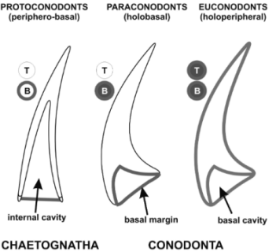

* **Cephalocordate**: Chordate with a head, first discovered conodont animal  
  - More evolved Pikaia, evolved independent of vertebrates in Chengjiang fauna  
  - Upper Cambrian-Triassic, mineralized chewing apparatus, notochord
* **Extinction**: Evolved during Paleozoic. Descendents of chaetognath/arrow worms  
  - Strongly affected numerically at Permian/Triassic, extinct at Triassic/Jurassic
* **Reconstruction**: Ate at bottom of ocean (scavenger), small size, big eyes

**Agnathan Evolution**

* Most primitive modern fishes: Cyclostomes: Parasitic way of life (lampreys)  
  - Lack of a jaw: Agnathan; well-developed head, no jaw, vertebral column

**Saccabambaspis**: Earliest agnathan (Lower Ordovician), discovered in Bolivia

* Headshield with 20 protective plates, 20 cm long
* Fishlike aspect, very well developed protective structure of wide bony plates
* Filter feeder, filtered bottom of ocean sediment for food
* Extremely slow swimmer, assured prey for the predators at this time

**Astraspis**: Resembles above, cephalic shield of many plates (Upper Ordovician)

* Oldest North American vertebrate, 15 cm long, anterior shield of many plates
* Eyes migrated from anterior position (front) to lateral position (side of head)  
   - Much wider range of vision to spot predators
* Still a filter feeder

**Ostracoderms:** Ordovician-Devonian, Anterior body w/ cephalic shield, few plates

**Thelodonts:** Upper Ordovician-Devonian, Cephalic shield in smaller plates, partly cover the body (mostly the anterior)

**Osteostracans**: Silurian-Devonian, single-piece cephalic shield, strong + slow

* Could take hits from major predators (sea scorpions)
* New organ to sense predators, sensing sea vibrations long before vision
* Evolved cerebellum, memories and knew where to go  
  - Reproduced inland (coastal, far away from sea scorpions), return to sea in #s
* Two genera: Zenaspis and Cephalaspis

**Heterostracans**: Evolved flat bodies for bottom of sea. Drepanaspis (Sil-Dev)

* Armored plates well separated for differing body parts, different shapes

**Thelodonts**: Drastic reduction of cephalic shield

* Genus *Lanarkia*, like Heterostracans but evolved earlier (Silurian)  
  - First agnathan to have dorsally compressed boy (thin guy)  
  - Followed by several hundred genera of fishes
* Example: *Furcacauda*: Devonian, Canadian, "Forked Tail"  
   - Tail with many distinct parts, looks like a ton of individual tails off of the back

**Fish Evolution**

* Evolved from Agnathans with the evolution of jaws, vertebral column, head

**Acanthodi**: Earliest Gnathostomes (mouths with jaws, Silurian-Today)

* Spiny, fins used for body balance and present a bony spine  
  - Extremely efficient moving forward, sluggish to turn, defense against predators
* Diplacanthus: Middle Devonian, length up to 4 meters, spines up to 60 cm  
  - Reduced evolutionary importance, practically everywhere in Silurian-Devonian

**Placoderms**: Remarkable active dwellers, oceanic water mass or sea floor

* Hid lower body behind very strong bony plates
* Two groups: Arthrodires and Antiarchs

**Arthrodires**: Large predators (10m), top predator of Devonian (Dunkleosteus)

* Cephalic shield of many bony plates connected at certain points, flexible & fast

**Antiarchs**: Mud-grubbers like ostracoderm ancestors, massive shield

* Coccosteus: Well ornamented plates in cephalic shield, fins protected by plates, rest of body is not protected (Devonian)  
   - Found internal structures resembling lungs, shallow water, could move inland for food or reproduction
* Rachiosteus: Other example

**Devonian Fishes:** Ancestors of both important fish groups of today

* *Chondrichthyes*: Late Silurian-Today, cartilaginous skeleton, sharks
* *Osteichthyes*: Late Silurian-Today, Bony fishes, most of the fishes today  
   - Only prey, survived by large numbers, suck water from water to move faster (more oxygen to the lungs)  
  - None of this helped, vertebrates evolved differently to survive by getting out of water. Conquest of land (Osteichthyes) with very high adaptability  
   - Conquest of land attempted many times, only succeeded in Late Devonian  
  - Contains Dipnoi, Actinisca, Rhipidista (below)

**Ancient Sharks – Devonian**

* Most frequent: Cladoselache (Devonian), small, solitary, < Dunkleosteus
* Stethacanthus: Discovered in Russia (Devonian)  
  - Numerous skeletons found in narrow region of seabed (underwater landslide)  
  - Group hunter
* Sharks didn't become top predators until the Cenozoic

**Batoid Sharks:** Squatina - Upper Jurassic, each piece of skeleton is cartilage

- Adapted to life in proximity of the sea bottom, rare fossilization due to cartilage

**Freshwater Sharks:** *Lebacanthus* - adapted to evade predators in salty waters by hiding in fresh waters (Permian)

* Still have Placoderms, slightly smaller and fewer

**Osteichthyes, Order Dipnoi:** (Dipnoi = lungfishes)

* Most lungfish live in freshwater rivers that periodically dry out
* Fish burrow into mud and aestivate (breathing w/ lungs)  
   - Hibernate during environmental stress
* Heat partly divided into left and right half (true land vertebrates, same pressure)
* Short extensions of muscle at the base of their fins, beginning evolution of limbs
* Fossil dipnoi: Largest lungfish today is 1.5m (Australia), past achieved gigantism  
  - Ceratodus: Triassic, example of giant dipnoi

**Order Actinisca:** History towards amphibians, evolved rapidly in Devonian

* Best specimens from Lebanon
* Long fins, extension of muscle tissue down the base of fins, *lobed-fin fishes*
* Extremely diverse, small & perfect prey, no real predators until Cretaceous

**Order Rhipidista:** First in Lower Devonian, diversified in Middle Devonian

* Eusthenopteron: Middle-Late Devonian, more muscle extensions down fins  
   - Transition from fishes to amphibians, last fish, all others will evolve

**Amphibian Evolution**

**Latimeria**: Modern Coelacanth, discovered by fisherman in offshore Africa

* Serious predator, survived to modern times with modifications, large guy

**Fish-Amphibian Transition:** Most obvious aspect is limbs

* Inferred life positions show resemblances rhipidistians and earliest amphibians
* Respiration through both lungs and skin, needed skin to be kept wet
* Laid a huge number of unprotected eggs (like fish), need water or dry out & die
* Fin-Limb structure evolved to more advanced morphological types

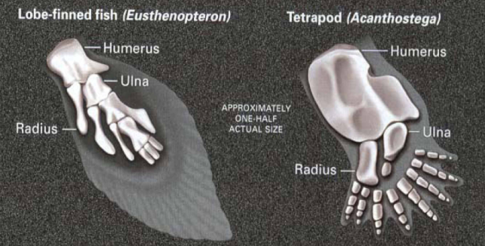

**Ichthyostega & Acanthostega:** First amphibians (Greenland), two genera

* Upper Devonian. Still present fish characteristics:   
   Delicate vertebrae + coastae, internal gills reduced but functional
* Back limbs have more than 5 toes (6 or 7), toes replaced fins  
  - More than 5 toes makes them close to Crossopterygians
* Bodies compressed at the back
* Two large eye sockets on top of skull, semi-aquatic mode of life

**Earliest Testrapods:** Acanthostega and Ichthyostega were aquatic animals

* 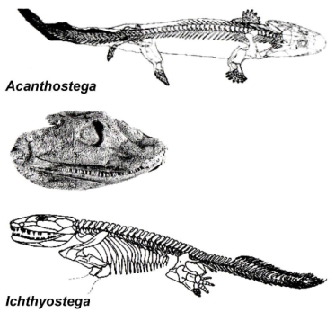Amphibious way of life
* Upper Devonian
* Acanthostega: Thin and many limbs   
  - Didn't use lungs very well  
  - No chest bone
* Ichthyostega: Better spine, larger ribs, strong limbs to move body inland  
   - Wide and large ribs to protect heart and lungs from attack  
   - Attackers would be other Ichthyostega, always cannibals

**Stem Tetrapods:** Several lineages in Devonian, Carboniferous (Upper Dev-Perm)

* Acanthostega was more amphibious than Ichthyostega
* *Pederpes*: First stem tetrapod with 5 toes, Lower Carboniferous (Scotland)
* Move inland reduced their size due to poorly developed muscles
* Earliest tetrapods have high evolution potential. Two important descendent groups: Amphibia (amphibians) and Amniota (birds, reptiles, mammals)  
  - Began laying eggs coated by a protective mineralized structure (shell)
* Diversification: Lower Carboniferous (Scotland, immediately after Devonian), found at different levels than fish, demonstrating complete separation of habits  
   - Amphibians only found in terrestrial deposits, serious inland migration, capable of developing life cycle inland returning only for reproduction  
  - Two new groups: Anthracosaurians, Temnospondyls

**Temnospondyls:** Ancestors of modern amphibians (Lisamphibia, did not continue to evolve), Pennsylvanian-Cretaceous

* Most diverse group in the Carboniferous (40 families, 160 genera)
* Eryops: Land locomotion, similar to crocodile, large w/ muscle and weight, evolved quite fast  
   - Top predator of Lower Carboniferous in continental conditions
* Cacops: Competely adapted to terrestrial habitat (Permian), 40 cm long  
   - Looks like a large frog, gave birth to modern Amphibians
* Micromelerpeton: Late Paleozoic (Lower Permian, Germany), dick shaped guy

**Modern Amphibians:**

* Small-bodied, soft-skinned, strongly differ from the early tetrapods
* Very poor fossil record
* Lisamphibians: First in Late Permian, now newts, salamanders, frogs, etc  
  - "Smooth Amphibians"
* *Andrias*: Miocene (Germany), classical example of cenozoic amphibians

**Anthracosaurians:**

* Ancestors of amniotes (vertebrates, eventual evolution of reptiles)  
  - Crocodile-like fisheaters, jaws to slam shut on prey  
  - Up to 4m in length, slender bodies, terrestrial
* Major predators, upper part of Mississippian: Replaced Eryops
* Limitations: Double respiration, permanently stuck to aquatic life  
  - No active breathing, had to swallow oxygen, skin had to remain wet

**Seymouria:** Permian (Germany), fully adapted to terrestrial life. Close to reptiles

* Of the Anthracosaurian group
* Small number of protected eggs
* Morphological features of a reptile, does not have a chest bone, ~60cm length

**Amniotes:** Most advanced organisms, needed to evolve to not require wet skin

* Egg is inside a membrane, small number of eggs protected by a shell
* Amniotes include higher evolved vertebrates: Reptiles, Birds, Mammals
* Group capable of spending its entire life inland

**Late Paleozoic Reptile Evolution**

**Kinds of Amniotes:** Number of holes in skull behind eye socket

* Anapsid (no holes), Diapsid (2 holes), Synapsid (1 hole, more evolved)
* Openings used for muscles, determines biting capabilities of certain reptiles

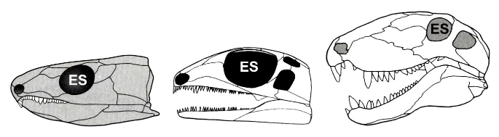

**Early Reptiles – Diapsids:** Fully terrestrial life mode due to availability of food

* Reproduced with small number of shelled eggs, some nurtured eggs until hatch
* Major evolution: Chest bone -> Capable of active breathing through the nostrils
* Moved at high speeds, small lizards, extremely high diversity & adaptability
* *Petrolacosaurus*: Forest Wanderer  
  - First reptile, Late Lower Carboniferous/Upper Mississippian
* Hylonomus: Early amniote from Upper Carboniferous, Pelycosaurid pre backsails
* Two small reptiles: (Late Paleozoic)  
   -Mesosaurus: all continents, short swimming distance, Pangaea  
  - Stereosternum

**Earlier Reptiles:** Amniotes developed full adaptation to terrestrial conditions

* Major challenge: Greater temperature differences
* New forms of thermoregulation: Efficient at gathering solar heat, increase size

**Synapsids:** Dominated Late Paleozoic (Late Carboniferous-Permian) land faunas

* Diapsids include dominant groups of the Mesozoic (dinosaurs, pterosaurs)
* Turtles have no skull openings, technically anapsid, likely readapted to aquatic conditions as their ancestors were diapsids (evolved loss of skull openings)

**Pelycosaurids:** Earlier synapsids, extremely diverse from the beginning

* *Totally dominated* the Late Mississippian and Pennsylvanian times
* Fully terrestrial tetrapods, 70% of Early & 50% of Late Carboniferous amniotes
* Decline in Late Permian, some evolved into the dominant therapsid group
* Forelimbs were massive, likely to prevent falling on face
* Thrust by strong back legs, no ankle-joint, strong muscles rotate femur in hip
* First attempt at regulating body temperature with backsails, increase size (4m)  
  - Extensions on back vertebrate with vascularised skin, big solar panel
* Example: Haptodus, very primitive genus (Pennsylvanian)
* Evolution of backsails occurred simultaneously between two similar groups:  
  - Edaphosaurus (vegetarian, groups, flee) and Dimetrodon (predator, individual)

**Behavioural Thermoregulation:** Equatorial, tropical regions, but active overnight

* Pelycosaurs developed new system of behavioural thermoregulation  
  - Could function over range of internal temperature, tried to control to optimum
* Large-sized reptiles were confined to tropical and subtropical zones
* Dimetrodon & Edaphosaurus independently developed large sails, control temp
* Pangaea begins to form during Carboniferous, south pole ice cap expands, too cold for Pelycosaurs (try to migrate south to Gondwana, way too cold for them)  
  - Finishes during Permian, slightly warmer with extremely harsh winters

**Invasion of Gondwana:** Backsails were not enough, skin could not retain heat

* Formation of Pangaea resulted in appearance of zone to be invaded
* Invasion of Gondwana (in Pangaea) happened to adapt to colder environments

**Therapsids-Mammal-like Reptiles:** Develop at mid-high latitudes

* Bodies to retain heat (massive bodies, thick limbs at bottom of bodies)
* Evolved layer of fat tissue to retain heat
* Example: Keratocephalus (Permian), fat and stocky dinosaur mf
* Too big and too cold of climate, could not be powered by solar heat
* Porous bones like mammals, red cells of blood in bones, warm-blooded guys
* Probably developed furry skin, mammal-like automatic thermoregulation  
  - Adapted to conserve heat, not generate it, long way before mammals
* Discovered north in Siberia (instead of southern Gondwana)  
  - Teeth capable of performing different functions (elongated canines)
* Ivantosaurus: Two extremely elongated teeth, major predator, extremely large, capable of killing in a single bite

**Mesozoic Evolution - Aquatic Reptiles**

* Two distinct groups of marine reptiles in the Mesozoic times

**Triassic:** Placodonts (order Placodontia) and Nothosaurs (order Sauropterygia)

* *Placodonts*: blunt-toothed shell crushers. Broad inner teeth behind outer teeth  
  - Armor resulted in appearance of large turtle, bony structure on bottom as ribs  
   - Protect ventral sides of body from cutting edges of shells
* *Nothosaurs*: Example: Ceresiosaurus (2.2 meters long)  
  - Not fully aquatic, only plunged periodically in water for food

**Jurassic-Cretaceous:** Plesiosaurs (Sauropterygia) and Ichthyosaurs (Ichthyosauria)

* *Plesiosaurs*: Long necked fish eater, undulates neck to disorient prey  
  - Example: Futabasaurus (famous fossil in Japan)
* *Ichthyosaurs*: Fish lizards, top predators in Jurassic and Cretaceous seas  
  - Relatively small (few meters), best adapted to aquatic (similar to dolphins)  
  - Extremely fast, anterior paddle-like limbs  
  - Really long beak-shaped head, large skull armor to protect eyes (from others)  
  - Best adapted to life in the aquatic environment  
  - Example: Leptonectes: Buried by landslides, mother caught giving birth  
   - Gave birth to live offspring, strategy close to dolphins and sharks

**Reptilian Non-Dinosaurian Flight – Pterosaurians**

* Evolved flight several times, not just one group. Pterosauria: Winged Lizards
* ~200 (now 400) species of flying reptiles during upper Triassic-Cretaceous  
  - Pterosaurian age corresponds to that of the dinosaurs
* Likely polyphyletic, group taxa that evolved winged morphology iteratively

**Flight Capabilities:** Representatives considered to be gliders from higher places

* Small guys used trees to start gliding, larger ones started from cliff or falaise
* Originally thought bodies would be too heavy like reptiles  
  - Bones were hollow, big creatures but very light  
  - Flight capabilities reevaluated, some could actively move wings during flight, highly maneuverable in the air

**Adaptations:** Heads are streamlined, hollow bones

* Body covered in hair: Ex. *Sordes pilosus*: Late Jurassic (Kazakhstan)  
  - Very good preservation, portions with fur, indicates endothermy (warm blood)
* Wings consisted of extended skin to modified arm skeleton over whole length  
  - Wings could be moved by massive pectoral muscles

**Feeding:** Extremely diverse

* Dimorphodon: Insectivores, many thin and narrow teeth
* Rhamphorhynchus: Fish eaters, like seagulls, hair on beak and claws, Jurassic  
  - Long, super spindly fossil picture taken from musem
* Ctenochasma: Fed on plankton at surface of ocean, skimmed it off the top
* Pteranodon: Very streamlined head, no teeth, large pelican beak, eat fish whole  
  - Upper Cretaceous

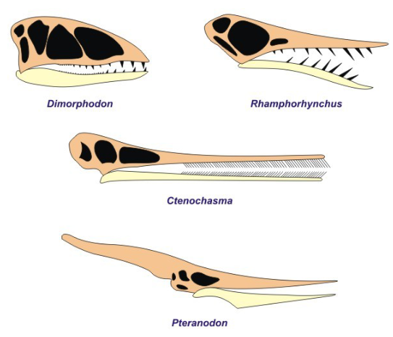

**Terrestrial Reptiles**

**Triassic Diapsid Takeover**

* Most significant change in Triassic was replacement of synapsids by diapsids
* Oldest diapsids in Carboniferous; Old genus: Petrolacosaurus, small insectivore
* Not among flourishing dominant reptiles of Carboniferous and Permian, but colonized variety of environments, adopting different feeding strategies
* Diversification began in Late Permian, two major groups evolved in Triassic:  
  - Lepidosaurs - Lepidosauromorpha (lizards, snakes, etc)  
  - Archosaurs - Archosauromorpha (crocodiles, etc)

**Lepidosauromorphs:** Remained terrestrial & quadrupedal since Early Triassic

* Not among dominant reptiles in the Mesozoic
* Squamates (order Squamata): Lizards and snakes  
  - Evolved in the Jurassic, diversified at Cretaceous/Paleogene boundary  
  - Evolved gigantism (Titanoboa: 1m tall, 100ft/30m long, fish eater, size climate)

**Superorder Dinosauria**

**Generalities:** Group of Mesozoic reptiles, evolved in the Triassic

* Typically diapsid, present morphological similarities with crocodilians and birds  
  - Evolved to have more sophisticated skulls, larger number of holes
* Jurassic and Cretaceous: Dominant land vertebrates, evolution resulted in occurrence of some of the largest animals in life history of the Earth

**Classification:** Two groups: Orders Saurischia and Ornithischia (lizard/bird-like)

* Fundamental structure is form and orientation of the pubis bone
* Significant contribution in deciphering the dinosaurian evolution & classification

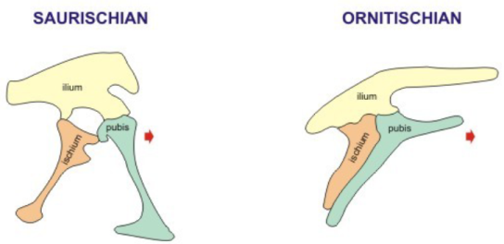

**Saurischian Dinosaurs:** Pubis bone oriented downward and forward from the articulation with the ilium and ischium

* Three suborders: Staurikosauria, Theropoda, Sauropodomorpha
* Name indicates pelvic girdle resembles those of the modern lizards

**Ornithischian Dinosaurs:** Pubis bone in ventral position, parallel to ischium that extends backwards. Five Suborders:

* Ornithopoda, Pachycephalosauria, Stegosauria, Anklyosauria, Ceratopsida

**Earliest Dinosaurs:** Originally small (turtles), mostly prey for other animals

* Earliest Tracks from Middle Triassic-Cretaceous

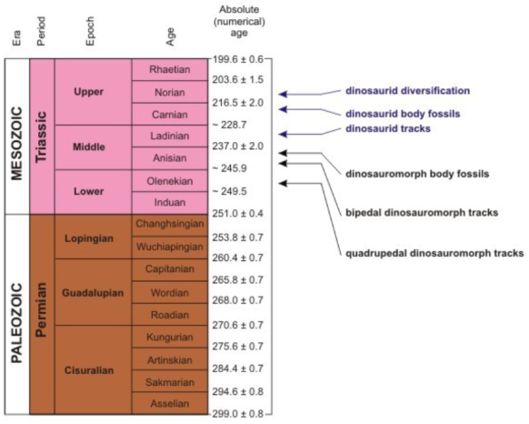

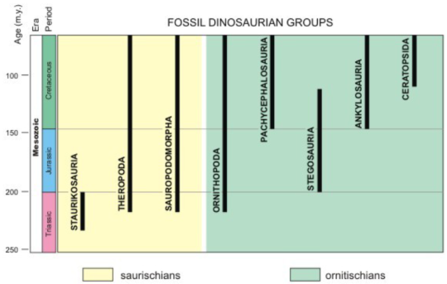

**Saurischian - Staurikosauria:** Earliest dinosaurs, bipedal small carnivores (2-4 m)

* Late Triassic earlier dinosaurs:   
  - Starikosaurus (Brazil), Herrerasaurus (Upper Triassic, Argentina)
* Anterior limbs are very well developed with claws, used for hunting
* Pelvic girdle presents resemblances with those of there thecodont ancestors
* Discoveries in all continents indicate this group was highly adaptable since the beginning of dinosaur evolution

**Saurischian - Theropoda:** Carnivorous dinosaurs of variable size

* 1 meter (Microraptor) to over 15 meters (Tyrannosaurus, Gigantosaurus)
* Bipedal, could run at high speeds (sum over 40 km/h), larger ones not as fast
* Major predators, strong jaws and backward oriented teeth, not for chewing
* Large sized heads with developed musculature (many skull openings)  
  - Capable of breaking bones of prey, not just slicing soft tissues
* Examples: Tyrannosaurus (Upper Cretaceous), Dromaeosaurus (Lower Cretaceous), Caudipteryx (Lower Cretaceous, China)  
  -Caudipteryx: Bird tail, as small as a turkey, part of group that gave birth to birds

**Saurischian - Sauropodomorpha:** Largest animals on Earth, some over 70 tons

* Vast majority were herbivores, some of the earliest members could eat meat
* Occasionally bipedal, Jurassic -> became quadrupedal  
  - Prosauropoda (Late Triassic-Early Jurassic)  
  - Sauropoda (Jurassic-Cretaceous)
* Usually very long neck, very slow body, small brain, swallow rocks to help digest
* Examples:   
  - Plateosaurus (Upper Triassic-Lower Jurassic), Ultrasaurus (Upper Jurassic)

**Ornithischian - Ornithopoda:** Oldest of the Ornithischians

* Herbivores, dentition modified for chewing, same ecological niches as modern herbivore mammals
* Earlier ones were small (1-2m), attained larger sizes (12m) later in evolution
* Bipedal and quadrupedal, two types of locomotion occurring in same species
* Back limbs were stronger than fore limbs, speeds of 15-20 km/h
* Ex: Iguanodon, Hypacrosaurus, Camptosaurus, Hadrosaurus, Edmontosaurus  
  - Iguanodon: Skull of duck with beak, labyrinthic internal structure in skull to create air currents, communication + mating (Upper Jurassic-Cretaceous)

**Ornithischian – Pachycephalosauria:** Cretaceous, thickened skull roof (thick head)

* Bipedal and herbivores, evolutionary origins not precisely known
* Thickened skull roof likely used as battering ram  
  - Original interpretation: Bonking heads over females for mating  
  - Now: Adaptation for defense against Theropods
* Examples: Stegaceras, Pachycephalosaurus (Upper Cretaceous)

**Ornithischian – Stegosauria:** Jurassic – Early Cretaceous

* Quadrupedal, medium-size herbivores, as long as 9 meters
* Osteoderms (plates, spines, spikes), larger spins in tail distal portion  
  - Original: Defense against bites of predators  
  - Now: Body thermoregulation with system of blood vessels  
  - Large tail spines used for defense, inflict deadly wounds
* Small brain, smaller brain in spine to coordinate body
* Packs of 5-6, easily take down very large lone predator if needed
* Example: Stegosaurus (Jurassic)

**Ornithischian – Anklyosauria:** Cretaceous, covered by bony plates in the skin

* Quadrupedal herbivores, continuous armor-like structure on their back
* Tail thickened at the end with a club-like structure, used for defense
* Typical genus: Ankylosaurus. Other example: Euoplocephalus(Lower Cretaceous)

**Ornithischian – Ceratopsida:** Late Cretaceous, best adapted for defense

* Quadrupedal chewing herbivore (up to 10 m), skull protected by cephalic shield extending backwards to the shoulders  
  - Can present anterior horns  
  - Used both for attack and defense
* Examples: Triceratops (Upper Cretaceous), Paraceratops, Chasmosaurs

**Reptilian Dinosaurian Flight – Evolution of Birds**

**Ancestors of Birds**

* Evolved in Late Mesozoic from dinosaurid ancestors (theropods)
* Earliest reptiles with avian features in Late Jurassic  
  - Close ancestors didn’t evolve until Early Cretaceous (Ornithuromorpha)  
  - Real birds didn't evolve until the Cenozoic  
  - Don't know exact reptile-bird boundary  
  - Safe interpretation: Bids when all avian features achieved (Paleocene)
* Preavian Theropods: Theropods with some avian features, but not all of them
* Ornithuromorpha: Greek for Reptiles with Bird Form. Not the first real birds yet

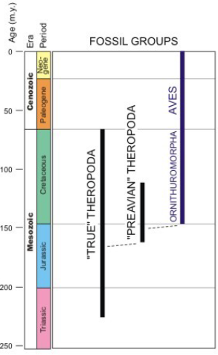

**Archaeopteryx Lithographica**

* Famous specimen exhibited in Berlin, missing reptile-bird link (feathered reptile)
* Reptile features: Tail, limbs with claws, beak with teeth, etc. Birds: Feathers  
  - Wide hollow spaces in bones, possibility of flight, not entirely hollow like birds
* Body features show high similarity with number of smaller groups of theropods
* Not capable of avian flight, feathers for high body temperature  
  - Secondary for flight, some think it was a glider
* Examples: Archaeopteryx (Upper Jurassic), Microraptor  
  - Microraptor from China, allow us to infer lifestyle from organic debris
* Feather morphology is identical to modern birds, definitely ancestors

**Origins of Bird Flight:** Two hypotheses to explain the flapped flight origin

* Arboreal: Origin from small-sized non-flying reptiles gliding from trees
* Cursorial: Origin from fast running animals, developed flapped flight on short distances in attempt to avoid ground level obstacles

**Earliest Bird-Like Organisms:** Late Jurassic and Cretaceous

* Closest relatives: Cretaceous group *ornithuromorpha*- Often referred to as birds, don't have all of the features required  
  - Examples: Hesperornis, Patagoptryx, Vorona
* Confuciusornis: Lower Cretaceous
* Parahesperoris: Resembled modern birds, Upper Cretaceous
* Diatryma: Giant bird with a huge head, Eocene (Middle Paleogene)

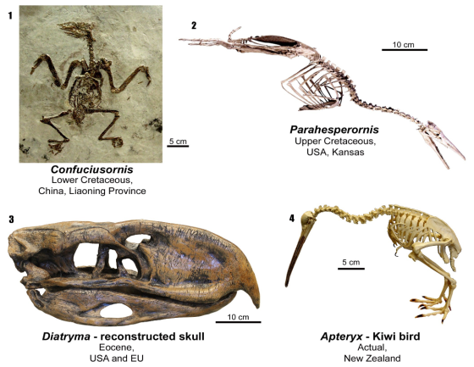

**Transition to Birds:** Morphological changes in the skeleton:

* Disappearance of teeth; Evolution of pygostyle to support tail muscles; Toe rearrangement (3 front, 1 back, loss of 5th); Pneumatic bones (hollow); Keeled downward projected sternum (chest bone, wide and powerful flying muscles); Loss of some vertebrae (more flexible vertebral column); Covered in feathers

**Midterm 1:**

* Bone fragment with age of 55 million years is considered: Fossil
* Fossils preserve traces of feeding are considered: Trace Fossils
* Fossil trilobites show: Hard body parts
* Oldest pre-scientific fossils are known from: Egypt
* First scholar reported fossils as vestiges of life forms: Xenophanes of Colophon
* First fossils figured in 1551 by: Christophorus Encelius
* Fossil spore and pollen debris represent topic of study in: Palynology
* Fossil distribution in space and time: Biostratigraphy
* Process not part of the clastic rock formation cycle: Metamorphism
* Fossils in metamorphic rocks occur in: Slates
* Fossils never occur in: Igneous Rocks
* Fossilized bivalve of pyrite was formed through: Replacement
* Fossils preserved through carbonization consist of a thin film of: Graphite
* External features of a shell by moldic fossilization are preserved on the: Cast
* Most frequent kind of preservation of plants: Carbonization
* Mineral frequently transformed into calcite during Recrystallization: Aragonite
* Principle where form of 1 layer only fluid above it: Successive Layer Formation
* Youngest eon in the Earth history: Phanerozoic
* Youngest period of Mesozoic Era: Cretaceous
* Oldest fossils on Earth known from rocks in this eon: Archean
* Most severe crisis in life boundary between these two periods: Permian/Triassic
* Oldest rocks on Earth are in this eon: Archean
* Oldest period of the Paleozoic: Cambrian
* Middle period of the Cenozoic: Neogene
* Fundamental level of organization of living in Linnean classification: Species
* Taxonomic level situated between order and infraorder: Suborder
* Most primitive organisms in this kingdom: Bacteria
* Single-celled eukaryotes included in kingdom: Protista
* Highest rate of evolutionary changes in kingdom: Animalia
* Stromatolites consist of the kingdom: Bacteria
* Most complex morphology amongst algae: Charophytes
* Group of land plants transitional between ferns and gymnosperms: Seed ferms
* Protective structure in foraminifers: Test
* Radiolarian habitat best described as: Marine and Planktic
* Radiolarian skeleton consists mostly of: Organic Silica
* Group of cephalopod molluscs, ancestors of modern squids: Belemnites
* Modern corals are included in this group: Hexacorals
* Molluscs that have shell consisting of one uncoiled piece: Scaphopods
* Graptolite colony is referred to as: Rhabdosome
* Most primitive land vertebrates: Amphibians

**Midterm 2:**

* Proteins are final products of the polymerization of: Amino Acids
* Polymer cellulose formed through repetition of this organic monomer: Glucose
* Oldest clustered fossils in lithostratigraphic unit in Australia: Strelley Pool Chert
* Living stromatolites first discovered in: Eastern Indian Ocean
* Precambrian stromatolites had patchy distribution in: Mesoarchean
* Photosynthetic bacteria and cyanobacteria dominate in: Growth Surface
* Stromatolites achieved global distribution in: Neoarchean
* Fossilized eukaryotic cells documented for first time in: Bitter Springs Formation
* Example of evolution of algal multicellularity: Bangiomorpha
* Earliest organism w/ animal-like metabolism is in group: Testate Amoebae
* Vestiges of catastrophic meteorite bombardment occur: At surface of the Moon
* First scientific name given to stromatolites: Cryptozoon
* Age of oldest multicellular animals on Earth is: Cryogenian
* Duoshantuo Formation in China yielded oldest: Fossilized Enimal Embryos
* Ediacaran occurs in uppermost portion of eon: Proterozoic
* Ediacaran organism as oldest known mollusc: Kimberella
* Age Gunflint Formation, prokaryote diversifified for 1st time: Paleoproterozoic
* Reduction of stromatolites (global -> patchy) happened in: Cambrian
* Spriggina, cephalization demonstrated by occurrence of: Cephalic Shield
* Earths appearance during Snowball Earth similar to: Europa
* Coral order where hermatipic-ahermatipic separation is not apparent: Tabulata
* All corals of Mesozoic and Cenozoic are of order: Scleractinia
* Rugose corals also known as: Tetracorals
* Each individual organism in stony coral colony known as: Corallite
* Age of fossils of Burgess Shale: Middle Cambrian
* Morphological structure making Pikaia a chordate: Notochord
* First major predator (Cambrian) is: Anomalocaris
* Fossil onychophorid genus from Burgess Shale: Ayisheaia
* Precambrian/Cambrian boundary defined with first occurrence of: Trace Fossil
* Most significant evolution from prokaryotes -> eukaryotes: Sexual Reproduction
* Existence of oceans in early history of Earth demonstrated by: Zircon
* Primordial atmosphere of Earth had this character: Reducing
* Isua Formation crops out in: Greenland
* Stromatolite development resulted in vast amounts of this gas: Oxygen
* Maximum development of BIFs in: Proximity of Archean/Proterozoic Boundary