Problem Statement and Requirements

Problem Statement
Currently most cities in the United States, collect data from various sensors across all the roadways. Most of the data goes unused and is confined to specific intersections or small areas within the cities. This data can be used to improve the efficiency of roadways across America, provide real time traffic conditions to first responders/drivers, and improve the planning of future roadways and public transportation routes. The challenge with smart traffic is aggregation of the various data sources and making meaningful use of all the available data.

Target Users
- Drivers
- First Responders
- City Planners
- Traffic Controllers

Functional Requirements
- The system shall support adding new intersections
- The system shall collect vehicle counts from every intersection
- The system shall collect temperature, precipitation, wind speed, and pressure from every intersection
- The system shall collect position data from all public transportation being monitored
- The system shall collect passenger counts for all public transportation routes being monitored
- The system shall support adding new public transportation routes
- The system shall automatically detect traffic accidents at intersections
- The system shall detect traffic conditions at intersections
- The system shall create alerts for traffic accidents
- The system shall create alerts for traffic conditions
- the system shall create alerts for bad weather conditions
- The system shall have control over traffic lights at each intersection
- The system shall optimize traffic lights for highest vehicle flow
- The system shall make use of machine learning to optimize traffic lights
- The system shall store all historic data in 3-minute intervals
- The system shall collect new data every 10 seconds
- The system shall allow a human to override the control of an intersection

Non-functional Requirements
- The system shall support adding as many intersections as needed
- The system shall authenticate all requests to override traffic lights
- The system shall be tested for each intersection added
- The system shall have a latency of no more than 30 ms
- The system shall scale databases as needed for historical data collection

System Design

Use Case Diagram
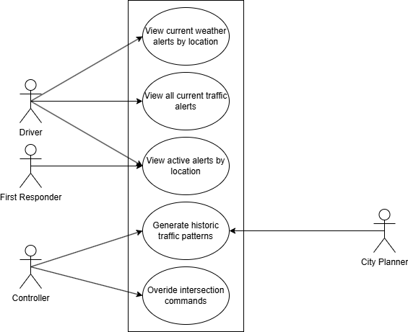
Figure 1: Use Case Diagram
The use case diagram above represents the 5 main use cases of the system with its main actors. One of the main overall use cases of the system is to extract data from the system to make use by the actors. Different types of information can be extracted from the system including current alerts in the system and historic traffic data.

Domain Model
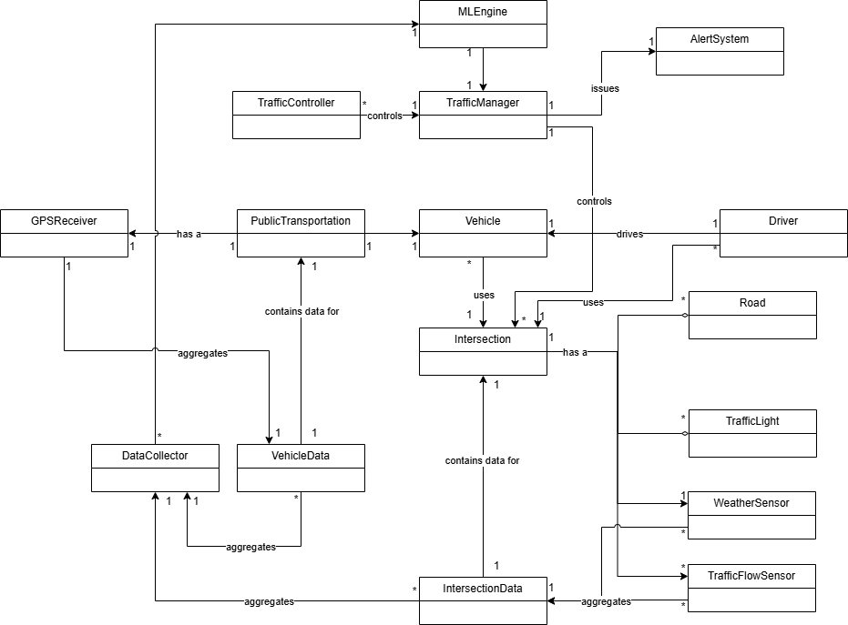
Figure 2: Domain Model
Figure 2 represents the domain model of the system. The main parts of the system include the intersections and vehicles this is the primary source of the data and is where all the main interactions of the system will occur.

Class Diagram
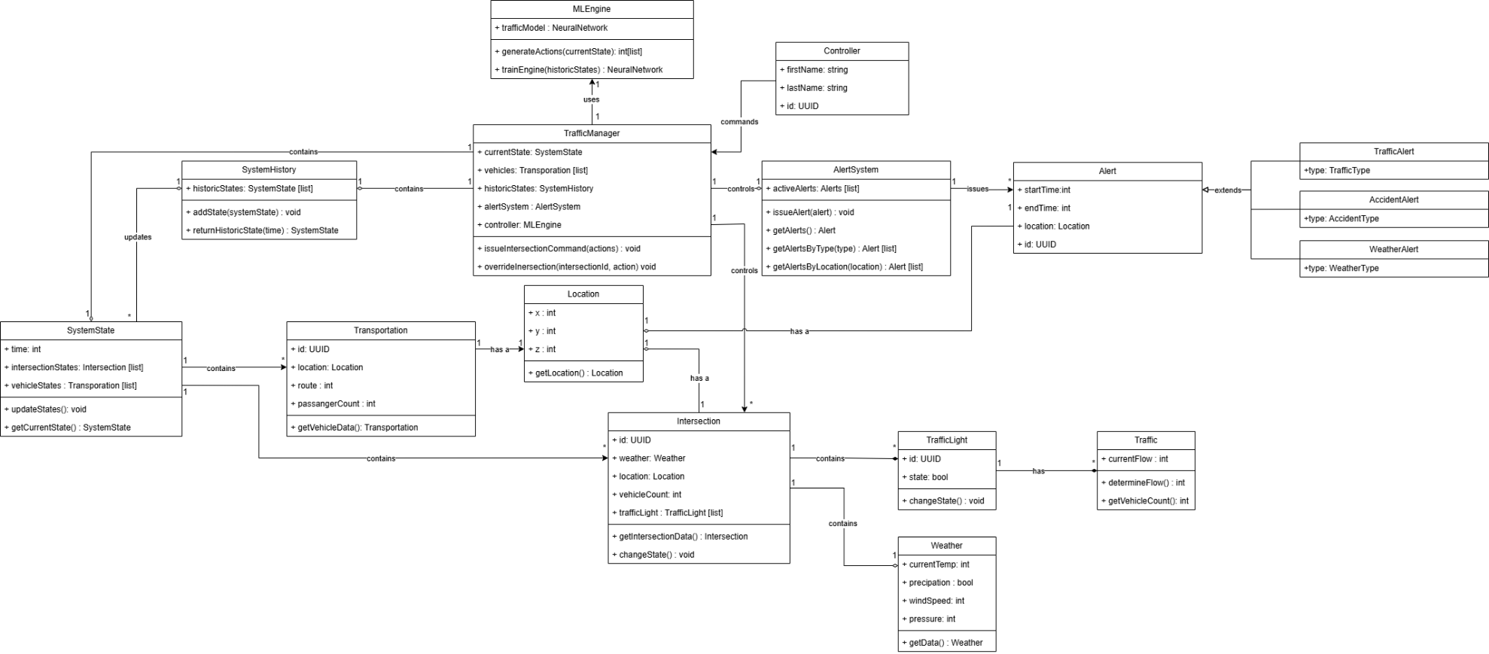
Figure 3: Class Diagram
The class diagram has 5 main classes TrafficManager, SystemState, Intersection, Transportation, and AlertSystem. These classes are responsible for a lot of the functionality withing the system. TrafficManager represents the overall system, it consumes data and produces actions based on the data. SystemState is responsible for collecting data from Intersections and Transportation. Intersection is responsible for controlling the traffic lights within the physical intersection itself along with collecting data about the intersection including traffic flow and weather. Transportation is responsible for collecting data from specific routes including buses and trains. AlertSystem is responsible for generating alerts that are provided by TrafficManager.

Sequence Diagrams
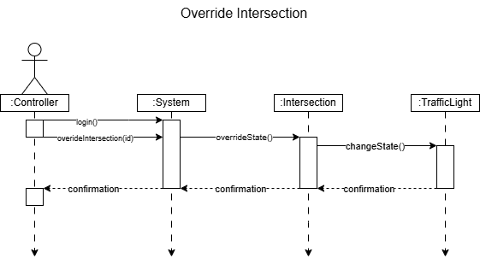
Figure 4: Sequence Diagram 1
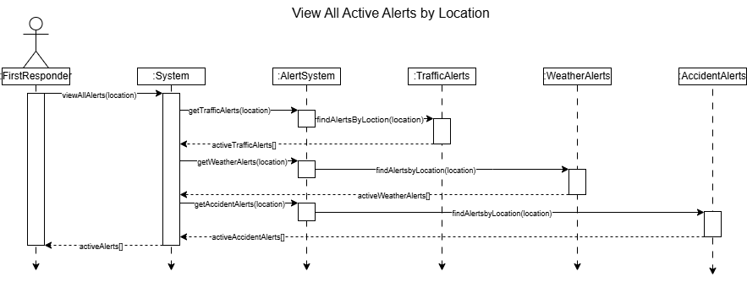
Figure 5: Sequence Diagram 2
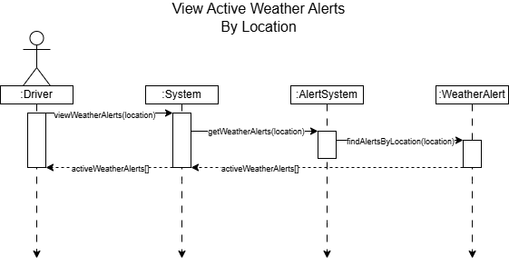
Figure 6: Sequence Diagram 3
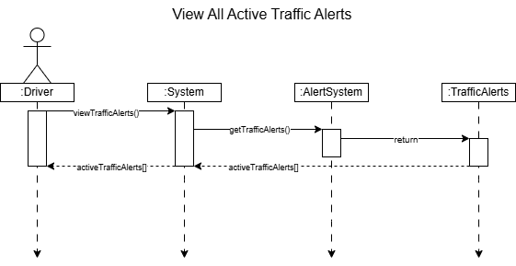
Figure 7: Sequence Diagram 4
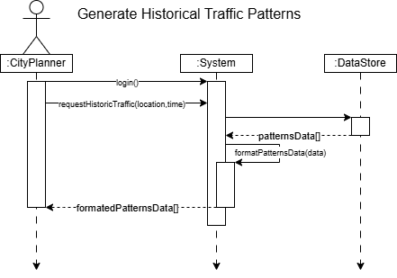
Figure 8: Sequence Diagram 5
The sequence diagrams represent the 5 main use cases for the system with its involved actors. While the main functionality of the system is to optimize traffic flow through the system by controlling traffic lights there is still direct interaction form actors. First is overriding control of the system because machine learning is in direct control of the different intersections, it is important that these controls can be overridden by a controller. Sequence diagrams 2-4 represent how drivers and first responders can view active alerts including weather, accidents, and traffic. The final sequence diagram represents the system returning historic traffic data that can then be used by a city planner to improve the system.

State Diagram
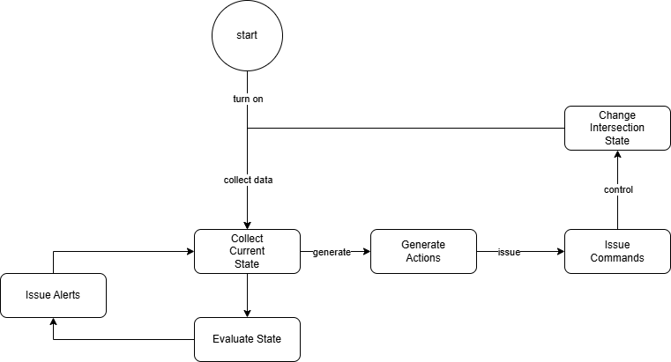
Figure 9: State Diagram
The state diagram represents the main functionality of the system. The main functionality includes collecting data and making decisions on that data to control traffic lights and sending out alerts based on the data collected. This cycle repeats itself if the system is running.

Activity Diagram
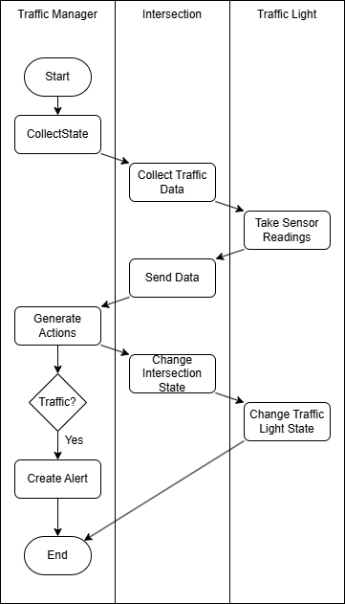
Figure 10: Swimlane Diagram
The activity diagram above shows the main use case of the system, collecting data and controlling traffic lights within the system.

Component Diagram
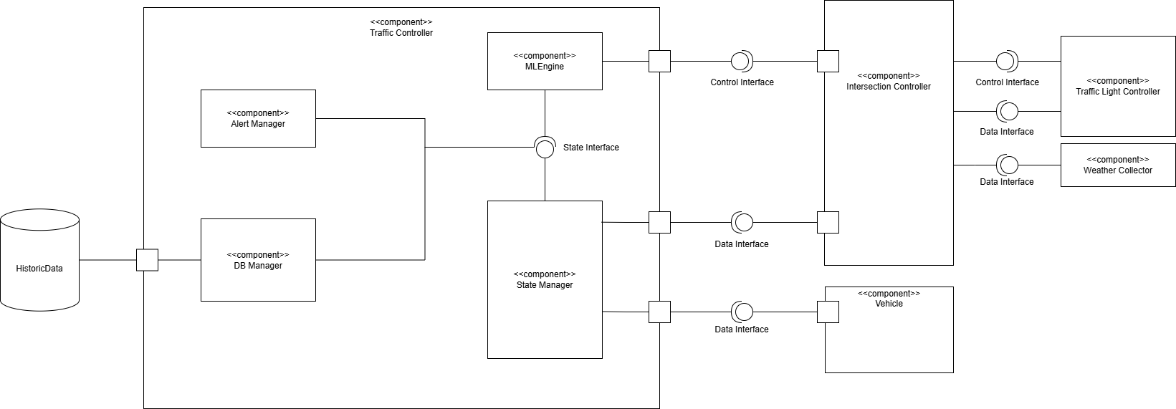
Figure 11: Component Diagram
The component diagram above represents the overall system. The Traffic Controller contains most of the components within the system. It directly interfaces with intersections and vehicles to collect data for consumption. These interfaces can be extended beyond their current implementations to include more data from different sources.

Deployment Diagram
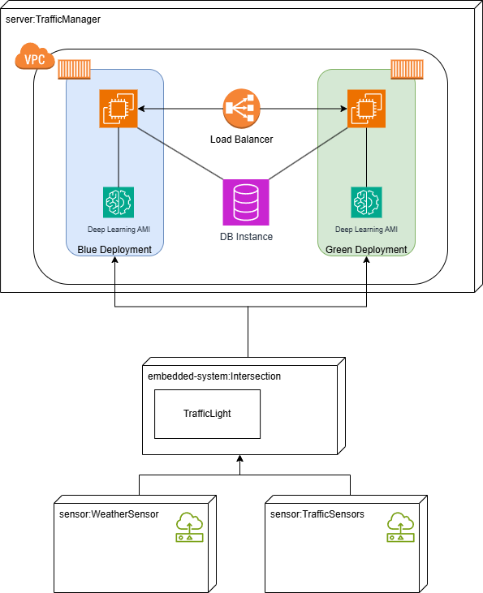
Figure 12: Deployment Diagram
The diagram above represents a cloud deployment diagram utilizing AWS services. A blue green deployment pattern was chosen because there can be no downtime between releases. The system is critical and puts lives at risk if there is any downtime between releases. Along with cloud deployment embedded systems will be deployed to every intersection in the system. They are responsible for collecting the data at the intersections so that it can be sent to the cloud deployment for processing. Along with the EC2 instances an RDS instance is needed to store historical data. This data is not used in the main operation for the system so redundant storage is not needed.

Skeleton Classes and Table Definitions
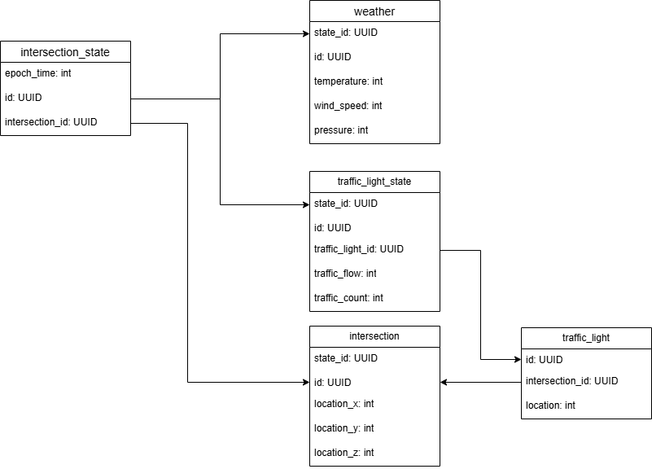
Figure 13: Table Definitions

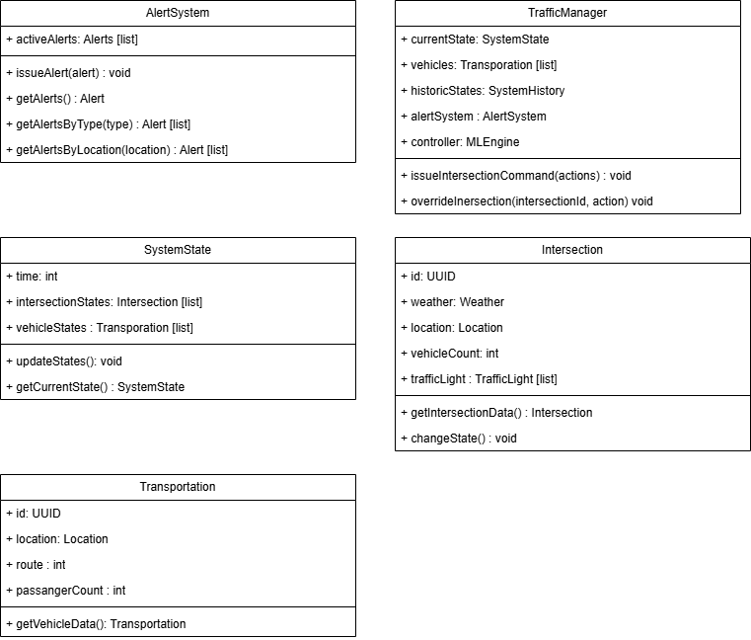
Figure 14: Skelton Classes
The data model in figure 13 represents historical data stored in the system. Each of the intersection state entries is time tagged with the time the data was collected. The ID on the intersection state table is the primary key and is used in other tables that store further information about the state at a given time. Figure 14 represents the skeleton classes for the main classes involved in the system along with their functions and attributes

Design Patterns
The system design contains some use of GRASP patterns including Controller and Expert. The system design consists of a TrafficManager this is a controller that represents the overall system. It is responsible for sending commands to other classes and receiving state information for processing. The system also consists of the use of the Expert pattern. Classes like intersections know the information about the intersection, so it is responsible for doing the work.

