总类: <https://book.jd.com/booksort.html>

子类: <https://list.jd.com/list.html?cat=1713,3258,3297>

观察子类页的原始响应:

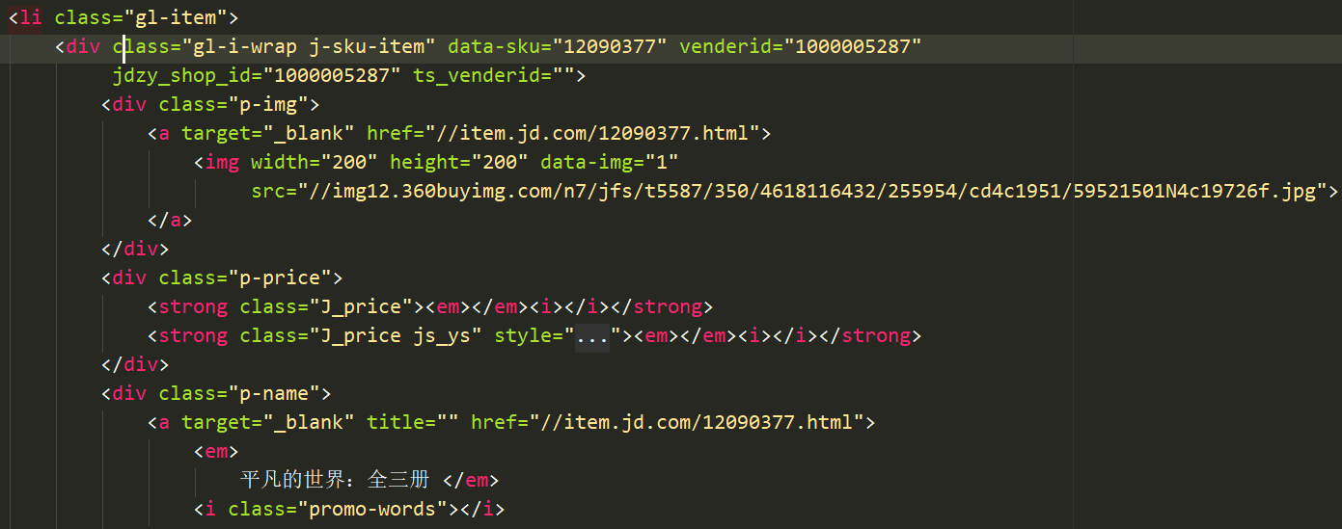

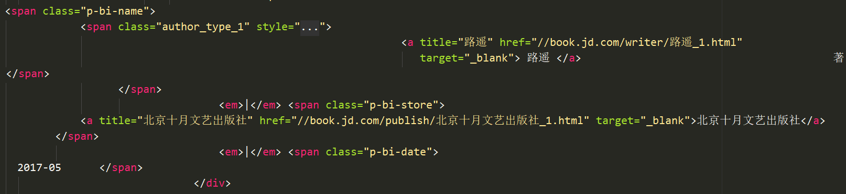

当前响应页有书名,出版社,作者

发现在当前响应页里Price数字是没有的

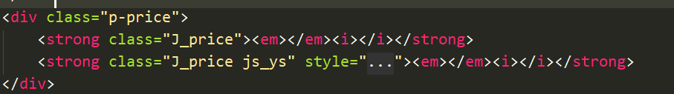

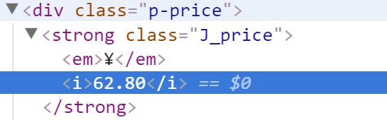

意味着是从别的地方请求数据,通过Js动态渲染到页面上的.

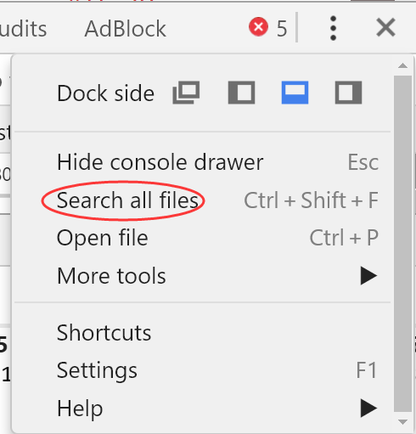

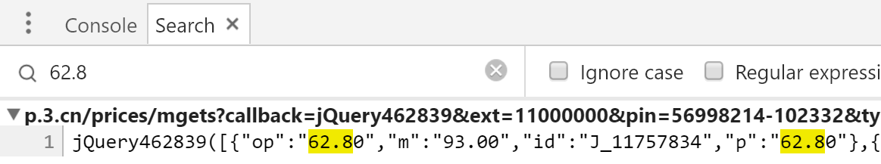

找到响应的文件

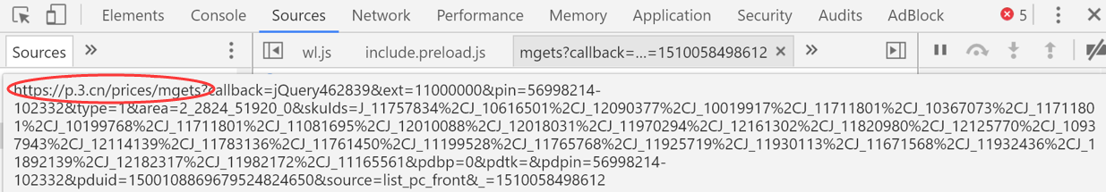

网址名

<https://p.3.cn/prices/mgets?callback=jQuery462839&ext=11000000&pin=56998214-102332&type=1&area=2_2824_51920_0&skuIds=J_11757834%2CJ_10616501%2CJ_12090377%2CJ_10019917%2CJ_11711801%2CJ_10367073%2CJ_11711801%2CJ_10199768%2CJ_11711801%2CJ_11081695%2CJ_12010088%2CJ_12018031%2CJ_11970294%2CJ_12161302%2CJ_11820980%2CJ_12125770%2CJ_10937943%2CJ_12114139%2CJ_11783136%2CJ_11761450%2CJ_11199528%2CJ_11765768%2CJ_11925719%2CJ_11930113%2CJ_11671568%2CJ_11932436%2CJ_11892139%2CJ_12182317%2CJ_11982172%2CJ_11165561&pdbp=0&pdtk=&pdpin=56998214-102332&pduid=1500108869679524824650&source=list_pc_front&_=1510058498612>

把url地址解码:

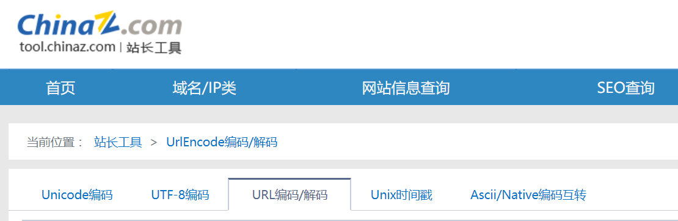

https://p.3.cn/prices/mgets?callback=jQuery462839&ext=11000000&pin=56998214-102332&type=1&area=2_2824_51920_0&skuIds=J_11757834,J_10616501,J_12090377,J_10019917,J_11711801,J_10367073,J_11711801,J_10199768,J_11711801,J_11081695,J_12010088,J_12018031,J_11970294,J_12161302,J_11820980,J_12125770,J_10937943,J_12114139,J_11783136,J_11761450,J_11199528,J_11765768,J_11925719,J_11930113,J_11671568,J_11932436,J_11892139,J_12182317,J_11982172,J_11165561&pdbp=0&pdtk=&pdpin=56998214-102332&pduid=1500108869679524824650&source=list_pc_front&_=1510058498612

内容:

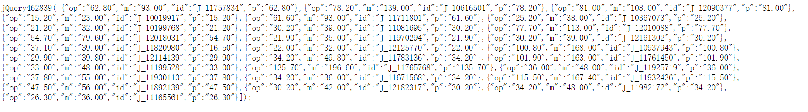

精简:

<https://p.3.cn/prices/mgets?&skuIds=J_11757834,J_10616501,J_12090377,J_10019917,J_11711801,J_10367073,J_11711801,J_10199768,J_11711801,J_11081695,J_12010088,J_12018031,J_11970294,J_12161302,J_11820980,J_12125770,J_10937943,J_12114139,J_11783136,J_11761450,J_11199528,J_11765768,J_11925719,J_11930113,J_11671568,J_11932436,J_11892139,J_12182317,J_11982172,J_11165561>

即使用skuids查询得到价格

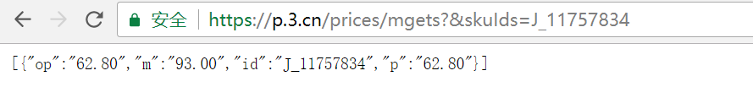

P是现在价格,m表示原价

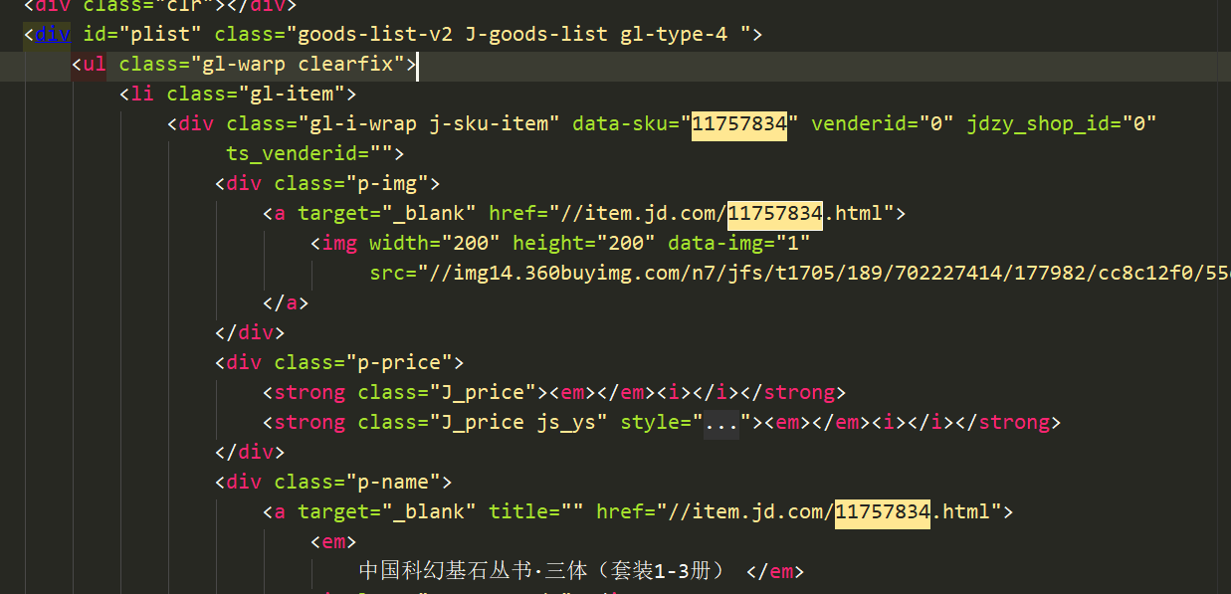

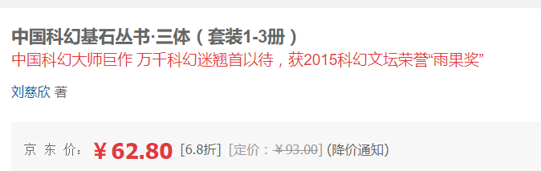

查询价格:<https://p.3.cn/prices/mgets?&skuIds=J_11757834>



看着像json数据

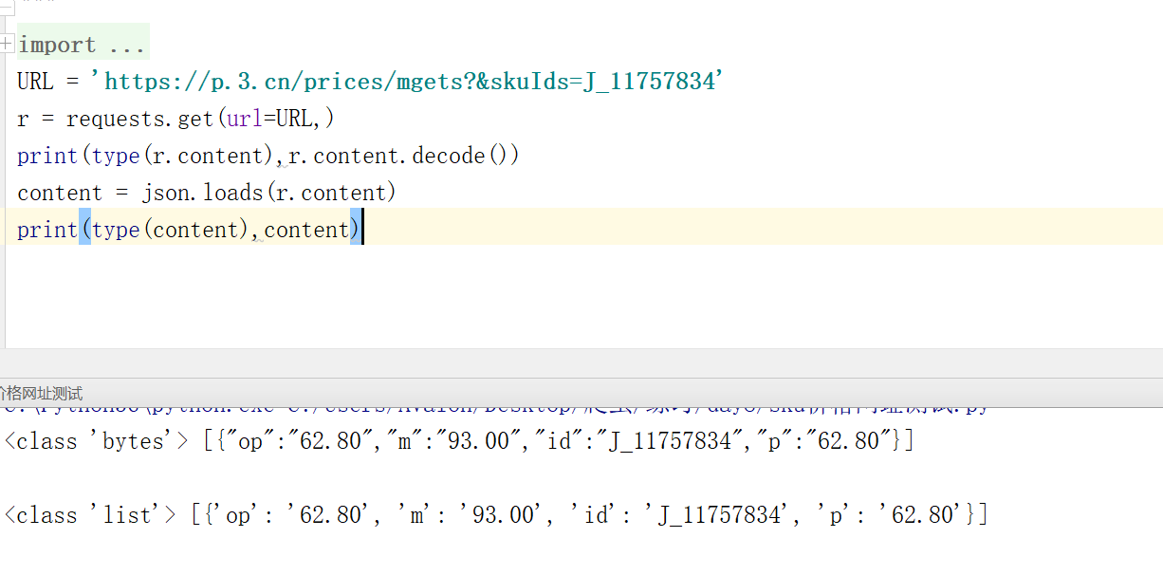

使用json解码后是一个长度为1的列表,包裹一个字典