HW3

Alex Shung

504049665

1. Tree Mining
   1. String representation of DFS
      1. T0: A B D F -1 -1 -1 C F -1 D
      2. T1: B A B -1 D -1 -1 B -1 C
      3. T2: A B -1 D
      4. T3: A C B -1 -1 E A B -1 C D
   2. No, T2 is not an induced subtree of T0 (No edge directly connecting A to D)
   3. Yes, T2 is an embedded subtree of T0
   4. Scope of each node

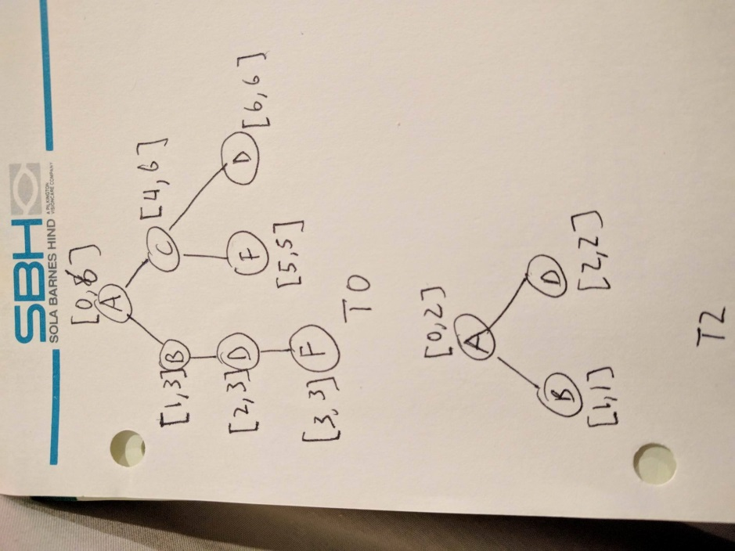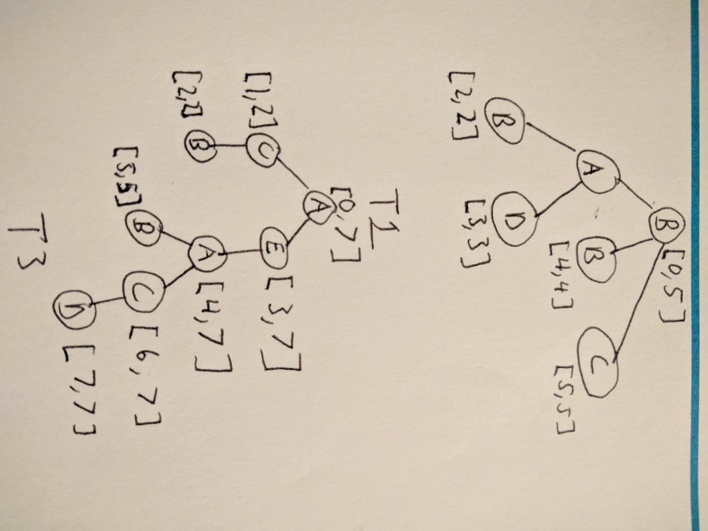

T1 A node scope [1,3]

* 1. Frequent embedded subtrees

|  |  |  |  |
| --- | --- | --- | --- |
| A | B | C | D |
| 0, [0,6] | 0, [1,3] | 0, [4,6] | 0, [2,3] |
| 1, [1,3] | 1, [0,5] | 1, [5,5] | 0, [6,6] |
| 2, [0,2] | 1, [2,2] | 3, [1,2] | 1, [3,3] |
| 3, [0,7] | 1, [4,4] | 3, [6,7] | 2, [2,2] |
| 3, [4,7] | 2, [1,1] |  | 3, [7,7] |
|  | 3, [2,2] |  |  |
|  | 3, [5,5] |  |  |

F and E are not frequent with sets {(0, [3,3]), (0, [5,5])} and {(3, [3,7])} respectively

|  |  |
| --- | --- |
| AB | AD |
| 0, 0, [1,3] | 0, 0, [2,3] |
| 1, 1, [2,2] | 0, 0, [6,6] |
| 2, 0, [1,1] | 1, 1, [3,3] |
| 3, 0, [2,2] | 2, 0, [2,2] |
| 3, 0, [5,5] | 3, 0, [7,7] |
| 3, 4, [5,5] | 3, 4, [7,7] |

Prefix AB, with elements (D,0)

Did a self-join with prefix A on elements (B,0) and (D,0), and using out scope join saw a common tree with B and D as siblings

|  |
| --- |
| AB (D,0) |
| 0, 01, [6,6] |
| 1, 12, [3,3] |
| 2, 01, [2,2] |
| 3, 05, [7,7] |
| 3, 45, [7,7] |
| 3, 02, [7,7] |

Frequent embedded sub-trees : A, B, C, D, AB, AD, AB (D,0) [Branched sibling]

* 1. Frequent induced subrees
     1. A, B, C, D, AB

1. Graph Mining
   1. CAM method
   2. FSG Candidate Number: 2
      1. A – A (branch) (A,A)
      2. A – Branch (A – A, A – A)
   3. Three cases for FSG
      1. Identical vertex labels
         1. The vertices of the graph are identical
      2. Core contains identical labels
         1. All of the nodes within the core are identical
      3. Core multiplicity
         1. Multiple potential cores when generating, so you may have to analyze each core separately and union the results of each core as the candidates generated