1603930

c314 ASSIGNMENT 1
REPORT

question 1)
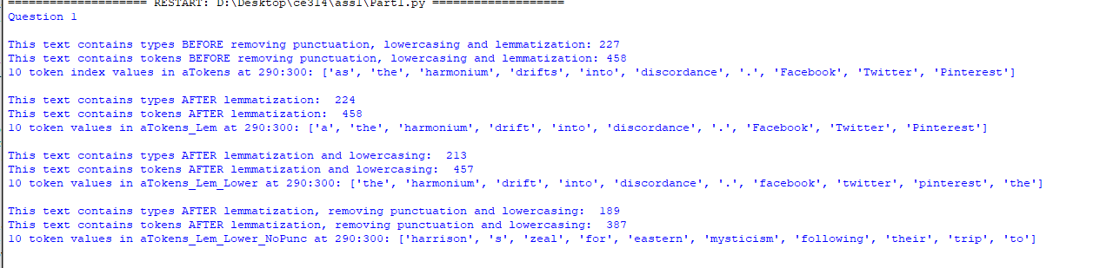
Here are the number of types and tokens. There are more “BEFORE” values (values after pre-processing has been implemented) programmed in for testing but are not showing as they are not necessary. The importance of lowercasing and removing punctuation is displayed after lemmatizing instead. The values for both tokens and types decrease. And after reviewing the data, it is more accurate.
For pre-processing, the use of “.lower()” on the string that is the article itself allows it to become completed lowercased. For removing punctuation a new list was created and appended words that are only alphabetical (by using “isalpha()”).
The number may seem low because with the use of a library called BeautifulSoup the program could isolate the Article class on the html site and output the desired text.

QUESTION 2)
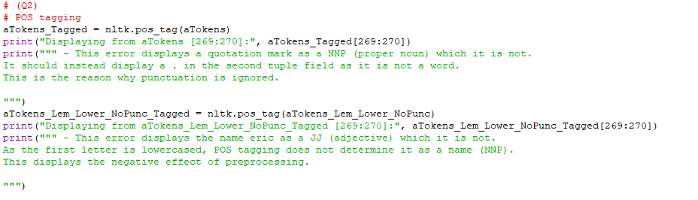
Through displaying random indexes, an error was bound to appear. The first error is displayed mainly to underlie the importance of removing punctuation during pre-processing and the second one to show the negatives of pre-processing, computers can be wrong too!

QUESTION 3)
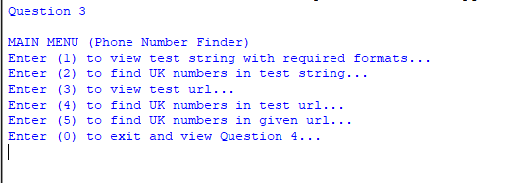
A simple interface is created using a while True loop that breaks when exit is selected. This interface takes integers are input. There is no validation but could have of been implemented.
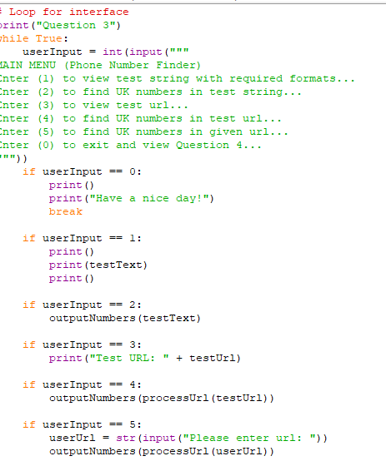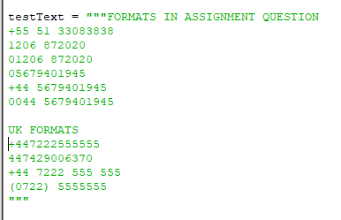
I utilised these formats of UK phone numbers and the ones specified in the question. My regular expression is quite complex and covers all formats displayed. I used https://regexr.com/ to create it, an extremely popular way of created regular expressions that is practiced in industry.
The output:
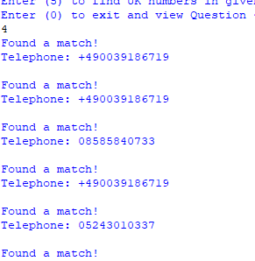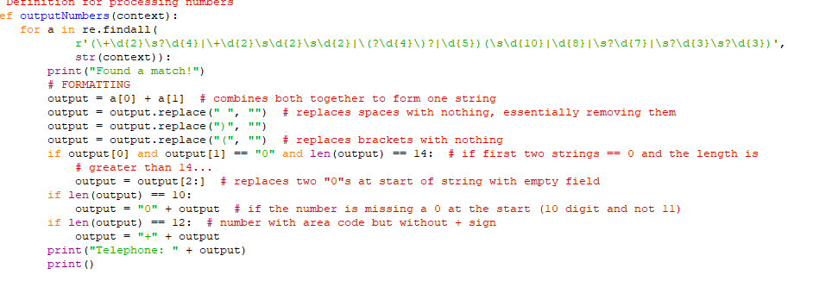I
This formatting utilises if statements to counter the specified phone formats as some numbers would return with a missing zero at the front and some would have two “0”s in place of a +. This way all output numbers are printed either as an 02… number or +44… number. After this was completed, this code was ready for a website that contains UK phone numbers. These formatted values are NOT saved and only printed in the for loop. However, this can be easily implemented with a simple list and appending “output” values into it.
Using BeautifulSoup again, a definition was implemented called processUrl() which returns a string (raw text). When the integer 5 is entered as input, it prompts for a URL. However, a preset URL is in the program ready for testing.
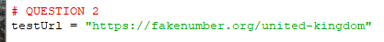
The phone numbers are extracted from the raw html string and then printed in the desired format.

QUESTION 4)

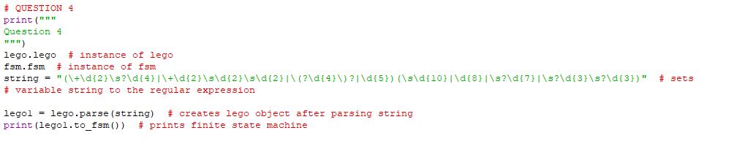
This does not answer the question, but only resembles an attempt. Initially, an attempt was made to generate a finite state automata diagram with http://ivanzuzak.info/noam/webapps/fsm_simulator/ however, the expression used in Question 3 does not work with this website. Using “Greenery”, the code parses the string as a “lego” object which is them printed as a fsm object (finite state machine).
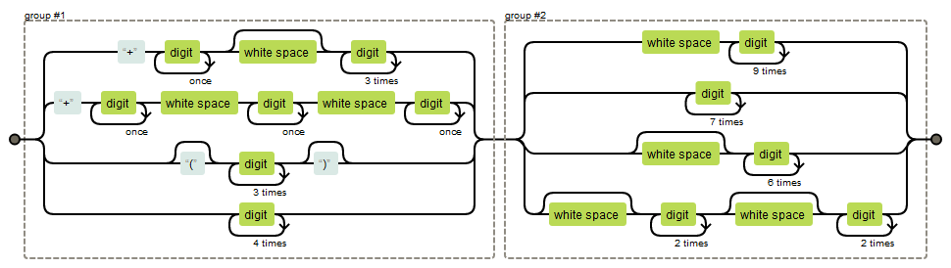
Using https://regexper.com/ this railroad image was generated with the implemented regular expression. This image is easy to read and display essentially how the expression works.

QUESTION 5)
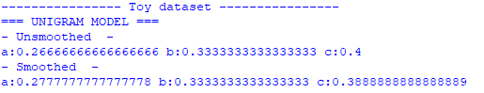
This output does not contain the UNK token, but the output will display one if one or more are present in the text file. For example(sampledata.txt):
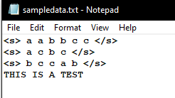 Once saved, the output of the probabilities is:
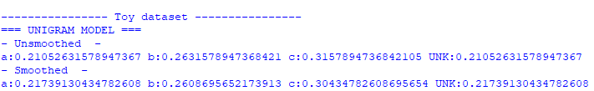
This is the result of this code:
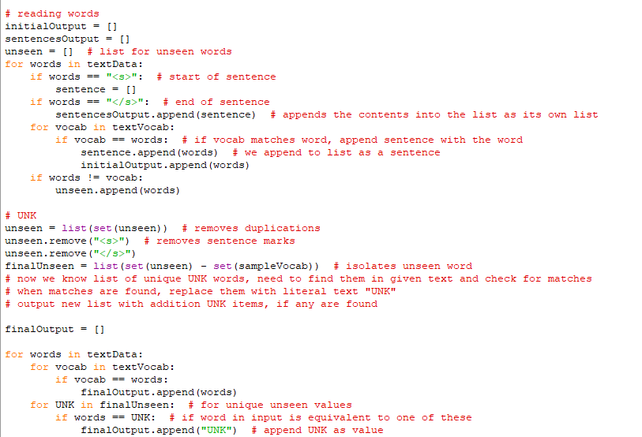
To simplify, the raw text data (obtained by using BeautifulSoup) is split into three outputs. intialOutput, sentencesOutput and unseen. initialOutput consists of the string but split into tokens, the “<s>” and “</s>” tokens are not placed in this list, the same applies for sentencesOutput but instead the tokens that are in sentences are in their own list. The unseen list is initially used to append words that do not classify as the current indexed vocab(determined by text file). This list then consists of multiple unwanted tokens such as “<s>” and actual used vocab. The list is then set as to remove duplicates, stripped from sentence format tokens to which it is only left with actual vocab of which is unwanted because the list is isolating the unseen token. Using set again, subtracting the unseen list with the vocab list, the unseen list is left with actual unwanted tokens to which we can use to compare words again. This time (second for loop) when matches are found between the two lists, the finalOutput will have a “UNK” token resembling an unseen token. These tokens can then be used to calculate probabilities as frequencies can be calculated.
The reason for the UNK token not being displayed is because FreqDist(nltk library) does not regard any tokens with the frequency of 0. Even whilst attempting to add it manually…
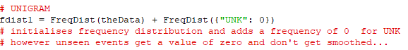
However, the output of probabilities does change for both unigram and bigram models when a frequency greater than 0 is found in the data file.
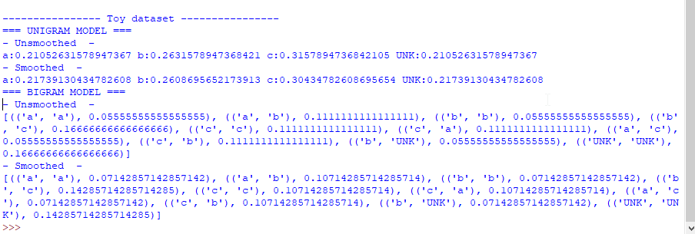
Table:
X | P(X) | P(X) with Laplace smoothing
a | 0.26666666666666666 | 0.2777777777777778
b | 0.3333333333333333 | 0.3333333333333333
c | 0.4 | 0.3888888888888889
UNK | N/A | N/A

Question 6

The output:
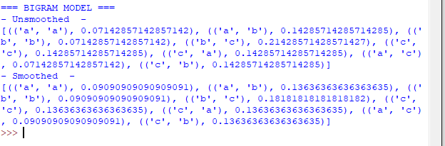
The format is not as of the desired one. However, the values are still correct according to the code (no UNK as frequency == 0). Utilising ngrams, FreqDist, MLE(no smoothing) and Laplace(smoothing) to generate these values. Here the <s> </s> tokens are also not included, as code is programmed to ignore them.
Without smoothing:
 | a | b | c
a | 0.07142857142857142 | 0.14285714285714285 | 0.07142857142857142
b |  | 0.07142857142857142 | 0.21428571428571427
c | 0.14285714285714285 | 0.14285714285714285 | 0.14285714285714285

With smoothing:
 | a | b | c
a | 0.09090909090909091 | 0.13636363636363635 | 0.09090909090909091
b |  | 0.09090909090909091 | 0.18181818181818182
c | 0.13636363636363635 | 0.13636363636363635 | 0.13636363636363635

Question 7

Did not attempt due to personal time constraints. However, the code does output the text file in a proper sentence list format… [[sentence], [sentence]].

APPRAISAL

I am personally not very experienced with Python and I struggled with this assignment. However, I did find it interesting and realised how applicable this module is to industry needs. I have developed my python skills and have started to develop an understanding for Natural Language Engineering.
I found Question 5 and 6 difficult and unsatisfying mainly because I was unsure of what to do. The question before these two were enjoyable, especially when I was solving my regular expression. This is something that I have not done before.
There are many things that I would like to change but I do not have the skills and understanding to do so yet.
I am proud of my solution for finding unseen tokens manually. I believe that this solution integrates with the NLTK library quite well when producing ngrams and calculating probabilities.

