Groups

# Clustergram (7 Selected)

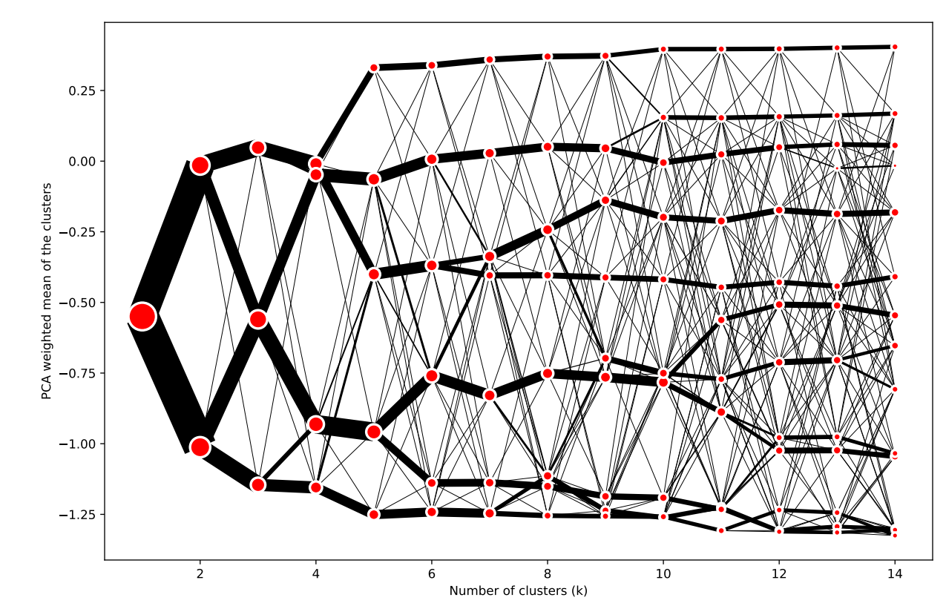

# Interactive Map

URL: <https://pinea.app.carto.com/map/b7fbd56c-88d0-4e5b-8fa6-bb87d0c864b3>

# Index Plot

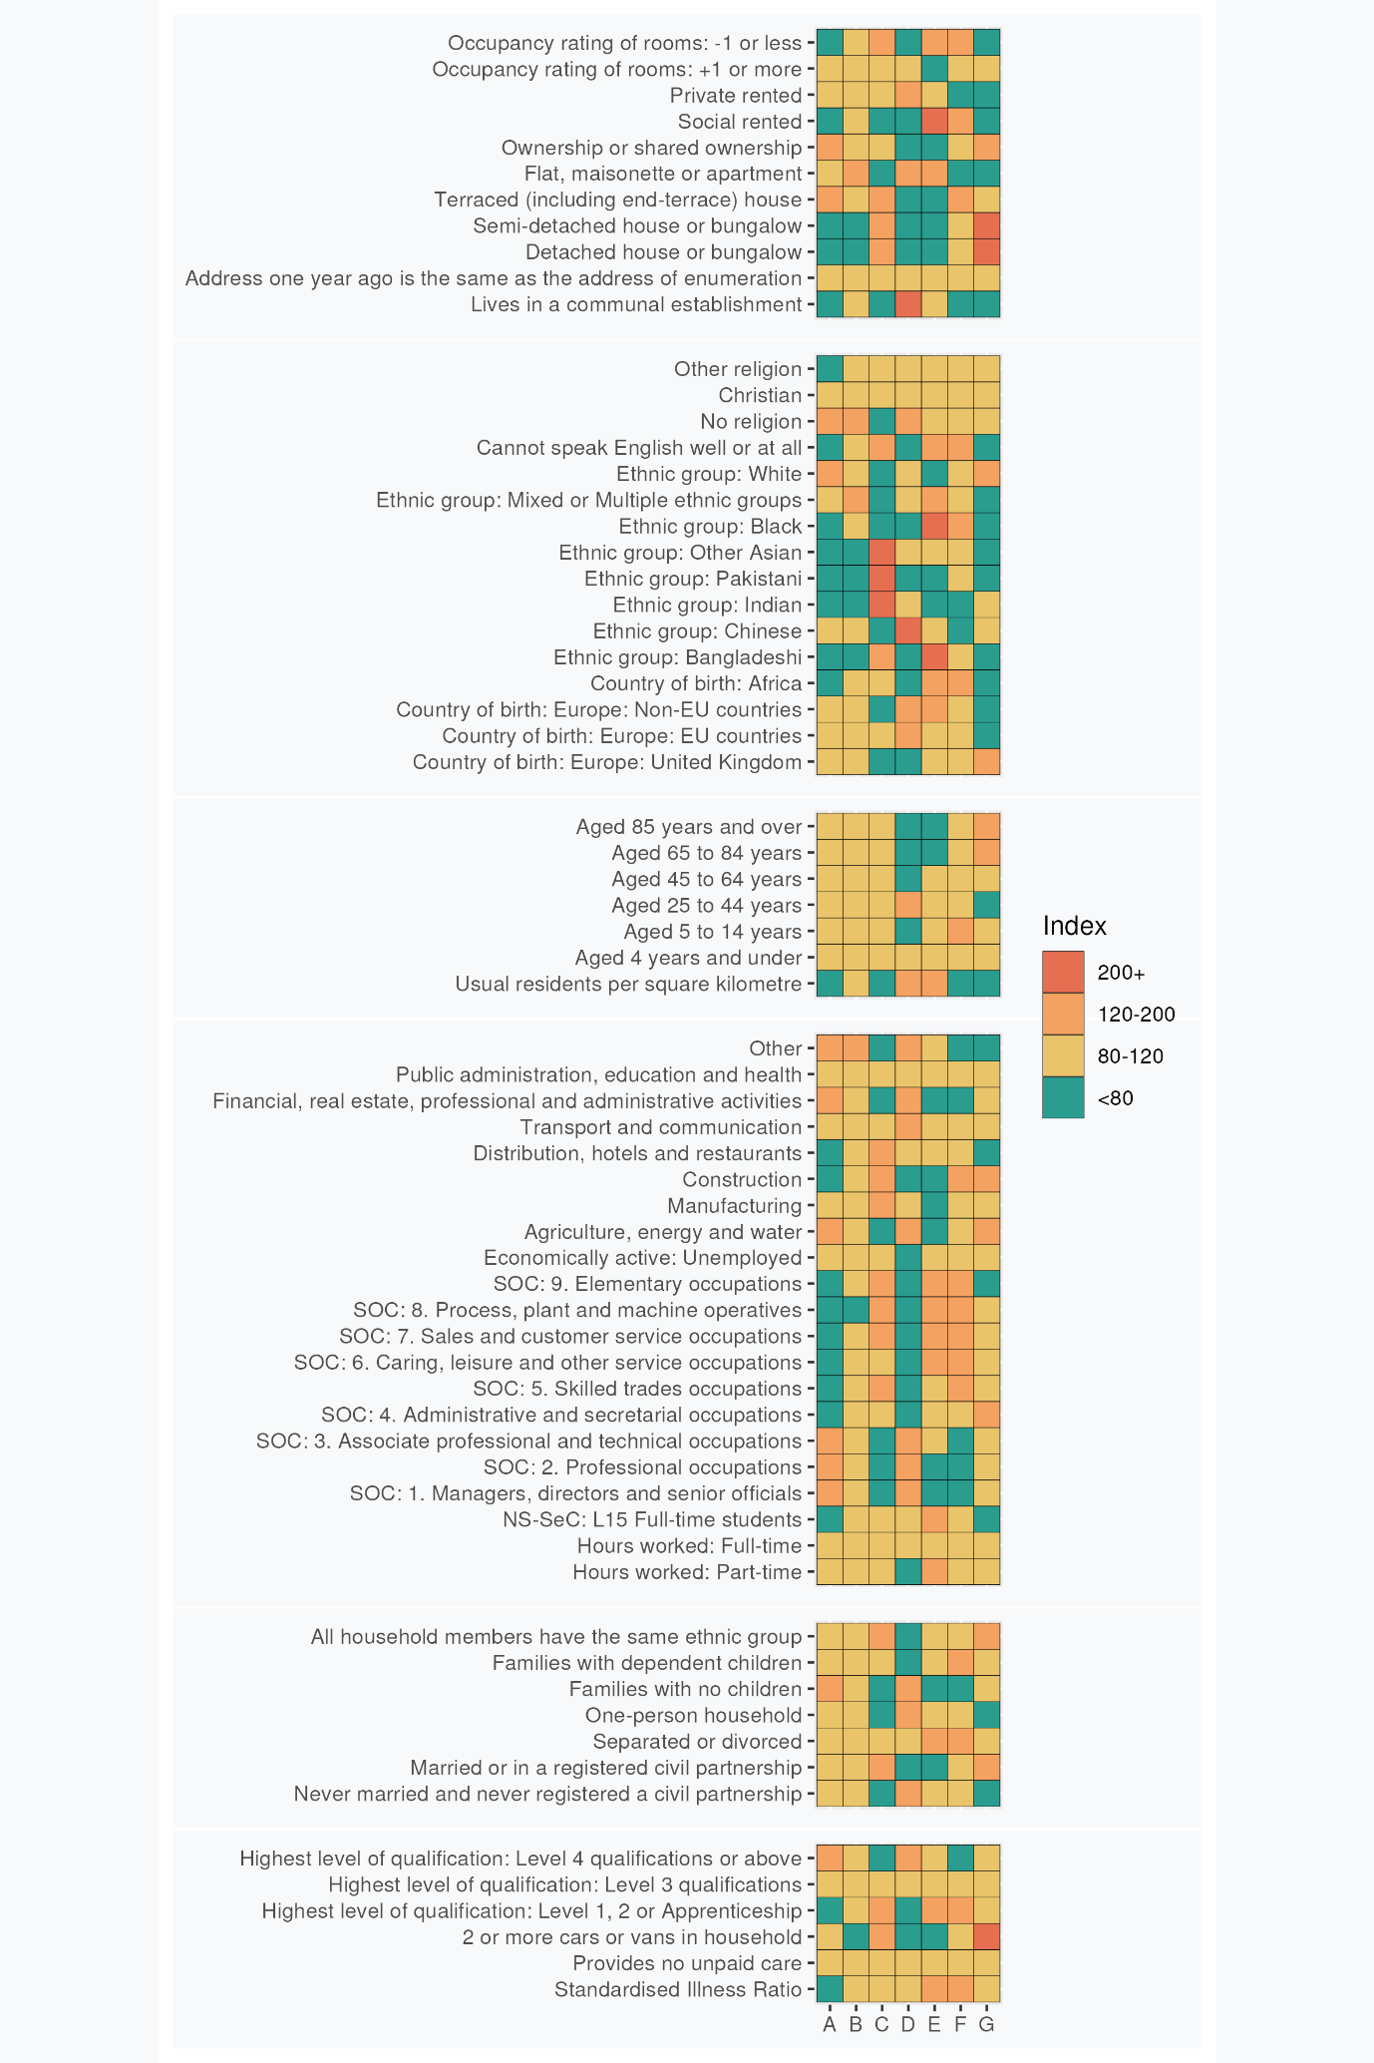

# Group Profiles

## **A: Stable Professionals**: This London neighbourhood houses a primarily white, educated, secular, and middle-aged population, with employment in professional industries and ownership of terraced homes.

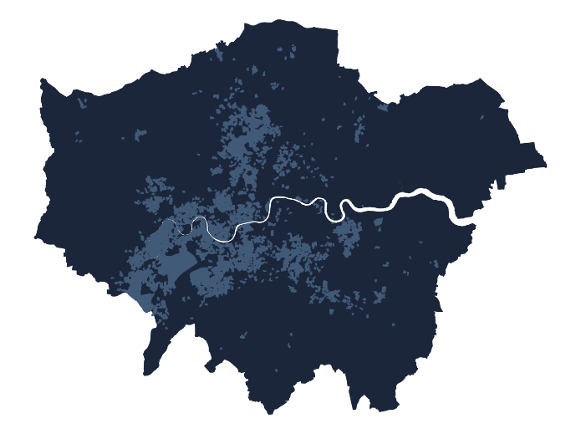This neighbourhood, when compared to the London average, displays a distinct demographic and lifestyle pattern. It predominantly houses an ethnically white population, with a rather limited presence of individuals of African, Bangladeshi, Pakistani, Indian, or other Asian ethnicities. A significant portion of residents adhere to no particular religion, indicating a more secular demographic.

Most residents belong to the middle-age bracket of 45-64 years, and a substantial number are married. It's interesting to note that the neighbourhood leans towards families without children. While there are varied living arrangements, the dominant residential type is terraced housing, with a fair percentage of residents owning their houses. There is typically ample space available, as overcrowding is notably lower than the London average.

The majority of residents are highly educated, with qualifications at Level 4 or above. This educational attainment translates into their professional status, as many are employed as managers, directors, or senior officials, or in professional or associate professional roles. There is a pronounced involvement in the financial, real estate, professional, administrative sectors, and in agriculture, energy, and water industries.

While most residents have been living at the same address for a year or more, the number of those residing in communal establishments is below average.

## **B: Cosmopolitan Mix**: A London community that skews towards single, well-educated professionals living in flats.

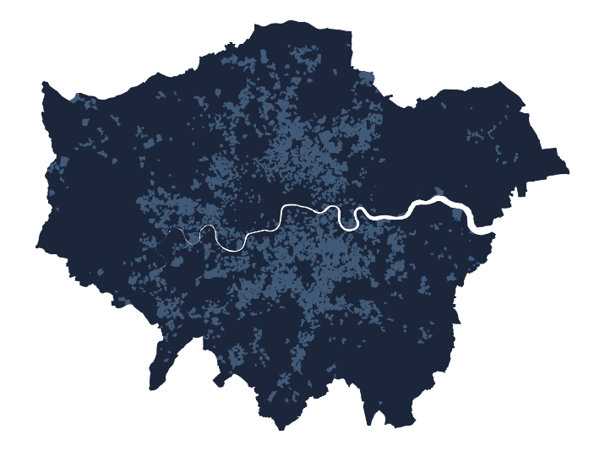This neighbourhood observes a lower-than-average prevalence of families with dependent children, while the number of never-married individuals and single-person households are relatively high. This suggests a skew towards younger, single residents or couples without children.

Housing arrangements include a high prevalence of flats with less outright ownership, while social and private renting are slightly more common.

Ethnic diversity is observed, but the neighbourhood veers more towards Black and White residents, while the representation of Bangladeshi, Indian, Pakistani, and other Asian ethnic groups is noticeably lower.

Professionally, the neighbourhood hosts a greater concentration of individuals in professional and associate professional roles, compared to London figures. The rate of employment in public administration, education, and health sectors is high. Meanwhile, the numbers in elementary occupations, or sectors like agriculture, energy, water, construction, and manufacturing, fall below the average.

Education levels slightly favour those with Level 4 and above qualifications. The number of residents with Level 1, 2 or Apprenticeship qualifications, and full-time students are slightly less than the London average.

A higher prevalence of individuals identify with no religion and English language proficiency appears to be high, with a lower rate of residents struggling with the language.

## **C: Settled Asians**: A London neighbourhood enriched by Indian, Pakistani, and Bangladeshi influences, featuring family-focused living, skilled trades, and varied housing, but also language and overcrowding struggles.

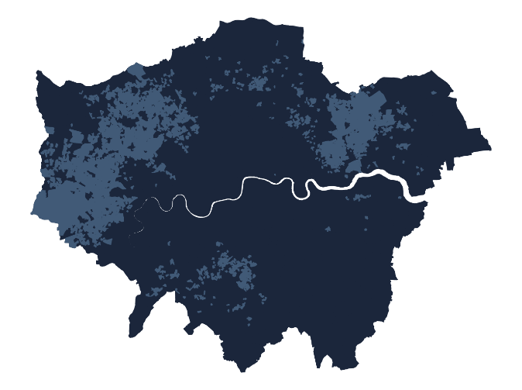Residents of this neighbourhood are predominantly from Asian descent, particularly Indian, Pakistani, and Bangladeshi, with rates significantly higher than the London average.

In terms of living arrangements, there's a distinct preference for houses over flats, with the majority of the residents owning their home or renting privately. Notably, there's a higher propensity towards family units comprising dependent children, and there's a commonality of ethnicity within individual households.

Marriage seems to be a more favoured societal norm, slightly surpassing the London average. Interestingly, the neighbourhood experiences instances of accommodation overcrowding, pointing towards a possible inclination towards larger family structures or multi-generational living.

When it comes to employment, the residents display a strong leaning towards skilled trades, sales and customer service occupations, and roles as process, plant, and machine operatives. Industries such as manufacturing and construction are significantly represented, along with distribution, hotels, and restaurants. This aligns with a noteworthy percentage of the population with level 1, 2, or apprenticeship qualifications.

English proficiency remains a challenge for a significant portion of the population. Religious adherence is relatively high, with a considerably few residents identifying as having no religion.

## **D: Urban Elite**: This London neighbourhood is a lively blend of young, educated professionals from diverse backgrounds, living in modern, urban conditions, and embracing a global, cosmopolitan lifestyle.

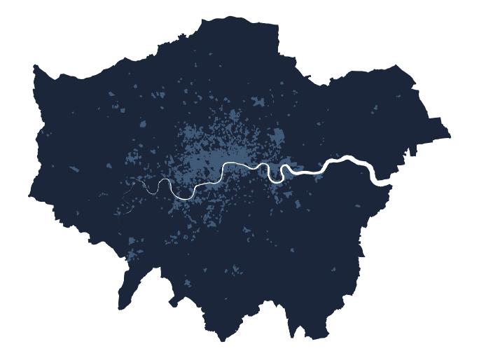The neighbourhood is predominantly inhabited by adults aged 25 to 44, it has fewer families with young children or dependent teenagers, signifying a demographic skew towards working professionals.

This neighbourhood has an international character and there is a considerable population of residents born both in the EU and outside of it, and a notably high Chinese population. When it comes to marital status and family structure, there's a marked tendency towards single living and childless households. There's a substantial number of individuals who've never been married and families without children.

The presence of communal establishments is notably high as well, which may be a result of the higher rates of full time students. The housing style of this neighbourhood leans towards privately rented flats, a scenario quite common in transient, bustling central urban areas.

Residents of these areas are well-qualified, with a significant number holding Level 4 or above qualifications. This well-educated character transfers to the employment market, with a higher percentage engaged in professional occupations, managerial positions, or associate professional or technical occupations. Additionally, the area's industry is heavily focused on financial, real estate, professional, administrative activities, and, to a lesser degree, transport and communication.

## **E: Ethnic Melting Pot**: London neighbourhoods rich in cultural diversity, with a high representation of African and Bangladeshi residents, a multilingual atmosphere where most living in flats.

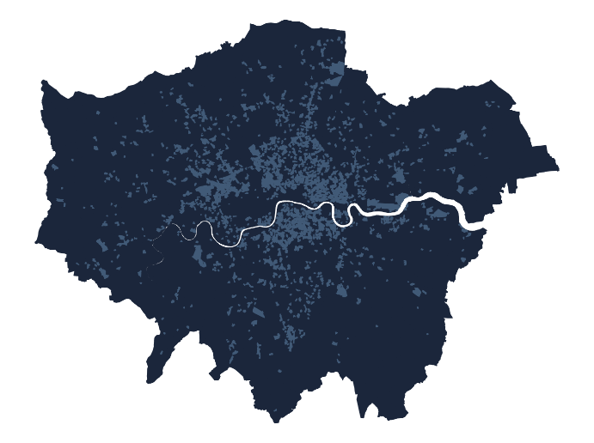 Residents of these neighbourhoods are strikingly multicultural, with a sizable portion hailing from non-EU countries, particularly Africa. This ethnic diversity comprises a high representation of the Bangladeshi community, followed by the Black population. Consequently, the proportion of residents identifying as White is significantly less than the London average.

There's an observable linguistic dimension too, with an elevated rate of individuals who may struggle with English proficiency. This suggests the possibility of a multilingual environment, enriched with diverse dialects and languages. Moreover, an important part of the community consists of people who have never been married or are separated or divorced, and the number of single-occupancy households is also notably high.

The housing landscape is dominated by flats, vastly outnumbering detached, semi-detached, or terraced houses. Ownership levels are relatively low, with a substantial number of these accommodations being socially rented. These areas represent some of the most over crowded in London, indicating a community where living conditions might be challenging, and households generally have less affluence.

In terms of health, there's a noticeable incidence of illness compared to London averages. Yet, the proportion of residents providing unpaid care remains consistent with the broader country. The neighbourhood features a larger proportion of individuals working in caring, leisure, and other service occupations, in sales and customer service, or as process, plant, and machine operatives. Similarly, full-time students and part-time workers form a noticeable segment of the local population.

While the level of unemployment is slightly above average, the level of higher education seems to be lesser than the London norm, with a substantial number of residents having completed level 1 or 2 qualifications or apprenticeships.

## **F: Diverse Young Families**: A family-oriented London neighbourhood with a considerable African and Black ethnicity presence, a higher than average child population.

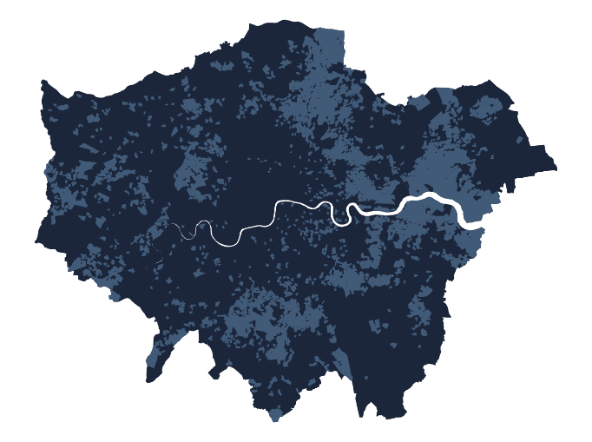 This neighbourhood presents a unique demographic profile, diverging from the London average in several intriguing ways. There's a noticeable presence of young children aged 5 to 14 years and families with dependent children. In contrast, the residents aged 25 to 44 years are less represented than the London average, suggesting a trend toward younger or older families.

In terms of ethnic composition, the area is characterized by a diverse cultural mix. There's a notably higher representation of residents born in Africa and individuals of Black ethnicity. However, the neighbourhood has fewer Chinese, Indian, and White ethnic groups than the London average.

The linguistic proficiency in this community is varied, with a higher number of individuals who have difficulties communicating in English. In terms of relationship status, there is a slightly higher incidence of separated or divorced individuals than the London average.

The neighbourhood features a higher proportion of terraced houses, while the number of flats is lower than the London average. Home ownership isn't as common, with a trend toward social rented homes, a rate higher than the London average. Overcrowded accommodation is also more frequent here than in the average neighbourhood.

The health profile is mixed, with a higher standardised illness ratio. The area exhibits a stronger leaning towards individuals with level 1, 2, or apprenticeship qualifications, while residents with level 4 or above qualifications are fewer.

The employment landscape is diverse, with a considerable presence of individuals employed in skilled trades, caring, leisure and other service occupations, sales and customer service occupations, and process, plant, and machine operatives. There's also an increased incidence of unemployment. The construction industry is also notably more represented, in contrast to the relatively lower presence of the transport and communication sector.

## **G: Ageing City Fringe:** London neighbourhoods with a higher concentration of mature, predominantly White UK-born residents, living in owned detached or semi-detached homes.

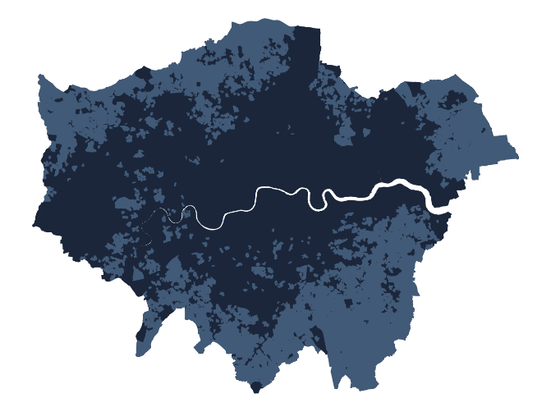 The majority of residents within these areas are mature, with a significant proportion of the population being aged between 65 and 84, and an even more notable presence of those aged 85 and over. This concentration of older residents is markedly higher than the London average.

The cultural and ethnic composition is largely homogeneous, with a major part of the population identifying as White and being born in the United Kingdom. The neighbourhood does not exhibit a strong presence of individuals born in the European Union or elsewhere, which is substantially lower than the London average. The representation of other ethnic communities, including Bangladeshi, Pakistani, Other Asian, Black, and even Chinese is very low.

Marital status and housing conditions in the area also yield noteworthy trends. Married individuals constitute a larger proportion compared to the London average. The neighbourhood is significantly characterized by a preference for detached and semi-detached houses or bungalows, in stark contrast to the low representation of flat dwellers. A large number of residents own their houses, a figure that comfortably exceeds the London average.

For those who are not retired, the neighbourhood is characterized by a larger proportion of individuals engaged in administrative and secretarial occupations, as well as in the construction industry.