Groups

# Clustergram (7 Selected)

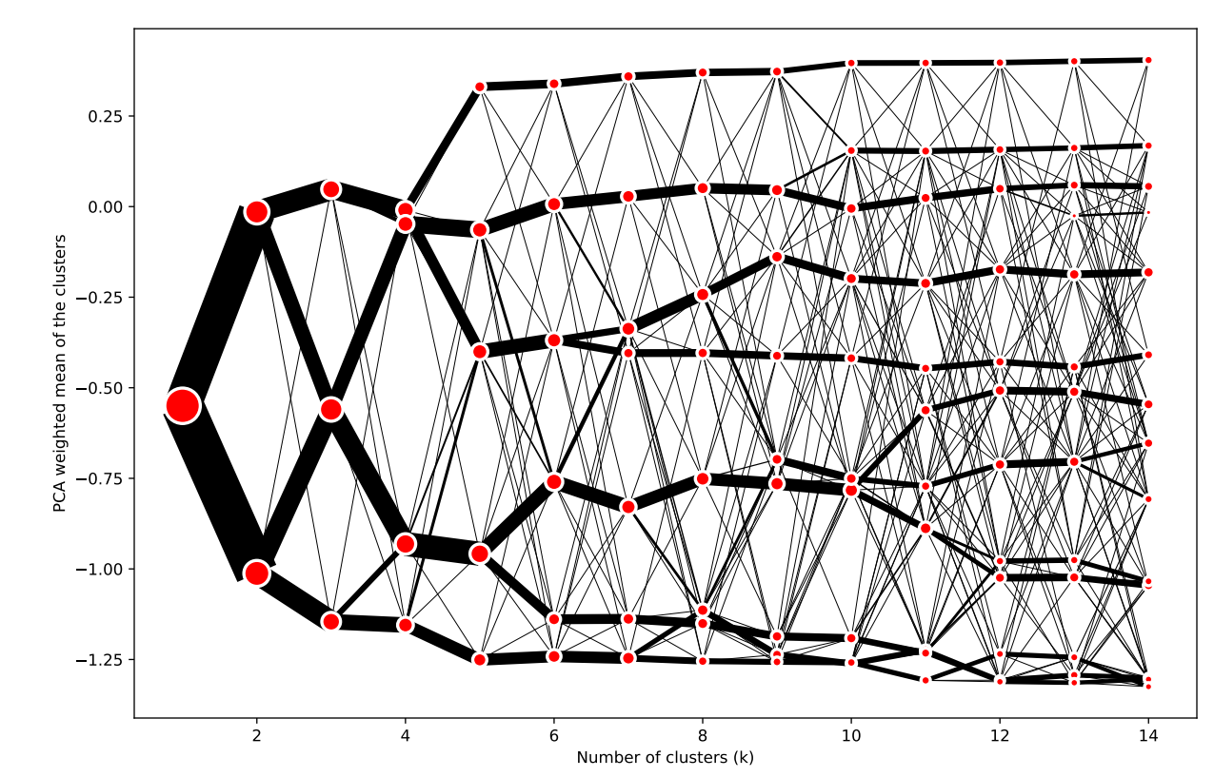

# Interactive Map

URL: <https://pinea.app.carto.com/map/b7fbd56c-88d0-4e5b-8fa6-bb87d0c864b3>

# Index Plot

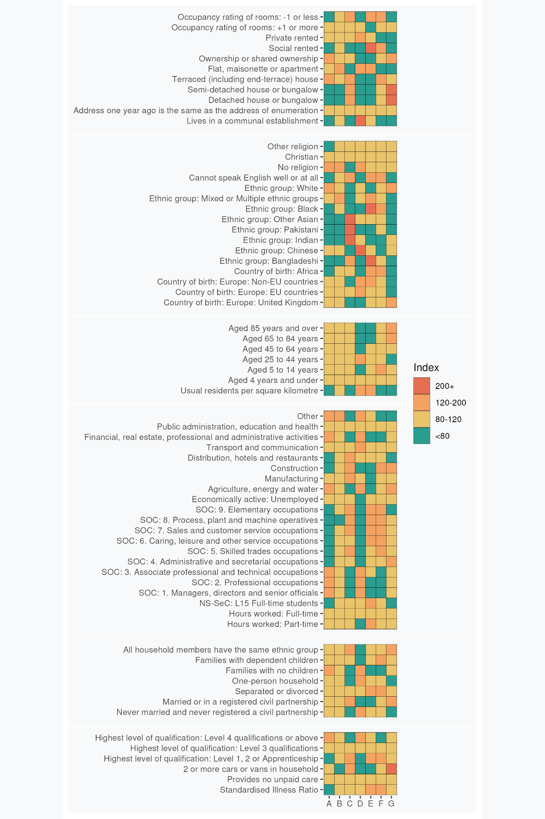

# Super Group and Group Profiles

## **A: Settled Professional Lifecycles**: These London neighbourhood residents are predominantly White, educated and secular. Many are employed in professional occupations and live in privately owned or rented terraced houses.

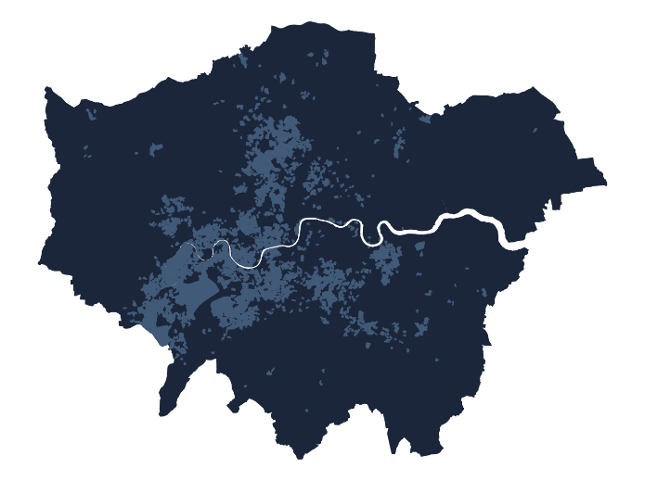These neighbourhoods house people of all ages, predominantly of White British and European extraction. Resident turnover is low. Religious affiliation is less common than the London average and they are more likely to be Christian if expressed. Homeownership rates, typically of terraced houses, are high and social renting is uncommon. Employment is typically in professional, managerial and associate professional or technical occupations and there are few full-time students. Level 4 qualifications are common.

More households lack dependent children than have them which, considered alongside low levels of crowding and the over-all age structure indicates that many households maybe post child-rearing with an ageing demographic structure. Levels of illness are low, as is residence in communal establishments.

### A1: Established Ageing Homeowners with Children

These prosperous London neighbourhoods are distinguished by an above-average concentration of elder residents relative to the Super Group, with a significant portion falling between the ages of 45 and 84 years. Most families live in terraced, detached or semi detached housing with very few residents living in flats. The area registers a relatively high count of married individuals and more families with dependent children than the national average.

### A2: Inner London Affluence

Given their more central location, these primarily inner London neighbourhoods provide a higher density of residences than the constituent Super Group, and unsurprisingly also have lower rates of car ownership. There are also fewer residents in these areas aged over 85, who are of non-EU or Chinese in origin; and rates of home ownership are also slightly lower than the Super Group.

### A3: Prestigious Enclaves

Residents of these areas live in some of the most desirable and expensive neighbourhoods in London. Relative to the Super Group, more of the population are at or beyond retirement age, with moderately more diversity relative to the Super Group, specifically those born outside the EU or identifying as Asian. Although not a significant population of these neighbourhoods, there are more students within these areas relative to the Super Group given proximity to centrally located university campuses, with corresponding higher prevalence of communal establishments. Lower occupancy ratings and privately rented flats are also more common than the Super Group, with correspondently fewer terraces.

## **B: Professional Mix**: Communities scattered throughout London with some tendency towards singles living in flats.

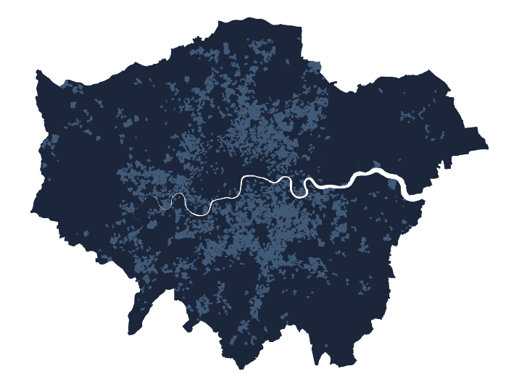Embodying London living in most all respects except the relative absence of residents identifying with (non-Chinese) Asian groups, these neighbourhoods pervade all but some parts of west and north-east London. There is some tendency towards lower-than-average prevalence of families with dependent children, while occurrences of never-married individuals and single-person households are relatively common. The age distribution is skewed towards younger, single residents and couples without children, with more identifying as mixed or multiple ethnicities.

Social or private renting are slightly more common than the London average and flats are prevalent.

Individuals typically work in professional and associated roles in public administration, education, and health rather than in elementary occupations in agriculture, energy, water, construction or manufacturing.

Incidence of educational qualifications are slightly below the London average, and full-time students are also slightly less common.

Individuals declaring no religion are more prevalent than the London average and incidence of difficulty in use of English is below the London average.

### B1: Social Renting Professional Support Workers

Most of these neighbourhoods are found within inner London, and relative to the Super Group more residents identify as Black, live in social housing, with a correspondingly lower rate of home ownership. Fewer people in these areas work in skilled trades, with more working in associate professional and technical occupations. There is also a lower rate of those who are or who have ever been married or in a civil partnership, alongside moderately worse health.

### B2: Skilled Manual Workers

These scattered and more peripheral neighbourhoods in London are lower density and have an increased prevalence of car or van ownership, given their weaker access to public transport and the higher numbers of skilled trade workers, particularly in construction. There are fewer students within these areas as they are more commonly found in less central locations. Relative to the Super Group moderately more residents identify as Pakistani and other Asian ethnicities, and there lower numbers of those who are of mixed ethnicity, while still remaining over represented relative to the London average. Social rented accommodation is less prevalent, and there are fewer flats.

## **C: Suburban Asian Communities**: London neighbourhoods featuring Indian, Pakistani, and Bangladeshi influences, with family-focused living in houses rather than flats. Outside of management and the professions, the labour force is very active across a full range of occupations, but some community members remain challenged by language barriers and overcrowding.

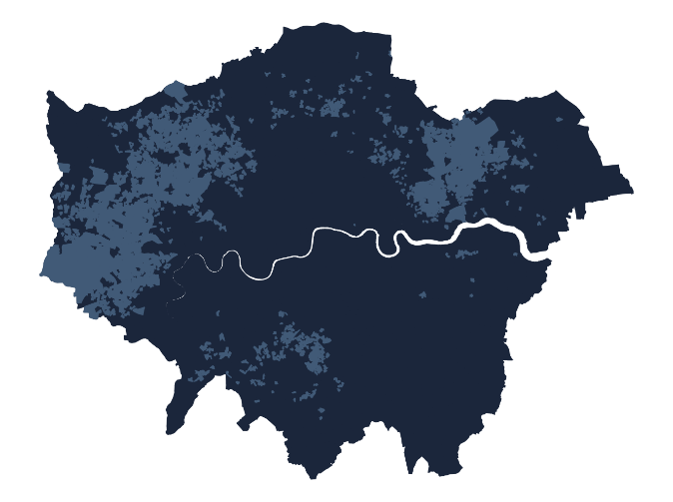Many residents of these neighbourhoods are of (non-Chinese) Asian descent, particularly India, Pakistan, and Bangladesh. Neighbourhoods are located across large areas of suburban west, north-east and south London.

Detached, semi-detached and terraced houses are more prevalent than flats and socially rented housing is uncommon. Few residents live in communal establishments. Many families have dependent children, sometimes in overcrowded accommodation, and few households are ethnically mixed.

Marriage rates are above the London average. The even age distribution, relative absence of individuals living alone and frequent incidence of households with children suggests that multi-generation households may be relatively common.

Employment is often in skilled trades, elementary, sales and customer service occupations, and roles as process, plant, and machine operatives. Manufacturing and construction are well represented, along with employment in distribution, hotels, and restaurants. Many adults have only level 1, 2, or apprenticeship qualifications.

English proficiency remains a challenge for some residents. Religious affiliation is relatively high.

### C1: Terraced Asian Families

These more centrally located terraced neighbourhoods comprise households with more dependent children relative to the Super Group. Complementing the prevalent large (non-Chinese) Asian population, relative to the Super Group, there are also moderately more Black residents, around the London average. Those in work have higher rates of being employed part time and in elementary occupations or process, plant or machine operatives relative to the Super Group. There are also more full-time students.

### C2: Settled and Integrating Asians

Like the Super Group, these neighbourhoods maintain larger populations of (non-Chinese) Asian descent, particularly India and Pakistan but fewer from Bangladesh. More residents were born in the UK relative to the Super Group, although still under the London average. Residents are more likely to live in semi-detached housing given the suburban locations and are also more likely to be property owners relative to the Super Group.

## **D: Central Connected Professionals and Managers**: These Central London neighbourhood are home for a blend of young, educated professionals from diverse backgrounds. Residents are of prime working age and typically live in privately rented flats, some of them crowded.

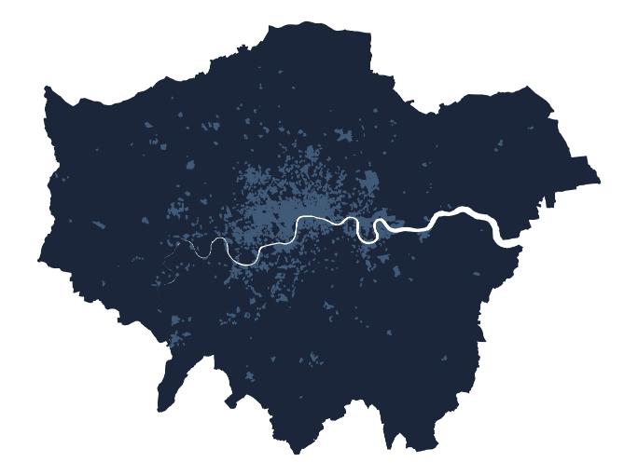Adult residents of these neighbourhoods are typically aged 25 to 44, working full-time in professional, managerial or associate professional occupations. There are few families with dependent children.

The predominantly Inner London neighbourhoods have an international character, including many residents born elsewhere in Europe alongside high numbers of individuals identifying as of Chinese. Many individuals are never married, childless and/or living alone.

Above average numbers of individuals, likely to be full-time students, live in communal establishments. Elsewhere, privately rented flats are the dominant housing type.

Residents of these areas are well-qualified, with a significant number holding Level 4 or above qualifications. There is a correspondingly high level of individuals employed full-time in professional, managerial and associate professional or technical occupations. Employing industries are financial, real estate, professional, administration, and, to a lesser degree, transport and communications. Unemployment is uncommon.

### D1: White Collar Support Workers

Scattered throughout inner London, these areas contain fewer workers in the most senior roles within organisations, with higher rates working in administrative functions relative to the Super Group. Residents in these areas are also less likely to be of Chinese ethnicity and there are increased rates of those born in Africa. Relative to the Super Group, these areas also have higher rates of socially rented accommodation and live in more overcrowded conditions, although both under the London average.

### D2: Central and City

Relative to the Super Group, residents of these areas are more likely to be separated or divorced, be in full time work and with better health, however fewer work in the most senior roles in organisations. Given the central location there are also more full-time students present, and few households with children. There are higher rates of other religions in these areas, and Christian denominations less prevalent.

### D3: Senior Professionals

These very central locations have moderately more residents who are middle or at retirement age than the Super Group, around the London average, with fewer very young or households with no children. They tend to have moderately better health, and are more likely to be married. These areas tend to be less diverse, with more White and less Indian and Chinese ethnic groups relative to the Super Group, although Chinese an over represented characteristic of these areas. Property tends not to be overcrowded, and given the central location there are more communal establishments relative to the Super Group.

## **E: Social Renters, Many with Children**: Predominantly located in Inner London, these community members are drawn from a wide range of ethnicities, with high incidence of African and Bangladeshi residents. Younger adults, many living with children, predominate, living in socially rented flats.

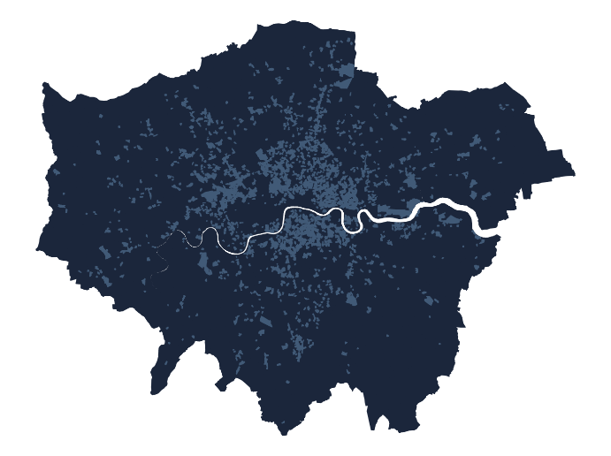Residents of these neighbourhoods together comprise sizable numbers drawn from outside Europe, particularly in Africa and from Bangladesh. The proportion of residents identifying as White, Indian and Pakistani is well below the London average,

Neighbourhood age profiles are skewed towards younger adults, and moderately more families have children than the London average. English proficiency levels are below the London average. Marriage rates are low, and levels of separation or divorce are above the London average.

Housing is predominantly in flats, and social renting the norm – few residents are owner occupiers. Housing units are often over occupied and are found within some of the most densely populated neighbourhoods in London. Illness rates are above the London average, although levels of unpaid care provision are around the London average.

Employment is in caring, leisure, other service occupations, sales and customer service, or process, plant, and machine operation. Part time working and full time student study are common. Levels of unemployment are slightly above the London average. Most residents have not progressed beyond Level 1 or 2 educational qualifications or apprenticeships.

### E1: Struggling Service and Warehouse Workers

Residents of these concentrated and mostly centrally located neighbourhoods are more likely to be married and have children relative to the Super Group. There are higher rates of unemployment, and those in work tend to work service occupations in hotels or restaurants and distribution. Relative to the Super Group there are fewer residents declaring ethnicity as Mixed and Multiple, Black or Other Asian, and very high concentrations of those who are Bangladeshi. Those living within these areas tend to be in accommodation that is more overcrowded.

### E2: Crowded and Constrained

Found in pockets across London, although employment broadly aligns to the Super Group, residents are moderately less likely to work in Transport and Communications relative to the Super Group. There are also lower numbers of Chinese or Bangladeshi residents, and a higher number of people who are Black and who were born in Africa. Rates of private renting are lower in these neighbourhoods relative to the Super Group.

## **F: Young Families and Mainstream Employment**: Family-oriented living, concentrated multi-ethnic neighbourhoods throughout London. Many residents identify as Black African and many families have children. Employment is across the labour market, apart from professional or managerial occupations.

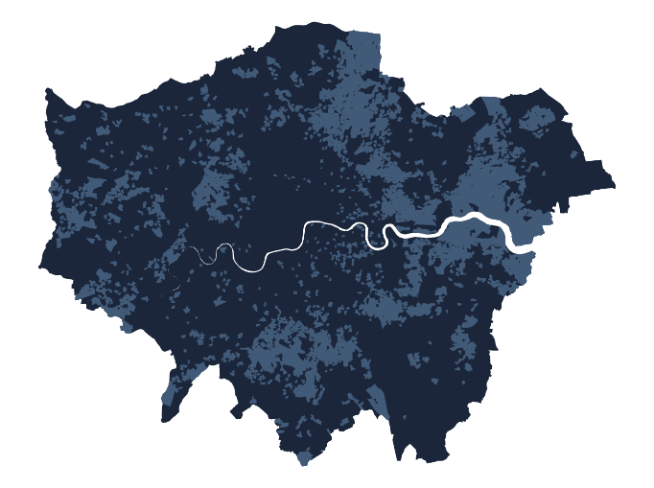 Mainly located beyond Inner London, many families in these neighbourhoods have young children. Socially rented is is prevalent, in terraced or semi-detached units. While over-all residential densities are low, overcrowding is also prevalent locally.

Residents are drawn from a range of ethnic minorities, with many residents identifying as Black and above average numbers born in Africa. Numbers of Chinese, Indian and White ethnic groups are below the London average.

Levels of proficiency in English are below the London average. Levels of separation or divorce and incidence of long-term illness are both above average.

Education is typically limited to Level 1, 2, or apprenticeship qualifications. Few residents work in professional or managerial occupations but the employment structure is otherwise diverse: it includes skilled trades, caring, leisure and other service occupations, sales and customer service occupations, construction, and work as process, plant, and machine operatives.

### F1: Terraced and Manual Workers

These are mostly outer suburban areas, with greater numbers of residents living in terraced and semi-detached houses, and relative the Super Group are less overcrowded. Given the location, there is a higher prevalence of owning two or more cars or vans. There are fewer residents aged 25-44, and for those employed, relative to the Super Group there are higher numbers employed in administrative and secretarial occupations. Residents are also more likely to be born in the UK, and there are fewer Bangladeshi residents, and those born in Africa.

### F2: Diverse Social Renters

Residents of these areas are more ethnically diverse, with those of Bangladeshi, Pakistani and Black ethnicities more prevalent; with fewer identified as White, and many born in a non-EU country. Relative to the Super Group there are fewer residents greater aged 85+ and there is a higher number living in flats or maisonettes, with more properties being socially rented. Patterns of employment are similar to the Super Group with moderately more working in Distribution, Hotels and Restaurants.

## **G: Mature Owner-Occupied Suburbs:** Outer London neighbourhoods mainly comprising White, UK-born owner-occupiers living in owned detached or semi-detached houses.

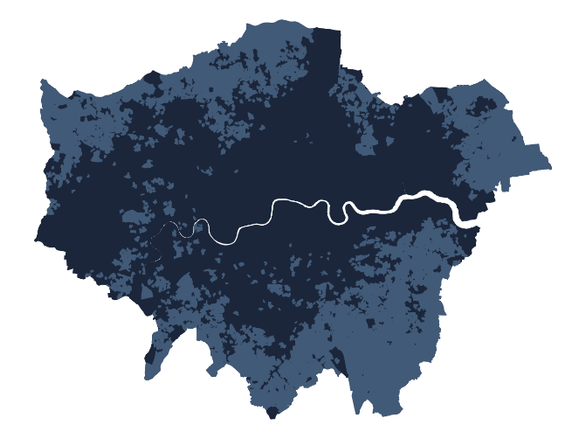The age distribution of these neighbourhoods is skewed towards older age groups, although few residents live alone or in communal establishments and numbers of dependent children are around the London average. Owner occupation is the norm, as is residence in detached or semi-detached houses. Residential densities are low and many households have spare rooms. Most residents were born in the UK and, aside from some members of Chinese and Indian ethnicities, identify as White British. Mixed ethnicity households are rare.

Incidence of married couples are higher than the London average and few individuals have never been married.

A large proportion of those individuals still in employment work in administrative and secretarial occupations, as well as in the construction industry. Few residents are students and many households own more than one car.

### G1: Professional Periphery

These neighbourhoods are more likely to house residents who are 65+, with greater than the Super Group identifying as of Indian, with correspondingly fewer White, and higher propensity for other religions. Those in work are more prevalently are managers, directors and senior officials; with fewer working in unskilled manual or support occupations. Although still under the London average, relative to the Super Group there are more communal establishments within these areas which may include residential care homes, alongside fewer terraces.

### G2: London Fringe

Residents of these neighbourhoods have their highest qualifications mostly below degree level, working more prevalently in skilled trade occupations, and relative to the Super Group, in distribution, hotels and restaurants. There is low ethnic diversity in these areas, with most residents of White ethnicity, with more than the Super Group specifying their religion as Christianity. These lower density areas have more detached or terraced houses which are under occupied relative to the Super Group.