LOAC 21 Consultation Document

# Update

At the first advisory meeting, feedback was sought on:

* The methodology and design of LOAC 21
* The Supergroup frequency and description
* The rationale for Group frequency

Both at the last meeting, and through later email correspondence, we received comments on the above topics which have been very helpful. We have prepared a separate document where we respond to each of these points, and where appropriate have incorporated them into this new iteration of LOAC 21.

As such, this document presents:

* Amendments to the Supergroups based on feedback
* Presentation of our initial Group names and descriptions based on the agreed numbers of clusters
* Enhanced interactive map with Borough boundaries and OAC Groups

We will present the Groups at the next meeting and would welcome feedback at the meeting or by email by close of business on **Friday 11 August**. We propose to then finalise LOAC 2021 for circulation in agreed formats. We would appreciate suggestions as to how best to support the final Open data product – for example, GIS files, PDF maps, online maps etc.

# Interactive Map

URL: <https://pinea.app.carto.com/map/b7fbd56c-88d0-4e5b-8fa6-bb87d0c864b3>

# Index Plot for Supergroups (previously circulated)

# Index Plot for Groups

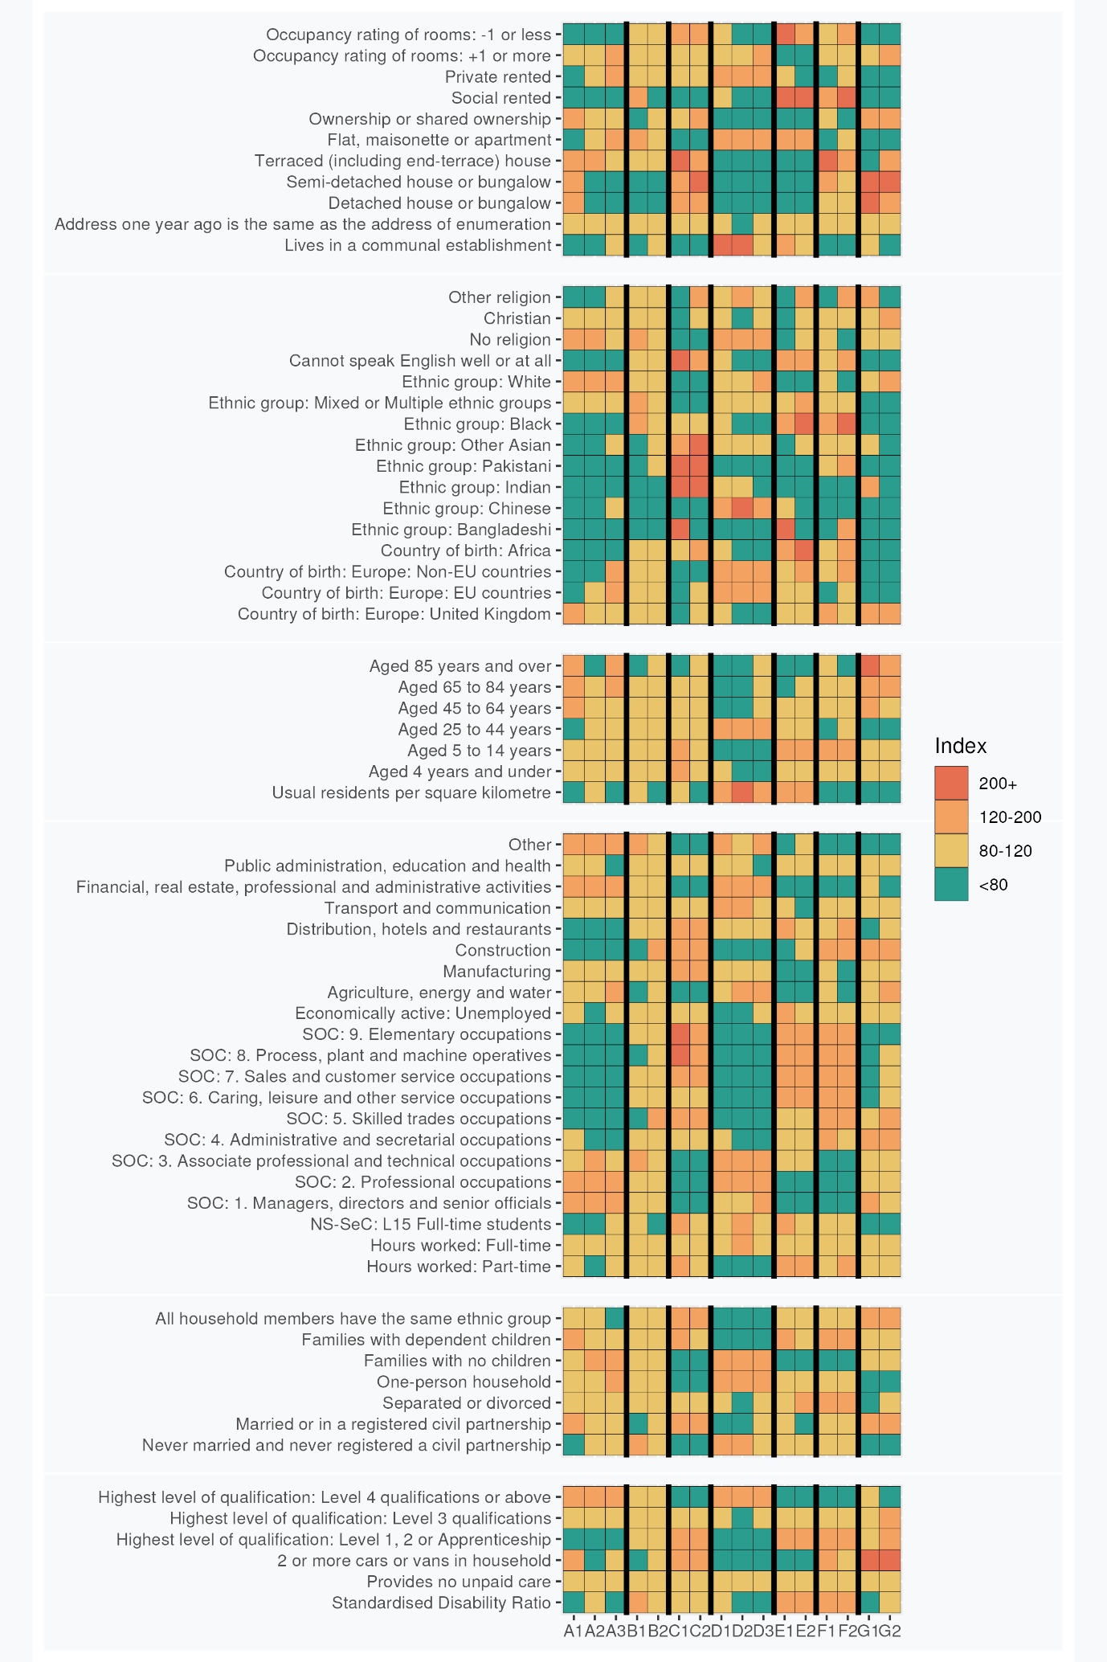

# Supergroup and Group Profiles

## **A: Professional Employment and Family Lifecycles**: These London neighbourhood residents are predominantly White, educated and secular. Many are employed in professional occupations and live in owned or private rented sector terraced houses.

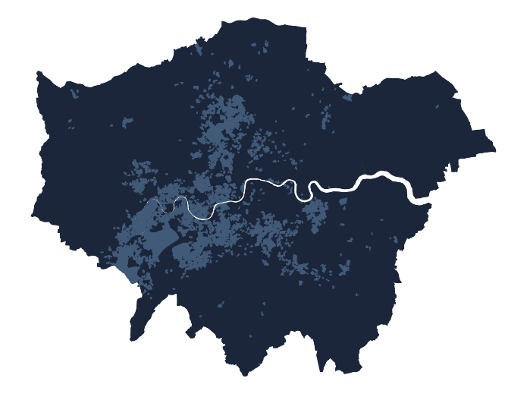These neighbourhoods house people of all ages, predominantly of White British or European extraction. Resident turnover is low. Religious affiliation is less common than average and tends to be Christian if expressed. Homeownership, typically of terraced houses, is common but use of the social rented sector is not. Employment is typically in professional, managerial and associate professional or technical occupations. There are few full-time students. Level 4 qualifications are common. More households lack dependent children than have them which, considered alongside low levels of crowding and over-all age structure, indicates that many households may be post child-rearing and in late middle age. Incidence of disability is low, as is residence in communal establishments.

|  |  |
| --- | --- |
|  | A1: Established Homeowners with Children These predominantly British-born residents are typically married/in civil partnerships and own the properties in which they are raising their children. Parents re typically over 45, and many other residents are beyond normal retirement age. Detached and semi-detached houses predominate and multiple car ownership is common. |
|  | A2: Inner London Working Professionals These primarily Inner London neighbourhoods are more densely populated than the Supergroup average. Residents have a younger over-all age profile than the Supergroup as a whole, and are less likely to be owner occupiers. Full time employment is more common than elsewhere in the Supergroup and multiple car ownership is uncommon. Chinese and non-EU-born European migrants are less in evidence than elsewhere in the Supergroup. |
|  | A3: European Enclaves Many residents of these well-connected neighbourhoods demonstrate wide-ranging non-UK European origins. Typically residing in privately rented flats, many residents live alone and are beyond normal retirement age. There are more students than elsewhere in the Supergroup, and some of them live in communal establishments. Household residents are often drawn from different ethnic groups. |

## **B: The Greater London Mix**: London remains much more diverse than much of the UK in terms of ethnicity and recent migration history. This Supergroup manifests diversity within neighbourhoods scattered throughout London. With some tendency towards singles living in flats.

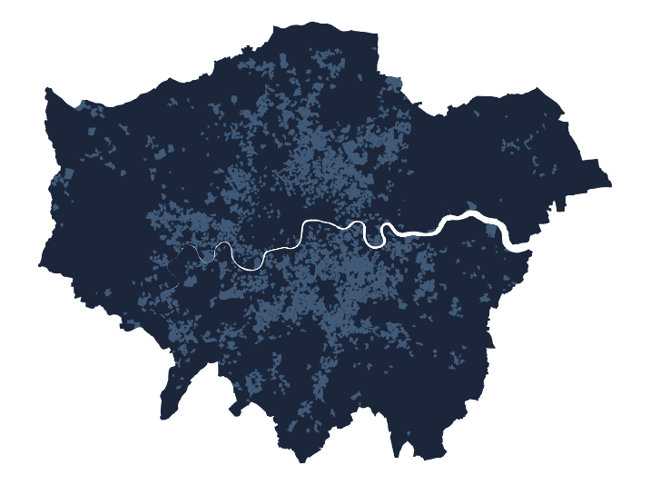A Supergroup embodying London’s diversity in many respects, apart from low numbers of residents identifying as of Bangladeshi, Indian, Pakistani or Other (non-Chinese) Asian ethnicity. There is lower than average prevalence of families with dependent children, while there are above average occurrences of never-married individuals and single-person households. The age distribution is skewed towards younger, single residents and couples without children, with many individuals identifying as of mixed or multiple ethnicity. Social rented or private rented housing is slightly more prevalent than average, and many residents live in flats. Individuals typically work in professional and associated roles in public administration, education or health rather than in elementary occupations in agriculture, energy, water, construction or manufacturing. Incidence of students is slightly below average. Individuals declaring no religion are more prevalent than average and incidence of difficulty in use of English is below average.

|  |  |
| --- | --- |
|  | B1: Social Rented Sector Professional Support Workers Mainly located in Inner London, these neighbourhoods retain a diverse employment structure, with some concentration in associated professional and technical occupations rather than skilled trades or construction. Social renting is more common and levels of homeownership are low. Many residents identify as Black. There is a lower than average rate of marriage or civil partnership, few that are very old (85 or over) and higher than average incidence of disability. |
|  | B2: Skilled Trades and Construction Workers These scattered, peripheral and often low residential density neighbourhoods house more workers in skilled trades and construction. Few households rent social housing and there are few students. Multiple car ownership is higher than the Supergroup average, perhaps because of poorer public transport connectivity. Incidence of mixed or multiple ethnicity is below the Supergroup average, and the absence of individuals identifying as Pakistani or Other Asian groups is also less pronounced. Flatted accommodation is less dominant than elsewhere in the Supergroup. |

## **C: Suburban Asian Communities**: London neighbourhoods featuring Indian, Pakistani, and Bangladeshi influences, with family-focused living in houses rather than flats. Outside of management and the professions, the labour force is very active across a full range of occupations, but some community members remain challenged by language barriers and overcrowding.

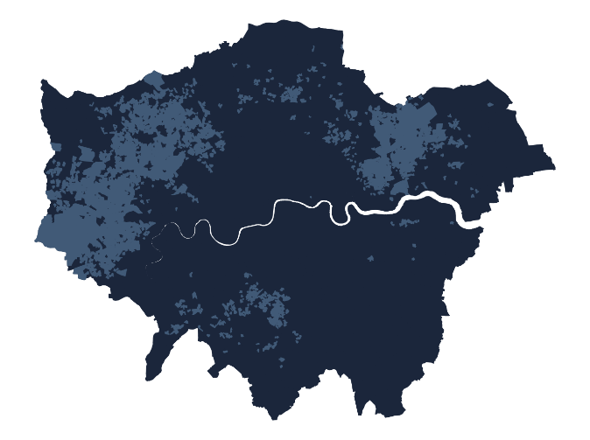Many residents of these neighbourhoods are of (non-Chinese) Asian descent, with many identifying as Indian, Pakistani or Bangladeshi. Neighbourhoods are located across large areas of suburban west, north-east and south London. Detached, semi-detached and terraced houses are more prevalent than flats and socially rented housing is uncommon. Few residents live in communal establishments. Many families have dependent children, sometimes in overcrowded accommodation, and few households are ethnically mixed. Marriage rates are above the London average. The even age distribution, relative absence of individuals living alone and frequent incidence of households with children suggests that multi-generation households may be relatively common. Employment is often in skilled trades, elementary, sales and customer service occupations, and roles as process, plant, and machine operatives. Manufacturing and construction are well represented, along with employment in distribution, hotels, and restaurants. Many adults have only level 1, 2, or apprenticeship qualifications. English proficiency remains a challenge for some residents. Religious affiliation is above average.

|  |  |
| --- | --- |
|  | C1: Young Asian Family Terraces These households with dependent children typically live in terraced housing and are of (non-Chinese) Asian extraction. Individuals with Bangladeshi origins are particularly in evidence. Employment is often in elementary occupations or as process, plant or machine operatives, and part-time work is generally common. Students are much in evidence. |
|  | C2: Settled Semi-Detached Asians These residents share Supergroup characteristics of large (non-Chinese) Asian populations but those identifying as Bangladeshi are notably absent. Many of these were born in the UK, while other more recent migrants have African birthplaces. Semi-detached housing, much of it owner occupied, prevails in these suburban residential locations. |

## **D: Central Connected Professionals and Managers**: These Central London neighbourhoods are home for a blend of young, educated professionals from diverse backgrounds. Residents are of prime working age and typically live in privately rented flats, some of them crowded.

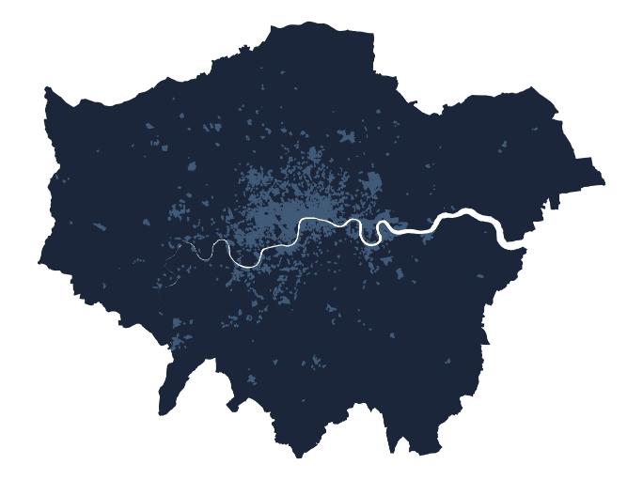Adult residents of these neighbourhoods are typically aged 25 to 44, working full-time in professional, managerial or associate professional occupations. There are few families with dependent children. The predominantly Inner London neighbourhoods have an international character, including many residents born elsewhere in Europe alongside high numbers of individuals identifying as of Chinese ethnicity. Many individuals are never married, childless and/or living alone. Above average numbers of individuals, likely to be full-time students, live in communal establishments. Elsewhere, privately rented flats are the dominant housing type. Residents of these areas are well-qualified, with a significant number holding Level 4 or above qualifications. There is a correspondingly high level of individuals employed full-time in professional, managerial and associated professional or technical occupations. Employing industries are financial, real estate, professional, administration, and, to a lesser degree, transport and communications. Unemployment is uncommon.

|  |  |
| --- | --- |
|  | D1: City Support Workers Scattered throughout Inner London, these areas house relatively few workers in the most senior roles within organisations, and greater prevalence of administrative roles relative to the Supergroup mean. Residents are less likely to be of Chinese ethnicity and are more likely to have been born in Africa. Relative to the Supergroup average, residents are also more likely to live in social housing and live in overcrowded conditions. |
|  | D2: Central and City These high density central neighbourhoods are characterised by high levels of residential turnover. Few children are in evidence Few individuals experience live with disability, with many in full-time employment or study. Levels of separation or divorce are low relative to the Supergroup average. The workforce is well-educated but not in the top flight of managerial occupations. Levels of affiliation to non-Christian religions are high. |
|  | D3: Senior Professionals These very central neighbourhoods house residents whose ages are more skewed towards older age cohorts than elsewhere in the Supergroup. Few households have young children. Rates of illness are low. White and Chinese ethnicities are common, and Indian ethnicity rare compared to the Supergroup mean. Property tends not to be overcrowded, despite the centrality of neighbourhoods and there more live in communal establishments than elsewhere in the Supergroup. |

## **E: Social Rented Sector Families with Children**: Predominantly located in Inner London, these diverse ethnic communities include many with Black African or Bangladeshi origins. Younger adults, many living with children, predominate, living in flats in the social rented sector.

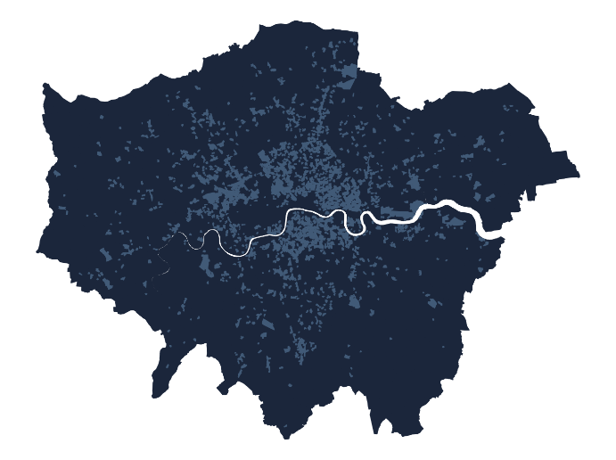Residents of these neighbourhoods include sizable numbers with roots outside Europe, particularly in Africa or Bangladesh. The proportion of residents identifying as White, Indian or Pakistani is well below the London average. Neighbourhood age profiles are skewed towards younger adults, and above average numbers of families have children. English proficiency levels are below average. Marriage rates are low, and levels of separation or divorce are above average. Housing is predominantly in flats, and renting in the social rented sector the norm – few residents are owner occupiers. Housing is often overcrowded, and neighbourhoods are amongst the most densely populated in London. Disability rates are above average, although levels of unpaid care provision are about average. Employment is in caring, leisure, other service occupations, sales and customer service, or process, plant, and machine operation. Part time working and full-time student study are common. Levels of unemployment are slightly above average. Most residents have only Level 1 or 2 educational qualifications or have completed apprenticeships.

|  |  |
| --- | --- |
|  | E1: Challenged Inner London Communities Resident in some of Inner London’s most over-crowded communities, many families have children and marriage/civil partnership rates are above the Supergroup average. Other adults such as students live in communal establishments. Few residents have Level 4 educational qualifications, levels of unemployment are above the Supergroup average, and employment is concentrated in service occupations such as distribution, hotels and restaurants. Relative to the Supergroup average, fewer residents identify as being of mixed/multiple ethnicities, Black or Other Asian. |
|  | E2: Social Rented Sector Pockets Found in pockets across London, residents are less likely to live in private sector rentals and fewer adults are students. Fewer individuals work in transport and communications occupations relative to the Supergroup average. More individuals identify as Black and were born in Africa. |

## **F: Young Families and Mainstream Employment**: Family-oriented residents, concentrated in multi-ethnic neighbourhoods throughout most of London. Many residents identify as Black African and many families have children. Employment is across the labour market, apart from professional or managerial occupations.

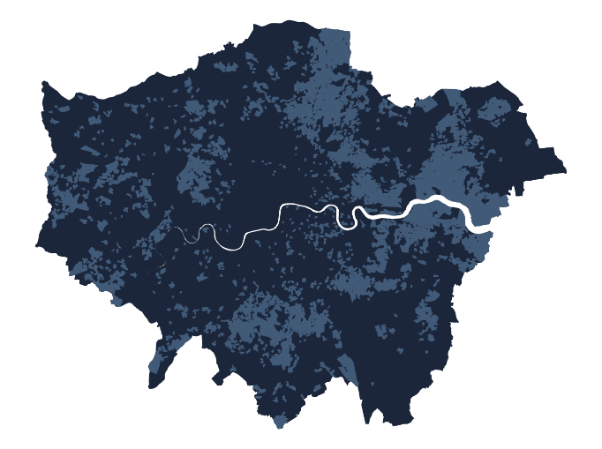Many families in these neighbourhoods have young children. Housing in principally in the social rented sector, in terraced or semi-detached units. While over-all residential densities are low, overcrowding is also prevalent locally. Residents are drawn from a range of ethnic minorities, with many identifying as Black and above average numbers born in Africa. Numbers of Chinese, Indian and White ethnic groups are below average. Levels of proficiency in English are below average. Levels of separation or divorce and incidence of disability are both above average. Education is typically limited to Level 1, 2, or apprenticeship qualifications. Few residents work in professional or managerial occupations but the employment structure is otherwise diverse: it includes skilled trades, caring, leisure and other service occupations, sales and customer service occupations, construction, and work as process, plant, and machine operatives.

|  |  |
| --- | --- |
|  | F1: Terraced and Semi-Detached Suburbs Mainly concentrated in suburban areas, these terraced and semi-detached developments are less overcrowded than the Supergroup average, and resident households are more likely to own two or more cars. There are fewer residents aged 25-44, and a larger share of residents employed in administrative and secretarial occupations. Residents are more likely to have been born in the UK, less likely to have been born in the EU or Africa, and much less likely to self-identify as Bangladeshi. |
|  | F2: Social Rented Sector and Diverse Origins Scattered across London’s Inner and Outer suburbs, residents of these neighbourhoods are typically housed in the social rented sector, and few others are owner occupiers. Although terraced and semi-detached houses predominate, more residents live in flats than elsewhere in the Supergroup. Neighbourhoods are more ethnically diverse than the Supergroup average, with those of Bangladeshi, Pakistani and some Black ethnicities more prevalent; and Europeans born in an overseas non-EU country making up more of the lower proportion of residents identifying as White. Few residents are very old (85+). Employment in distribution, hotels and restaurants is more common than elsewhere in the Supergroup. |

## **G: Older Residents in Owner-Occupied Suburbs:** Outer London neighbourhoods mainly comprising White, UK-born owner-occupiers living in detached or semi-detached houses.

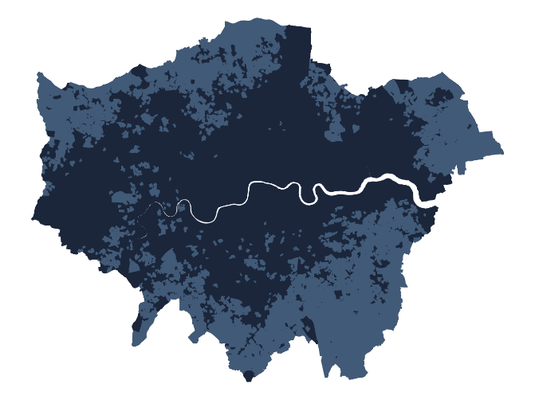The age distribution of these neighbourhoods is skewed towards the middle-aged and old, although few residents live alone or in communal establishments and numbers of dependent children are around average. Owner occupation is the norm, as is residence in detached or semi-detached houses. Residential densities are low and many households have spare rooms. Most residents were born in the UK and, aside from some members of Chinese and Indian ethnicities, identify as White. Mixed ethnicity households are rare. Incidence of married couples is higher than average and few individuals have never been married. A large proportion of individuals still in employment work in administrative and secretarial occupations, or in the construction industry. Few residents are students, and many households own more than one car.

|  |  |
| --- | --- |
|  | G1: Professional Periphery These neighbourhoods are more likely to house residents aged over 45, including the very old (over 85s). Those still in work are more likely to be managers, directors or senior officials than elsewhere in the Supergroup, with fewer working in unskilled manual or support occupations. The incidence of terraced housing is below the Supergroup average, but more residents live in communal establishments. White ethnic groups are less dominant than elsewhere in the Supergroup, with greater numbers self-identifying as Indian, and there is greater affiliation to non-Christian religions. Levels of illness are below the Supergroup average. |
|  | G2: London Fringe Predominantly located in neighbourhoods on the outskirts of Greater London, residents of these neighbourhoods typically have their highest qualifications below degree (Level 4) level, with those still in work engaged in skilled trades and occupations in distribution, hotels and restaurants. There is low ethnic diversity in these neighbourhoods and high levels of Christian religious affiliation. Detached or terraced houses predominate, often with spare rooms. |