Groups

# Clustergram (7 Selected)

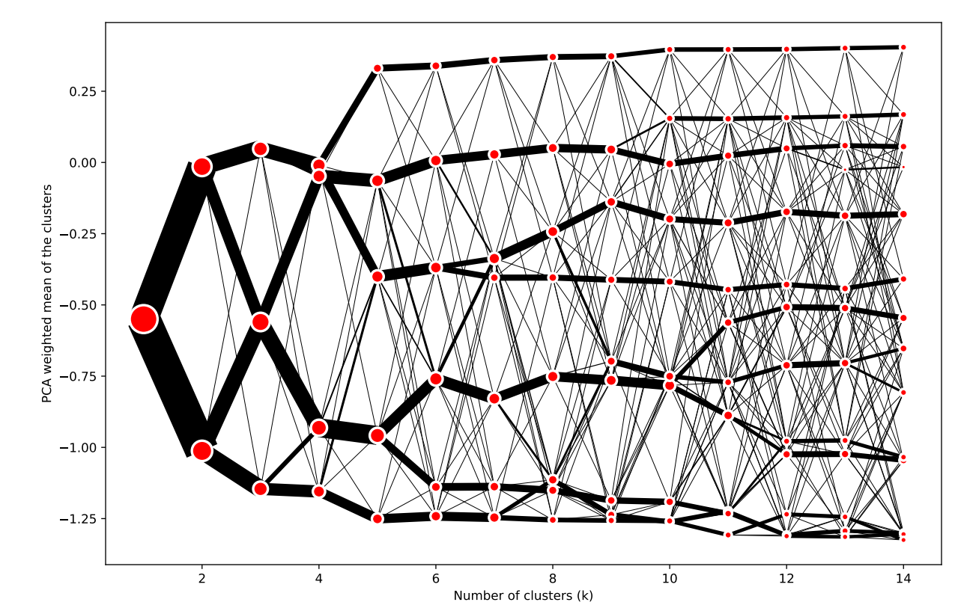

# Interactive Map

URL: <https://pinea.app.carto.com/map/b7fbd56c-88d0-4e5b-8fa6-bb87d0c864b3>

# Index Plot

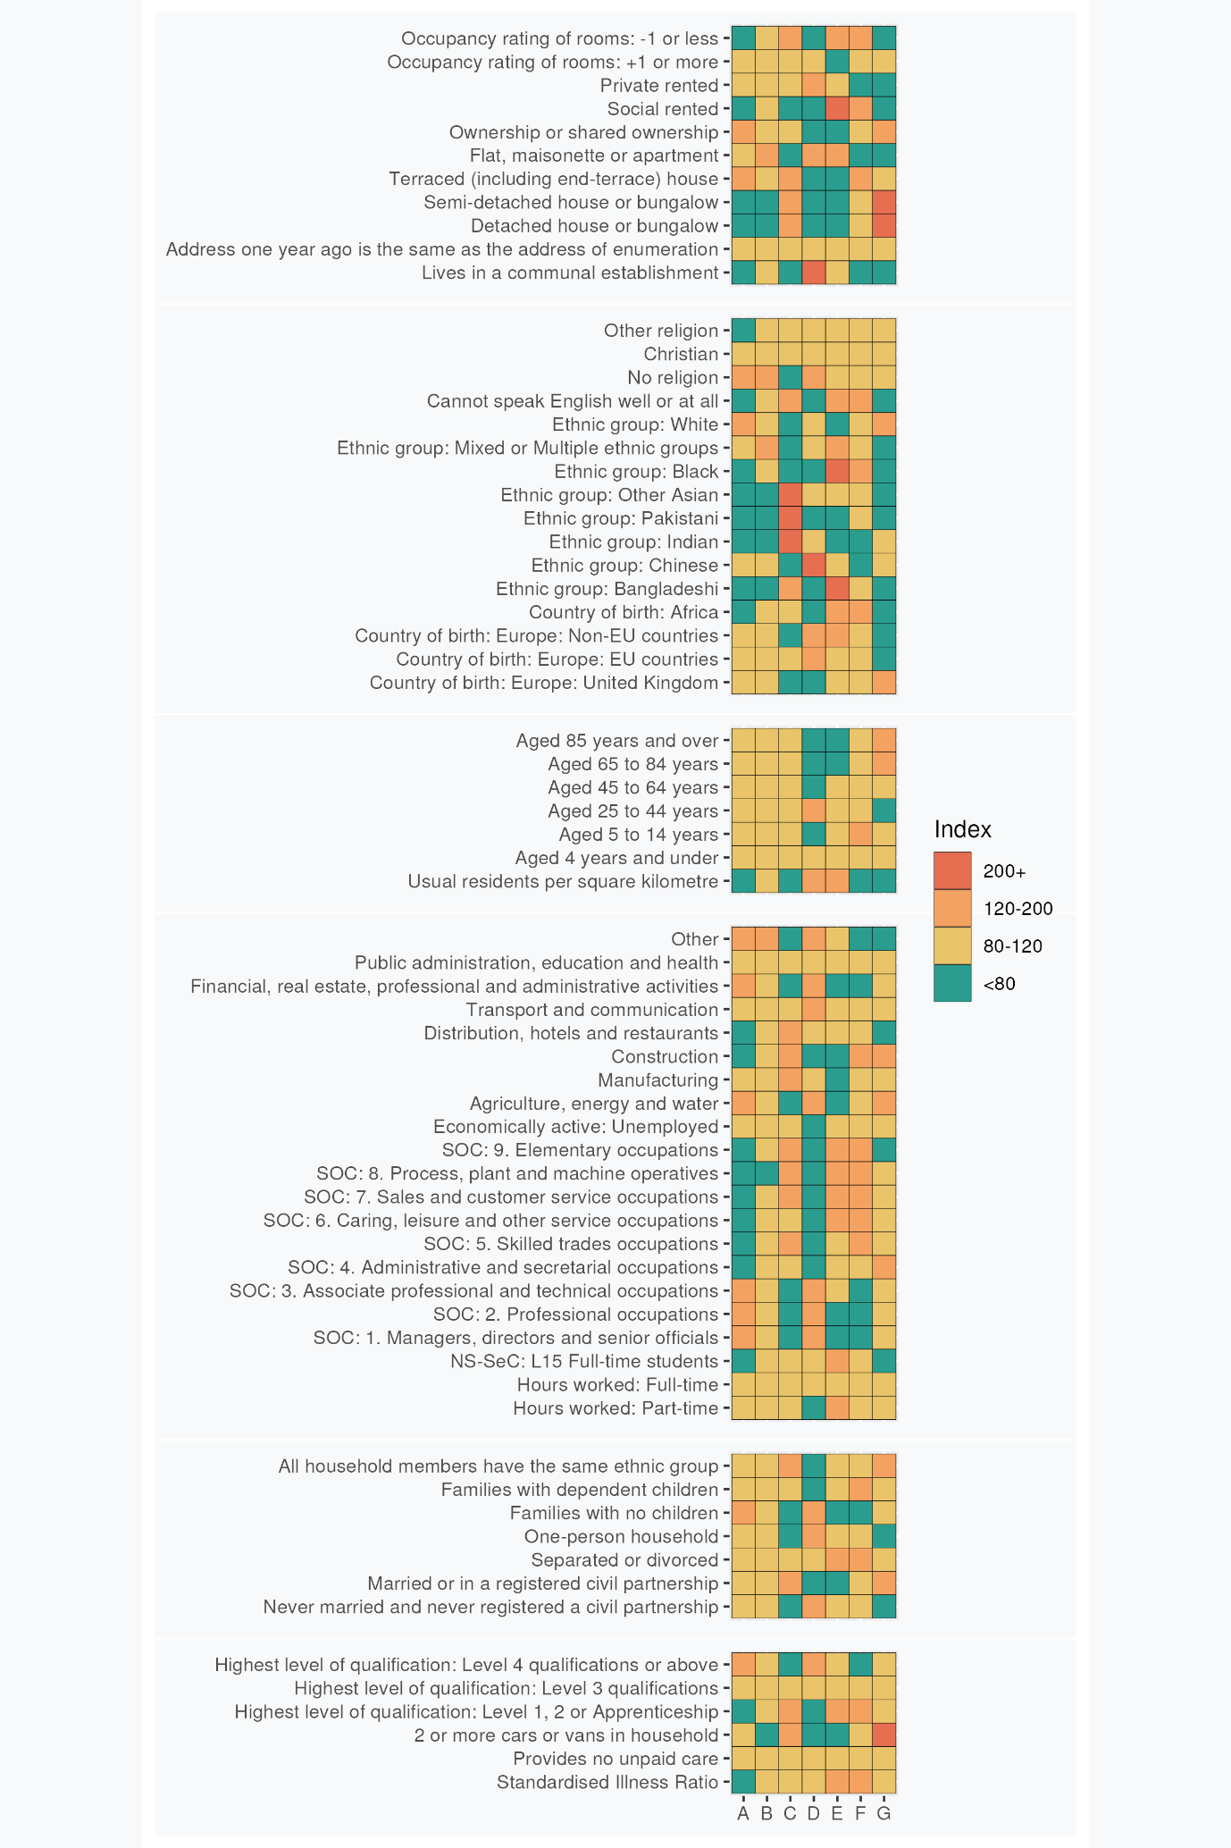

# Supergroup and Group Profiles

## **A: Established Professional Lifecycles**: These London neighbourhood residents are predominantly White, educated and secular. Many are employed in professional occupations and live in privately owned or rented terraced houses.

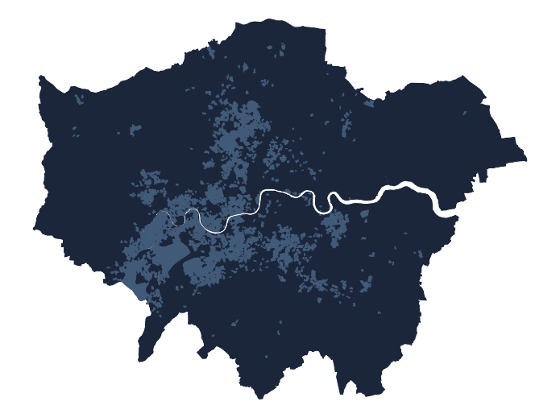These neighbourhoods house people of all ages, predominantly of White British and European extraction. Resident turnover is low. Religious affiliation is less common than the London average and to be Christian if expressed. Homeownership rates, typically of terraced houses, are high and social renting is uncommon. Employment is typically in professional, managerial and associate professional or technical occupations. There are few full-time students. Level 4 qualifications are common.

More households lack dependent children than have them which, considered alongside low levels of crowding and over-all age structure, indicates that many households may be post child-rearing and in late middle age. Levels of illness are low, as is residence in communal establishments.

### A1: Long-Settled and Ageing Homeowners with Children

These predominantly British-born residents are typically married/in civil partnerships and own the properties in which they are raising their children. Parents re typically over 45,and many other residents are beyond normal retirement age. Detached and semi-detached houses predominate and multiple car ownership is common.

### A2: Inner London Working Professionals

These primarily Inner London residents live in neighbourhoods that are more densely populated than the Supergroup average. Residents have a younger over-all age profile than the Supergroup as a while, and are less likely to be owner occupiers. Full time employment is more common than elsewhere in the Supergroup and, perhaps unsurprisingly given their residential locations, multiple car ownership is uncommon. Chinese and non-EU-born European migrants are less in evidence than elsewhere in the Supergroup.

### A3: European Enclaves

Many residents of these well-connected neighbourhoods have widespread non-UK European origins. Many live in privately rented flats. Many residents live alone and are beyond normal retirement age. There are more students than elsewhere in the Supergroup, some living in communal establishments, and residents of multi-person households are often drawn from different ethnic groups.

## **B: The Greater London Mix**: Communities scattered throughout London with some tendency towards singles living in flats.

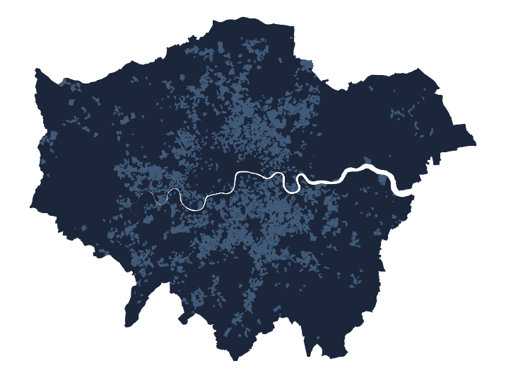London remains much more diverse than much of the UK in terms of ethnicity and recent migration history and this Supergroup embodies this diversity in most all respects apart from low numbers of residents identifying as Bangladeshi, Indian, Pakistani or Other (non-Chinese) Asian. These neighbourhoods pervade all but some parts of west and north-east London. There is lower-than-average prevalence of families with dependent children, while occurrences of never-married individuals and single-person households are relatively common. The age distribution is skewed towards younger, single residents and couples without children, with many individuals identifying as of mixed or multiple ethnic heritage.

Social or private renting is slightly more prevalent than the London average, and many people live in flats.

Individuals typically work in professional and associated roles in public administration, education, and health rather than in elementary occupations in agriculture, energy, water, construction or manufacturing.

Incidence of educational qualifications is slightly below the London average, and full-time students are also slightly less common.

Individuals declaring no religion are more prevalent than the London average and incidence of difficulty in use of English is below the London average.

### B1: Social Renting Professional Support Workers

Mainly located in Inner London, these neighbourhoods retain a diverse employment structure, with some concentration in associate professional and technical occupations rather than skilled trades or construction. Social renting is more common and levels of homeownership are low. Many residents identify as Black. There is a lower than average rate of marriage or civil partnership, few that are very old (85 or over) and higher incidence of ill health.

### B2: Skilled Trades and Construction Workers

These scattered, peripheral and often low residential density neighbourhoods house more workers in skilled trades and construction. Few households rent social housing and there are few students. Multiple car ownership is higher than the Supergroup average, perhaps because of poorer public transport connectivity. Incidence of mixed or multiple ethnicity is below the Supergroup average, and the absence of individuals identifying as Pakistani or Other Asian groups is also less pronounced. Flatted accommodation is less dominant than elsewhere in the Supergroup.

## **C: Suburban Asian Communities**: London neighbourhoods featuring Indian, Pakistani, and Bangladeshi influences, with family-focused living in houses rather than flats. Outside of management and the professions, the labour force is very active across a full range of occupations, but some community members remain challenged by language barriers and overcrowding.

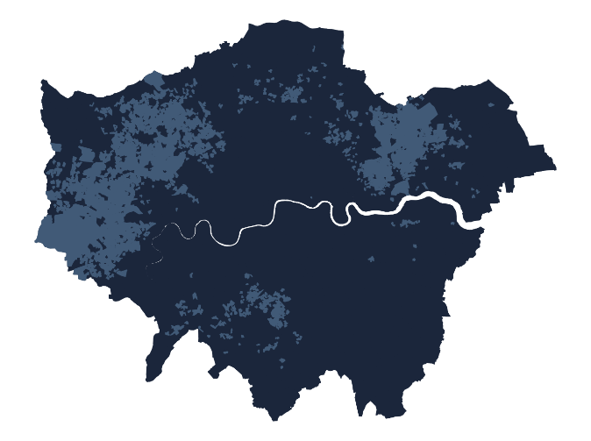Many residents of these neighbourhoods are of (non-Chinese) Asian descent, particularly India, Pakistan, and Bangladesh. Neighbourhoods are located across large areas of suburban west, north-east and south London.

Detached, semi-detached and terraced houses are more prevalent than flats and socially rented housing is uncommon. Few residents live in communal establishments. Many families have dependent children, sometimes in overcrowded accommodation, and few households are ethnically mixed.

Marriage rates are above the London average. The even age distribution, relative absence of individuals living alone and frequent incidence of households with children suggests that multi-generation households may be relatively common.

Employment is often in skilled trades, elementary, sales and customer service occupations, and roles as process, plant, and machine operatives. Manufacturing and construction are well represented, along with employment in distribution, hotels, and restaurants. Many adults have only level 1, 2, or apprenticeship qualifications.

English proficiency remains a challenge for some residents. Religious affiliation is relatively high.

### C1: Young Asian Family Terraces

These households with dependent children typically live in terraced housing and are of (non-Chinese) Asian extraction. Individuals with Bangladeshi origins are particularly in evidence. Employment is often in elementary occupations or as process, plant or machine operatives, and part-time work is generally common. Students are much in evidence.

### C2: Settled Semi-Detached Asians

These residents share Supergroup characteristics of large (non-Chinese) Asian populations but those identifying as Bangladeshi are notably absent. Many are likely to have been born in the UK, while other more recent migrants have African birthplaces. Semi-detached housing, much of it owner occupied, prevails in these suburban residential locations.

## **D: Central Connected Professionals and Managers**: These Central London neighbourhoods are home for a blend of young, educated professionals from diverse backgrounds. Residents are of prime working age and typically live in privately rented flats, some of them crowded.

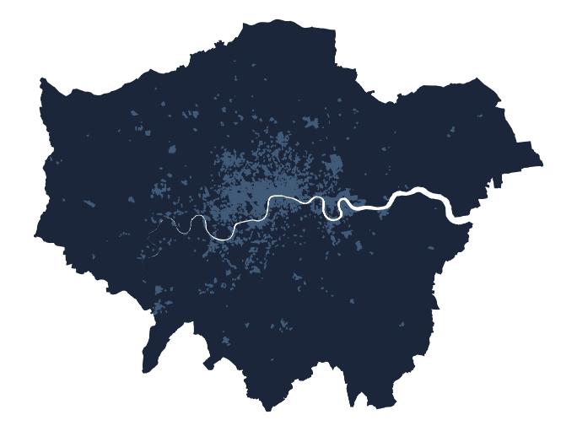Adult residents of these neighbourhoods are typically aged 25 to 44, working full-time in professional, managerial or associate professional occupations. There are few families with dependent children.

The predominantly Inner London neighbourhoods have an international character, including many residents born elsewhere in Europe alongside high numbers of individuals identifying as of Chinese ethnicity. Many individuals are never married, childless and/or living alone.

Above average numbers of individuals, likely to be full-time students, live in communal establishments. Elsewhere, privately rented flats are the dominant housing type.

Residents of these areas are well-qualified, with a significant number holding Level 4 or above qualifications. There is a correspondingly high level of individuals employed full-time in professional, managerial and associated professional or technical occupations. Employing industries are financial, real estate, professional, administration, and, to a lesser degree, transport and communications. Unemployment is uncommon.

### D1: White Collar Support Workers

Scattered throughout Inner London, these areas house relatively few workers in the most senior roles within organisations, and greater prevalence of administrative roles relative to the Supergroup mean. Residents are less likely to be of Chinese ethnicity and are more likely to have been born in Africa. Relative to the Supergroup average, residents are also more likely to live in social housing and live in overcrowded conditions.

### D2: Central and City

Residents live in high density central locations characterised by high levels of residential turnover. Few children are in evidence Few individuals experience ill health, with many in full-time employment or study. Levels of separation or divorce are low relative the Supergroup average. The workforce is well-educated but not in the top flight of managerial occupations. Levels of affiliation to non-Christian religions are high.

### D3: Senior Professionals

These very central locations house residents whose ages are more skewed towards older age cohorts than elsewhere in the Supergroup. Few households have young children. Rates of illness are low. White and Chinese ethnicities are common, and Indian ethnicity rare compared to the Supergroup mean. Property tends not to be overcrowded, despite the centrality of neighbourhoods and there are more communal establishments than elsewhere in the Supergroup.

## **E: Social Renters, Many with Children**: Predominantly located in Inner London, these community members are drawn from a wide range of ethnicities, with high incidence of African and Bangladeshi residents. Younger adults, many living with children, predominate, living in socially rented flats.

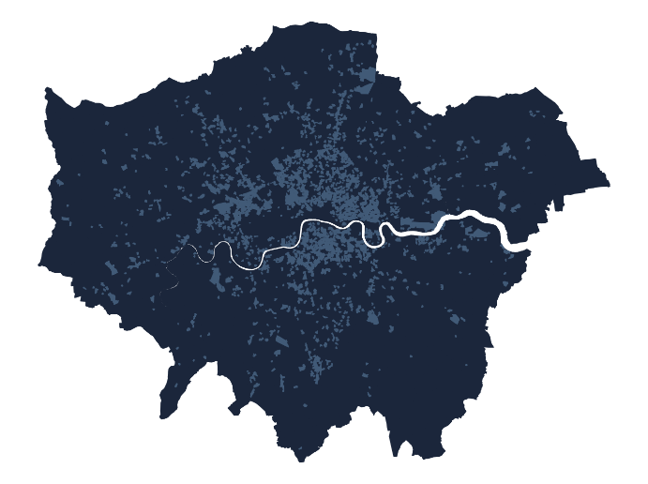Residents of these neighbourhoods together comprise sizable numbers drawn from outside Europe, particularly in Africa and from Bangladesh. The proportion of residents identifying as White, Indian or Pakistani is well below the London average,

Neighbourhood age profiles are skewed towards younger adults, and more families have children than the London average. English proficiency levels are below the London average. Marriage rates are low, and levels of separation or divorce are above the London average.

Housing is predominantly in flats, and social renting the norm – few residents are owner occupiers. Housing is often overcrowded and neighbourhoods are amongst the most densely populated in London. Illness rates are above the London average, although levels of unpaid care provision hover around the London average.

Employment is in caring, leisure, other service occupations, sales and customer service, or process, plant, and machine operation. Part time working and full-time student study are common. Levels of unemployment are slightly above the London average. Most residents have only Level 1 or 2 educational qualifications or have completed apprenticeships.

### E1: Challenged Inner London Communities

Resident in some of London’s most over-crowded Inner London communities, many families have children and marriage/civil partnership rates are above the Supergroup average. Other adults such as students live in communal establishments. Few residents have Level 4 educational qualifications, levels of unemployment are above the Supergroup average, and employment is concentrated in service occupations such as distribution, hotels and restaurants. Relative to the Supergroup average, fewer residents identify as being of mixed/multiple ethnicities, Black or Other Asian.

### E2: Social Rented Sector Pockets

Found in pockets across London, residents are less likely to live in private sector rentals and fewer adults are students. Fewer individuals work in transport and communications occupations relative to the Supergroup average. More individuals identify as Black and were born in Africa.

## **F: Young Families and Mainstream Employment**: Family-oriented living, concentrated multi-ethnic neighbourhoods throughout London. Many residents identify as Black African and many families have children. Employment is across the labour market, apart from professional or managerial occupations.

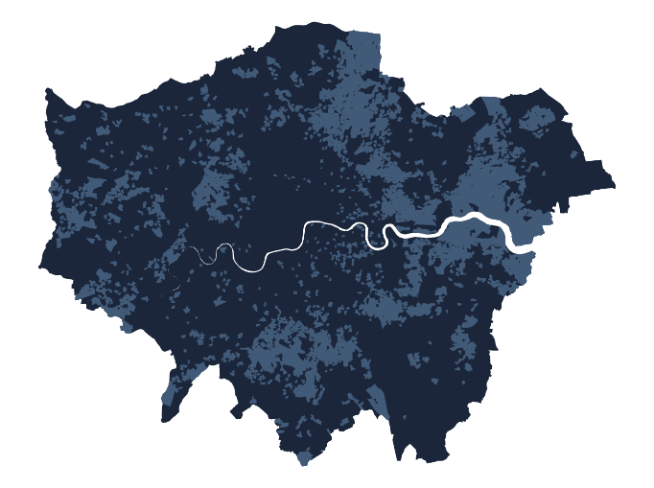 Mainly located beyond Inner London, many families in these neighbourhoods have young children. Housing in the social rented sector is prevalent, in terraced or semi-detached units. While over-all residential densities are low, overcrowding is also prevalent locally.

Residents are drawn from a range of ethnic minorities, with many identifying as Black and above average numbers born in Africa. Numbers of Chinese, Indian and White ethnic groups are below the London average.

Levels of proficiency in English are below the London average. Levels of separation or divorce and incidence of long-term illness are both above average.

Education is typically limited to Level 1, 2, or apprenticeship qualifications. Few residents work in professional or managerial occupations but the employment structure is otherwise diverse: it includes skilled trades, caring, leisure and other service occupations, sales and customer service occupations, construction, and work as process, plant, and machine operatives.

### F1: Terraced and Semi-Detached Suburbs

Mainly concentrated in outer suburban areas, these terraced and semi-detached developments are less overcrowded than the Supergroup average, and resident households are more likely to own two or more cars. There are fewer residents aged 25-44, and a larger share of residents employed in administrative and secretarial occupations. Residents are more likely to have been born in the UK, less likely to have been born in the EU or Africa, and much less likely to self-identify as Bangladeshi.

### F2: Social Rented Sector and Diverse Origins

Scattered across London’s Inner and Outer suburbs, residents of these neighbourhoods are typically housed in the social rented sector, and few others are owner occupiers. Although terraced and semi-detached houses predominate, more residents live in flats than elsewhere in the Supergroup. Neighbourhoods are more ethnically diverse than the Supergroup average, with those of Bangladeshi, Pakistani and some Black ethnicities more prevalent; and Europeans born in an overseas non-EU country making up more of the lower proportion of residents identifying as White. Few residents are very old (85+). Employment in distribution, hotels and restaurants is more common than elsewhere in the Supergroup.

## **G: Older Residents in Owner-Occupied Suburbs:** Outer London neighbourhoods mainly comprising White, UK-born owner-occupiers living in owned detached or semi-detached houses.

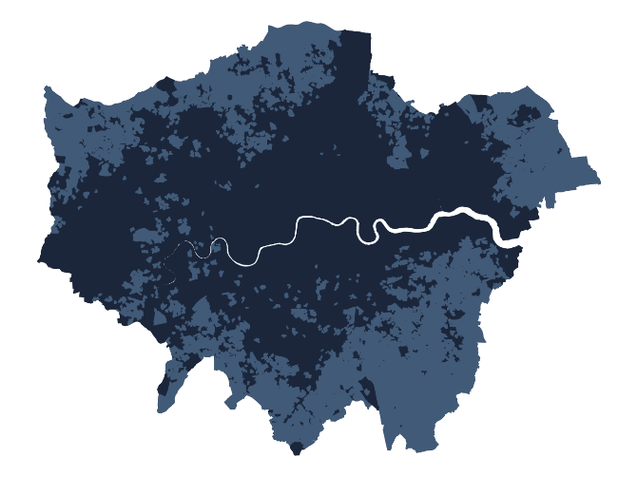The age distribution of these neighbourhoods is skewed towards older age groups, although few residents live alone or in communal establishments and numbers of dependent children are around the London average. Owner occupation is the norm, as is residence in detached or semi-detached houses. Residential densities are low and many households have spare rooms. Most residents were born in the UK and, aside from some members of Chinese and Indian ethnicities, identify as White British. Mixed ethnicity households are rare.

Incidence of married couples is higher than the London average and few individuals have never been married.

A large proportion of those individuals still in employment work in administrative and secretarial occupations, as well as in the construction industry. Few residents are students and many households own more than one car.

### G1: Professional Periphery

These neighbourhoods are more likely to house residents who aged 45+, including the very old (85+). Those still in work are more likely to be managers, directors or senior officials than elsewhere in the Supergroup, with fewer working in unskilled manual or support occupations. The incidence of terraced housing is below the Supergroup average, but more residents live in communal establishments. ethnic groups are less dominant than elsewhere in the Supergroup, with greater numbers self-identifying as Indian, and there is greater affiliation to non-Christian religions. Levels of illness are below the Supergroup average.

### G2: London Fringe

Predominantly located in neighbourhoods on the outskirts of Greater London, residents of these neighbourhoods typically have their highest qualifications below degree (Level 4) level, with those still in work engaged in skilled trades and occupations in distribution, hotels and restaurants. There is low ethnic diversity in these neighbourhoods and high levels of Christian religious affiliation. Detached or terraced houses predominate, often with spare rooms.