INDIVIDUAL SUMMARY CASE STUDY ANALYSIS TEMPLATE:
Alex Soderlund
Lululemon
- Analytic Framework
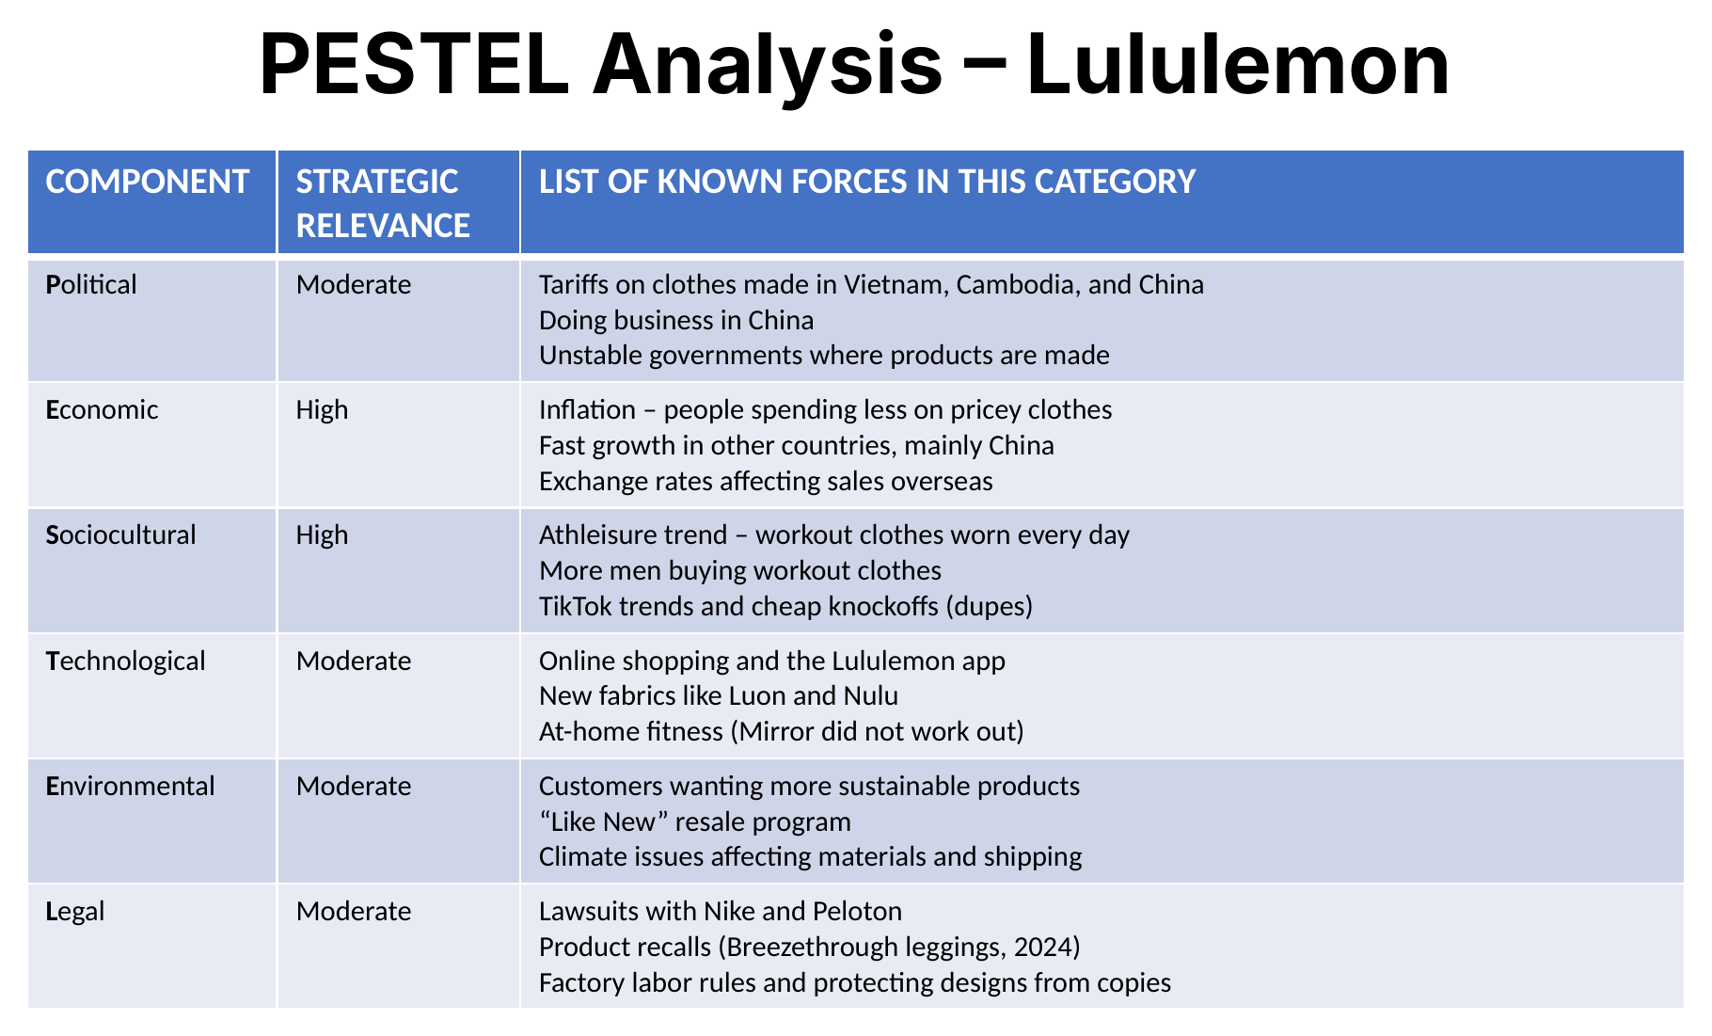
The PESTEL shows that the biggest outside forces on Lululemon are economic and sociocultural. Lululemon sells expensive workout clothes, so when prices go up and people have less money to spend, it hurts the company. At the same time, the brand is growing fast in other countries like China, which helps make up for slower sales in the U.S. The athleisure trend is a big reason Lululemon has done so well, since more people are wearing workout clothes every day and not just at the gym. Social media has also helped the brand blow up, like with the belt bag going viral on TikTok, but it has also led to a lot of cheaper knockoffs. Tariffs are something to watch because most of their clothes are made in Vietnam and Cambodia. Technology matters some through online sales and new fabrics, but the Mirror purchase shows that not every tech idea works out. Environmental and legal issues like lawsuits and recalls are there, but they do not really change the company’s overall direction.

- Recommendation
I would recommend that Lululemon’s CEO continue to push international expansion, with a strong focus on China and other Asian markets, while being careful about relying too heavily on the slowing North American market. The PESTEL analysis shows that the U.S. consumer is being squeezed by inflation and that competition from cheaper dupes is rising, while international markets are still growing at a fast pace. Expanding overseas spreads out the economic risk and takes advantage of the global athleisure and wellness trend that is driving demand. At the same time, Lululemon should diversify its manufacturing across more countries to lower the impact of tariffs and trade tensions. Overall, this approach would keep revenue growing, reduce the company’s exposure to any one economy, and strengthen Lululemon’s position as a global athletic apparel brand.

- References & AI Usage Statement
No outside resources were used. Copilot AI was used to help me better understand Lululemon’s current situation, improve the flow of the paragraphs I wrote, and fix minor grammar and punctuation mistakes.

