Product: | Subcuvia S/D
Title: | Use of eight (8) Sartobran filter cartridges for the final clarifying filtration of LEGCL036
Reference: | ER 11/1223
Type of document: | Final Report
Author:
Michael Brion / Date
Process Improvement Specialist
Approvers:
François Hupet / Date
Process Improvement Manager
Dimitri Declèves / Date
QO Bulk Supervisor

Table of content
1. Purpose 3
2. Scope 3
3. Description of the event 3
4. Root cause investigation 4
4.1. Historical review 4
4.2. LE-CAPA-0047: Investigation results 5
4.3. Identification of the clogging agent 5
4.4. Investigation of process at Lessines 5
5. Product impact assessment 7
6. Process/System/Equipment Impact Evaluation 7
7. Conclusions 7
8. Attachments 7

Purpose
The purpose of this report is to document the investigation associated to the use of eight (8) Sartobran filter cartridges to complete the final clarifying filtration of Subcuvia S/D lot LEGCL036.

Scope
This investigation report applies to ER 11/1223 and to Subcuvia S/D lot LEGCL036.

Description of the event
The occurrence of the exception and the respective batch lot number are documented in Table 1.

Table 1
Exception # | Lot # | Occurrence Date
11/1223 | LEGCL036 | 09 November 2011

During the final clarifying filtration of Subcuvia S/D lot LEGCL036, it was noticed by the operator that the filtration flow rate was abnormally decreasing. As observed in Attachement#1, eight (8) Sartobran filter cartridges were required to complete the final clarifying filtration of Subcuvia S/D lot LEGCL036 (See Table 2).
Note that the use of more than 1 Sartobran filter cartridge to complete the final clarifying filtration of Subcuvia S/D batch (i.e. 90 kg of Fr. II pastes) is an exception to Standard Operating Procedure,
LE-09-FT03076.

Table 2
Subcuvia S/D lot LEGCL036 | Mass of solution  left to be filtrated after filter replacement (Kg) | Filter lot #
1st filter used : Start time 10h17 | 259 | 11D28B331O
2nd filter used : Start time 10h56 | 223 | 11D28B331O
3rd filter used : Start time 11h30 | 179 | 11D28B331O
4th filter used: Start time 12h06 | 139 | 11D28B331E
5th filter used : Start time 12h41 | 100 | 11D28B331E
6th filter used : Start time 13h11 | 58 | 11D28B331O
7th filter used : Start time 13h40 | 28 | 11D28B331O
8th filter used: Start time 14h02 | 0 | 11D28B331O
End of filtration : 15h18

Root cause investigation

Historical review
Several Subcuvia S/D lots produced in 2010 and 2011 had encountered filter clogging during the final clarifying filtration. For all these lots, the most likely root cause identified for filter clogging was the relatively high protein concentration reached at the end of the second concentration. Calculations showed that the protein concentration at the end of the second concentration (before post-wash) in the final formulation tank may range between 15 and 20g/dl. Those high protein concentrations were confirmed by in-process measurements performed in the retentate of the UF system at the end of the second concentration.
As a consequence and to reduce the Sartobran clogging frequency an action plan was initiated to lower the target for the total protein concentration of the second concentration (See PA 10/326 and PR00000983/CCR00000527). The lowering of the total protein concentration during the second concentration was implemented during the manufacture of Subcuvia S/D lot LEGCL005, on February 03, 2011. Since then, nine (9) Subcuvia S/D lots have experienced filter clogging during the final clarifying filtration (i.e. Subcuvia S/D lots LEGCL013, LEGCL018, LEGCL022, LEGCL023, LEGCL026, LEGCL029, LEGCL033, LEGCL034 and LEGCL035).
The investigations led into the frame of ER 11/0417 (i.e. related to Subcuvia S/D lot LEGCL013) could not identify a root cause of filter clogging occurring during the final filtration. Therefore, Quality and Manufacturing management initiated LE-CAPA-0047 to identify the root cause of these recurring events.

LE-CAPA-0047: Investigation results
The investigations performed in the frame of LE-CAPA-0047 included on-the-floor observations, lab-scale experiments, statistical analyses, and identification of the clogging agent. Results of the investigations showed that:
- The final pH adjustment lead to a pronounced increase of the turbidity and a decrease in the filterability of the final formulated protein solution;
- The final pH adjustment at full-scale can be performed in some cases too quickly;
- Clogged and non-clogged Subcuvia lots were consecutively produced starting from the same raw materials;
- The clogging agent is only made up of IgG.

It was concluded that the root cause of the Sartobran filter clogging is the final pH adjustment that may lead in some cases to the precipitation of some IgG proteins.

Identification of the clogging agent
During the final clarifying filtration of Subcuvia S/D LEGCL036, protein samples were taken in ELIV tank and at the inlet of the carter. Those samples and the replaced Sartobran filter cartridge were transferred to Technical Services Laboratory. The filter was back-flushed and the collected solution was analyzed.
SDS Page electrophoresis was performed to determine the clogging agent. All the samples have similar electrophoresis profiles corresponding to IgG, with clear bands at 22.5 kD (light chains), 53 kD (heavy chains), ~100kD and 150 kD (combined fragments and IgG). No other bands than IgG were noticed in the electrophoresis profiles (Attachment#2). These results further confirm the investigation performed in the frame of LE-CAPA-0047.

Investigation of process at Lessines
No other exception report, besides the exception related to the Sartobran filter replacement, was issued during the upstream manufacturing of Subcuvia S/D lot LEGCL036.
In-process parameters, from first concentration to final clarifying filtration of Subcuvia S/D lot LEGCL036, were reviewed (Attachment#3). The investigation showed that all in-process parameters were within the run-sheet ranges.
Samples were taken before and after the pH adjustment of recently Subcuvia S/D lots LEGCL031, LEGCL032, LEGCL033 and LEGCL036, namely:
- After UF post-wash (@~11g/dL);
- After glycine stabilization and pH adjustment (@~11 g/dL).

Note that:
- LEGCL031 and LEGCL032 did not experience a reduced flow rate during the final clarifying filtration;
- LEGCL033 and LEGCL036 did experience a reduced flow rate during the final clarifying filtration;
The collected samples were filtered through Optiscale Milligard 47mm, 0.5/0.2µm filter from Millipore and the obtained filtration profiles were graphically compared (Figure 1). The volume filtrated was scaled-down appropriately, i.e. 300 ml for the final solutions @~11 g/dL.

Figure 1
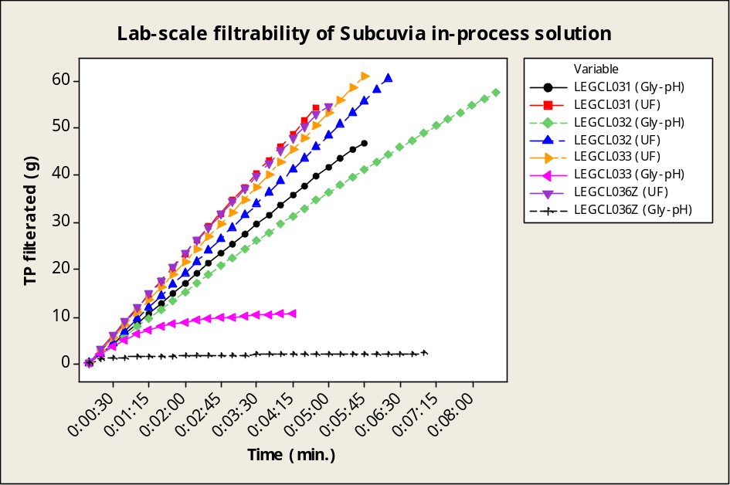

It can be concluded that there is a significant difference in terms of filterability between samples taken before and after pH adjustment. The protein samples collected at IN carter (i.e. LEGCL033 and LEGCL036 (Gly-pH)) experienced a reduction in flow rate as observed during the manufacture of Subcuvia S/D lot LEGCL033 and LEGCL036. These results further confirm the investigation performed in the frame of LE-CAPA-0047.
As per SOP LE-27-RSFT511, the protein solution is stabilized using 0.055 g of glycine per gram of protein. The solution is homogenized at constant mixing speed (i.e. 80%) and temperature (i.e. 6°C) for a minimum of 10 minutes. The resulting clear protein solution is further pH adjusted prior to the clarifying filtration. The final pH adjustment is performed using either 1N HCl or 1N NaOH prior to the clarifying filtration and briefly described in SOP LE09MP03061. This specific step is prone to operator/operator variability which could explain the observed difference in terms of filterability between samples taken before and after the final pH adjustment step.
As there is a significant difference in terms of filterability between samples of LEGCL033 and LEGCL036 after the pH adjustment, the operations performed during the final adjustment step were thoroughly investigated. As observed in Attachment#4, the mixing speed was dramatically reduced up to 10% during the pH adjustment using 1N NaOH and was constantly adjusted until the start of the final clarifying filtration (from 10% to 80% and from 80% to 0%). These observations confirm that the final pH adjustment step of Subcuvia S/D lots is the most likely root cause of these recurring events.

Based on the investigation, it can be stated that the most likely root cause of ER11/1223 is the final pH adjustment prior to the final clarifying filtration.

Product impact assessment
As the clogging material is exclusively made up of IgG proteins, it is concluded that the clogging and the subsequent filter replacement does not have any impact on the quality of Subcuvia S/D lot LEGCL036. The product quality of Subcuvia S/D lot LEGCL036 was therefore not affected by the use of eight (8) Sartobran filter cartridges to complete the final clarifying filtration. All testing results are satisfactory (Attachment#5).

Process/System/Equipment Impact Evaluation
There is no impact on the process, system or equipment as Sartobran filters are single use materials.

Conclusions
The investigation put forward that:
- All in process parameters – from first concentration to final clarifying filtration – were within the specified run sheet ranges;
- No other exception report, besides the exception related to the filter replacement, was issued during the upstream manufacturing of Subcuvia S/D lot LEGCL036;
- Lab-scale filtrations clearly showed that there is a significant difference in terms of filterability between samples taken before and after the pH adjustment;
- Mixing speed was dramatically reduced up to 10% during the pH adjustment using 1N NaOH and was constantly adjusted until the start of the final clarifying filtration. Therefore, the most likely root cause is the final pH adjustment of Subcuvia S/D lot LEGCL036;
- The clogging material was exclusively made up of IgG proteins;
- All testing results are satisfactory.
As the clogging material is exclusively made up of IgG proteins, it is concluded that the use of eight (8) Sartobran filter cartridges does not have any impact on the quality of Subcuvia S/D lot LEGCL036.

Attachments
N° | # of page | Description
1 | 1 | Tank (ELIV) weight trend during final clarifying filtration of lot LEGCL036
2 | 1 | SDS Page Electrophoresis results – LEGCL036
3 | 2 | In-process parameters from final adjustment to final clarifying filtration (LEGCL036)
4 | 1 | pH adjustment step of LEGCL036
5 | 1 | Testing results

