PARENT SIGNATUR.e

Ms. Pozzebon

ICS3U - Introduction to Cornputer Science

Unit O - Foundations

|  |  |  |  |  |  |  |
| --- | --- | --- | --- | --- | --- | --- |
| KNOWLEDGE | | THINKING | | COMMVN!CA'ffON | | APPLlCATfON |
|  | *')* /15 | L.- | /8 |  | l/) *19* | *9-...!:>* /5 |
| . | | |  | | | |

**Nan1e:** Alt/..

**Date:** rt-\? 1,*,j,.*

\

.***y***,

**KNOWLEDGE:**

**MATCHING** - **Use the scantrou provided to record your answers.**

Match the following **terrns** to their **definitions.** Fill in the bubbles for both letters (e.g.: for [ab] fill in the [a] and [b] bubble on the scantron).

**Terms:**

[9]

*&.--*

iaJlJ?-;d,oft e­

**-(ae)** Infbnnatlon •

fbej We,

,lad) I ltility Programs

**[bd)** Operating System

**-feel** Sourcet:ode

., -

**Definitions:**

*s* , , . - oc,

*'®*I. *ctb*

,

Marii(g'fs the c<;>mmunieati0n bet\veen the haFdware and applications. **a** 0; -1 **e**

Flash memory insicle yourc c@mputehr at pr0v1cles the necessary information for

your computer to wor,k. **l;::it'-0** \

*M_*

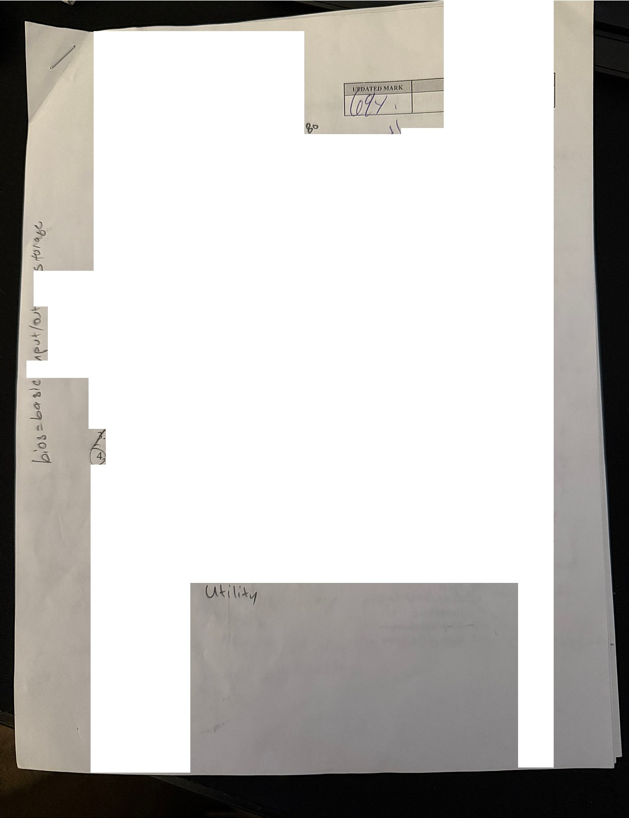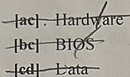

*I* A:t

f/- C.t..

/. *be+*

*fk*

*1*

·Physical parts of the computer.t( **1--f*4v,,tJ.r*** *(.*

Provides instructions to the c0mputer f0r specific **task g-f-,-\- o.f(l**

A collection of data like a complete mailing address.''t'l\ ofMta.ti"" A proguam written in a high-level language. **'5** \J **ICt *c JR***

Individual facts like first name, last name, address, city, postal code, country. 1J\Ot***lrct***

The unit of measure used to 1neasure the CPU's processing speed or cycles per He, 2- second.

Performs tasks related to the 1naintaining the health of the con1puter (i.e. hard\.vare, data).

1

**rd your answers and record your**

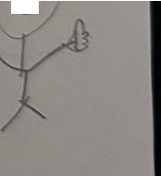

**MULTIPLE CliOlCE** - **Use the scantron provided to reco (5)**

**ans,vers on the test page.**

***[Jµ.."X.***

**yf_**\\'hich of the follo\ving is NOT a function of the Information Processing C c e?

*I*• *a)* )Hpttl-- o ,_,I!:" {i>' ' *<;*

**1" OutpUI. _1.v,.** I *I*



Graphics

e None of the above

***If·*** Who was the creator of the first 1nechan ical computer, the Analytrca . ngrne • • a Bill Gates

*'-. /*

_/, • IE • ??

) Charles Babbage

.._, Ada Lovelace

1. Steve Jobs
2. None of the above

1 /ALU stands for:

***r·***

*I* a Application Log.Upload

b) Arithmetic Logical Unit (,_­

Assembly Language Utility dl_ Activ;: beg-iA-Y-serl!T

¢:) ll-l0- tte of rt'ie a:t5ove r=

(;:;\What type of storage is required for data that is "filed away" for future use?

V -

\ **--Vii tnal"** , *¢*

j- r ! y () \ \ \$ -**j**

**1"' (y,**

d) Cloud *6 ('* **t,**

All of the above **V**

1 *I.*Which of the following types of memory is considered to be non-volatile?

d s

*f.* a) Flash **40'\**

*@* ;,ive I's Pe.*(*

... d) A I ef the aae •e *(/*\ \ \

...-e) Noneoftheabove

2

**COMMUNICATlONi** /\ns"ver the following questions in complete sentences

1· Describe the differenee between systc1n sofnvarc and application software. Provide

one ex mp\c:reach to support you,answcr. - • /t4J

,s d'.ti *i t* /.t •,,

Slce.,,"1 *,i* Jr\.J. Co""\".,,e1, I<\IC e *Of* .r.. , **o,** li *1•* 1\

\ s .f\,J! t• t""" l,4-\" rvII *o* ,t,,,.i. *C,Q* t • 'Sy *.9\C* "" ; *s*

u,' roP•...i. *tJA I fl,,12 1*"81!. *i,.at1*1 '- *.COc w*:*rdP* ..,t • Ai;>t \ *a,,.r\\o,,*

/11t:. µ:11.t --- *yov '-ovlP* ., se *"-f"al ('l""Y-* A c,1,1\,-.

**t/V** *N*t*I*

91" l *oJf*f *v-* ._,. *t-<> W"* r-!C. *5'0,..a* "-i(1*ea ;*.,, 9oft *wa* t •.. *c"* • ""

***[vi' ,t)I'* cQ(kA:-1\ S ve.,-411.('l, f""-01'-4.. 01' c.,Vt *Ah..vf* (\,\_,A** (_ ***WI'* ,f./\._.,.._**

**l..}J\f\(AOW** $ ":.> /_..21.**fl.V**In your op1.n1. on, wh.ich 1. s the best OJ!)erating system? Compare it to another one. **[5]**

**i-t e. vtty** *..f'Q*0r *fV* • **fvf *MO{Q***

***<1dlt1-111J.;* beji *n"'5 N'i* r iJIIPl**•

*e;*e_r;y ***e. y*** *,1--o* ***s*e** f d"'

\s lvo,se I be *c se*

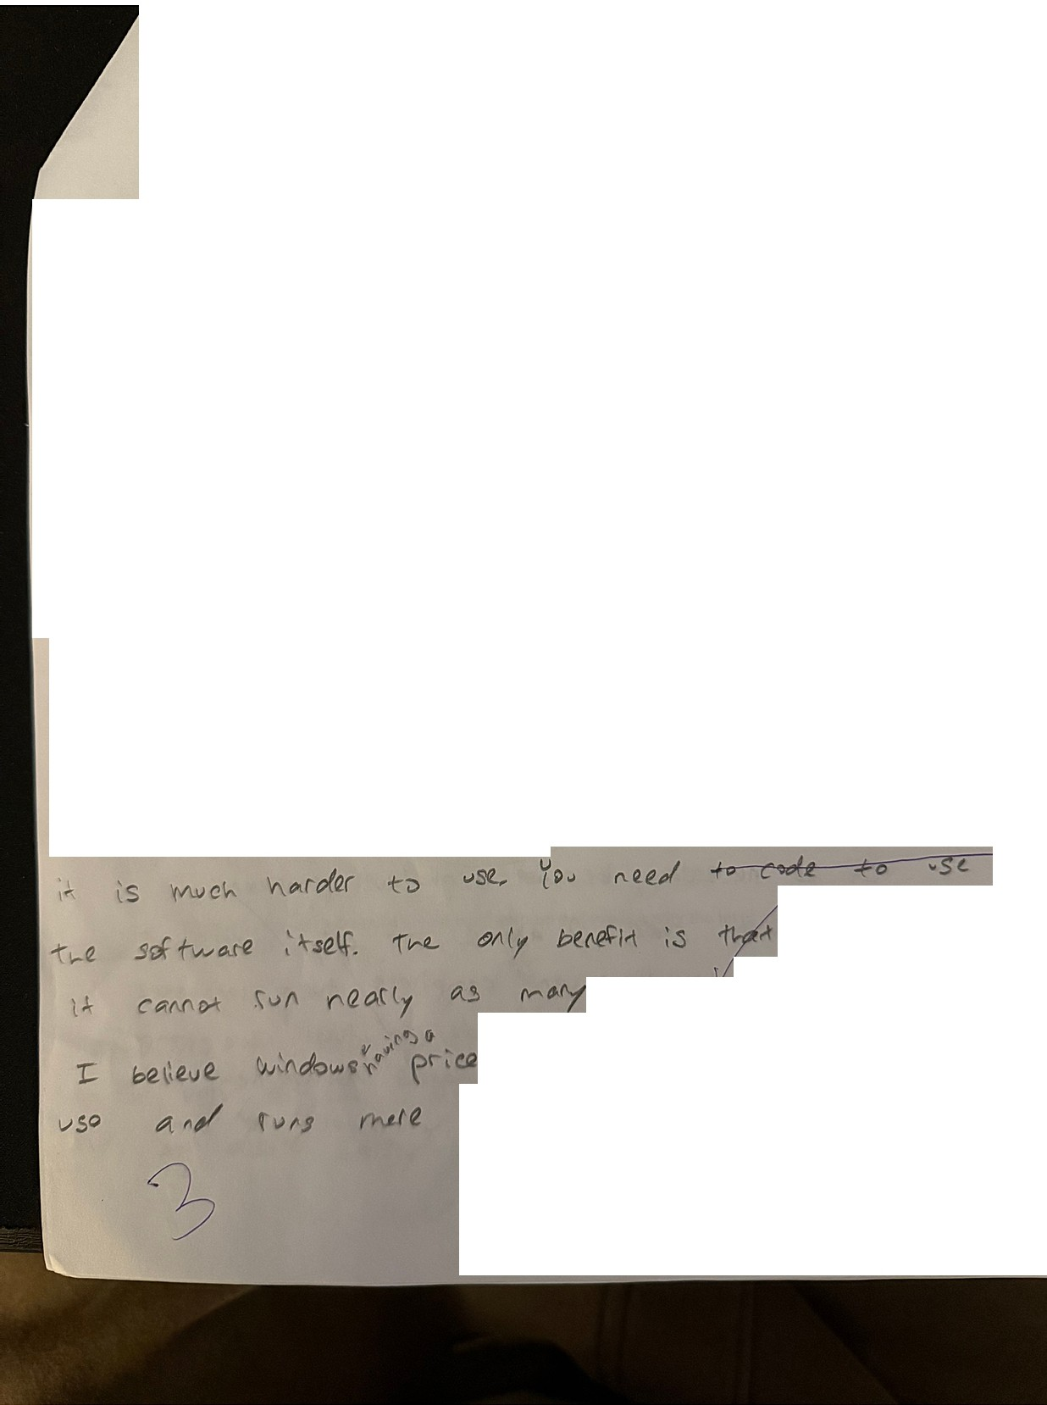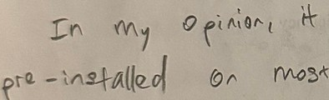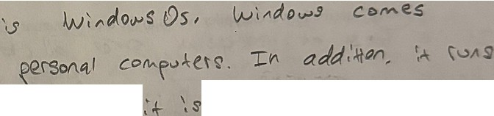

t'\' tee., '='""'"

f *,O*cjr *alV* J *.a w f\ o/****o* u.,,** ...

*ts* .suiet; *Ct"'*

*1*

*'If (,'t"lf'f* bW'S.

3

1. Describe ho,¥ an l1 reter "vorks wit'h Source Code

:r-+ ***d* ,S** \ l' ***('.Fl,* b***1* l\ **l\.rl** *I* ***r,.J C f'l***

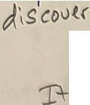

e,,ct **s***<* ***e. s .e.(*** t:> .fl" ***-S\' et*** *fA.Q te.e\lP* •

6 Describe ho , an Interpreter works in the area of emory Efficiencx

ig 5,9w *cxk* f.r,oc.es i/\j,• lf\te (ll'a ***1,1*** ·, , s7

[I]

[1]

I



*-to* t:*rrJ e,C[Qt'J* o.to/\b f *1.)-J* ..

(

3. Describe how a Con1piler works with Source Code 1]

*:r.r* J'cs*e.*e,(-s cJ;iatQ *coh OJtt:y /,t,1.Jc,fci.y* al\ *at-* **'3(1** ( **t**

/ *an.II '-*

r **'1** +-et*C::".s* C\J ,{ *(Vl()di, -:r+r l,,.ov,eve.t)*

**!$)fl**

*I*

*cl{JQ.*

r'l¢ rt ***wh,1tf?*** */ }'9t-* ***A* g**

\,-<t,-.... Describe how a Compiler works in tine area of Memory Efficiency

'"""' it- **roeeJ-61 ,, *a****-****t****:;{:,.0..._«-+-***Qne_e_**

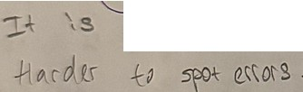

# [1]

•



·/

5. Why did the arrival of high-le interpreters and compilers?

1 programming languages m . e it necessary to create

# [4]



'&V'bV t

beea. l -(euet f'°Ofi

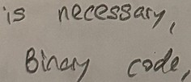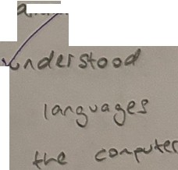***0 1ttl 1,J*** *I* ***0;***

**/Y\A1,,vf\**

*b>.,.* C Mft>kets. -rhe.

w( *Cr,.,..* **.$fte:t***'(* **or**

<' A et te.."e.,.s

evt" I12 r fl

*r.d* **CO""- \.l('S** +ur-- *(*

-1.:0 *cod.i1*

*ft.."* ***t"l 4*** *iov c* '

*cor/.l-.*

*IJ.s*

*o* te,{S





**IHINKING:** Answer the following questions in co1nplete sentences

4

**APPLICATION:** Answer the following questions incomplete sentences



The followingt·ypes of co111puters are listed fro1n lowest to the highest level of processing power:

i) personal co111puter ii) n\ainfra1ne iii) supercomputer

)9_ ,,,,.,._ ***fA,/rl,J.\kt-...1,*** ,.....,. , f **ltvt-**



1. List and desc.-ibe the th•·ee (3) factu,s used to dewm ine the power ofa computer. [3] r *1:,*

,; ***L ti***- , :f"tiS¼r' "' be\+£ t, 'SL**o** wer " "-'•Is e ( y\,)lt" *"'"""f.lr' i,.,,,,I( )*

5.fotek t -;, *11°-* """ *C"-* 1, , *....kW"* J.t- *('"'* Si-,,,. .,. *Ol'*

I?l-\ \:¥ '- /{o.., *"'eCu*I 'l. *e* °"""r-''°e\ I • 's

S "- **ho""** -£***a*** \ **et• f.1**,**\ S oro.:it,** ,.._,,..,. l,¾o ,,_.ioo 1"' - "•'"•

(2..e,t. lo1l'. , \.-,,_ov-i !,/ "-!'\ *A"i* ur te "l".a t(.

2P.ersonal Cotnpute-r describe the pritnary purpose and explain why thelevel of processing

power it possesses is sufficient. [ 1]

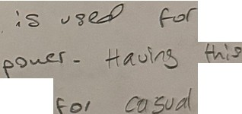***/Jt;p,I*** *t"0* ***aa:zm* +"-L** )1-- \{l.e\ *I* flA-1 8,.,,&, ***a ,..o(***

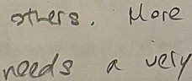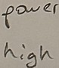



*\3*

F->:'er *C,A.f'* b C "- e.., , *ti et\.l)v0* s. et

b1 s, J *,,rJt.1.\\ ()tMJS* •.-{_oll¾.

*!·* Super Computer - describe the primary purpose and explain why the level of processing po,ver 1t possesses is sufficient. [1]

"[he..

f'''

MA.ty

;5 ,8)

*f1Ad*

*('(l (tr* C OA--fle' ,-

*(X'o QM.3 ./n et0{ve,,, t,/ce* **t..ve** er *fore cqs l St"'-Ce -<'-eads*

*f-o v€cy* (?('oftr1e,. fJAfA- *f'Ood.9* t' *,k for cttf(v(-..A(* f\!) p (

***A11I*** *f?* ***(;(19v(€..*** *.s iy oF* Adt0 A *pt,J* "-*'s t,'vei-*

5

\