A comparison of two New Zealand politicians’ tweets

Robin Morgan

7 October 2019

# About me

I am Robin Morgan. I am from Wanaka, a beautiful town in the South Island of New Zealand. I am a first year student pursing BAppSc degree in Data Science, with a minor in Management. The papers I am taking this semester are:

* COMP120 - Practical Data Science
* COMP101 - Foundations of Information Systems

# Scope of this report

This report is a part of an asssessment in COMP120. This report demonstrates my understanding of the use of R Markdown. For this purpose, I will be presenting an analysis of Jacinda Ardern’s and Winston Peter’s tweets. The provided dataset contains a total of 3196 tweets from Jacinda Ardern and 2533 tweets from Winston Peters. In total, there were 5729 tweets in the combined dataset called *tweets*.

This report is organised as follows. The next section presents three types of analyses conducted. The last section concludes the report.

# Timeline analysis

In this section, first the results of combined tweet counts of all tweets from both politicians are presented. Next, comparative counts of original tweets (i.e., excluding retweets) of these two politicians between 2013 and 2018 are presented. Finally, the number of URLs in original tweets for the same time period is presented (i.e., excluding retweets).

## Combined counts of tweets

The code below produces a bar graph of the counts of tweets from Jacinda Ardern and Winston Peters. To do: describe what the axes represent.

tweets$year <- as.factor(year(tweets$created))  
ggplot(tweets, aes(x = year, fill = year)) +  
 geom_bar() +   
 ggtitle("Tweets per year") +  
 xlab("Year") +  
 ylab("Count")

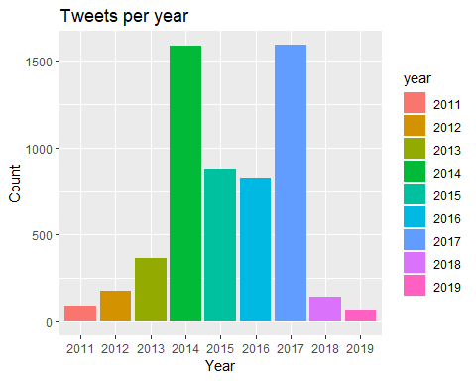

The graph above shows that the maximum and minimum number of tweets posted in a year were 1593 and 68, respectively. The graph also shows … (To do: describe the patterns you see in this graph).

## Comparative counts of tweets between 2013 and 2018

To do: describe what the graph below is about and the patterns you see.

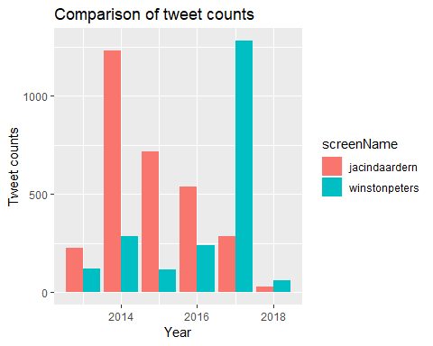

## Comparative counts of URLs in tweets between 2013 and 2018

To do: describe what the graph is about and the patterns you see.

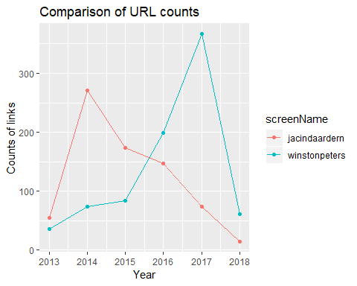

# Conclusion

To do: write an appropriate conclusion based on what you inferred from your preliminary analyses above.