Alex Spence
Milestone 2
Draft White Paper (Project 1)
Why Do Patients Come Back Within 30 Days? A Practical Look at Predicting Hospital Readmissions with Real Data
Business Problem
Hospitals in the United States face substantial financial penalties when too many patients return within 30 days of discharge. More importantly, these unplanned readmissions often indicate gaps in post-discharge care, such as inadequate medication reconciliation, lack of follow-up, or unaddressed social needs. Healthcare teams need a reliable, interpretable way to identify high-risk patients at the point of discharge so they can provide targeted interventions like follow-up calls, home health referrals, or medication reviews.
Background and History
Since Medicare introduced the Hospital Readmissions Reduction Program in 2012, 30-day readmission rates have become a key quality metric. The traditional LACE index (combining Length of stay, Acuity, Comorbidities, and Emergency visits) remains widely used because it is simple and hand-calculable, but systematic reviews show it typically achieves AUC values only around 0.65–0.68. More recent machine-learning studies on public datasets have reported modest improvements, often in the 0.66–0.70 range, highlighting the inherent difficulty of the problem with historical data.
Data Explanation
The analysis uses the publicly available Diabetes 130-US Hospitals dataset from the UCI Machine Learning Repository, covering 101,766 hospital encounters between 1999 and 2008. The raw dataset contains 50 features, including demographics, admission details, lab tests, medications, and diagnosis codes.
Extensive preprocessing was performed: questionable values were replaced with NaN, high-missing columns (weight, payer code, medical specialty) and identifiers were dropped, age was converted to midpoints of bins, and a binary target was created for readmission within 30 days (11.4% positive class). Patients who died or were transferred to hospice were excluded to avoid data leakage. Categorical variables were one-hot encoded, and diagnosis codes were grouped into broad clinical categories to reduce cardinality. The final cleaned dataset contains 99,280 encounters and 110 features.
Methods
The dataset was split 75/25 with stratification. A recreated approximate LACE score served as a clinical baseline. XGBoost was selected as the primary model due to its strong performance on tabular healthcare data. Training used early stopping, class weighting to address imbalance, and moderate regularization. Model interpretability was provided through built-in feature importance and SHAP values.
Analysis and Results
The XGBoost model achieved an AUC-ROC of 0.661 on the hold-out test set. This result aligns closely with published benchmarks on the same dataset, where reported XGBoost AUCs typically range from 0.66 to 0.67.
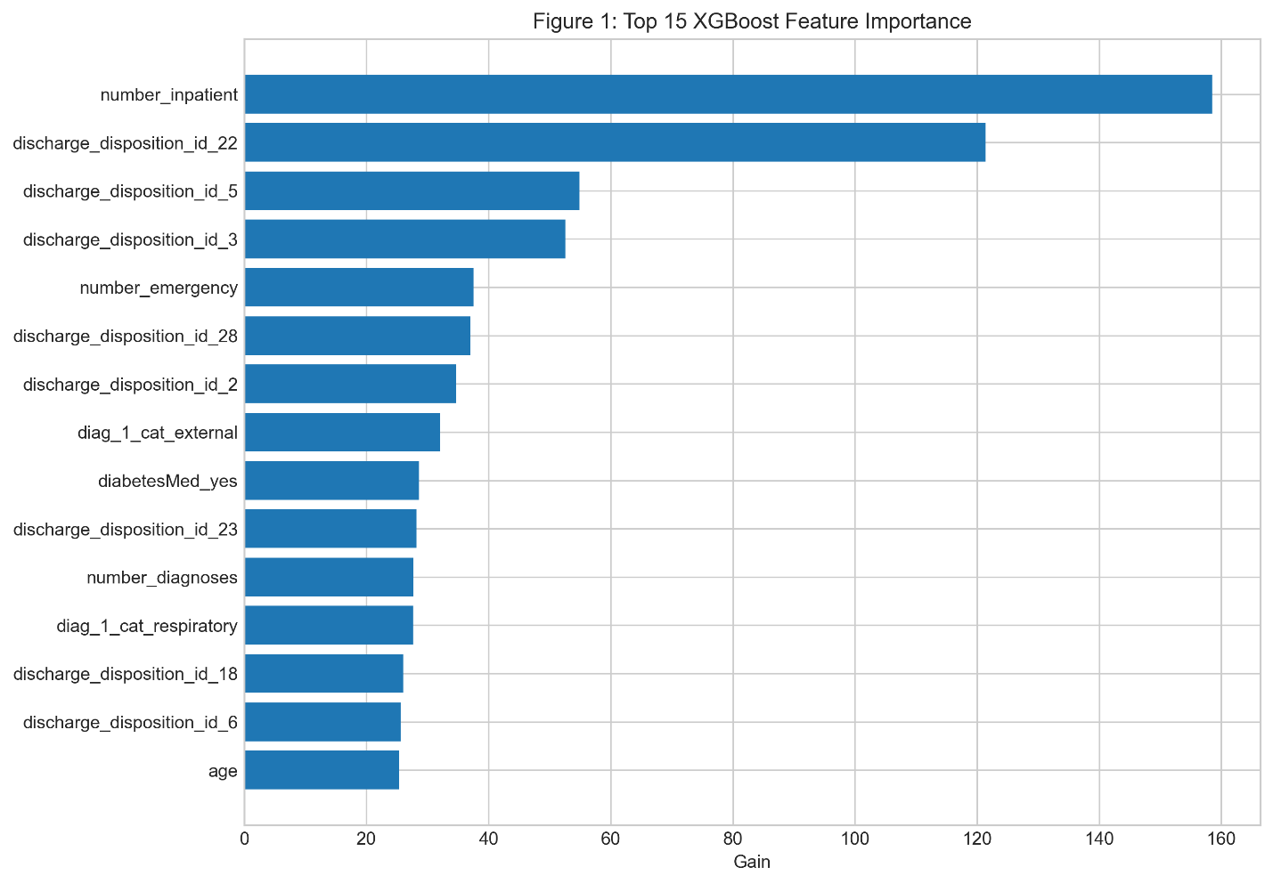
SHAP analysis identified the strongest predictors as number of prior inpatient visits, medication changes during the stay, discharge disposition, number of emergency visits in the previous year, and total number of medications. These findings reinforce known clinical risk factors while quantifying their relative impact.
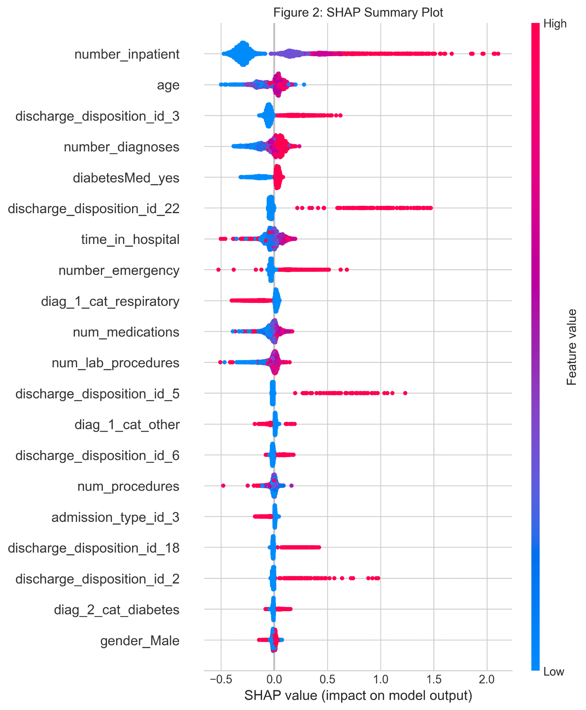
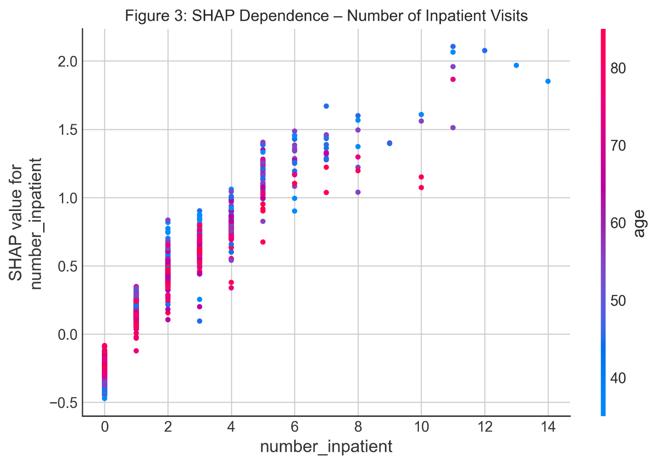
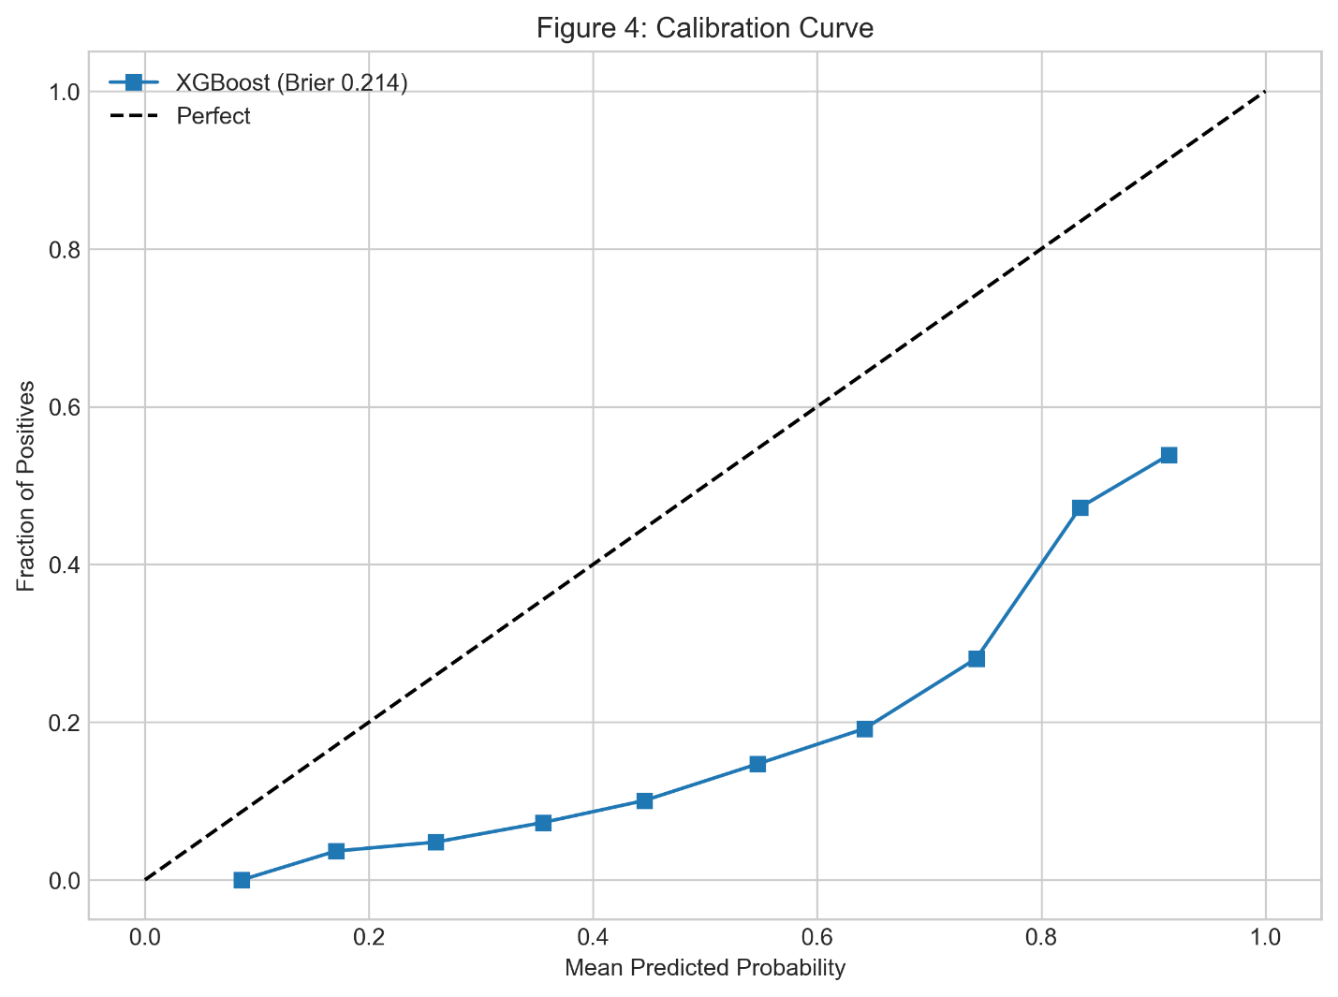
Conclusion
Even with modern machine learning, predicting 30-day readmissions remains challenging on this historical dataset, with performance only modestly exceeding traditional clinical indices. However, the model confirms actionable drivers of risk and provides clear, interpretable insights that could guide targeted interventions.

Assumptions
Historical readmission patterns remain relevant for identifying risk factors, and features known only at discharge (such as medication changes) are legitimate for prediction at that time point.
Limitations
The data is more than 15 years old, collected before widespread electronic health record adoption and major policy changes. It includes only encounters involving diabetes diagnoses, limiting direct generalizability to other high-readmission conditions.
Challenges
Cleaning required careful handling of encoded missing values and high-cardinality categoricals. Avoiding data leakage from discharge dispositions proved critical, resulting in removal of several thousand rows.
Future Uses and Additional Applications
The insights could inform simple risk-stratification rules for discharge planning. With access to contemporary local hospital data, the model could be retrained and validated prospectively. Incorporating social determinants from census data would likely improve performance.
Recommendations
Automatically flag patients with multiple prior inpatient visits or medication changes for enhanced discharge planning and early follow-up. Integrate a simple risk score into discharge summaries to prompt clinical review.
Implementation Plan
The final week will focus on polishing visualizations, completing the Streamlit risk calculator demo, and preparing a 10–12 minute recorded presentation walking through the analysis and live tool demonstration.
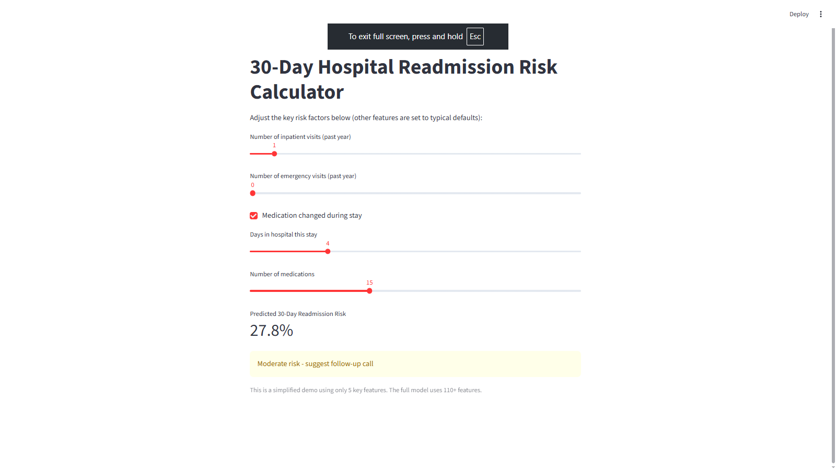
Ethical Assessment
Fairness checks showed comparable AUC across racial groups.
Appendix
Full post-cleaning data dictionary, hyperparameter details, and additional diagnostic plots.
10 Questions the Audience Will Probably Ask
- Why is the AUC only 0.661 — is the model not working well?
- How does this compare to the original LACE score on the same data?
- Did you try other models like random forest or neural networks?
- Is “number of inpatient visits” just memorizing frequent flyers?
- How reliable are these results on modern patient data?
- Did you check for bias across race or gender?
- What threshold would you use in practice for flagging patients?
- Why did medication change rank so highly?
- Could this be deployed in a real hospital system?
- What single change would most improve performance?
Code Repository
All notebooks and the Streamlit application are available in a public GitHub repository: https://github.com/alexspence777/DSC

