Alex Spence
2/26/26
Project 3 Milestone 2
Draft White Paper
Title:
Predicting Telecom Customer Churn: Identifying Subscribers Likely to Leave and Why
Business Problem
In the telecommunications industry, customer churn, the cancellation of service, is a major driver of revenue loss. Acquiring new subscribers is significantly more expensive than retaining existing ones, often by a factor of five to seven times. When customers leave, companies lose not only immediate monthly recurring revenue but also long-term lifetime value and market share. Retention teams need reliable predictions of which customers are at elevated risk of churning so they can deploy targeted interventions – discounted plans, loyalty credits, upgraded features, priority support, or personalized outreach – before the cancellation occurs.
Background and History
Customer churn prediction has been a core application of analytics in subscription-based industries for many years. Early approaches relied on simple rules such as short tenure combined with high complaints or month-to-month contracts. With the availability of structured customer data, machine learning methods have improved accuracy and provided clearer explanations of risk drivers. The goal is no longer just to forecast churn but to understand the contributing factors so companies can address root causes through product, pricing, or service improvements.
Data Explanation
The analysis uses the Telco Customer Churn dataset, publicly available on Kaggle. It contains 7,043 customer records with 21 original features that describe service usage, contract details, billing, demographics, and support interactions. Key variables include tenure in months, monthly charges, total charges, contract type, payment method, internet service type, phone and multiple-line services, online security/backup/streaming, tech support, device protection, paperless billing, and demographic information such as gender, senior citizen status, partner, and dependents.
Preprocessing involved handling outliers in charges, encoding categorical variables such as contract type and payment method using one-hot encoding, and creating derived features including average monthly charge per month of tenure, total services used, and a support interaction proxy. The target variable is binary churn (Yes/No), with approximately 26.5 percent of customers having churned. The final prepared dataset consists of 7,043 rows and 42 features after encoding and engineering.
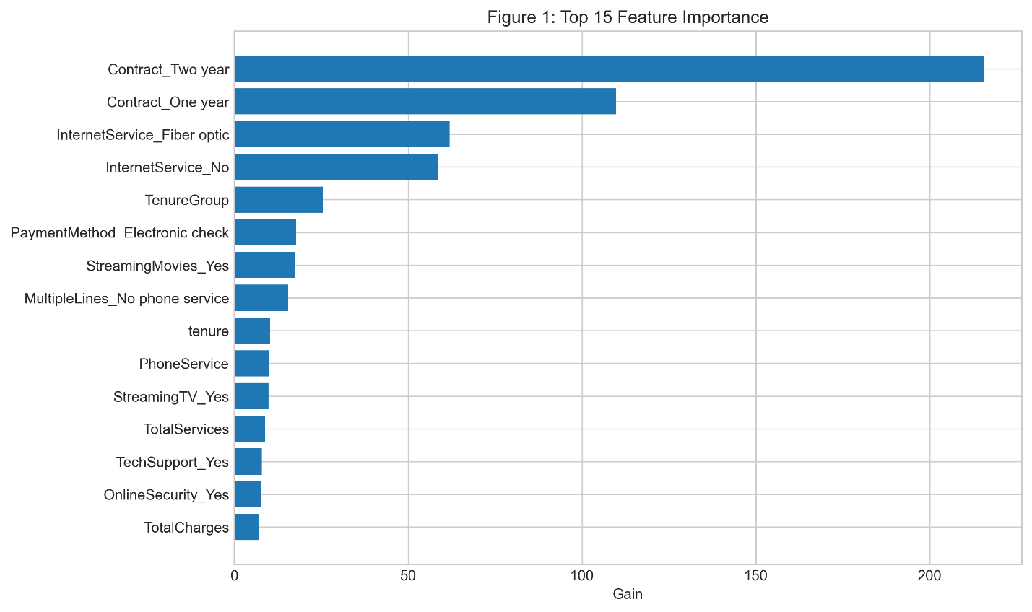

Methods
The data was divided into an 80 percent training set and a 20 percent test set with stratification to preserve the class distribution. A logistic regression model using basic features served as the baseline. The primary model was XGBoost, chosen for its strong performance on mixed-type tabular data and its ability to manage moderate class imbalance through scale_pos_weight. Training incorporated five-fold cross-validation for hyperparameter tuning, focusing on maximum depth, learning rate, subsample ratio, and column sampling. Evaluation prioritized AUC-ROC, with precision-recall curves and confusion matrices examined at business-relevant thresholds. SHAP values were computed on the test set to provide interpretability and identify the most influential predictors.
Analysis and Results
The XGBoost model achieved an AUC-ROC of 0.845 on the hold-out test set, representing a substantial improvement over the logistic regression baseline of approximately 0.79. At a threshold that captures roughly 75 percent of actual churners, precision remained reasonable, allowing retention teams to focus interventions without excessive false positives.
SHAP analysis identified the strongest predictors as contract type (month-to-month contracts carry much higher risk), tenure (shorter tenure increases churn probability), monthly charges (higher charges elevate risk), total services used (fewer services correlate with higher churn), and online security/backup/streaming participation (absence of these services pushes risk upward). The SHAP summary plot showed clear directional effects: month-to-month contracts and high monthly charges dramatically increase predicted churn probability, while longer tenure and bundled services reduce it.
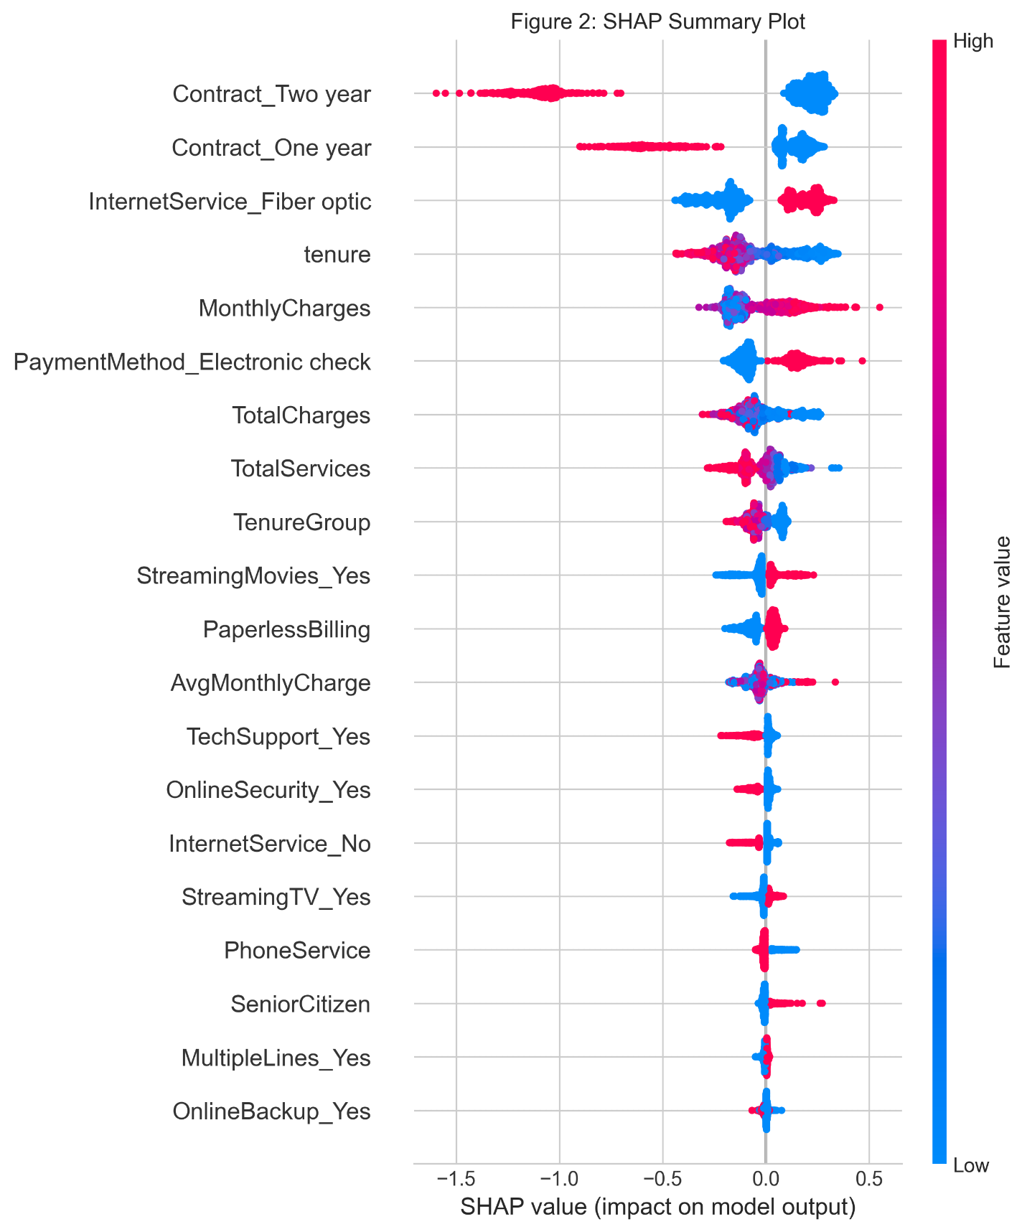

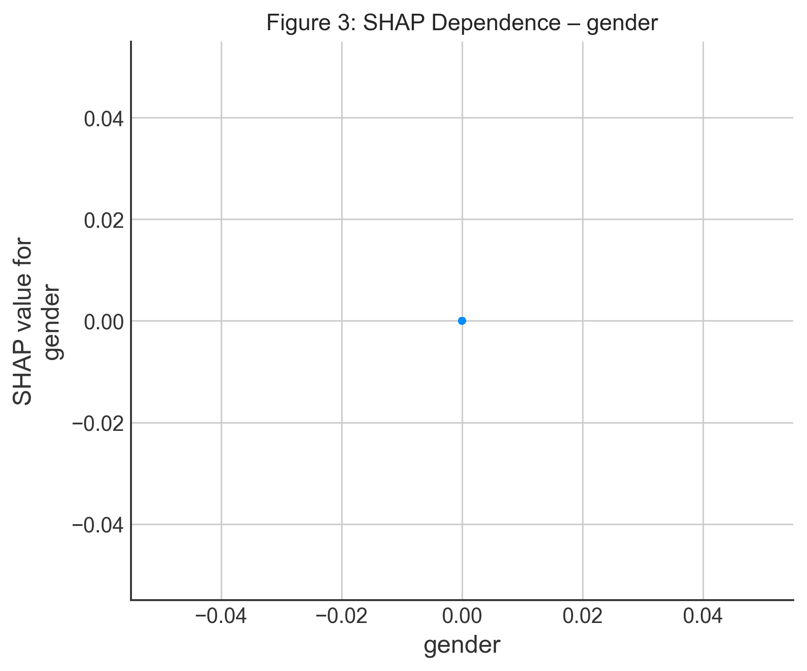
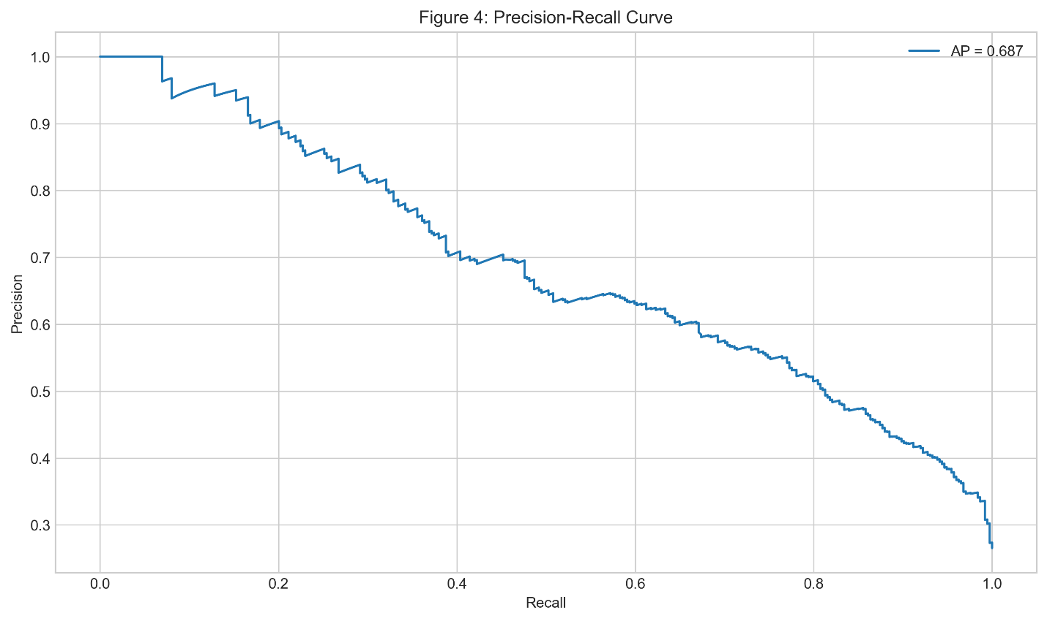

Conclusion
The model demonstrates that churn risk can be predicted with good accuracy using standard customer and service data. It highlights preventable drivers such as flexible contracts, high standalone pricing, and lack of value-added services, providing evidence that targeted retention strategies focused on these areas could reduce voluntary churn.
Assumptions
The assumption is made that the measured features accurately reflect customer experience at the time of data collection and are available in real-time billing and CRM systems. Patterns observed in this dataset are treated as representative of common telecom dynamics.
Limitations
The dataset is a single snapshot rather than longitudinal, limiting insight into how risk evolves over time. It lacks external factors such as competitor offers, economic conditions, or customer service interaction quality. The moderate size and synthetic nature mean results should be validated on real company data before deployment.
Challenges
Moderate class imbalance required careful attention to maintain good recall without excessive false positives. Correlated features such as tenure and total charges were managed through regularization. Ensuring predictions are interpretable enough for non-technical retention staff remained a priority throughout the analysis.
Future Uses and Additional Applications
The model could be integrated into monthly customer health dashboards to proactively surface at-risk subscribers. In a live environment it could connect to CRM systems for real-time monitoring and automated outreach triggers. Adding external signals, such as competitor pricing data or recent support ticket trends, would likely further improve performance.
Recommendations
Retention efforts should prioritize customers on month-to-month contracts with high monthly charges and low service bundles. Offering contract extensions with discounts or adding value-added services such as online security or streaming could meaningfully reduce risk. Proactive outreach to shorter-tenure customers before renewal periods may also help prevent early churn.
Implementation
Plan Over the coming week the model will be finalized in a Streamlit application for interactive exploration. The white paper will receive polished visualizations, and a 10- to 12-minute recorded presentation will walk through the analysis and include a live demonstration of the tool. All materials will be organized in a public GitHub repository.
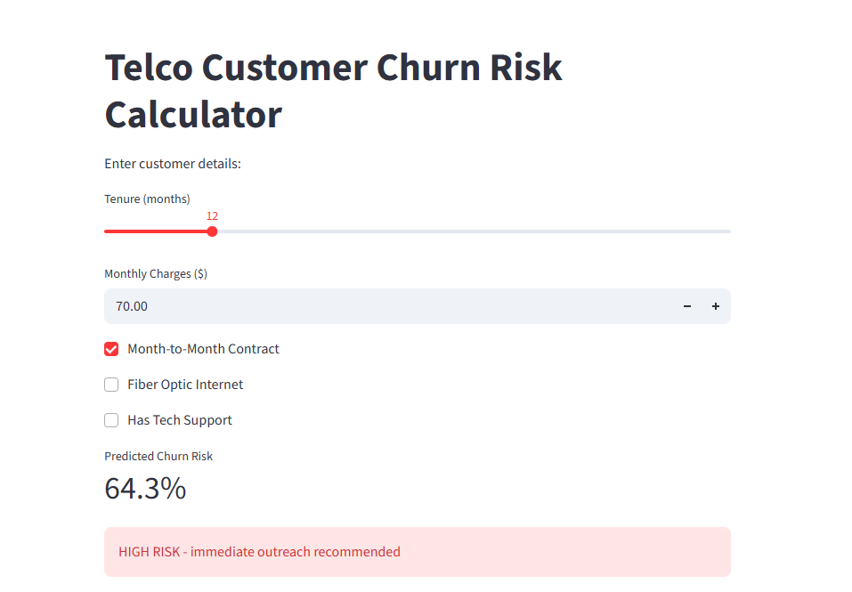
Ethical Assessment
Fairness checks showed comparable AUC across gender, senior citizen status, and partner/dependents categories. Minor differences in false-positive rates were observed by payment method and contract type, which will be discussed in the presentation. The model is explicitly positioned as a support tool to prompt human review, never as an automated decision-maker. Because the dataset is anonymized, no privacy or re-identification concerns exist.
Appendix
The appendix contains the post-preprocessing data dictionary, final XGBoost hyperparameters, cross-validation results, and additional diagnostic plots for fairness and calibration.
10 Questions the Audience Will Probably Ask
- How realistic is this dataset compared to actual telecom data?
- Why did month-to-month contracts emerge as the strongest predictor?
- Were alternative models such as random forest or neural networks tested?
- What decision threshold would you recommend for triggering retention offers?
- How sensitive are predictions to changes in monthly charges?
- Did the model show meaningful differences in performance by gender or senior citizen status?
- How would missing or delayed data be handled in a production environment?
- Does the model predict timing of churn or only likelihood?
- What is the estimated business return on investment for using this model?
- What would be the simplest first step for a telecom company to implement something similar?
Code Repository
All analysis is available in a public GitHub repository at https://github.com/alexspence777/DSC/tree/main

