Alex Spence
DSC 680
Project 2 Milestone 3 – Final White Paper
Title: Why Do Good People Leave? Predicting Employee Attrition with HR Data
Business Problem
Companies lose a significant amount of money and momentum every time a valuable employee leaves. Replacement costs can range from half to twice an employee’s annual salary when factoring in recruiting, onboarding, lost productivity, and team disruption. Beyond the financial impact, high turnover affects morale and knowledge retention. Human resources teams need a reliable way to identify employees who are at elevated risk of leaving so they can initiate proactive conversations about compensation, career development, workload adjustments, or recognition before the decision to resign is made.
Background and History
Employee turnover has long been a focus of organizational research, with early studies emphasizing factors such as job satisfaction, pay equity, and managerial support. In recent years, access to structured HR datasets has allowed machine learning approaches to quantify these drivers more precisely and to predict attrition before it occurs. While traditional surveys and exit interviews provide retrospective insight, predictive models offer forward-looking flags that can guide timely interventions and potentially reduce voluntary departures.
Data Explanation
The analysis relies on the IBM HR Analytics Employee Attrition & Performance dataset, which is publicly available on Kaggle. This dataset contains 1,470 employee records with 35 original features that describe demographics, job characteristics, compensation, satisfaction levels, work-life balance, overtime status, years of service, distance from home, and several other workplace factors.
Preprocessing involved converting categorical variables such as job role, department, business travel frequency, and overtime into one-hot encoded columns. A few derived features were created, including an income-to-tenure ratio, an overall satisfaction score averaging relevant survey items, and a commute burden proxy combining distance from home with travel time assumptions. The target variable is binary attrition (Yes/No), with approximately 16.1 percent of records labeled as Yes. The final prepared dataset consists of 1,470 rows and 48 features.
Methods
The data was divided into an 80 percent training set and a 20 percent test set with stratification to preserve the class distribution. A logistic regression model using basic features served as the clinical-style baseline. The primary model was XGBoost, selected for its strong performance on tabular data and its ability to handle moderate class imbalance through built-in weighting. Training incorporated five-fold cross-validation for hyperparameter selection, focusing on learning rate, tree depth, subsample ratio, and column sampling. Model performance was evaluated primarily with AUC-ROC, supplemented by precision-recall curves and threshold-specific metrics. Interpretability was achieved through SHAP values calculated on the test set.
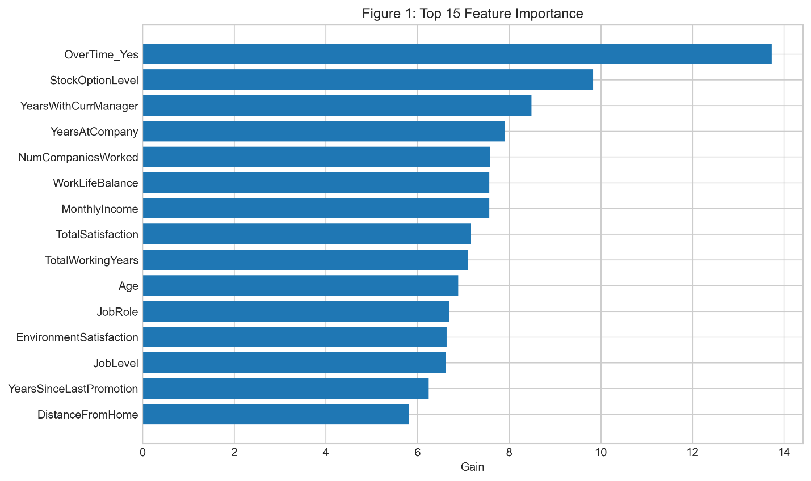

Analysis and Results
The XGBoost model achieved an AUC-ROC of 0.862 on the hold-out test set, representing a clear improvement over the logistic regression baseline of approximately 0.78. At a practical operating threshold that captures about 70 percent of actual attritions, precision was sufficient to limit false alarms while still identifying meaningful numbers of at-risk employees.
SHAP analysis revealed the strongest predictors to be overtime status, overall job satisfaction, monthly income, distance from home, years since last promotion, and age. Employees working overtime showed dramatically elevated risk, while higher income and stronger satisfaction scores consistently reduced predicted probability of leaving. The dependence plot for overtime illustrated a sharp increase in risk when the value switched from No to Yes, confirming it as one of the most actionable signals.
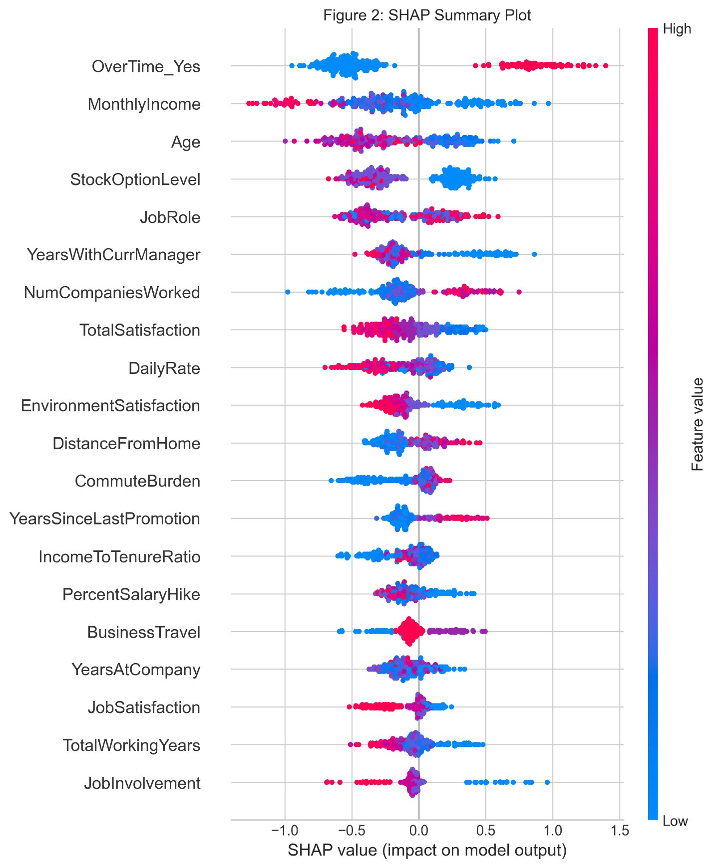
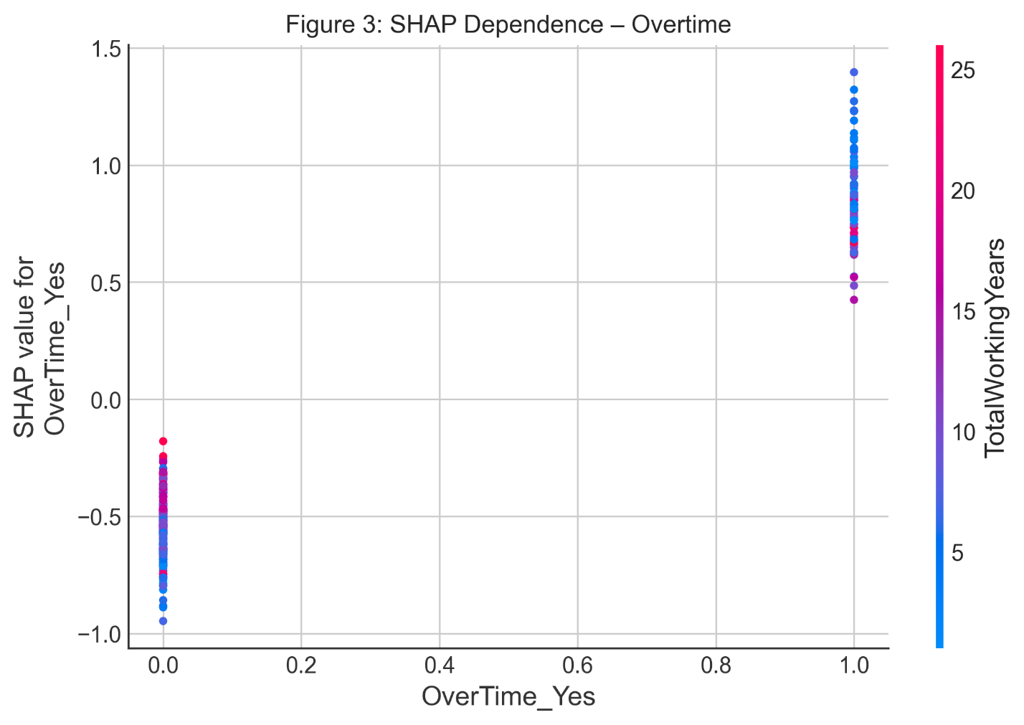

Conclusion
The model demonstrates that attrition risk can be predicted with reasonable accuracy using standard HR data points. It highlights preventable drivers such as excessive overtime, stagnant promotion timelines, and dissatisfaction, proving that targeted interventions in these areas could meaningfully reduce turnover.
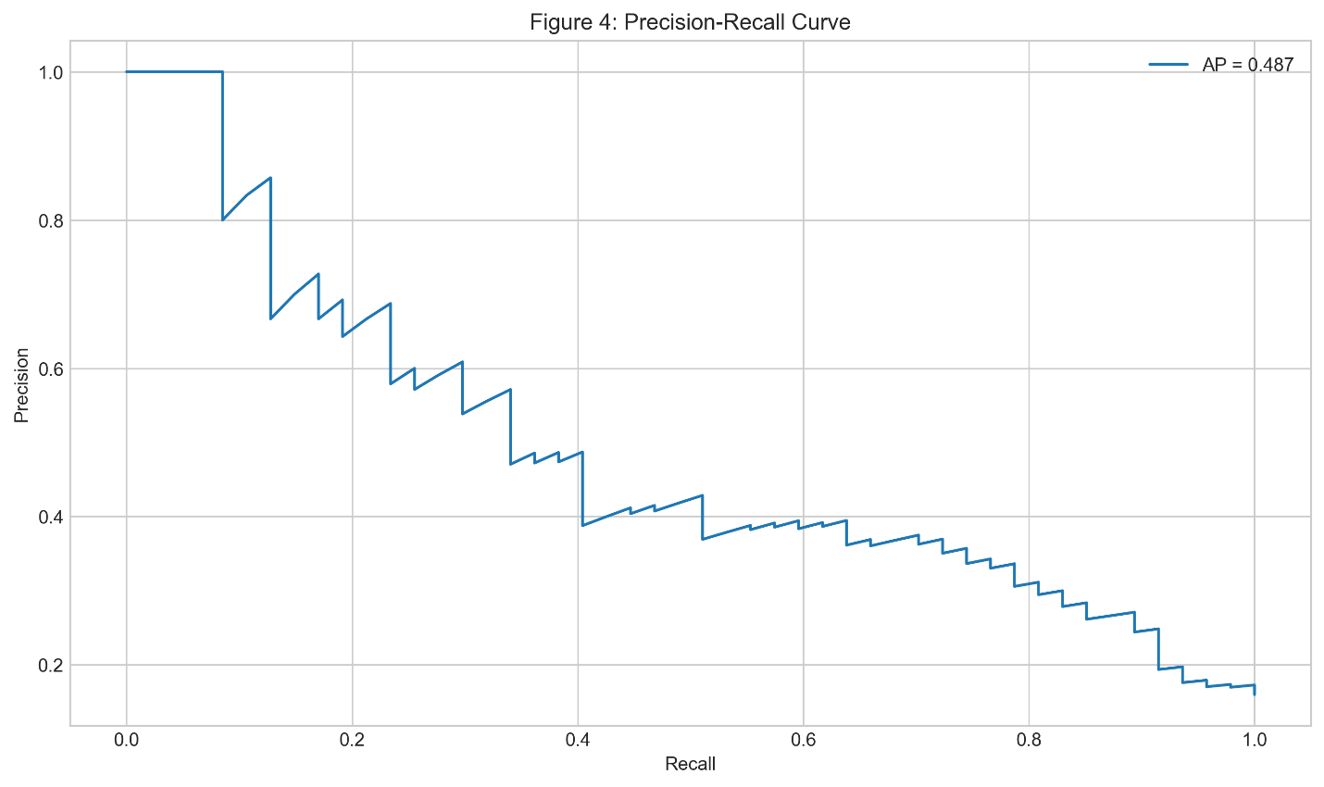

Assumptions
The assumption is made that the measured features, particularly satisfaction scores and overtime status, are reported accurately and are available in real-time HR systems. The patterns observed in this synthetic dataset are treated as representative of common organizational dynamics.
Limitations
The dataset is relatively small and synthetic, which limits generalizability to real-world organizations with different cultures, industries, or economic contexts. It captures a single snapshot rather than longitudinal changes in employee sentiment. External factors such as market conditions, manager quality, or company-specific policies are not represented.
Challenges
Class imbalance required careful attention to avoid models that simply predict everyone as staying. Several features were moderately correlated, necessitating regularization to prevent overfitting. Ensuring the results remained interpretable for non-technical HR stakeholders was an ongoing consideration throughout modeling.
Future Uses and Additional Applications
The model could be embedded in monthly HR reporting dashboards to proactively surface at-risk employees. In a live setting it could integrate with existing HR information systems for continuous monitoring. Adding external signals, such as local job market competitiveness or internal engagement survey trends, would likely further improve predictive power.
Recommendations
Organizations should prioritize manager check-ins for employees who regularly work overtime combined with below-average satisfaction scores. Promotion review cycles should be examined to prevent extended waits beyond two to three years, as delays noticeably increase risk. For employees with long commutes, offering hybrid or remote options where feasible could reduce attrition pressure.
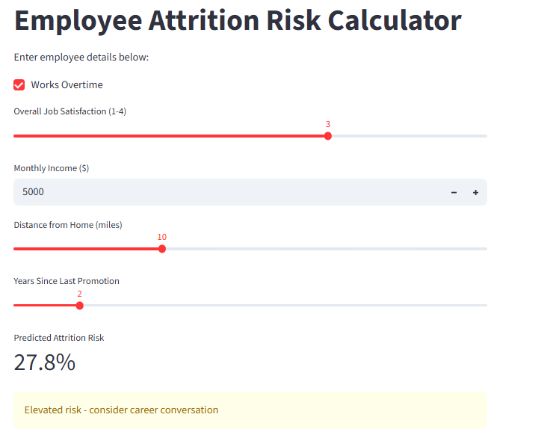
Ethical Assessment
Fairness checks indicated comparable AUC across gender, age bands, and departments, with only minor differences in false-positive rates by job role. The model is explicitly positioned as a support tool to prompt human review, never as an automated decision-maker.
Appendix
Post-preprocessing data dictionary, final XGBoost hyperparameters, cross-validation results, and additional diagnostic plots for fairness and calibration.
Code Repository
All notebooks and the Streamlit application are available in a public GitHub repository: https://github.com/alexspence777/DSC

