(x, y, width, height)

total frame should be 950x750

unless otherwise specified, use the generic panel layout

coordinates are relative to the lowest level panel that they’re under

text coordinates are approximate for now; futz until they’re right and make them consistent with each other

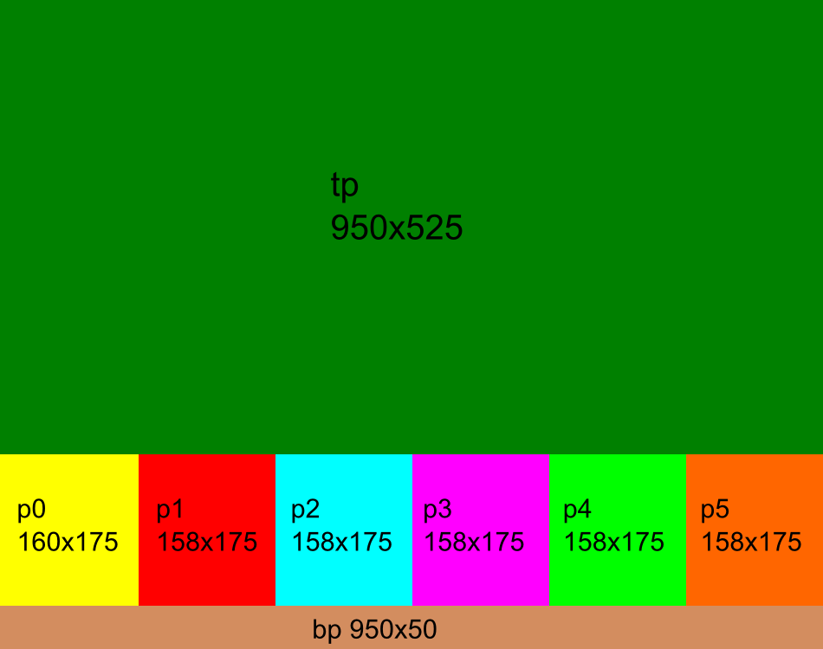

* Start screen (single panel that fills the frame)
  + Background - startscreen.png
  + Quit button – (13, 708, 166, 35)
    - hover – quithover.png
  + Load button – (592, 708, 166, 35)
    - hover – loadhover.png
  + New button – (773, 708, 166, 35)
    - newhober.png
* Game setup
  + tp – gamesetup.png
    - background – gamesetup.png
    - arrow – uparrow.png
    - difficulty arrow – (x, 237, 45, 24); x = [173, 452, 735]
    - player arrow – (x, 481, 45, 24); x = [173, 313, 452, 598, 735]
    - easy – (162, 168, 72, 34)
    - medium – (408, 166, 134, 28)
    - hard – (716, 166, 76, 28)
    - 1-5 – (x, 397, 53, 43); x = [171, 311, 451, 591, 731]
  + p0 – p00.png
    - map – (21, 37, 119, 66)
      * m1, m2, m3, m4, m5.png
    - difficulty text – (124, 162, 162, 25), 20, Candara, [68, 39, 7], centered
  + p1-p5 – p10, p20, p30, p40, p50.pngs
    - namefield – (11, 35ish, 137, 30), 20, Candara, [68, 39, 7], centered
    - sprite – (25, 47, 74, 100)
      * pngs are named with the first letter of the animal and the first letter of the color; example: red elephant is er
    - color – (122, 127, 18, 18)
      * pngs are named with circ appended to the first letter of the color; example: red circle is circr
  + bp – bp0.png
    - back button – (13, 8, 166, 35)
      * hover – backhover.png
    - okay – (773, 8, 166, 35)
      * hover – okayhover.png
* Map selection
  + tp – mapselection.png
    - arrows 1-3: (x, 289, 45, 24); x = [199, 453, 705]
    - arrows 4-5: (x, 444, 45, 24); x = [326, 580]
    - maps 1-3: (x, 163.714, 220, 122); x = [112, 367, 619]
    - maps 4-5: (x, 319, 220, 122); x = [238, 491]
  + p0-p5 and bp same as game setup
* Player selection
  + tp – playerselection.png
    - race arrows: (x, 210, 45, 24); x = [117, 275, 450, 619, 787]
    - color arrows: (x, 482, 45, 24); x = [117, 275, 450, 619, 787]
    - races: human.png, elephant.png, squirrel.png, frog.png, cat.png
    - races: (57, 472, 839, 226)
  + p0-p5 and bp same as game setup
* Overworld
  + tp – map1, map2, map3, map4, map5.png
    - mountains – mount1, mount2, mount3.png (x\*100, y\*100, 100, 100)
    - flags – flagr, flagb,flagp, flagg, flago.png (x\*100, y\*100, 100, 100)
    - tile select – tileselect.png (x\*100, y\*100, 100, 100)
  + p0 – p01.png
    - food
    - energy
    - fossil
    - crystite
    - mules
  + p1-p5 – p11, p21, p31, p41, p51.png
    - name
    - food
    - energy
    - fossil
    - crystite
    - money
  + bp – bp1.png
    - clock – t90, t75, t60, t45, t30, t15, t00.png, (11, 4, 41, 41)
* Town
  + tp – town.png
    - assay – (54,55, 209, 386)
    - store – (262, 93, 236, 349)
    - land – (491, 114, 231, 327)
    - pub – (713, 161, 185, 280)
* Store on a separate doc
* Land Office
  + Tp = landoffice.png
    - Sell land – (126, 283, 166, 35) – selllandhover.png
    - Buy land – (126, 198, 166, 35) – buylandhover.png
* Menu
  + tp – menu.png
    - buttons – (390, Y, 166, 35)
    - resume –165; resumehover.png
    - save – 240; savehover.png
    - load – 315; loadhover.png
    - quit – 390; quithover.png