FaceTec Design Rationale

# Contact Form Redesign

In order for me to start redesigning the contact form I did a bit of user testing on it to see what issues arose. I tried it on a few older participants (Baby Boomers), and a few younger participants (Millennials). The main issue Baby Boomers had with the design was that you couldn’t click anywhere within the form in order to activate the cursor. You had to click right on the placeholder, or so it seemed. After later investigation I realized this was most likely because you had not given the input box much height, and made it transparent so intuitively the lines that are used as borders gave the impression all that space could be used to activate the form; this was not the case. With Millennials they didn’t have too many issues. They’re technologically intuitive for the most part and found it appealing. I mean most people do enjoy minimalism (even Kanye), on a latter note this led me to look into “Big name companies” as the assignment said to.

## Competitive Analysis

While looking at a lot of big name companies one thing I realized was that a lot of them don’t have contact forms for the most part. When they do have input boxes they’re white with shadow. This makes them appear three-dimensional and are easily noticeable. This led me to literally google “How to style an input box”. Almost all of these were just interesting designs that fit the theme of the site they were made for. One thing they all did have in common though was white input boxes. The white made them quite obvious to the user making them impossible to miss. With this common theme I decided I should begin styling, see what happens intuitively, reiterate, but most definitely leave the input boxes visible.

## B. Development and styling

My first design was a white background, with white input boxes and green placeholders. When you hovered over them the whole div turned green, as did the input box, and the placeholder was white. I got negative feedback on this so I went back to the drawing board. “Contact” was in white with the gradient in the background of the div.

*Note: I did this design cause I noticed all the pages you had that you could interact with where white, but the ones that had the gradient just had icons you couldn’t click on. I was trying to keep this intuitive cohesiveness.*

After going back to the drawing board I decided to make the redesign as minimal as possible. This lead me to start with a gradient background, white input boxes, and greenish placeholders. From this I realized the terminology “Name”, “Email, etc was just too bland. Also when you clicked inside the input box the cursor placed itself behind the placeholder. I saw both of these as issues for people who aren’t completely technologically intuitive. I wanted to make what was meant to go in the input box more explicit, I then remembered a study where I read the best way to get a user to understand the purpose of a button was to use both icons and words. I decided to apply this study for style purposes, as well as clarity. Next was to improve the overall placeholder. I thought to myself “What’s The best way to get someone to understand the information you want from them?”. The answer was so obvious, yet was one of my last discoveries. A question. In order to make sure the icons and placeholder didn’t interfere with the UX, but enhanced it I made sure on focus the input box stretched and the icons and questions moved above the cursor so it would be as if the user was just filling out a questionnaire.

I made the validation errors red just so they’d stick out. I was going to go with white but thought the user would just think it was part of the regular interface, and not an error.

In the end I stuck to all your fonts for cohesiveness and just increased the font weight of the “Contact” title. The thin font barely made me notice it and I felt that was a bit of an issue if I was working on the contact form.

# 

# 2. Screen Redesign

This was probably the most difficult aspect just because there was no particular design flaw in the screen itself. This section will just be explaining my rationale behind the redesigns. I won’t give you any mundane details about the research or competitive analysis. Now to the show!

## Level 1

So here is my level 1 redesign: https://invis.io/XRBPJ5SD6#/233709461_ZL4

You asked for a very minimal change. Something in verbiage, and perhaps animations. I felt that while the icon you were using was useful it wasn’t as relatable as it could be. I felt something showing how the face should fit into the oval would work better, since if your face is set like that and it fits in the oval you’re most likely doing nothing wrong. I also took out the word “Remember”, cause it isn’t ever mentioned before the enrollment error how to properly do enrollment. Just tried to use informative, yet supportive verbiage.

## Level 2

For this level you asked for something dynamic. I interpreted this as in if there’s bad lighting give an error message specific to that. I’m not sure if your software can pick up on that or not but that’s how I designed these three error screens. I didn’t have times to make animations/icons, just a few videos in illustrator which should be in a folder labeled “Media Examples”.

## Bad Eye Contact:

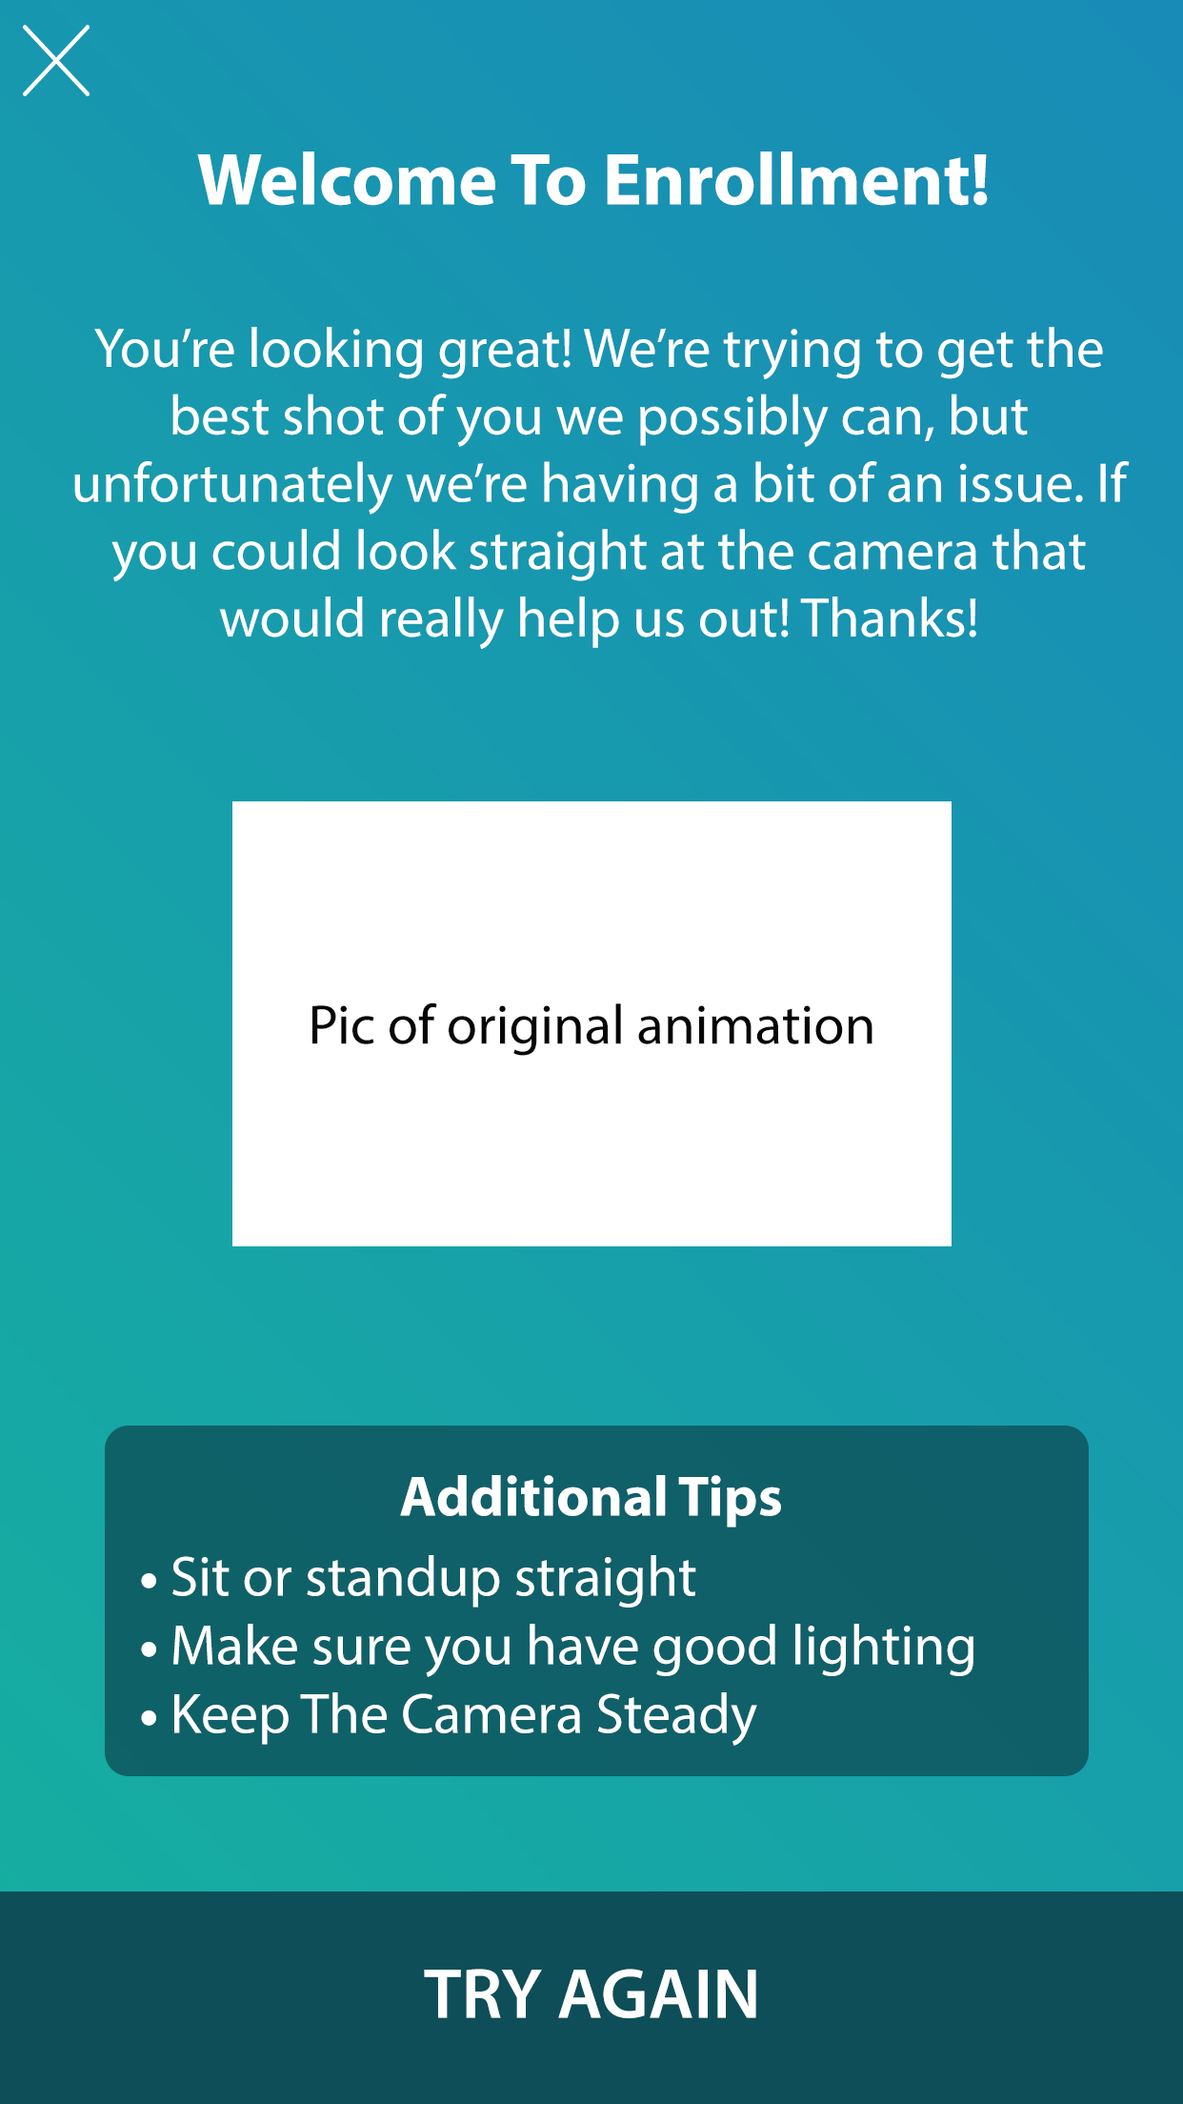

In this I just made the verbiage specifc to the error. Felt putting verbiage first was a bit more important since studies show the first place users look on a screen is the top left corner.

## Bad Lighting:

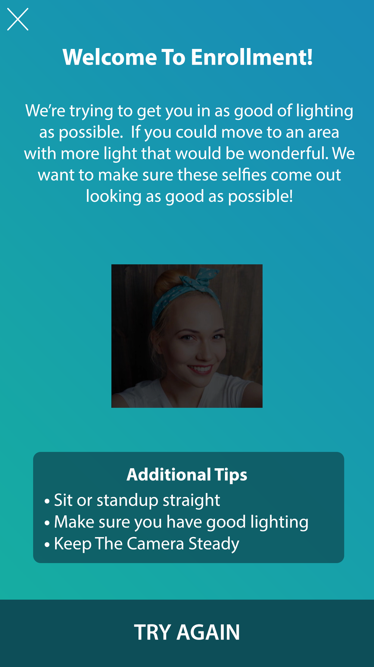

Again, I made verbiage that was specifc to the event. The picture would slowly go from darker to lighter. Perhaps have icons of lights above it that slowly shed more and more light on it?

## Bad Posture:

## 

This one would exhibit an animation of someone fixing their posture. I made a short video in premier that I’ll send to you. It’s nothing fancy.

## Level 3

So for this you asked for an out of the box redesign. This isn’t a total redisgn, but it’s a concept that can be used as a first error page or a page that is shown before any involvment with the app to help instruct users. It would show one page at a time, and each time you hit continue jump down to the next set of instructions. This would force the user to thoroughly understand each set of instructions. Unlike apps like Tinder, where before you enter the app they give you instructions and show your progression by which tiny ball your on, this one would just have users go through the app having them more focused on the instructions than how far along they are.

The image is a strip that is to big to fit on this document so I’ll put it in the “Media Examples” folder I spoke of earlier.

# Conclusion

Main takeaways I got from form redesign were that it’s good to make the input boxes noticed even if it is not the most aesthetically pleasing thing in the world. If you guys don’t take my design and stick with yours I’d suggest drastically increasing the height of them so they’re almost to the brim of the borders you used.

For the redesigns some things I didn’t speak of are:

1. I find leaving the face in the background a bit distracting from the purpose of the page
2. The logo in the background isn’t necessary, it is also necessary
3. The cohesiveness of the color scheme is good, as well as the animation.

If you took time out of your day to read through all this, thank you again for this opportunity