**Lab 3: Online Grocery Website Alternative Design**

**SEG 3125 – Analysis and Design User Interfaces**

**Winter 2023**

**School of Electrical Engineering and Computer Science**

**University of Ottawa**

Section: A-03

Group: 19

            Course Coordinator:   Dr. Omar Badreddin

            Teaching Assistants:  Samee Mohammad Sayeed

Dhruvi Goyal

Alexander Su (300081295)

Eric Dam (300012511)

Kenneth Chen (300114058)

Symoom Saad (300063843)

Submission Date: Sunday February 5th, 2023

**Links:**

**GitHub Pages Link for Lab 3:** <http://alexsu100.github.io>

**Repository for Lab 3:** <https://github.com/edam016/SEG3125LABS>

**GitHub Pages Link for Lab 2:** <https://alexsu100.github.io/Lab-2-Archive/>

**Repository for Lab 2:** <https://github.com/edam016/SEG3125LABS/tree/main/Lab%202>

______________________________________________________________________________

**Team contribution:**

**Alexander Su:** Improve UX Experience (made products into grid, header image), lab report.

**Eric Dam:** Implemented breadcrumbs, replacing navigation bar.

**Kenneth Chen:** Added categories for products.

**Symoom Saad:** Added functionality to add multiple products to cart.

______________________________________________________________________________

**Screenshots of the website:**

Client page:

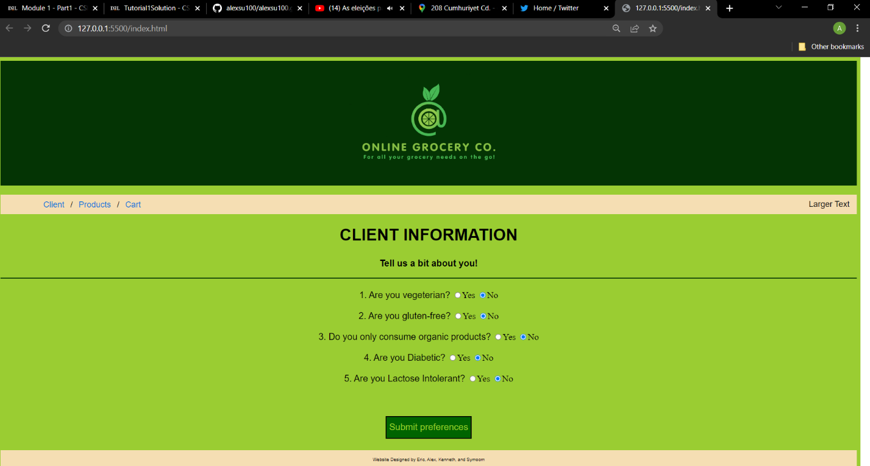

Customer page:

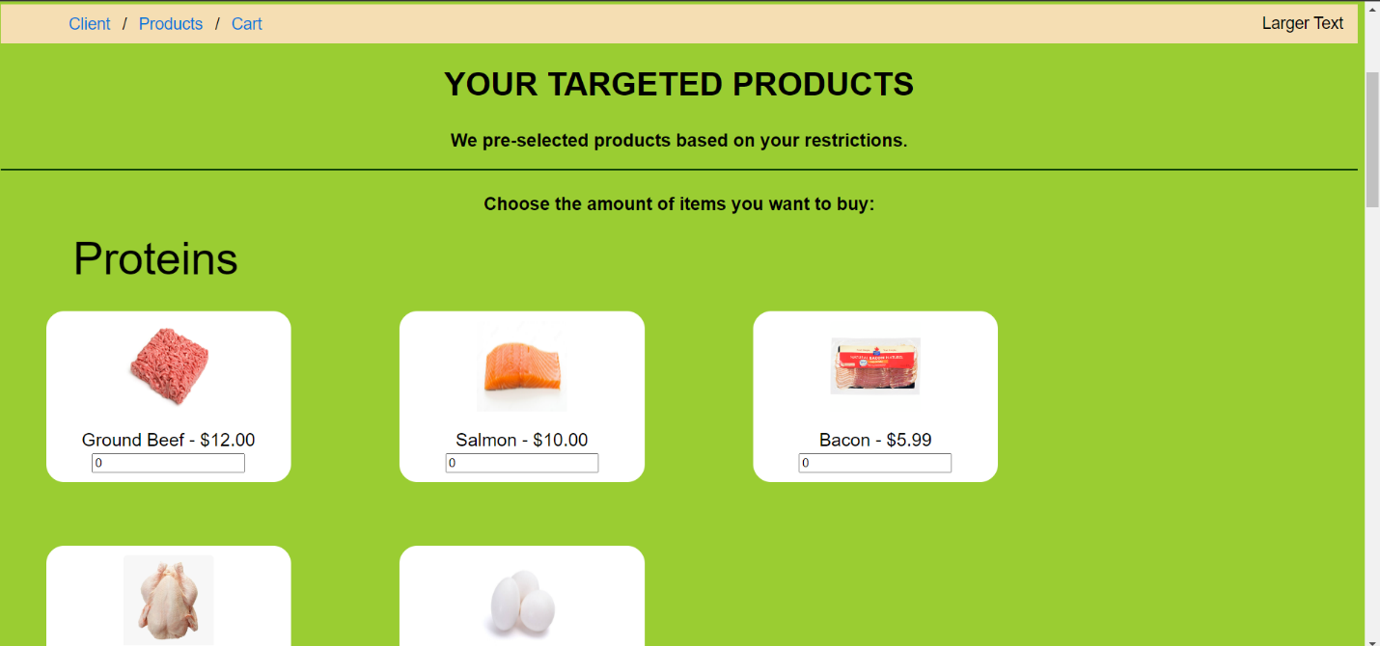

Customer page scrolled down:

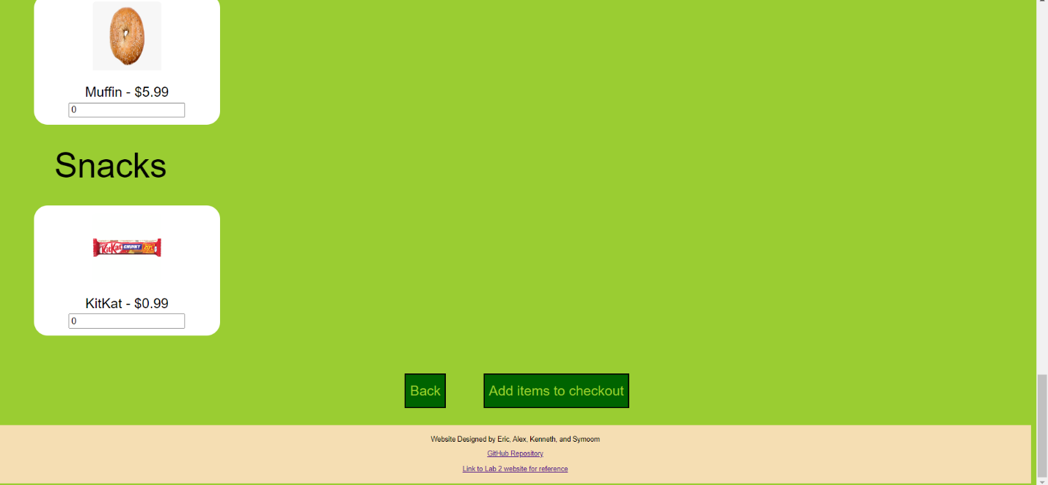

Cart Page:

