**Lab 2: Construction of an Adaptive Online Grocery Website**

**SEG 3125 – Analysis and Design User Interfaces**

**Winter 2023**

**School of Electrical Engineering and Computer Science**

**University of Ottawa**

Section: A-03

Group: 19

            Course Coordinator:   Dr. Omar Badreddin

            Teaching Assistants:  Samee Mohammad Sayeed

Dhruvi Goyal

Alexander Su (300081295)

Eric Dam (300012511)

Kenneth Chen (300114058)

Symoom Saad (300063843)

Submission Date: Sunday, January 29th, 2023

**Links:**

**Original Collaborative GitHub Repository:** <https://github.com/edam016/SEG3125LABS>

**GitHub Pages Link:** <http://alexsu100.github.io> *(Note: Original repo has to be forked to Alexander Su’s account in order to be hosted on GitHub Pages, both repos are identical.)*

**GitHub Repository of the host page:** <https://github.com/alexsu100/alexsu100.github.io>

______________________________________________________________________________

**Team contribution:**

**Alexander Su:** Lab report, Website Host, Optional Requirements (Adding images to products, improving UI) in HTML, CSS, JavaScript.

**Eric Dam:** Compulsory requirements, Products page (Added additional dietary restrictions on the client page and more products) in HTML, CSS and JavaScript.

**Kenneth Chen:** Compulsory requirement, Cart page and Optional Requirements (Improving the readability of the code, added an option to enlarge the text font) in HTML, CSS and JavaScript.

**Symoom Saad:** Compulsory requirements, Client page (Implemented client information filtering dietary restrictions) in HTML, CSS and JavaScript.

______________________________________________________________________________

**Screenshots of the website:**

**Client Page:**

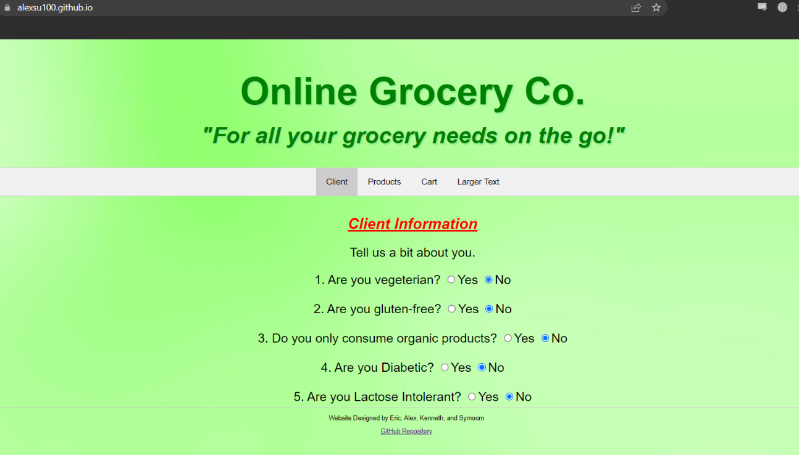

**Products Page:**

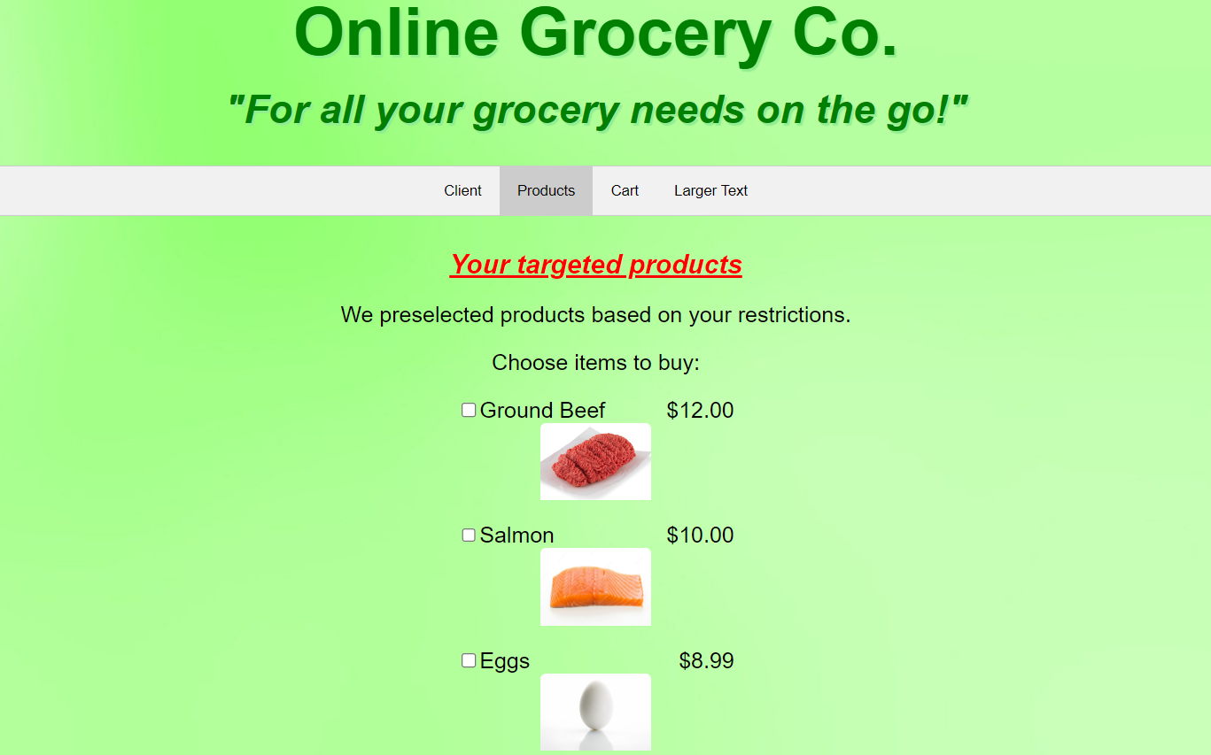

**Cart Page with total amount of groceries tabulated:**

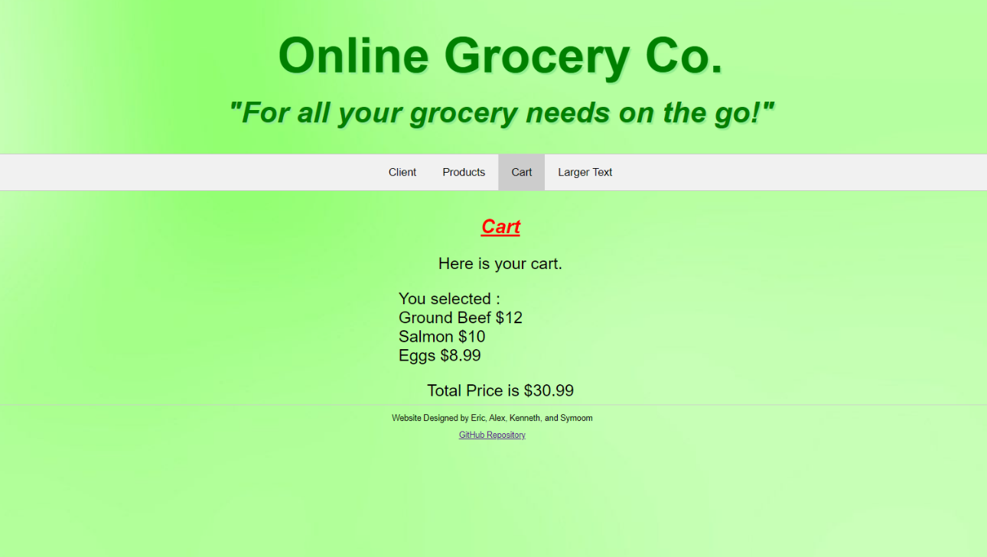

**Cart Page but with the font increased by 125%:**

