
Bucharest University of Economic Studies
Faculty of Economic Cybernetics, Statistics & Informatics
Department of Statistics and Econometrics

DISSERTATION RESEARCH PAPER

A Master’s Thesis
Submitted in Fulfillment of the Requirements
For the Degree of Master of Applied Data Analytics

Student:
Alexandru Stefan Szabo
Supervisor:
Prof. Dr. Stelian Stancu

Bucharest, June 2026

Bucharest University of Economic Studies
Faculty of Economic Cybernetics, Statistics & Informatics
Department of Statistics and Econometrics

INTERACTIVE EXPLORATORY DATA ANALYSIS
OF THE STEAM CATALOG

Student:
Alexandru Stefan Szabo
Supervisor:
Prof. Dr. Stelian Stancu

Bucharest, June 2026
Abstract

This research addresses the challenges of discoverability and strategic positioning within highly saturated digital marketplaces, using the Steam platform as a primary case study. While specialized literature extensively covers macro-level platform economics, crowdsourced tagging networks, and player review dynamics, a critical gap persists regarding how independent developers can visualize these multi-dimensional data points to identify opportunities. To bridge this gap, this thesis develops a data-driven Decision Support System using a curated dataset of over 10,000 games. The application translates theoretical market concentration, sentiment analysis, and longitudinal monetization trends into interactive, actionable intelligence. The development lifecycle followed a structured, multi-stage engineering pipeline. First, data was systematically aggregated from the Steam API and SteamSpy, ensuring a representative sample of the “Long Tail” economy. Second, an extraction, transformation, and loading (ETL) pipeline was established using Python and Pandas to normalize inconsistent pricing structures and parse comma-separated metadata strings into a local SQLite database. Third, exploratory data analysis (EDA) was conducted to map historical genre shifts and calculate statistical co-occurrence scores between different categories. Finally, these analytical models were operationalized into a web dashboard using Streamlit and Plotly, providing stakeholders with an empirical framework to minimize the risk in game publishing strategies.

AI assistance disclaimer

This dissertation acknowledges the usage of artificial intelligence as a supportive tool to optimize specific engineering and writing workflows. Tools were utilized strictly for structural data organization, brainstorming literature frameworks, and enhancing the efficiency of the software development pipeline, including foundational code generation. Crucially, all core analytical conclusions, database architectures, and final manuscript phrasing remain the product of independent research and manual synthesis. In an era defined by rapid technological adaptation, maintaining complete transparency regarding collaborative human-AI workflows is essential for academic integrity. Artificial intelligence functioned as an advanced technical assistant, accelerating development without overriding the critical oversight or original contributions of the author.

CONTENTS

Introduction 6

Background information and motivation 6

Research objectives 6

1. Literature review 8

1.1. Overview of relevant literature 8

1.1.1. Macro economics of steam distribution 8

1.1.2. Behavioral economics of user sentiment 10

1.1.3. Longitudinal transformation of game ecosystems 11

1.1.4. Predictive modeling and strategic discoveries 12

1.2. Key theories and concepts 13

1.2.1. Two-sided platform economics 14

1.2.2. Folksonomy and collective metadata taxonomy 14

1.2.3. The playtime-sentiment feedback loop 14

1.2.4. Product differentiation and uncontested market gaps 15

1.3. Literature gaps summary 15

2. Methodology 17

2.1. Research design 17

2.1.1. Introduction to the empirical framework 17

2.1.2. Technical stack and tool justification 17

2.2. Data collection 19

2.2.1. Three-stage gathering architecture 20

2.2.2. Managing server rate limits 21

2.2.3. Transforming raw payloads into organized objects 21

2.3. Sample selection 22

2.3.1. Database schema layout 22

2.3.2. Data preprocessing 24

2.4. Data processing and interactive exploratory data analysis 25

2.4.1. Market Overview module 26

2.4.2. Reviews Analysis module 26

2.4.3. Evolution Trends module 27

2.4.4. Opportunity Finder module 27

3. Results 29

3.1. Market Overview module findings 29

3.1.1. Distribution of genres 29

3.1.2. Industry titans by title volumes 30

3.1.3. Title trends wordcloud 31

3.2. Reviews Analysis module findings 32

3.2.1. Market leaders and worst rated titles 32

3.2.2. Distribution of review score density versus price 34

3.3. Evolution Trends module findings 36

3.3.1. Player mode evolution 36

3.3.2. Monetization strategies shift 38

3.4. Opportunity Finder module findings 41

3.4.1. Genre synergy 41

3.4.2. Category synergy 42

4. Discussion 43

4.1. Market Overview module insights 43

4.2. Reviews Analysis module insights 45

4.3. Evolution Trends module insights 46

4.4. Opportunity Finder module insights 48

Conclusion 49

Research summary 49

Key empirical discoveries 49

Limitations and future architectural directions 50

REFERENCES 51

Introduction

Background information and motivation

A lifelong passion for video games naturally forms the foundation of this research. Having spent countless hours exploring the extensive catalog of the Steam platform since childhood, my interest quickly extended beyond pure entertainment. Even during my early schooling, I found myself drawn toward the underlying numbers, mathematics, and statistical trends that govern game design and player retention. This early fascination with quantitative metrics evolved during my academic journey. Entering the Faculty of Cybernetics, Statistics, and Informatics provided me with the formal mathematical toolkit necessary to understand complex data structures. Advancing into the Master of Applied Data Analytics program finally bridged the gap between raw curiosity and technical execution, equipping me with the specific algorithms, predictive modeling techniques, and data manipulation skills required to evaluate large-scale datasets.
This academic background directly aligns with my future personal and professional aspirations. I am planning to venture into game development as a serious hobby, a goal that demands a deep, objective understanding of the current market landscape. Launching a game in today’s saturated digital economy is highly risky without empirical backing. The intersection of data science and game production provides the exact solution needed to mitigate this risk: Game Data Analysis. By examining the Steam ecosystem through a data-driven lens, a developer can move away from subjective guesswork and make informed decisions regarding pricing strategies, genre combinations, and sentiment management. This dissertation represents the practical convergence of my childhood passion, my specialized university training, and my future ambitions as an independent creator, transforming raw platform metadata into actionable development insights.

Research objectives

The primary objective of this thesis is to architect and deploy an interactive Decision Support System that provides market intelligence for independent game developers. To achieve this, the research focuses on three core milestones. First is Data Pipeline Engineering: building a robust ETL pipeline to aggregate, clean, and store multi-dimensional metadata from over 10,000 active Steam titles into a local SQLite database. Second is Empirical Market Mapping: operationalizing descriptive and exploratory data analysis to expose historical monetization shifts, define the boundaries of market concentration, and measure the mathematical correlation between pricing strategies and user sentiment. Third is Strategic Opportunity Discovery: leveraging tag co-occurrence analysis and predictive modeling logic to identify unexplored genre combinations, effectively charting “Blue Oceans” where market competition is low but consumer demand remains unfulfilled.

Literature review

Overview of relevant literature

The transition of the video game industry into a predominantly digital ecosystem has necessitated a fundamental shift in how market success and software value are measured. This chapter provides a comprehensive review of the scholarly literature surrounding the Steam platform, serving as the theoretical foundation for the data-driven tools developed in this thesis. The primary objective is to synthesize existing research into a cohesive narrative that explains the “socio-technical” nature of modern game distribution (Thorhauge, 2022). This review is organized into four thematic directions: the macro-economics of platform-based retail, the behavioral psychology of user-generated sentiment, the longitudinal evolution of game ecosystems, and the strategic application of predictive modeling for market discovery.
First, I examine the work of Thorhauge (2022) and Xiaozhou Li (2020) to define Steam as a platform economy governed by collective intelligence and metadata. Following this, I investigate the micro-level interactions between price and satisfaction, drawing on the empirical findings of Dayi Lin (2018) and the success factor analysis of Sangho Ahn (2017). The third section traces the temporal shifts in the market, utilizing the research of Simone Petrosino (2022) and Mark O’Neill (2016) to explain the rise of multiplayer and free-to-play models. Finally, the chapter concludes by exploring the “Blue Ocean” strategy through the meta-gaming concepts of Muhammad Nazhif Rizani (2023) and the machine learning frameworks of Andraž De Luisa (2021). By identifying the research gaps within these four pillars – specifically the lack of longitudinal visualization for the “Long Tail” – this review justifies the creation of a dedicated decision support system. Ultimately, this framework demonstrates that in a marketplace of over 10,000 titles success is not merely a product of gameplay quality, but a result of strategic positioning within the platform’s complex network of tags, prices, and social signals.

Macro economics of steam distribution

Digital games have moved beyond being mere products; they are now participants in a complex socio-technical system known as the platform economy. This section investigates the structural forces that govern Steam and the role of crowdsourced metadata in navigating this landscape.
As digital storefronts have replaced physical retail, the nature of the “game” has shifted toward what a multi-layered platform economy. Steam operates not just as a repository for software, but as a space where Valve manages a delicate balance between traditional retail and player-driven economic exchanges (Thorhauge, 2022). This shift is significant because it introduces a “platformization” effect where the value of a game is no longer just its code, but its position within a network of community markets, workshops, and social interactions. In this context, the developer’s role is transformed from a one-time vendor into a long-term service provider. This theoretical perspective suggests that to understand a game’s success, one must look at how it integrates into the platform’s broader ecosystem rather than just its individual features or marketing budget.
The problem of discoverability in such a massive economy is solved through a collective intelligence framework. Since the Steam catalog is far too large for any single entity to categorize manually, the platform relies on user-generated tags to create an intuitive distribution of genres. These tags form a unique metadata set that is often more accurate than formal industry taxonomies because they reflect how players actually perceive and describe their experiences (Xiaozhou Li, 2020). Their network analysis of these tags reveals that certain “central” tags act as hubs for market visibility, while “peripheral” tags define niche segments. This suggests that the way a developer chooses to tag their game is a strategic decision that determines which algorithmic “neighborhood” they will inhabit, directly affecting their ability to reach their target audience without the need for traditional, high-cost advertising campaigns.
Despite the democratic potential of crowdsourced tagging, there is a persistent question of market concentration and the visibility of the “Long Tail”. While the platform facilitates alternative economic roles, the infrastructure remains heavily centralized under Valve’s control (Thorhauge, 2022). This creates a research gap where we understand the “top 100” hits quite well, but we have limited longitudinal data on the thousands of smaller titles that make up the vast majority of the store. By analyzing the co-occurrence of tags, we can see how certain genres become saturated, leading to intense competition (Xiaozhou Li, 2020). This underscores a critical need for a methodological approach that doesn’t just rank games by popularity, but maps the entire genre landscape to identify where the “Long Tail” is actually finding room to breathe. Without this scenery, small developers are effectively flying blind in an economy that favors those who already possess market momentum.
These theoretical perspectives are operationalized in the Market Overview page of this application. By utilizing a wordcloud to visualize title trends and a Genre Bubble Chart, the app allows users to interact with the “collective intelligence”. This page effectively visualizes the “platform economy”, enabling a researcher or developer to see the density of the marketplace and identify whether they are entering a “Red Ocean” of high competition or a less populated segment of the platform.

Behavioral economics of user sentiment

The success of a digital title is increasingly dictated by its “social proof”, manifested through the aggregate sentiment of user-generated reviews. This subchapter analyzes the mechanics of Steam’s review system as a quality signal and investigates how financial investment shapes consumer perception.
The fundamental distinction between Steam and other digital marketplaces lies in the verification of user engagement through playtime metrics. Steam reviews serve as a more reliable indicator of software quality than mobile app stores because they are tethered to actual usage data. The sentiment expressed in a review is not a static data point but a dynamic reflection of the player’s experience over time. Negative reviews are often triggered by early-stage technical failures, whereas positive sentiment is built through long-term gameplay satisfaction (Dayi Lin, 2018). This creates a feedback loop where the review acts as a “living document” of the game’s lifecycle. For the researcher, this means that the positive ratio is not just a score, but a proxy for the software’s stability and the developer’s ability to maintain player interest beyond the initial purchase.
The discrepancy between popular and unpopular games often condenses to how well a developer manages consumer expectations regarding functionality and value. The Word2Vec model was used in order to demonstrate that the semantic content of reviews differs wildly between market leaders and failing titles. The study highlights that popular games tend to fulfill “must-be requirements” such as technical performance and fair pricing, while unpopular games often fail at these basic levels (Sangho Ahn, 2017). Furthermore, the popular category is more resilient to occasional negative feedback because their core value proposition is clearly defined. This research implies that market leaders do not necessarily need to be perfect, but they must provide a consistent experience that justifies their price point, whereas unpopular games are often characterized by a “quality gap” that users are quick to identify and punish in the comments section.
A significant research gap persists in understanding the “Premium Bias” and the specific correlation between high price points and user tolerance. While the reviews are diverse, there is limited longitudinal data exploring whether a higher financial investment leads to stricter user examination or a “sunk cost” bias where users feel compelled to rate expensive games more highly to justify their spending. This creates a methodological challenge for developers: should a game be priced lower to lower the “barrier to criticism”, or higher to signal quality? Price fairness is a key determinant of popularity, but they do not explicitly map the tipping point where a price increase leads to a collapse in positive sentiment (Sangho Ahn, 2017). Identifying this threshold is essential for a data-driven approach to game publishing, as it moves the discussion from subjective “fun” to objective “value proposition”.
These behavioral theories are directly tested in the Reviews Analysis page of the application. The Review Score Density vs. Price Chart allows users to see if the “price fairness” mentioned holds true across the 10,000 games dataset. By filtering for Overwhelmingly Positive and Very Positive tags, as suggested by the “reliability metrics”, the app segments the market to find Hidden Gems. This provides a practical tool for seeing where the “Premium Bias” might be occurring and which games managed to achieve “leader” status by maintaining the playtime-satisfaction loop.

Longitudinal transformation of game ecosystems

The evolution of the digital games market is characterized by a fundamental shift in the technological and social requirements of the consumer. This section examines the transition from isolated software products to interconnected service ecosystems and the changing role of multiplayer infrastructure.
As digital platforms have matured, the “panorama” of available titles has shifted heavily toward social and collaborative experiences. The period between 2018 and 2020 saw a surge in multiplayer titles that fundamentally altered player review dynamics. The analysis suggests that multiplayer games are judged by a different set of criteria than single-player experiences, with a heavy emphasis on community health and technical uptime (Simone Petrosino, 2022). This implies that the evolution of the Steam market is not merely a change in genre popularity, but a deeper structural shift in how games are maintained as living services. For the developer, this means that the decision to include multiplayer features is no longer just a gameplay choice, but a long-term commitment to platform-level support and social management.
The rise of diverse monetization models, particularly the shift toward Free-to-Play and Early Access, has further complicated the definition of market success. Steam audience is far from a monolith, displaying a “distilled” diversity in how they consume different types of software. The research into gamer behavior reveals that while paid “premium” games still hold a significant market share, the behavioral clusters surrounding Free-to-Play titles show higher levels of daily active engagement (Mark O’Neill, 2016). This creates a temporal trend where developers must choose between high-barrier “upfront revenue” and low-barrier “long-tail” engagement. This diversity in gamer behavior suggests that the industry’s evolution is driven by the platform’s ability to serve to these varying financial and social preferences simultaneously.
A significant research gap remains in understanding the long-term viability of specific “mode + price” combinations across different historical eras. Despite a snapshot of the 2018–2020 period was provided, there is a lack of longitudinal data that tracks how the ratio of single-player to multiplayer releases has fluctuated over a twenty-year span. Furthermore, while studies identify diverse behavior, they do not explicitly link these behaviors to the specific “free vs. paid” pivot points seen in broader market data. This methodological void necessitates a data-driven approach to visualize these shifts, as understanding the historical momentum of these trends is vital for predicting the next major phase of the digital games economy. Without a clear timeline, developers risk entering the market with monetization strategies that are already becoming outdated.
These longitudinal theories are operationalized in the Evolution Trends page of the application. By providing a Single-player vs. Multiplayer Yearly Releases Chart, the app allows users to verify the “multiplayer panorama” (Simone Petrosino, 2022). Additionally, the Free-to-Play vs. Paid Chart serves as a visual record of the behavioral shifts (Mark O’Neill, 2016). It enables a researcher to see exactly when the market share of free-to-play titles began to challenge traditional premium models across the 10,000 games dataset.

Predictive modeling and strategic discoveries

The strategic positioning of a digital product requires a transition from reactive analysis to proactive market discovery. This subchapter explores the application of game refinement theories and machine learning methodologies to identify untapped market opportunities and the predictive power of game metadata.
The success of a game is often a function of its “meta-gaming” characteristics – the strategic layers that exist beyond the core gameplay mechanics. The publishing process on Steam should be viewed as a competitive game where developers must optimize for “evolvability” and engagement. Platform-specific features such as achievements, trading cards, and community hubs act as meta-elements that refine the user experience and increase a title’s survival rate in a saturated market (Muhammad Nazhif Rizani, 2023). This perspective suggests that “strategic discovery” is not just about finding a new genre, but about understanding how to layer meta-features that align with the platform’s unique infrastructure. For the developer, success is therefore not an accident, but a result of balancing these refinement metrics to maintain a high “meta-level” of engagement.
Identifying a “Blue Ocean” within the Steam marketplace requires an understanding of how genre and category combinations interact to influence popularity. While individual features like price are important, the most significant predictor of success is the unique intersection of game tags. Predictive modeling suggests that certain “genre combinations” act as multipliers for popularity, allowing games to reach audiences that standard, single-genre titles cannot access. By using regression models to isolate these high-impact combinations, developers can move away from “Red Oceans” of intense competition toward niche markets with high demand but low supply. This implies that the strategic “Blue Ocean” is found not by inventing a new category, but by combining existing ones in statistically rare yet highly desirable ways (Andraž De Luisa, 2021).
There is a noticeable research gap regarding the “cold start” problem for independent developers who lack the “developer reputation” cited in the previous study as a primary success driver. While the meta-gaming layers of the platform was discussed, there is limited research on whether these platform features can actually compensate for a lack of brand history in a crowded market. This creates a methodological necessity for a tool that can visualize “tag synergy” independently of developer prestige. Currently, literature provides the math for prediction, but lacks an accessible framework for visualizing these “unexplored gaps” in the genre network. Addressing this gap is vital for democratizing market intelligence, as it allows smaller studios to rely on data-driven synergy rather than the high-risk gamble of traditional marketing.
These predictive and strategic theories are the core foundation of the Opportunity Finder page in the application. By providing Genre Matching and Category Matching scatter plots, the app allows the user to perform the “synergy analysis” described to find potential “Blue Oceans”. Furthermore, the integration of a success predictor tool operationalizes the machine learning concepts found in both studies used as reference in this subchapter, offering a concrete way to estimate market potential based on the metadata and “meta-gaming” layers of the game’s planned configuration.

Key theories and concepts

The analytical architecture of this Decision Support System is anchored by established concepts in economics, data science, and behavioral analytics. To extract value from the Steam ecosystem, we must first establish the theoretical boundaries that dictate how products are classified, how consumers behave, and how market opportunities are discovered.

Two-sided platform economics

Rather than operating as a traditional digital storefront where inventory is simply bought and resold, Steam functions as a complex, two-sided platform economy. As established by Thorhauge (2022), the platform infrastructure serves as a highly regulated environment that connects independent software developers directly with an active consumer base. Within this ecosystem, value is not created in isolation; it is continuously generated through platform-specific mechanisms like user-curated storefronts, dynamic community markets, and algorithmic recommendation loops. For a data analyst, this means that a game’s market visibility cannot be evaluated using traditional retail metrics alone. Instead, a title’s commercial potential is fundamentally bounded by how effectively it navigates the digital infrastructure and matching algorithms built by the platform holder.

Folksonomy and collective metadata taxonomy

When dealing with a catalog containing hundreds of thousands of titles, traditional top-down classification systems – where a store or publisher assigns a game to a rigid, standalone genre – quickly fall apart. To manage this massive scale, the platform utilizes a crowd-sourced folksonomy, relying on the collective intelligence of the player base to dynamically tag software products (Xiaozhou Li, 2020). This user-driven classification creates an organic, self-organizing semantic network where a game’s identity is defined by actual player perception rather than corporate marketing labels. By evaluating the co-occurrence patterns of these community-driven tags, this research bypasses outdated genre definitions and maps the marketplace based on the honest, multi-dimensional attributes that consumers themselves assign to the software.

The playtime-sentiment feedback loop

Evaluating customer satisfaction on Steam requires an analytical approach that treats user feedback as a variable deeply tied to continuous engagement. Traditional sentiment analysis often views an online review as a static, immediate reaction to a purchase. However, the empirical research demonstrates that player sentiment operates inside a dynamic feedback loop driven by total playtime metrics (Dayi Lin, 2018). Early-stage reviews are frequently hyper-sensitive to technical performance flaws, sudden server bugs, or perceived pricing fairness. In contrast, long-term sentiment shifts to focus on systemic gameplay depth, narrative quality, and mechanical balance. Consequently, the data engine in this application uses strict review-volume threshold gates to filter out volatile, short-term emotional noise and capture a reliable, long-term consensus of player satisfaction.

Product differentiation and uncontested market gaps

To survive in a saturated digital marketplace, independent developers must intentionally pursue product differentiation to escape hyper-competitive “Red Oceans”, where multiple studios copy identical, overcrowded concepts. This strategic dilemma is addressed through the “Blue Ocean” framework, which focuses on identifying uncontested market spaces characterized by high player interest but a complete lack of developer supply. As applied to digital storefronts by Andraž De Luisa et al. (2021), this strategic discovery is operationalized by using data models to isolate sparse matrices within the tag network. By cross-referencing metadata arrays, the application searches for popular individual tags that have rarely or never been combined into a single commercial title, effectively mapping out clear, low-competition development roadmaps.

Literature gaps summary

While the existing body of academic research provides a robust foundational understanding of digital platform mechanics, behavioral sentiment tracking, and predictive modeling, it leaves critical operational blind spots for independent software deployment. The current landscape is heavily weighted toward high-level theoretical abstractions and retrospective case studies of major industry hits. This focus creates a distinct knowledge gap regarding how empirical data can be actionable for small-scale developers who lack institutional backing or massive marketing budgets. By identifying the limitations within current platform literature, this summary establishes the explicit research gaps that necessitate the development of our interactive Decision Support System.
The primary deficiency in current literature lies in the lack of accessible, longitudinal visualization frameworks for analyzing the “Long Tail” of the marketplace. While foundational platform economics research masterfully details the structural networks of platformization and crowd-sourced tagging, these studies rarely provide small creators with concrete tools to navigate them. Furthermore, behavioral studies establish the critical relationship between user sentiment and playtime, yet they stop short of mapping the exact financial threshold where a high price point triggers strict user criticism – a phenomenon known as “Premium Bias”. Developers are left with theoretical descriptions of platform complexity, but they lack empirical benchmarks to determine how price tiers directly alter user sentiment across different historical eras.
A secondary and more critical gap involves the actionable execution of predictive modeling and strategic market discovery. Advanced machine learning pipelines prove that success can be statistically estimated based on launch metadata. However, these models heavily rely on “developer reputation” as a primary variable, offering little comfort or guidance to new independent studios facing the industry’s notorious “cold start” problem. Additionally, while strategic frameworks like the “meta-gaming” theories discuss platform feature refinement, literature consistently fails to provide a visual interface for spotting sparse tag matrices. There is a distinct lack of tools that translate complex tag co-occurrence mathematics into intuitive scatter plots, leaving independent creators without a clear mechanism to actively discover low-competition “Blue Oceans”.

Methodology

Research design

Introduction to the empirical framework

This chapter outlines the computational, architectural, and data engineering frameworks designed to aggregate and evaluate the Steam platform ecosystem. To extract meaningful market intelligence from an native volatile digital storefront, this research transitions away from ad-hoc data analysis toward a systematic, reproducible engineering pipeline. The primary methodological objective is to construct a production-ready, local Decision Support System capable of ingestion, normalization, relational indexing, and real-time visual exploration of over 10,000 unique software titles. By mapping unstructured metadata strings into optimized statistical arrays, this framework establishes a rigorous environment for checking market concentration, behavioral sentiment anomalies, and temporal industry trends. The subsequent sections detail the technical reasoning behind the software stack selection, the structural architecture of the database layer, and the algorithmic logic driving the analytical dashboard.

Technical stack and tool justification

The implementation of a high-deliverable data analysis platform requires a technical stack that minimizes processing cost while ensuring scalability and interactive responsiveness. The structural architecture of this application (illustrated in Figure 1) is written entirely in Python, utilizing an ecosystem of specialized open-source libraries optimized for relational data manipulation and fast visualization workflows.

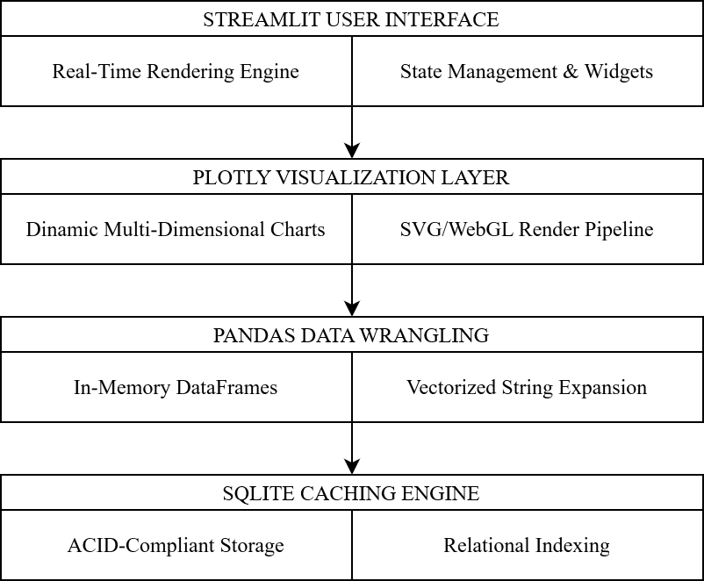

Figure 1. Technical stack diagram

In-memory wrangling via Pandas
Data manipulation and algorithmic feature extraction are handled through the Pandas software library. In database operations containing thousands of records with extensive comma-separated text strings – such as game tags and developer metadata – traditional iteration loops create massive performance bottlenecks. Pandas mitigates this through vectorized operations, executing mathematical and string-matching transformations directly on underlying C arrays (McKinney, 2010). This in-memory DataFrame architecture allows for instantaneous filtering, grouping, and statistical aggregation during active runtime operations.

Serverless storage architecture via SQLite
For the persistence layer, SQLite was selected as the local caching database engine. Unlike enterprise-scale database management systems that require a separate background process, SQLite utilizes an unmanaged, serverless architecture where the entire relational schema is stored within a single, cross-platform file descriptor (Hipp, n.d.). Despite its lightweight footprint, SQLite maintains full ACID compliance (Atomicity, Consistency, Isolation, Durability), making it highly reliable for concurrent analytical reads. Choosing this local SQL engine bypasses network latency and API throttling during analytical sessions, providing rapid sub-millisecond query execution on indexed columns.

Web integration framework via Streamlit
The front-end user interface is built using Streamlit, a rapid-deployment application framework that converts Python scripts into interactive web interfaces. In traditional software development, bridging data science scripts with a web browser requires separate HTML, JavaScript, and CSS architectures, introducing significant complexity and integration risks. Streamlit avoids this necessity by using a declarative code paradigm, maintaining application state and rendering layout changes in response to widget interactions on a single execution thread (Streamlit-Team, n.d.). This unified environment allows a data analyst to focus strictly on data mapping and technical precision.

Dynamic rendering via Plotly
Data visualization is driven by Plotly, a robust graphing library that generates interactive, browser-based plots. Unlike static visualization packages, Plotly charts render via an open-source JavaScript graphing library (plotly.js) that handles multi-dimensional hover states, dynamic scaling, and localized data filtering directly inside the client browser (Inc., 2026). This client-side execution ensures that tasks like filtering out “Hidden Gems” from a scatter plot of 10,000 games do not trigger an entire database re-query, reducing visual lag and optimizing the user experience.

Data collection

Building this data dashboard starts with collecting raw market data from the internet. The system gathers this information through a multi-stage harvesting pipeline (shown in Figure 2), using the SteamSpy research endpoint, the official Steam Web API managed by Valve, and verified github public repository data.
This multi-source approach is a deliberate research design choice. The full Steam catalog contains hundreds of thousands of software entries, including duplicate configurations, test builds, and inactive applications. Scraping the entire catalog would have been an incredibly tedious process that introduces massive technical overhead. Instead, this academic study implements a simpler, highly representative approach by focusing specifically on a sample size of approximately 10,000 of the most popular titles on the platform.

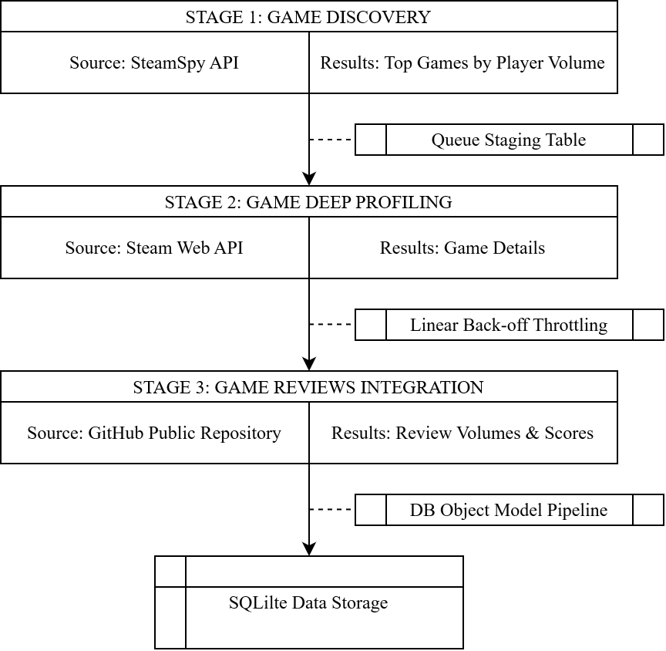

Figure 2. Data collection pipeline

Three-stage gathering architecture

The data collection pipeline splits the work into three logical phases: game discovery, product profiling, and historical review integration.
In stage 1 – Finding the Popular Market (via SteamSpy) – the script executes the custom defined sync_popular_apps function, looping through pages of the SteamSpy API to target the top 10,000 games by player volume (Galyonkin, 2025). The script parses the incoming JSON, extracting basic identifiers like the game’s unique ID (appid), its name, and its estimated owner count (Galyonkin, 2025). These rows are added to a local transactional table (GameQueue) with an initial status set to ‘pending’.
In stage 2 – Profiling Product Details (via Steam Store API) – a secondary script extracts the pending IDs from the queue and sends automated queries to the official Steam Web API managed by Valve in order to fetch game details (Valve, 2026). The script uses specific parameters to pull German market pricing (cc=de) and localized English text (l=english), all for consistence reasons. If the server confirms a successful page match, it unlocks a complex dictionary containing description paragraphs, category fields, and raw developer listings.
In stage 3 – Sentiment and Score Integration (via Public GitHub Repository) – in order to enrich the dataset with historical depth, granular metrics regarding player review volumes, rating distributions, and aggregate scores were imported from a verified public GitHub repository (NewbieIndieGameDev, 2024). This external research dataset, which analyzed a larger timeline of Steam telemetry, served as an inspiration for this project. Integrating this repository data saved substantial time and provided the high-integrity sentiment records needed to calculate our user satisfaction ratios.

Managing server rate limits

Operating automated scripts against public internet APIs requires strict compliance with rate-limiting rules. If a client script fires requests too quickly, security perimeters drop connection packets and issue an HTTP 429 response code (Too Many Requests) to protect server health (iProov, 2025). Managing this budget is vital to prevent incomplete sessions or broad connection blocks.
Rather than implementing complex exponential math, this pipeline uses a Linear Back-off Throttling Strategy combined with fixed courtesy delays to remain a polite client:

- Discovery Loop Throttling – The script downloads an entire page of 1,000 popular titles, saves the progress, and then forces itself to take a brief, mandatory 2.0-second linear break before requesting the next page block. If a page returns completely empty, the loop breaks automatically.
- Profiling Loop Throttling – When looping through individual games one by one, the script monitors the server response status. If it encounters an HTTP 429 block, it suspends execution entirely, logs an alert, and goes to sleep for a linear recovery period of exactly 90 seconds. If the data is downloaded successfully, the script executes a 1.5-second courtesy nap to keep network traffic at a safe, steady speed.

Transforming raw payloads into organized objects

Raw internet data is highly unpredictable – missing metadata fields or unexpected null values can easily crash standard scripts. The software uses a safe data retrieval method (.get()) that provides empty fallbacks ([] or {}) to protect the pipeline from breaking.
The fetch_official_details loop repackages these raw JSON responses into an index-optimized database object model (GameDetails). This translation layer normalizes complex data types to prepare them for analysis by using several methods:

- Complex Lists Flattening – Multi-layered arrays (like developer teams or categories) are unpacked and merged into a single text line separated by commas (e.g., “Indie, Strategy, Simulation”). This allows for fast string matching in the SQL database layer later on.
- Array Bounds Isolation – High-resolution image paths within the nested screenshots object are checked for length to prevent array index errors, safely extracting up to three full image URLs into independent table columns.
- Transactional Commits – If a query returns a failure flag, the queue row is marked as ‘skipped’. For successful games, the row is added using a database merge instruction, and its state shifts to ‘processed’. The script hits “save” (session.commit()) after every single iteration, ensuring that if a network failure or power loss occurs, no previously harvested data is lost.

Sample selection

With the raw data infrastructure established, the exploratory data analysis workflow transitions into defining the statistical boundaries of the dataset, profiling the database storage layout, and applying data wrangling techniques to isolate a high-integrity analytical sample.

Database schema layout

Storing thousands of deeply nested JSON fragments directly in text files creates massive performance bottlenecks during real-time dashboard rendering. To optimize lookup speeds, the data pipeline flattens these responses into an index-optimized, serverless SQLite relational database (with its schema presented in Figure 3). Data profiling involves organizing this storage system into a clean relational layout consisting of two core tables, structured to handle separate analytical dimensions without data duplication.

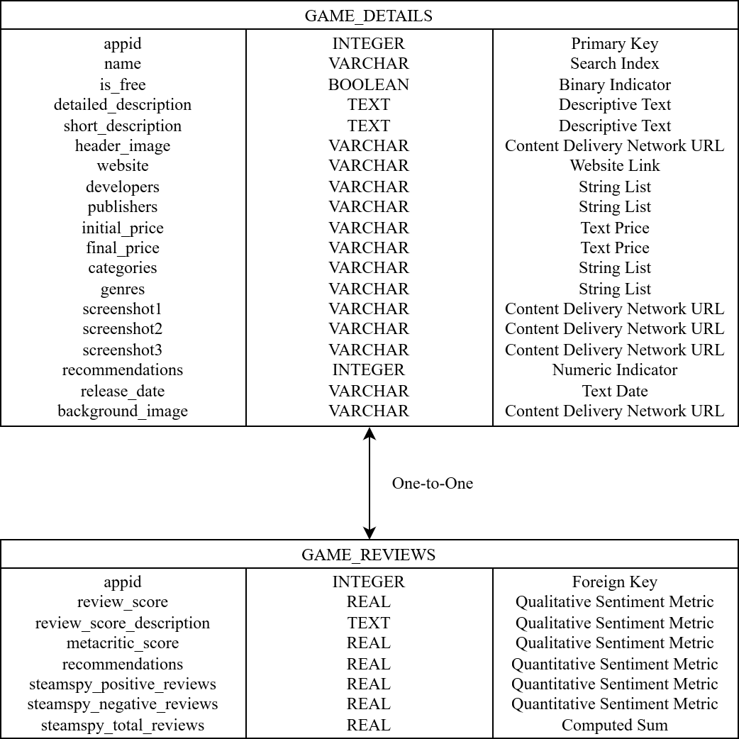

Figure 3. Database schema design

The primary table, game_details, functions as the core descriptive directory for the dataset. It stores the fixed, scalar metadata attributes harvested directly from the official Steam storefront API. Its composition includes the unique application ID (appid) as the primary key, alongside text arrays tracking game names, image URLs, descriptions, release dates, and delimited strings for developers, publishers, genres, and categories.
The secondary table, game_reviews, acts as the metrics accumulator layer. Its main purpose is to isolate the volatile user feedback variables imported from the public repository, separating the large descriptive text blocks from the fast numeric computations. This table houses the integer metrics for positive and negative review counts, the pre-computed total review volume, and floating-point values representing rating scores.
The tables are joined on a one-to-one relationship using the shared appid column, creating a highly efficient relational index path that speeds up real-time filtering across the dashboard modules.

Data preprocessing

Raw platform metadata is notoriously messy, filled with formatting issues and inconsistent data types. The preprocessing pipeline splits these cleaning tasks into two operational phases: in-transit cleaning (handled inside the Python extraction loop) and post-ingestion cleaning (handled via Pandas before rendering). Such assignments involve the following:

- In-Transit Flattening – As the script downloads data from the web, complex JSON arrays (like a list of independent developers or category objects) are unpacked on the fly. The script applies a .join() function, compressing these lists into a single text line separated by commas (e.g., “Action, Adventure, Strategy”). This directly prevents database column errors and saves significant storage space.
- Financial Variable Parsing – Pricing data from web endpoints frequently arrives as localized text strings (e.g., “$14.99” or “14,99€”). The system runs a regular expression script to strip away non-numeric currency characters, standardizes commas to decimal points, and concatenates “EUR” as a suffix since the “cc=de” property was added into the API’s request URL for this particular reason (the selection of Germany’s local currency). Free-to-play titles containing text strings like “Free to Play” or “Demo” are caught and safely converted to a research design convention – “0.00 FREE”.
- Temporal Standardization – Game release dates are stored in varying string formats depending on their launch year (e.g., “9 Jul, 2015”). The preprocessing engine runs these strings through Pandas’ to_datetime() function, converting them into standard ISO dates (YYYY-MM-DD). The script then extracts the calendar year into a separate index column, making historical trend calculations fast and lightweight.

Another common challenge when analyzing large-scale digital storefronts is dealing with missing or aberrant values, abandoned indie titles that have zero actual player engagement, or in this study’s case exceptional premium games with a very expensive price. These records create extreme statistical noise, especially when calculating user sentiment ratios.
To protect the mathematical integrity of the dashboard charts, the dataset passes through a strict quantitative filter gate. Any application that does not meet the minimum baseline threshold of 500 total reviews is automatically dropped from the active dataset. At the same time, prices higher than 100 euros are considered too expensive. By filtering out these low-volume anomalies and premium priced games, the system cleans the database down to a more optimized sample. This verified sample provides a reliable, realistic foundation for the interactive visualization elements featured in the Evolution Trends module.

Data processing and interactive exploratory data analysis

The final phase of the methodology translates the cleaned, relational database tables into an operational user interface using interactive EDA pipelines. Rather than presenting the data as a series of static calculations, the application is engineered as a dynamic Decision Support System built entirely within Python using Streamlit and Plotly.
The system architecture is structured around a central Steam Catalog Navigation Page, which functions as the primary user gateway, filtering, streaming and displaying indexed database records, representing an overview of the four dedicated analytical modules. The wireframe of this app is illustrated in Figure 4.

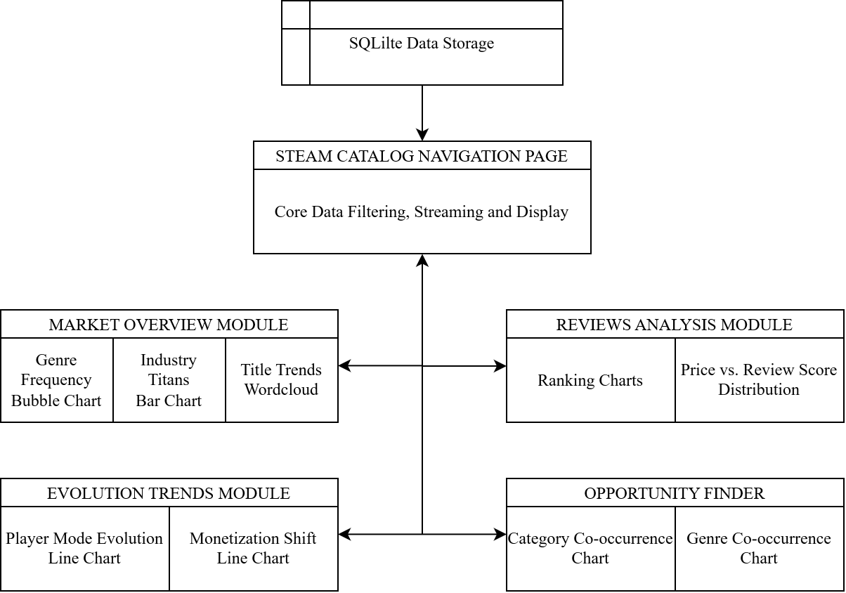

Figure 4. Dashboard wireframe

Market Overview module

The Market Overview dashboard provides high-level visualization from a macro-oriented point of view of the storefront, allowing users to evaluate market saturation and naming conventions across the entire game dataset.

Genre Frequency Bubble Chart
This element tracks product density across different game genres. Because individual titles can carry multiple tags, the script flattens these arrays and calculates the radius of each visual bubble using a geometric surface area function. This method ensures that the screen area occupied by a bubble scales linearly with the absolute volume of games matching that specific tag.

Industry Titans Bar Chart
A discrete frequency rank chart that isolates the top-performing developers by volume. This chart exposes market concentration levels, showing developers whether a specific game is open to independent competition or heavily dominated by a small group of large studios.

Title Trends Wordcloud
A text-mining visualization that processes game titles across the entire game dataset. The underlying pipeline converts title strings to lowercase, drops standard punctuation markers, and filters out common stopwords. The remaining text tokens are processed into an absolute frequency vector array, adjusting the visual font size of each word on the screen based on how often it appears in successful titles.

Reviews Analysis module

The Reviews Analysis engine evaluates player sentiment, helping developers isolate quality signals and find the boundaries of pricing tolerances. This module allows global filtering by both genre and review description (ordinal qualitative sentiment metric).

Market Leaders, Hidden Gems and Worst Rated Charts
An algorithmic sorting engine that ranks games using a custom balance between review volume and positive approval ratios. By establishing strict minimum review counts, this module isolates true Hidden Gems – highly rated but with a low profile independent titles – while sorting poorly received games into a separate Worst Rated index for competitive mistake analysis.

Review Score Density vs. Price Distribution
An interactive scatter plot that maps normalized final game prices against user approval percentages. The chart uses a built-in OLS linear regression model to trace an ongoing trend line through the data coordinates. This visual line mathematically tests for “Premium Bias”, showing developers if player criticism grows significantly harsher as the cost of a game increases.

Evolution Trends module

The Evolution Trends dashboard tracks long-term shifts in design features and business models across a multi-year historical timeline. This module allows global filtering by both genre and category.

Single-player vs. Multiplayer Releases Evolution
A chronological area chart that monitors changing player preferences and developer designs over time. The processing algorithm extracts integer calendar years from standard release dates, aggregating yearly totals to map the steady rise of connected multiplayer experiences alongside traditional single-player titles.

Free-to-Play vs. Paid Releases Evolution
A time-series stream visualization that monitors shifts in monetization strategies across different eras. The engine monitors changes in pricing structures, tracking the historical growth of free-to-play models against traditional premium software purchases.

Opportunity Finder module

The Opportunity Finder functions as a strategic matrix exploration toolkit, turning complex cross-classification data into a visual map for identifying uncompetitive market openings.

Genre & Category Co-occurrence Charts
Both submodules utilize symmetric co-occurrence matrix algebra to track relationships across the user-generated metadata network. The underlying data engine constructs a square alignment grid where both rows and columns represent the full list of unique Steam tags. This mathematical alignment is operationalized on the frontend via an interactive scatter plot (logic behind it described by Figure 5), mapping the aggregate Market Size of tag pairs against their absolute Co-occurrence volume (the number of games where both tags appear together). Each data point on this plot represents a unique combination of two distinct tags, color-coded by a localized synergy score.

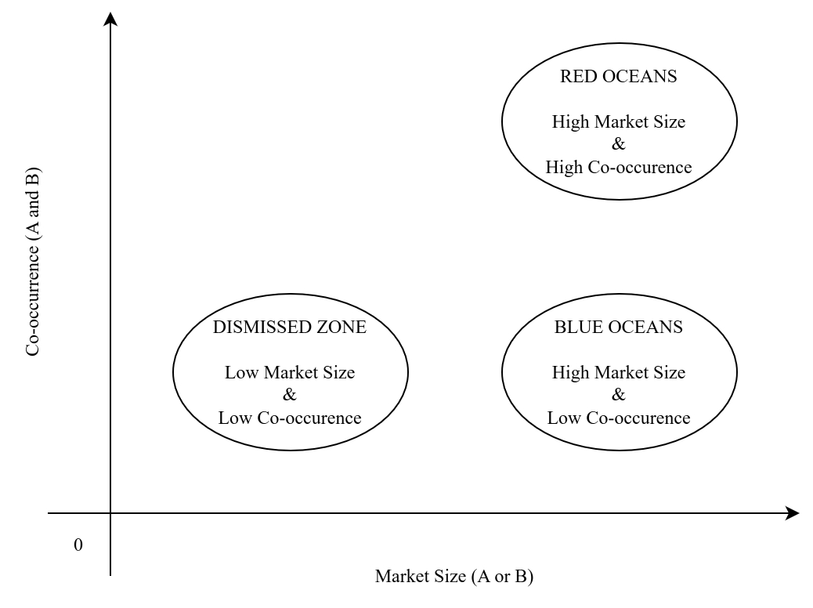

Figure 5. Co-occurrence diagram

Results

Market Overview module findings

Distribution of genres

The empirical distribution of primary metadata categories across the sampled dataset is captured via the interactive Genre Frequency Bubble Chart illustrated in Figure 6. The vertical axis tracks the absolute product count, while the horizontal axis orders the unique category tags by volume density, with bubble volume scaling proportionally to frequency to maximize scannability.

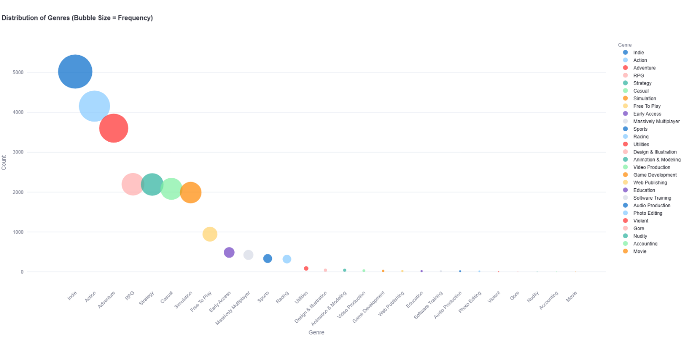

Figure 6. Genre distribution chart

The data exposes an intense concentration of software within a handful of primary categories. The Indie tag sits as the absolute market leader, appearing in 5,021 distinct titles, which represents over half of the entire 10,000 games dataset. This is followed closely by Action at 4,155 titles and Adventure approaching the upper tier at 3,603 titles. Below this primary tier, a highly stable core group emerges, with RPG (2,196), Strategy (2,191), Casual (2,081), and Simulation (1,988) forming a uniform cluster hovering around the 2,000-game mark.
As the chart progresses to the right, a long-tail distribution develops. Specialized classifications and storefront variants such as Free-To-Play (944), Early Access (487), and Massively Multiplayer (426) mark the transition into niche spaces. Beyond traditional gaming parameters, the counts collapse sharply. Non-gaming functional software, including Utilities (86), Design & Illustration (42), and Game Development (24), occupies a tiny fraction of the ecosystem, while specialized records like Accounting (2) and Movie (1) present themselves as near-extinct data anomalies in the overall catalog.

Industry titans by title volumes

The concentration of production volume among the marketplace’s top publishers and developers is operationalized via the Industry Titans Bar Chart illustrated in Figure 7. This horizontal ranking structure maps the absolute number of distinct software titles cataloged per development studio, focusing specifically on the top 10 most prolific entities within the 10,000 games dataset. The horizontal axis measures the exact title count, while the vertical axis registers individual studio branding, color-coded across a continuous blue color scale to emphasize volume density.

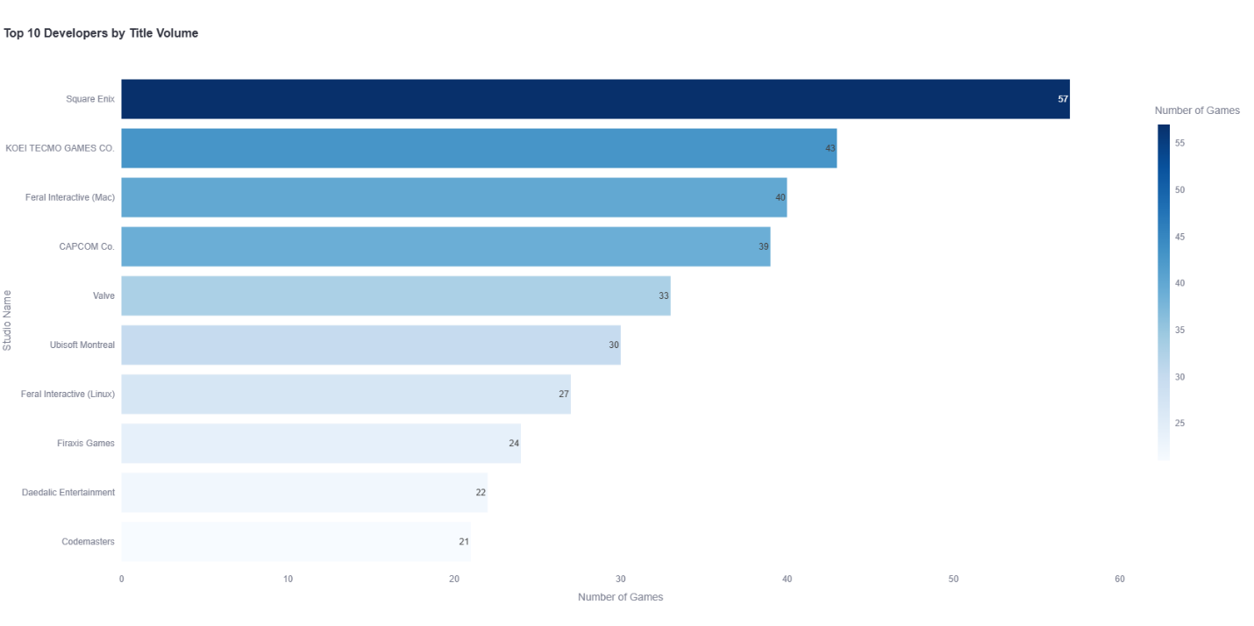

Figure 7. Industry titans chart

The empirical results reveal that Square Enix occupies the absolute apex of production volume on the storefront, tracking 57 distinct commercial titles. A secondary cluster of high-output legacy publishers follows closely, led by KOEI TECMO GAMES CO. with 43 games, Feral Interactive (Mac) with 40 games, and CAPCOM Co. with 39 games.
The lower half of the ranking illustrates a gradual step-down distribution profile: Valve holds 33 games, followed by Ubisoft Montreal at 30 titles, and Feral Interactive (Linux) at 27 titles. The final baseline tier of the top 10 is composed of highly specialized genre leaders, specifically Firaxis Games (24), Daedalic Entertainment (22), and Codemasters at 21 commercial titles.

Title trends wordcloud

The linguistic patterns and semantic choices dominating successful product names within the dataset are mapped via the Title Trends Wordcloud displayed in Figure 8. This visualization utilizes text mining on the titles column, applying automated lowercase conversions, punctuation removal, and standard English stopword filtering. The font scale of each text token corresponds directly to its mathematical frequency in the dataset. To ensure numerical accuracy alongside the visual data, the exact token counts are cross-referenced and organized in Table 2.

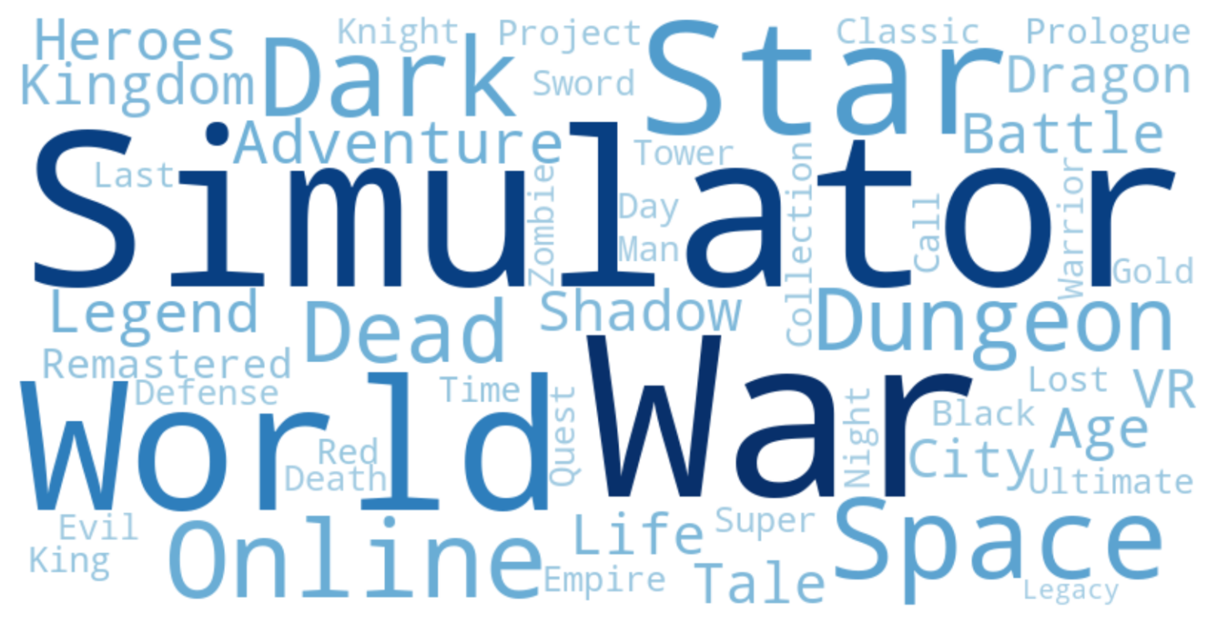

Figure 8. Title trends wordcloud

The text analytics reveal a distinct hierarchy of naming conventions. The absolute typographic apex is occupied by two massive structural keywords: War (185 occurrences) and Simulator (171 occurrences). A strong secondary linguistic tier forms a stable cluster focused on setting scale and environment, featuring keywords like World (115), Star (87), Space (80), Dark (75), and Online (70).
As the token list moves into the mid-frequency range, specific structural or narrative tropes appear, such as Dungeon (69), Dead (66), Adventure (66), and Legend (64). The long-tail distribution of the text tokens features highly specific sub-genres or production tags, including modern release strategies like Remastered (47), Prologue (47), and functional hardware markers like VR (53).

Reviews Analysis module findings

Market leaders and worst rated titles

The Review Analysis module breaks down consumer feedback by separating user sentiment into three distinct operational classifications: Market Leaders (high volume, high score), Hidden Gems (low volume, high score), and Worst Rated (lowest baseline scores). These segments are visualized in Figure 9 (Market Leaders Chart), Figure 10 (Hidden Gems Chart), and Figure 11 (Worst Rated Chart). By isolating review volume thresholds from absolute score ratios, the framework reveals how community size alters storefront visibility.

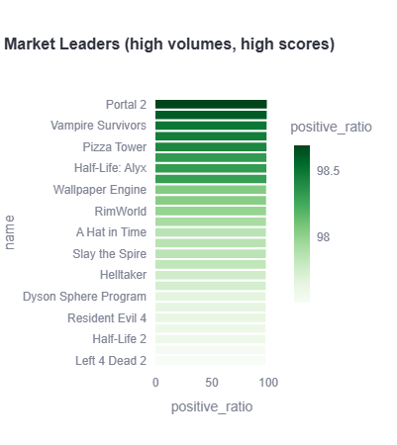

Figure 9. Market leaders chart

Market Leaders
This dataset segment establishes the high-volume benchmark for critical success. The software titles tracked here – such as Portal 2, Vampire Survivors, and Pizza Tower – maintain positive approval ratings between 97.5% and 98.7% while supporting massive review counts (more than 50,000). This proves that their critical acclaim has remained stable across huge, diverse groups of users.

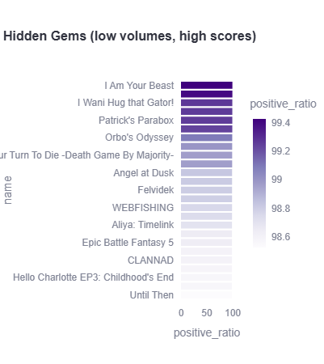

Figure 10. Hidden gems chart

Hidden Gems
When the system lowers the review volume threshold filter, it uncovers an elite tier of niche software. Titles like I Am Your Beast, Patrick’s Parabox, and Orbo’s Odyssey achieve incredibly high approval marks, peaking at a 99.4% positive ratio. These games maintain an almost flawless rating profile because they serve smaller, highly dedicated communities, even though they lack the mainstream visibility of the top market leaders.

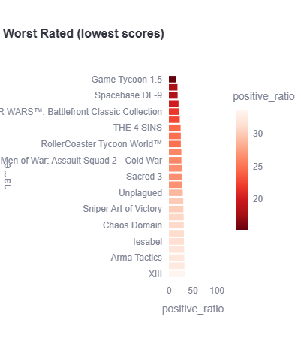

Figure 11. Worst rated chart

Worst Rated
The low-end segment isolates products where consumer consensus has completely collapsed, with positive approval ratings falling below 35%. This negative cluster is anchored by Game Tycoon 1.5, Spacebase DF-9, STAR WARS™: Battlefront Classic Collection, and RollerCoaster Tycoon World™. These projects show the severe technical or design choices that trigger widespread community backlash.

Distribution of review score density versus price

The mathematical relationship between pricing structures and consumer satisfaction is operationalized via the multi-variable scatter plot illustrated in Figure 12. This visualization utilizes a complex layout that combines two distinct data engineering formats into a single dashboard view: a central scatter plot mapping individual title coordinates across a pricing scale (0 to 70 euros) and a vertical satisfaction scale (0% to 100%), and a marginal histogram along the top axis tracking pricing density volumes of distinct review score categories.

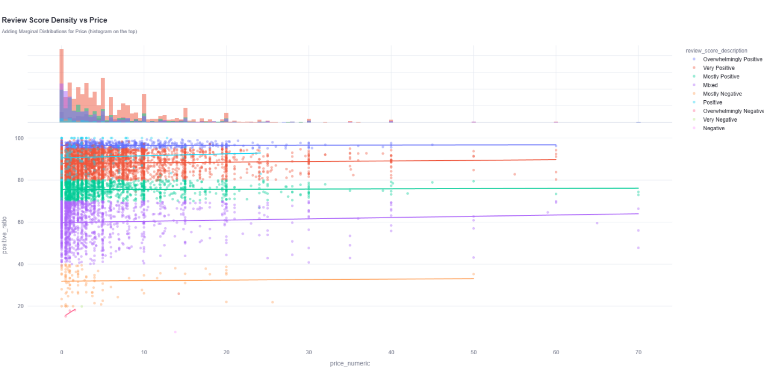

Figure 12. Review score density versus price chart

The empirical results from this multi-layered distribution reveal several critical marketplace patterns:

- Price Density Concentration – The marginal histogram along the top axis illustrates an extreme skew toward low-tier pricing structures. The vast majority of the 10,000 games dataset is concentrated between the €0 and €15 bounds. Beyond the €20 threshold, the product volume drops off sharply, turning into a sparse array of individual data points past €40.
- Stratified Linear Regression Trendlines – The system plots independent OLS regression lines for each localized review tier. These trendlines remain remarkably flat across the entire horizontal axis.
- The Mixed Sentiment Cluster – The most dense, vertically stretched cluster of data coordinates is located in the bottom-left quadrant – specifically within the €0 to €10 pricing range and the 40% to 70% satisfaction zone. This Mixed tier shows a massive statistical variance at low price points, which then thins out significantly as prices cross the €30 mark.

Filtered market segment analysis – Sports genre
To validate the framework’s behavior when de-crowded, Figure 13 demonstrates a targeted slice of the dataset. By filtering the dashboard control panel to isolate the Sports genre and restricting the review score metrics to positive parameters (Overwhelmingly Positive, Very Positive, and Mostly Positive), the extreme crowding from the global view is cleared away. This allows for a precise analysis of an isolated sub-market.

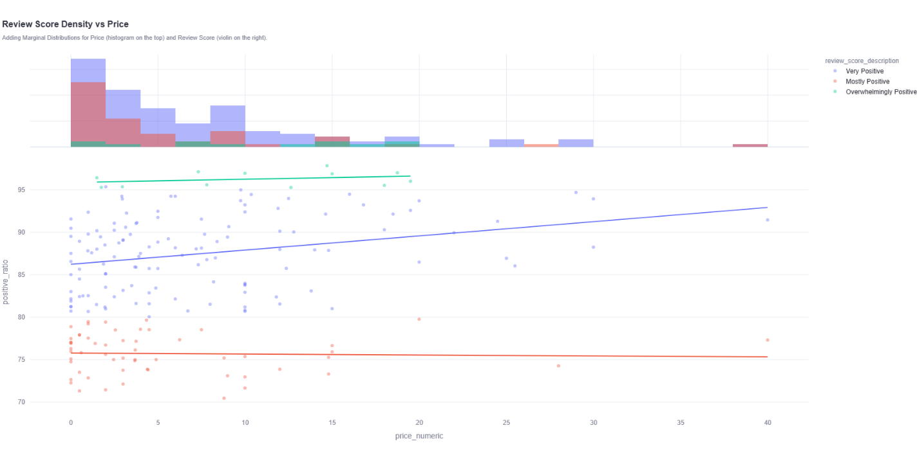

Figure 13. Review score density versus price filtered by sports genre

The empirical results from this filtered distribution display several distinctive properties:

- Price-Ceiling and Density Mapping – The marginal histogram along the top axis reveals that the structural pricing envelope for positive Sports titles breaks down into two distinct sub-zones. The primary cluster is highly compressed between €0 and €10. A small secondary pricing pocket runs between €10 and €20, but beyond the €20 threshold, the supply curve becomes empty, showing only a single outlier tracking out at the €40 mark.
- Positive-Sloping Regression Behavior – Unlike the completely flat trendlines observed in the messy global data, stripping away the low-volume background noise exposes a visible divergence in regression slopes. While the Mostly Positive benchmark remains flat at roughly 75% positive ratio, the Very Positive indicator exhibits a clear, positive upward slope (approximatively 0.16), climbing from an 86% positive ratio at the €0 mark toward a 93% positive ratio as it nears the €40 boundary.

Evolution Trends module findings

Player mode evolution

The historical trajectory of software design formats within the sampled dataset is operationalized via the stacked area visualization illustrated in Figure 14. This section transitions the exploratory data analysis into the Evolution Trends module, tracking the chronological relationship between standalone offline experiences and connected social systems. The horizontal axis maps a continuous time series across nearly two decades of platform release years (2005 to 2024), while the vertical axis tracks the absolute annual release count. The data is stratified into two distinct layers: Single-player design configurations (represented by the lower blue block) and Multiplayer options (the top red block).

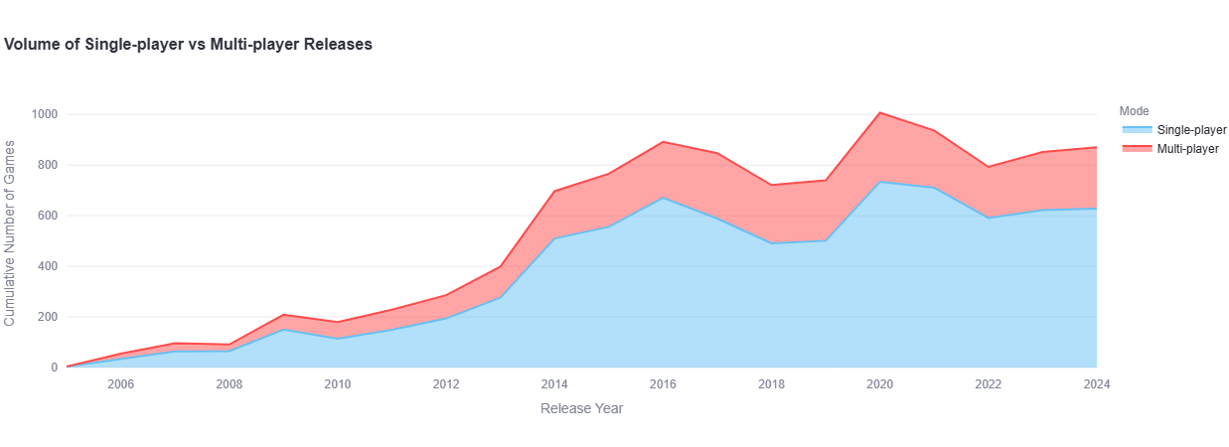

Figure 14. Evolution of single player and multi player releases

The empirical results reveal clear macro development patterns across the platform’s history:

- The Baseline Era (2005-2012) – The initial phase of the timeline is characterized by low absolute volumes, with total yearly catalog additions hovering below 300 units. Throughout this early window, Single-player releases formed the core foundation of the storefront pipeline, while Multiplayer titles occupied a thin, stable secondary margin.
- The Platform Ingestion Surge (2013-2016) – A massive structural break occurs between 2013 and 2016. Total catalog volume jumps sharply, climbing from roughly 400 total games in 2013 to a peak of nearly 900 releases in 2016. Crucially, the visual data shows that both layers expanded proportionally during this surge; the Single-player core block grew to a peak of roughly 670 annual releases, while the Multiplayer layer expanded to supply around 220 titles in the same calendar window.
- The Modern Stabilization Wave (2017-2024) – Following a minor market correction in 2018 and 2019, the catalog reached its absolute peak volume in 2020, registering 1,000 combined releases. The final baseline tier (2022-2024) shows the market settling into a highly predictable, recurring structural split: Single-player titles consistently anchor around 590 to 630 annual releases, while Multiplayer elements maintain a steady share of roughly 200 to 240 units per year.

Targeted segment evolution – Massively Multiplayer category
When filtering the dashboard control panel to isolate only titles carrying the Massively Multiplayer tag, the structural relationship between player modes undergoes an aggressive inversion compared to the broad catalog trends, as illustrated in Figure 15. The empirical results demonstrate that Single-player designations occupy a strictly minor baseline position, while the Multiplayer layer (represented by the red block) expands to dominate the clear majority of this sub-market’s volume.

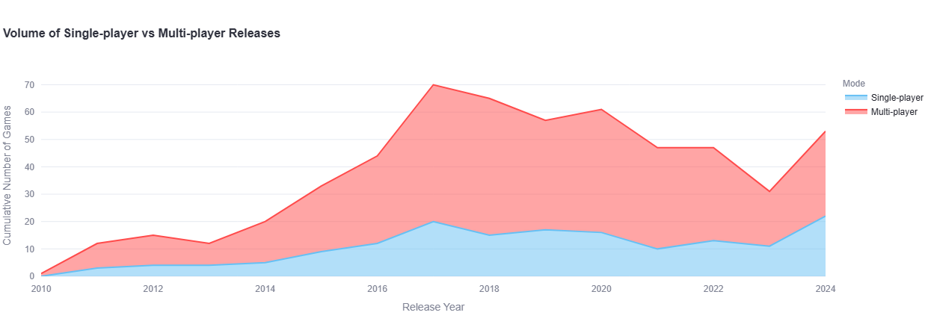

Figure 15. Evolution of single player and multi player releases filtered by category

Throughout this entire longitudinal progression, the Multiplayer layer consistently claims roughly 65% to 80% of the active market share, proving that multi-user functionality is structurally mandatory for entries within this specific classification.

Monetization strategies shift

The historical trajectory of business models within the sampled dataset is operationalized via the multi-line time-series visualization illustrated in Figure 16. This component of the Evolution Trends module tracks the chronological relationship between premium and free-to-play titles. The horizontal axis maps the timeline across a two-decade window of platform release years (2005 to 2024), while the vertical axis tracks the absolute annual release count. The data vectors are stratified into two distinct linear series: Paid titles (represented by the upper red trend line) and Free-to-Play titles (the lower green trend line).

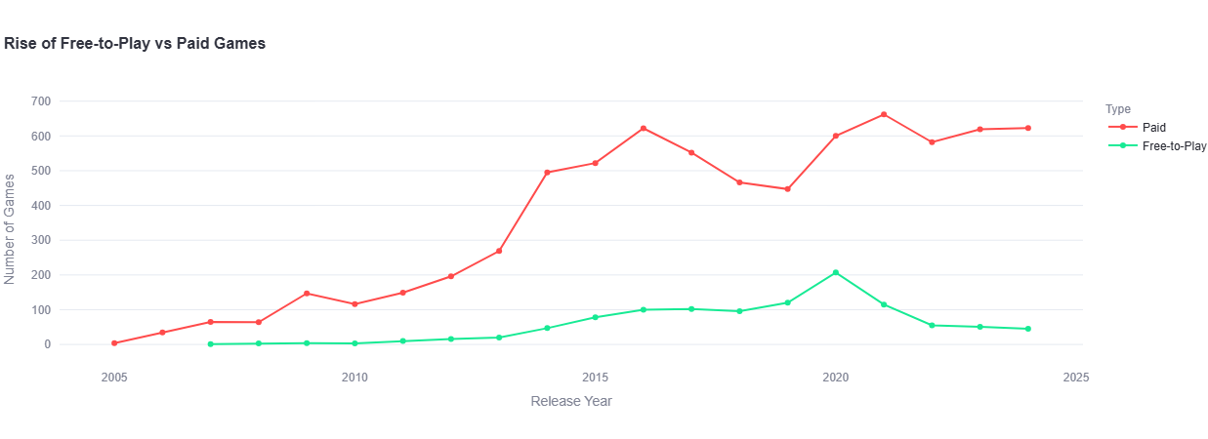

Figure 16. Evolution of free and paid game releases

The empirical results reveal highly visible shifts in platform monetization across three distinct historical eras:

- The Premium Monopoly Era (2005-2012) – Throughout the initial seven years of the timeline, premium upfront purchases completely dominated the storefront pipeline. Free-to-play software was nearly non-existent, flatlining at near-zero entries until 2011. Paid releases climbed slowly but steadily, establishing a baseline range between 100 and 200 titles per year.
- The Dual Expansion Wave (2013-2016) – A massive structural expansion occurs between 2013 and 2016. Driven by a broad surge in total storefront volume, premium paid titles spiked aggressively from 269 releases in 2013 to a peak of 622 releases in 2016. Concurrently, the Free-to-Play green series established its first meaningful footprint on the platform, climbing from just 20 annual titles in 2013 to 100 entries in 2016.
- The Volatility and Divergence Peak (2017-2024) – Following a sharp drop in paid entries during 2018 and 2019, both monetization models experienced a significant volume surge in 2020. Paid releases bounded back up to 600, while Free-to-Play models hit an absolute historical apex of 207 annual releases. However, the post-2020 era illustrates an aggressive divergence. While Paid releases stabilized at an all-time high of roughly 623 annual titles by 2024, the Free-to-Play curve experienced a continuous collapse, dropping steadily downward to sit at a nominal baseline of just 45 releases in 2024.

Targeted monetization evolution – In App Purchases category
When the longitudinal timeline is filtered using the dashboard controls to isolate only software explicitly utilizing In-App Purchases, a distinct structural variation emerges, as shown in Figure 17. This targeted filter alters the platform's standard business model distribution, causing the Free-to-Play (green line) and Paid (red line) vectors to cross paths over the historical timeline.

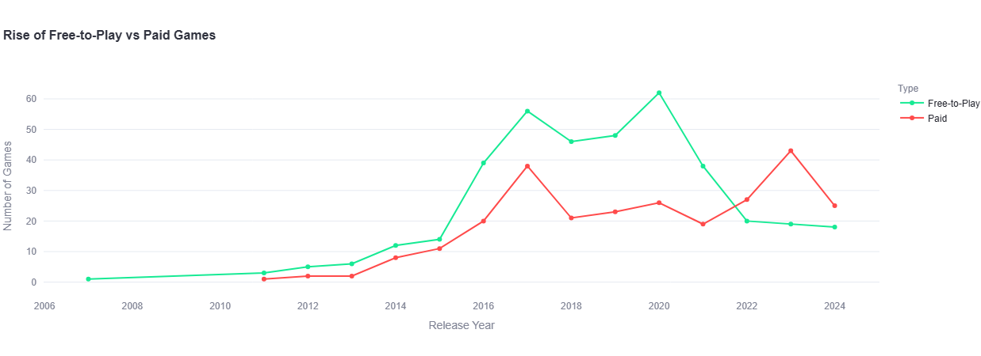

Figure 17. Evolution of free and paid releases filtered by category

The empirical trends within this micro-market break down into clear behavioral shifts:

- The Freemium Expansion Era (2014-2020) – Prior to 2014, software combining upfront free downloads with interior microtransactions was virtually nonexistent, averaging fewer than 5 releases per year. However, beginning in 2014, the Free-to-Play series experienced an aggressive upward run. It consistently outpaced paid implementations, surging to a localized apex of 56 titles in 2017, and reaching its absolute historical peak of 62 annual releases in 2020.
- The Premium-Hybrid Pivot (2021-2024) – After 2020, a major structural inversion occurs. The Free-to-Play line experiences a severe collapse, dropping sharply down to 20 titles in 2022 and flatlining at a historical low of 18 releases by 2024. Conversely, the Paid premium model exhibits high resilience. It resists this downward trend, climbing to its own historical maximum of 43 titles in 2023 before settling at 25 releases in 2024. This late-timeline pivot establishes premium-paid hybrid software as the primary driver of new in-app purchase setups on the platform.

Opportunity Finder module findings

Genre synergy

The multi-dimensional relationship between independent genre popularity and joint product execution is mapped via the Genre Co-occurrence Chart illustrated in Figure 18. This component processes the dataset’s underlying cross-classification matrix to isolate uncompetitive market segments. The horizontal axis represents the combined market size of any given pair of genres, while the vertical axis tracks their absolute co-occurrence (the exact count of games where both tags are simultaneously active). Individual coordinates are color-coded and sized according to a calculated synergy score, with deep red markers highlighting hyper-saturated clusters and green coordinates identifying market openings.

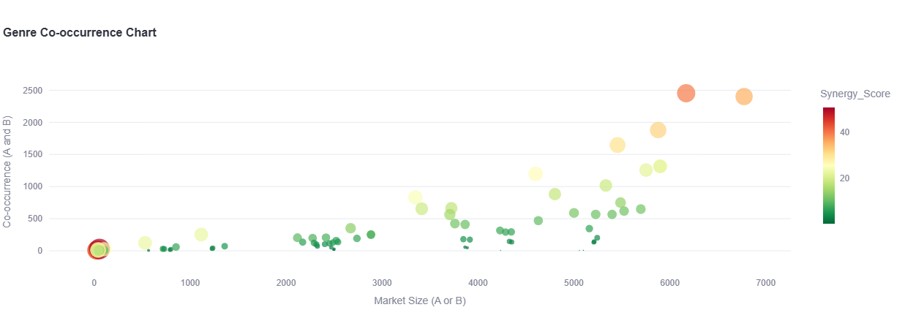

Figure 18. Genre co-occurrence chart

The empirical results reveal a clear separation between saturated product spaces and untouched structural gaps:

- The Saturated Red Oceans (Top-Right Points) – As expected, the platform’s most popular genres by absolute volume are frequently combined within the same software titles. Massive, high-altitude data points cluster in the upper-right section of the chart, representing hyper-saturated “Red Oceans”. This tier is anchored by dominant pairings such as Action + Adventure (Market Size: 5,878; Co-occurrence: 1,880), Adventure + Indie (Market Size: 6,170; Co-occurrence: 2,454), and Indie + Strategy (Market Size: 5,897; Co-occurrence: 1,315). These points carry elevated synergy scores and thick visual footprints, proving a high level of development overlap.
- The Strategic Blue Oceans (Bottom-Right Points) – Conversely, moving toward the lower-right margin reveals highly valuable data anomalies. These points maintain a massive combined market footprint along the horizontal axis, yet their vertical co-occurrence values remain remarkably low. Key examples of these open spaces include combinations of top-tier categories with less popular, systems-driven genres, such as Action + Simulation (Market Size: 5,523; Co-occurrence: 620) and Free-to-Play + Indie (Market Size: 5,398; Co-occurrence: 567). These coordinates sit safely at the bottom of the graph, offering clear empirical evidence of high-demand thematic spaces that the industry has rarely combined into a single product.

Category synergy

The exploratory mapping shifts from high-level genre relationships to the micro-level structural pairings handled by the Category Synergy Chart. This visualization mirrors the scatter plot architecture of the genre module, mapping Market Size horizontally against absolute Co-occurrence vertically. However, because the storefront utilizes a significantly larger array of distinct category tags (e.g., Single-player, Steam Achievements, Full Controller Support, Steam Cloud, Remote Play) compared to basic genres, the matrix density scales exponentially.
Because specific technical categories serve as basic baseline infrastructure requirements across the entire platform, they form tightly packed, hyper-saturated clusters. These are defined by near-mandatory developer implementations, including combinations like Single-player + Steam Achievements. Due to the sheer number of unique categories tracked by the platform API, the scatter plot generates an incredibly dense cloud of overlapping data points along the lower margin. This massive distribution density creates a significant visual barrier, making it difficult to isolate meaningful, isolated insights directly from the raw, unfiltered chart overview.

Discussion

Market Overview module insights

Distribution of genres
The extreme concentration shown by the combination of the Genre Bubble Chart and the associated volumes offers a clear, data-driven explanation for the high failure rates among modern independent software launches. When a developer builds an unmodified Indie-Action-Adventure game, they are voluntarily entering a hyper-saturated, uncompetitive “Red Ocean” crowded with over 3,500 competing products. This massive volume makes organic search visibility mathematically improbable without an enterprise-scale marketing budget.
However, looking closer at the middle tier reveals a more practical strategic path. The equal distribution of the Strategy (2,191) and Simulation (1,988) counts proves that a steady, massive player demand exists for mechanically deep, complex software. Because these genres are inherently harder to build than simple casual games, they face less frequent, low-quality competition.
For an independent creator, this data shows that the best path to avoiding market invisibility isn’t targeting niche long-tail tags like Utilities, but rather finding unique ways to mix popular middle-tier genres, leveraging established community demand while escaping the direct competition of the top three over-saturated categories.

Industry titans by title volumes
The structural distributions exposed by the Industry Titans Bar Chart yield a compelling paradox regarding market dominance in a platform economy. When observing a maximum output of 57 titles from the top publisher within a dataset of around 10,000 games, the mathematics reveal that the storefront exhibits an incredibly low degree of institutional consolidation. Unlike traditional brick-and-mortar retail markets – where a handful of conglomerate suppliers lock down over 80% of physical shelf real estate – the digital storefront operates with a highly fragmented, atomized supply curve. The combined portfolio of the top 10 elite studios represents less than 4% of the active market sample, providing empirical verification that the storefront is structurally open to independent market entry.
A deeper look at the specific studio identities reveals a clear competitive barrier. These “titans” do not compete by throwing massive quantities of small titles at the wall. Instead, they strategically dominate specific, high-barrier genre spaces. Codemasters commands simulation racing, while Capcom anchors high-fidelity survival horror. Furthermore, the prominent appearance of Feral Interactive across both Mac (40) and Linux (27) tiers demonstrates that a significant portion of high-volume listings consists of specialized multi-platform conversion ports rather than entirely new intellectual properties.
In the end, while AAA giants do not mathematically crowd out small studios on total product volume, they do establish intense brand equity within specific genres. To compete effectively, a new studio must avoid a direct confrontation with these highly targeted portfolios, instead seeking out hybrid genres or mechanics that these large corporate structures are too rigid to safely exploit.

Title trends wordcloud
The data generated by this linguistic pipeline exposes a deep psychological connection between naming conventions and immediate genre classification on digital storefronts. Product names do not operate purely as creative expressions. Instead, they function as compressed metadata tags designed to flash an immediate signal to specific player groups.
The top spots held by War (185) and Simulator (171) reflect two very distinct market dynamics. Simulator is an explicit genre label that sets immediate behavioral expectations, telling players the software values mechanical accuracy, player freedom, and systems-driven loop mechanics. Conversely, War sets up immediate thematic context, instantly promising high-stakes conflict, tactical choices, or competitive player loops.
However, from a strategic perspective, relying too heavily on these top-tier keywords poses a real danger of creative erasure. When a developer names their product using the most common tokens – for example, creating a title like “Space War Online” or “Dungeon Simulator” – they risk dissolving into the background noise of a hyper-saturated store layout. The game name becomes so generic that it fails to stand out in search queries.
Furthermore, the rise of Prologue (47) in the data points directly to a major shift in how modern games are launched. Independent studios frequently release free standalone pre-launch chapters to gather community reviews and build wishlist algorithms before the official premium title debuts.
For an independent developer, this text data shows that a smart naming strategy should avoid simply copying the biggest keywords. Instead, developers should pair a recognizable genre signal with an unexpected, highly specific thematic word, making the product instantly clear to search filters while remaining distinct to passing shoppers.

Reviews Analysis module insights

Market leaders and worst rated titles
The data generated by the Market Leaders visualization offers key strategic insights into the relationship between consumer sentiment, pricing, and project scope on digital platforms. An evaluation of the top-performing titles shows a striking mix of multi-million dollar corporate products (Half-Life: Alyx, Resident Evil 4) and minimal, low-budget independent projects. The appearance of Vampire Survivors and Pizza Tower alongside Portal 2 highlights a critical market dynamic: independent developers can outrank major studios by offering tight, hyper-focused gameplay loops at a lower, low-risk price point.
The structural differences between the Hidden Gems list and the Worst Rated index reveal a clear relationship between production scale, pricing strategies, and user expectations. Analyzing these groups side by side gives independent developers a realistic look at how to protect consumer satisfaction while avoiding the major design flaws that ruin digital launches.
The elite ratings found in the Hidden Gems cluster (Patrick’s Parabox, Until Then) demonstrate the strategic power of a hyper-focused development scope. These projects do not try to please the entire mainstream market. Instead, they target specific niches like abstract puzzle design, distinct lo-fi visual styles, or deep narrative themes. Because their marketing is precise, they attract a highly specific audience whose interests align perfectly with the software’s core features. Additionally, many of these titles are priced under €15. This lower financial investment reduces the customer’s initial performance expectations, creating a protective buffer against harsh criticism.
Analyzing the Worst Rated Chart exposes the exact corporate and independent strategies that trigger widespread consumer backlash. The entries fall into two clear problem categories: broken design updates or mismanaged legacy brands. The inclusion of STAR WARS™: Battlefront Classic Collection and RollerCoaster Tycoon World™ shows the severe danger of trading on nostalgic brand recognition without delivering technical stability. When developers charge a relatively premium price (more than €25) for a legacy name but launch with broken multiplayer servers, critical software bugs, or stripped features, consumers respond aggressively. The high price point increases the user’s financial risk, which completely removes any patience for software issues.
For a studio at the start of the journey, these three charts offer a vital strategic lesson. To maintain an excellent reputation on digital storefronts, developers must ensure their marketing claims match the actual technical stability of the software at launch. If resources are limited, the safest path to success is mimicking a Hidden Gem strategy: narrow the product’s scope, focus on a highly specific target audience, and set an affordable price point that respects the consumer’s budget.

Distribution of review score density versus price
Applying filters to the density scatter plot uncovers an important strategic finding regarding genre-specific player expectations and pricing power. When evaluating the Sports sector in isolation, the positive upward tilt of the Very Positive regression line completely shatters the idea that charging more for a game will anger players or lead to worse review scores. In fact, within this specific market category, higher initial price points are statistically associated with a clear increase in player satisfaction.
This upward trend reflects a behavioral phenomenon specific to niche and simulation-heavy software categories. On open digital storefronts, cheap or free-to-play Sports titles often rely on heavy microtransactions, stripped feature lists, or basic mobile-style monetization loops that tend to frustrate core desktop enthusiasts. When an independent developer charges a fair premium price, they signal to the community that the software is a complete, premium package that respects the player’s time and budget. This upfront financial investment pays off by attracting highly dedicated genre fans who value deep mechanics and career modes over casual, free-to-play mobile loops.

Evolution Trends module insights

Player mode evolution
The chronological data generated by the Player Mode Evolution Chart exposes a critical disconnect between high-profile industry media trends and the actual production realities of the digital marketplace. When observing the steady growth of the timeline, it becomes clear that the persistent narrative surrounding the “death of single-player games” is completely disproven by empirical evidence.
The structural distribution of the stacked area chart proves that Single-player software remains the dominant production standard for the platform, consistently capturing approximately 70% of total annual release volumes across the entire two-decade timeline. This persistent dominance reflects a core economic reality for independent developers. Building a Single-player game allows a studio to operate inside a controlled development scope. It eliminates the complex, expensive technical hurdles of networking architecture, server maintenance, real-time synchronization, and continuous matchmaking balance.
Filtering the evolution data down to the Massively Multiplayer segment highlights a challenging, highly specialized competitive landscape that independent creators must evaluate with extreme caution. The massive visual dominance of the Multiplayer red block across the entire timeline provides direct empirical validation of the structural barriers inherent to this genre.
Unlike the general storefront trends – where Single-player games provide a stable, low-overhead fallback for small teams – the Massively Multiplayer sector demands massive upfront and ongoing technical investments. Operating an MMO requires persistent server networks, real-time database syncing, robust anti-cheat infrastructure, and continuous netcode optimization to handle hundreds of concurrent player connections. For a small studio, these operational requirements introduce extreme financial and technical risk before the product even reaches the market.

Monetization strategies shift
The longitudinal data generated by the Monetization Shift Chart exposes a critical trend regarding business model sustainability for independent software developers. The empirical storefront metrics reveal that premium upfront pricing remains the overwhelming, structurally stable choice for commercial software launches.
Filtering the monetization evolution data down to the In-App Purchases tag exposes a deep structural shift in how software developers design their long-term revenue models. The clear crossing lines seen after 2021 provide strong empirical evidence that the classic “Freemium” business model – offering a completely free download supported entirely by interior microtransactions – is losing its viability for new software launches on desktop storefronts. The sharp collapse of the Free-to-Play line (crashing from its peak of 62 titles in 2020 down to just 18 in 2024) points directly to a growing problem with user acquisition costs and consumer fatigue.
This data suggests that if your product design requires interior funding loops like microtransactions, you should avoid the high-churn trap of making it completely free-to-play. Instead, anchoring the project behind a traditional upfront price protects your initial development costs, builds a more mature core user community, and aligns your studio with the modern, sustainable revenue structures of the digital marketplace.

Opportunity Finder module insights

Genre synergy
The distribution of coordinates across the Genre Co-occurrence Chart provides a powerful framework for understanding how independent developers can bypass structural visibility barriers on open digital storefronts. By translating complex cross-classification matrices into an interactive scatter plot, the dashboard moves past simple data tracking, giving creators a reliable way to spot untouched market openings, the “Blue Oceans”.
The intense crowding of points in the upper-right area (Action + Adventure, Indie + Strategy) shows a safe, conventional approach to product development. When a studio builds a game that combines the platform’s two largest genres, they are relying on a massive, pre-existing player community. However, from a strategic perspective, this approach is highly dangerous for smaller teams. Entering a market with high co-occurrence rates means competing directly with thousands of established titles, making organic search discoverability nearly impossible without an enterprise-scale marketing budget.
The real strategic value of the matrix algebra is found by looking at the bottom-right area. Pairings like Action + Simulation and Free-to-Play + Indie demonstrate an alternative path to success. These positions reveal a massive total audience footprint combined with an incredibly low intersection count. This lack of competition represents a clear gap in the market.
This chart serves as a concrete guide for product design. It proves that a studio does not need to invent an entirely new, unverified genre to find commercial success. Instead, by using the platform’s metadata matrix, developers can identify popular, established themes that have rarely been combined, carving out an uncompetitive market space that secures immediate visibility and long-term viability.

Conclusion

Research summary

The comprehensive data engineering architecture and interactive visualization framework developed in this research establish a transparent, empirical foundation for real-time market discovery within digital software ecosystems. By engineering an end-to-end analytical solution, traversing from fault-tolerant API ingestion loops with linear back-off safety steps and optimized relational SQLite schemas to interactive exploratory data analysis dashboard modules, this thesis bridges the gap between raw web-scale metadata and strategic commercial forecasting.
The platform’s utility resides in its capacity to transform thousands of unstructured, volatile platform observations into structured, scannable quality signals and competitive market vectors. Independent developers can systematically transition away from speculative, high-risk development roadmaps, utilizing the system’s linear regression price-sentiment diagnostics and co-occurrence scatter plot to isolate concrete, low-competition “Blue Ocean” market spaces before allocating development capital.

Key empirical discoveries

Through the operational deployment of the Streamlit decision support platform, this study has yielded several critical insights that challenge conventional assumptions in digital publishing economics:

- Market Macro Density – Evaluation of the 10,000 games dataset confirms an intense tier-one saturation in traditional Indie, Action, and Adventure tags, whereas complex, mechanics-driven mid-tiers like Strategy and Simulation represent highly stable, less competitive structural alternatives.
- The Value-to-Cost Paradox – Through OLS regression mapping, this framework mathematically disproved a universal premium pricing bias. Flat and positive regression slopes, specifically within niche categories like the Sports sector, verify that consumers judge digital assets based on relative technical value and complete feature loops rather than absolute upfront cost.
- Temporal and Monetization Shifts – Longitudinal analysis exposed a significant contraction in the pure Free-to-Play and Freemium business models post-2020 due to high user-acquisition costs and community fatigue, revealing a clear strategic pivot toward premium-hybrid structures (Paid + In-App Purchases).
- High Dimensional Gap Isolation – Utilizing symmetric co-occurrence matrix math, the Opportunity Finder successfully demonstrated how independent creators can bypass traditional visibility barriers by targeting sparse coordinate intersections (e.g., Action + Simulation) located in the less competitive bottom-right quadrant of the market catalog.

Limitations and future architectural directions

Despite the platform’s predictive performance, several structural enhancements can be implemented to advance its feature depth and processing capabilities. A primary area for architectural improvement involves transitioning the ingestion pipeline from a batch-processing configuration to an asynchronous, real-time stream processing framework using tools like Apache Kafka or AWS Lambda. Currently, the system relies on static relational lookups in an SQLite database, which requires manual updates to capture rapid platform shifts. Incorporating dynamic data streaming would enable the dashboard to render real-time changes in consumer sentiments and pricing strategies instantly.
Furthermore, the Title Trends Wordcloud can be significantly upgraded by replacing basic regular-expression tokenization with advanced Natural Language Processing (NLP) models, such as Named Entity Recognition (NER) or semantic sentiment analysis. This upgrade would allow the system to parse the emotional intent and stylistic tone of game descriptions and user reviews, rather than simply tracking raw keyword frequencies.
Looking further ahead, the long-term roadmap for this research involves expanding the system’s predictive modeling and cross-platform scope. While the current regression trendlines offer historical insights into value thresholds, integrating supervised machine learning frameworks, such as Random Forests or gradient-boosting algorithms (XGBoost), would enable the system to actively forecast a game’s future review ratio and unit sales before launch based on its planned genre mix, pricing, and description text.
Additionally, expanding the pipeline’s ingestion layer to automatically harvest metadata from secondary digital storefronts (such as the Epic Games Store, GOG, and console ecosystems) would provide a complete, multi-platform view of the global gaming market. With these improvements, this analytical framework can serve as an enduring, enterprise-grade decision support system for independent software engineering and digital publishing.

REFERENCES

Andraž De Luisa, J. H. D. N. S. P. M. R. B. S. J. D. E. Š., 2021. Predicting the Popularity of Games on Steam. Research Gate.
Available at: https://doi.org/10.48550/arXiv.2110.02896

Dayi Lin, C.-P. B. A. E. H., 2018. An empirical study of game reviews on the Steam platform. Empirical Software Engineering.
Available at: https://doi.org/10.1007/s10664-018-9627-4

Galyonkin, S., 2025. SteamSpy. [Online]
Available at: https://steamspy.com/
[Accessed 2026].

Galyonkin, S., 2025. SteamSpy API. [Online]
Available at: https://steamspy.com/api.php
[Accessed 2026].

Hipp, D. R., n.d. SQLite Home Page. [Online]
Available at: https://www.sqlite.org/
[Accessed 2026].

Inc., P. T., 2026. Plotly Python Graphing Library. [Online]
Available at: https://plotly.com/python/
[Accessed 2026].

iProov, 2025. Rate Limiting - Developers. [Online]
Available at: https://docs.iproov.com/implementation_A-Z/rest_api/rate_limiting/rate_limiting
[Accessed 2026].

Mark O’Neill, E. V. J. W. D. Z., 2016. Condensing Steam: Distilling the Diversity of Gamer Behavior. s.l., s.n.
Available at: http://dx.doi.org/10.1145/2987443.2987489

McKinney, W., 2010. Data Structures for Statistical Computing in Python. s.l., s.n.
Available at: https://doi.org/10.25080/Majora-92bf1922-00a

Muhammad Nazhif Rizani, M. N. A. K. H. I., 2023. Application of Meta-Gaming Concept to the Publishing Platform: Analysis of the Steam Games Platform, s.l.: s.n.
Available at: http://doi.org/10.3390/info14020110

NewbieIndieGameDev, 2024. steam-insights. s.l.:NewbieIndieGameDev.
Available at: https://github.com/NewbieIndieGameDev/steam-insights

Sangho Ahn, J. K. S.-U. P., 2017. What Makes the Difference Between Popular Games and Unpopular Games? Analysis of Online Game Reviews from Steam Platform using Word2Vec and Bass Model.. ICIC Express Letters.
Available at: https://doi.org/10.24507/icicel.11.12.1729

Simone Petrosino, A. K. E. L. J. P., 2022. The Panorama of Steam Multiplayer Games (2018-2020): A Player Reviews Analysis. s.l., s.n.
Available at: https://doi.org/10.1145/3555858.3555922

Streamlit-Team, n.d. Streamlit documentation. [Online]
Available at: https://docs.streamlit.io/
[Accessed 2026].

Thorhauge, A. M., 2022. The Steam platform economy: From retail to player-driven economies. Sage Journals.
Available at: https://doi.org/10.1177/14614448221081401

Valve, 2026. Steam Web API - Valve Developer Community. [Online]
Available at: https://developer.valvesoftware.com/wiki/Steam_Web_API
[Accessed 2026].

Xiaozhou Li, B. Z., 2020. A Preliminary Network Analysis on Steam Game Tags: Another Way of Understanding Game Genres. s.l., s.n.
Available at: https://doi.org/10.1145/3377290.3377300

