FOCUS: THE CIVIL WAR; POST-WAR AMERICA; LOCAL COLORISM

THE CIVIL WAR (1861-1865)

The most significant issue of the century was slavery. All northern states had abolished slavery by the early 1800s, but the plantation system of farming in the South depended on a cheap labor force for its economic survival, and black slaves were therefore indispensable. Denouncing the ‘peculiar institution’ of slavery as a moral sin, the abolitionist movement gained strength particularly in the New England states, and southerners became more and more convinced that federal government would eventually outlaw it. During the 1830s some southern leaders justified the existence of slavery by arguing that whites were superior to blacks and that their status as slaves was perfectly suited to their natural condition, an argument that found many supporters in the South. This very delicate question rapidly became the issue of a sectional quarrel whose roots lay in the different economic and social structure of the North and South. It was later to lead to the outbreak of civil war.

The ongoing dispute between North and South over the issue of slavery came to a head in the 1850s. The vast areas of land conquered in the West had to be split up into territories and then states. This meant that the delicate constitutional balance in the Senate between free states and slave states – achieved by means of the Missouri Compromise in 1820 – would once again be at risk. The newly formed states would have to declare themselves in favor of slavery or its abolition, and the painstakingly earned political status quo would be overthrown.

When California applied for statehood in 1849 a fierce debate ensued as to whether it should be a free state or a slave state: northerners favored the former and southerners the latter solution. Compromise was reached a year later: California would be admitted as a free state and in Washington slavery would be abolished. In order to satisfy the southern states Congress created two new territories, New Mexico and Utah, and ruled that residents would decide whether or not to become slave state when they were given full statehood.

The problem rose again in the early 1850s when Congress began considering the creation of new territories between Missouri and present-day Idaho. Flagrantly ignoring the requirements of the Missouri Compromise that slavery would be ‘forever prohibited’ in all the territory gained from Louisiana Purchase north of Missouri’s southern border, Congress passed the Kansas-Nebraska Act in 1854: two territories – Kansas and Nebraska – were created west of Missouri and the people were to be allowed to decide for themselves as to their future status as free or slave states. With this controversial measure popular sovereignty took precedence over congressional edict.

The effects of this Act were calamitous and the country was thrown into social and political turmoil. A group of ‘free soil’ and anti-slavery advocates formed the Republican Party in 1854 and were joined by sympathizers from both the Democratic and the Whig parties. A new party called the Know Nothing Party attracted the support of Americans seeking simpler answers to a very complicated question. Political disintegration was accompanied by a split among church groups, while the Supreme Court – a highly respected American institution – lost credibility in the North as a result of the Dred-Scott Decision in 1857: blacks, it was held, were not citizens and the laws limiting the spread of slavery were unconstitutional. The compactness of the Union was in great danger of disintegrating.

Social disorder and fighting between pro- and anti-slavery groups became commonplace.

The publication of **Harriet Beecher Stowe’s** *Uncle Tom’s Cabin* in 1851 served to inflame public opinion still further:

* Initially published in serial form in the *National Era*, an anti-slavery paper in Washington;
* The novel was highly influential in stirring up popular feeling against slavery, and was cited by Lincoln as one of the main causes of the Civil War.
* The impact of the book lies in its illustration of slavery’s effects on families, and to help readers empathize with enslaved characters.
* *Uncle Tom’s Cabin* contributed to the outbreak of war by personalizing the political and economic arguments about slavery.
* Conversational writing style, which inspired people.

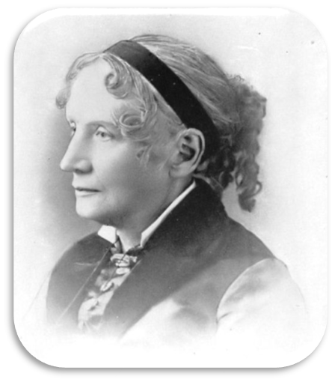 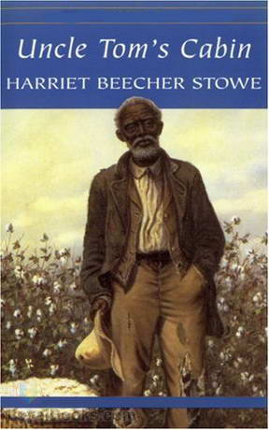

**Harriet Elisabeth Beecher Stowe** (1811 – 1896)

The election of Republican Party candidate, Abraham Lincoln, to the Presidency of the United States in 1860 was to prove unacceptable to southerners because of his staunch anti-slavery views, and in December of that year South Carolina seceded from the Union. Six other southern states took the same decision a month later and together they formed the Confederate States of America. Five more states, including Texas and Virginia, joined the confederacy later, in 1861: the Union was well and truly split down the middle. Once in office Lincoln refused to recognize the Confederacy and insisted they had no right to leave the Union, which was to be preserved at all costs. By April 1861 Confederate forces were at war with those of the Union: the American Civil War had begun.

Better organized and financed, the soldiers of the Union gradually wore down the spirited forces of the Confederacy, led by the courageous general Robert E. Lee. In 1865 General Ulysses Grant forced Lee’s surrender in Virginia. The Civil war cost the country dear: it has been estimated that approximately 360,000 Union troops and 260,000 Confederates died during the conflict – more than in any other war in which Americans have participated. Cities, roads, factories and plantations were left in ruins in the South, and feelings of bitterness between Southerners and Northerners were to long outlast the boom of the ferocious cannons.

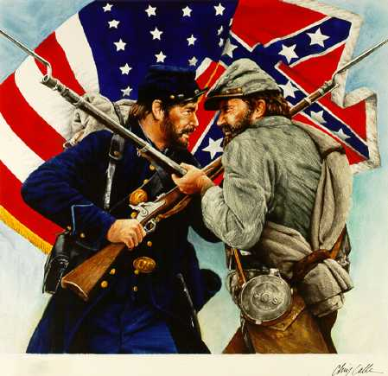

RECONSTRUCTION

After the war a period of rebuilding known as Reconstruction began in the war-torn South. Disagreement among the Northerners as to when and under what conditions Confederate states should be re-admitted to the Union led to a split among politicians. Northern moderates sought mild treatment of offenders while the radicals looked for more severe forms of punishment and greater guarantees for blacks. Lincoln’s attempts to pacify the two factions were cut short by John Wilkes Booth who assassinated him one week after the war ended. Andrew Johnson, his successor, was unable to placate the fury of the radicals and was forced to bow to their wishes in the program of reconstruction.

Much to the dismay of the Southerners, troops were sent to occupy the South and Republican politicians took over local government in the area. Confederate states were forced to accept and follow all federal laws before being allowed back into the Union. By 1870 the Union was once again complete, all ex-Confederate states having returned to the fold. Congress passed the thirteenth, fourteenth and fifteenth amendments to the constitution in an attempt to further the rights of blacks in America: the thirteenth amendment (1865) abolished slavery in the United States, the fourteenth (1868) confirmed the citizenship of blacks and the fifteenth (1870) made it illegal to deny the right to vote on the basis of race. All these measures aroused resentment on the part of Southerners.

THE EFFECTS OFTHE **RECONSTRUCTION**

Reconstruction can only be said to have been partially successful. Although legally free, the majority of blacks who remained in the South continued their lives much as before, and Congress was unable to provide them with any form of social and economic security. Indeed, violence and intimidation (the Ku Klux Klan had its beginnings in this period) on the part of desperate whites ensured there was very little progress in terms of human rights, and black rights was to remain a highly delicate issue for generations to come. Defeat in the Civil War also meant the end of certain way of life in the South: many of the great plantation owners were forced to sell their lands to small farmers and abandon their aristocratic southern lifestyle.

INDUSTRIAL EXPANSION

Post-Civil War American society was characterized by massive industrialization in the North and an astonishing growth in population. The social and economic problems which accompanied this expansion were met by a large number of political reforms as the newly united nation slowly began to find its feet on both the domestic and international stage. The South of the United States remained essentially agricultural, both blacks and whites now having become landowners and farmers. The American frontier began to close since much of the vacant land had been sold at very low prices to farmers, under the Homestead Act of 1862. Many of these men set up farms among the Great Plains which had wrongly been considered barren and infertile. Settlement, or the laying down of roots, also put an end to the Indian way of life: the buffalo herds on which many tribes depended were slaughtered by advancing whites and by 1900 the vast majority of Indians lived on reservations provided by the federal government.

In a process comparable to the Industrial Revolution in Britain, American industry became more highly mechanized. Manufacturing methods became more efficient and productive as newer and larger factories in the growing number of industrial cities, particularly in the North, were organized along the lines of the division of labor. Machines were used in ever greater numbers and businesses were able to charge lower prices for the range of new products available: the typewriter (1867), the telephone (1876), the phonograph (1877) and the gasoline automobile (1885) made their first appearances in this period. The last one was to have an enormous impact on American – and world – society as Ransom Olds and Henry Ford began turning out mass produced vehicles. Indeed, by 1916 no less than 3.5 million people owned a car – as opposed to only 8,000 in 1900.

America’s wealth of natural resources – including timber, coal, copper, silver and, most importantly, gasoline oil – was exploited to the full. Iron and steel products enabled men like Andrew Carnegie to build growing numbers of railroads, machines, bridges, cars and skyscrapers, and as the landscape of the country changed, so these self-made men joined the burgeoning ranks of America’s first millionaires.

BIG BUSINESS

The discovery of oil in Texas and other states assisted northern industry in its inexorable drive forwards and was to prove vital to the future economy of the United States. Business was booming. The number of banks increased rapidly, as did the number of people willing to invest money in capitalistic enterprises. The role of business owners in the political decision-making process was to become ever more important as time progressed, although a lack of regulations and laws regarding business and corporations was not without its problems, as the growing number of ruthless monopolies and trusts demonstrated.

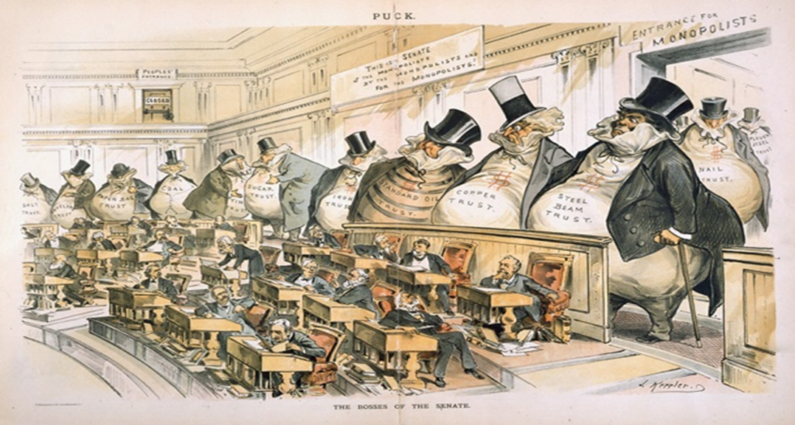

Important steps were also made in the field of transport and communications. Railroad construction reached its peak in the late 1860s with the completion of the first transcontinental railroad system in Utah: with the joining of the Central Pacific and Union Pacific railroads the United States was linked coast to coast for the first time. By the end of the century the railway network had spread from 14,500 km in 1850 to an astonishing 320, 000 km, thus facilitating national transportation not only of passengers but of goods as well. Just as the railroad marked an advance on the stagecoach with regard to mail delivery, so the telephone gradually substituted the telegraph system, and communications became quicker and more reliable.

AMERICAN SOCIETY

Economic growth was in part facilitated by a growing domestic market. By 1916 America’s population had more than doubled its 1870 level of 40 million to almost 100 million. Significantly, half of these people lived in towns or cities where business thrived and work was more readily available. Immigration was a prime factor in swelling the numbers of population: more than 25 million people from countries all over the world entered America between 1870 and 1920. Immigrants arriving in the ‘Promised Land’ provided both cheap labor and a ready market of consumers.

During what Mark Twain called ‘The Gilded Age’, many individuals amassed huge fortunes and attempted to imitate the culture and manners of their upper class European counterparts. They built glamorous mansions, bought and imported European works of art, attended the opera and went to refined clubs and restaurants. The growing ranks of America’s middle class consisted mostly of small time business owners and factory or office managers. They too shared in the enormous quantities of wealth generated by the boom. The working or laboring class, however, lived for the most part in great poverty in crowded slums and tenement buildings with little or no sanitation. Disease was common, working hours were long and education among the poor was virtually non-existent. Unemployment due to labor surpluses only served to aggravate their wretched conditions during the depressions of 1873, 1884, 1893 and 1907. No state assistance was available at that time and many workers faced an enormous struggle to survive. What little leisure time they possessed was spent at circuses, vaudeville shows and sporting events. Indeed, baseball became the national sport, and dime novels, together with magazines and, after 1900, the motion pictures, helped to form a mass leisure market which changed relatively little up until more recent times.

THE ‘PROGRESSIVE ERA’ (1890-1917)

During what is frequently referred to as the ‘Progressive Era’ (1890-1917), reformers or ‘progressives’ as they had become known, succeeded in bringing about many changes. During the 1880s farmers’ unions successfully pressed the railroad companies to lower transport costs. Better wages and working conditions were obtained through the efforts of the American Federation of Labour (AFL), a union of skilled labourers formed in 1886. Strikes of varying length and effectiveness became increasingly common occurrence in American society, although it was not until the twentieth century that the situation of laborers improved to any great extent. Their cause was set back considerably by the Haymarket riots in 1886 when eight policemen died during an open rally. The National Woman Suffrage Association was founded in 1869, and in the same year Wyoming was the first territory to give women the right to vote. Other states followed suit afterwards, although suffrage was limited to local elections only.

LITERARY CONTEXT

As the nineteenth century drew to a close, American writers produced a wide variety of works, particularly in the field of prose. If American drama had to wait until the 1920s for its true voice in Eugene O’Neill, poetry was still reeling from the shock waves generated by Whitman, and very little of note was produced until the early decades of the twentieth century.

As the frontier moved west to its ultimate resting place on the Pacific Ocean, so Americans became more inquisitive about people living in other parts of the country. After the Civil War, their curiosity was in part satisfied by a number of authors known collectively as ‘literary comedians’ and ‘local colorists’.

LOCAL COLORISM – THE BEGINNING OF REALISM

* Wrote mainly for newspapers and magazines;
* Concentrated on colorful descriptions of local traditions, customs, manners, dress and – most importantly – dialects and speech;
* Their humor - mostly bound up with slang, bad spelling and incorrect grammar;
* Some of these authors wrote amusing ‘tall tales’ about exaggerated heroes and incidents;
* More serious stories and novels covering almost every corner of the country were written by the ‘local colorists’: in their sympathetic portrayal of mostly simple folk in provincial communities and their attention to dialect and local customs.
* These works in part paved the way for the movements of realism and naturalism which were to dominate the American novel over the coming decades.
* **Francis Bret Harte (1836 – 1902)** – best remembered for his short fiction featuring miners, gamblers, and other romantic figures of the California Gold Rush.