**THE LOST GENERATION**

FOCUS: Ernest Hemingway; Francis Scott Key Fitzgerald

World War I was followed by a period of spiritual crisis characterized by:

* the feeling of gloom and despair;
* modern warfare was not glorious or heroic;
* a sense of doom, dislocation and fragmentation;
* a sense of loss: a loss of faith and of inherited, pre-war values, which no longer seemed relevant;
* pre-war ideals of patriotism, faith and morality were questioned;
* writers felt the old norms were no longer relevant.

**LOST GENERATION** - in general, the post-World War I generation, but specifically a group of U.S. writers who established their literary reputations in the 1920s: **Ernest Hemingway, F. Scott Fitzgerald, John Dos Passos, E. E. Cummings, Archibald MacLeish, Hart Crane, T. S. Eliot** and many other writers who made Paris the center of their literary activities in the 1920s. They were never a literary school and in the 1930s they turned in different directions.

Spiritual alienation from a U.S. that seemed to be hopelessly provincial, materialistic, and emotionally barren.

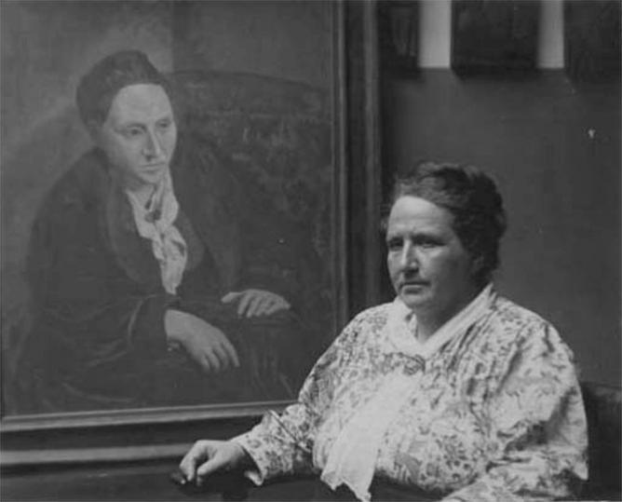The term was coined by **Gertrude Stein** -an American novelist, poet, playwright, and art collector, who once said to Hemingway:

***“All of you young people who served in the war. You are a lost generation... You have no respect for anything. You drink yourselves to death.”***

**Gertrude Stein**

CHARACTERISTICS:

* Expatriates who lived in Paris;
* Sought the meaning of life;
* Youthful idealism;
* Excessive drinking;
* Excessive behavior;
* Frequent love affairs;
* Rejected modern American materialism;
* Produced some of the finest literary masterpieces.

COMMON THEMES:

* The authors’ experiences in World War I and their life after it;
* The lifestyle and the low moral of the wealthy (*The Sun Also Rises; The Great Gatsby*);
* The death of the American dream (*The Great Gatsby*).

**Ernest Hemingway**(1899–1961)

SOME BIOGRAPHICAL FACTS

* In high school - worked on his school newspaper, *Trapeze and Tabula*, writing primarily about sports;
* Immediately after graduation - went to work for the *Kansas City Star;*
* 1918: went overseas to serve in World War I as an ambulance driver in the Italian Army;
* At the age of 20 - returned to the United States;
* Spent time in northern Michigan before taking a job at the *Toronto Star;*
* Met his first wife (Hadley Richardson) and they moved to Paris;
* In Paris, Hemingway soon became a key part of what Gertrude Stein would famously call the *Lost Generation*;
* Hemingway made the acquaintance of many great writers and artists of his generation: F. S. Fitzgerald, Ezra Pound, Pablo Picasso and James Joyce;
* 1928: settled in Key West, Florida;
* The 1930s: writing and chasing adventure - big-game hunting in Africa, bullfighting in Spain, deep-sea fishing in Florida;
* When the United States entered World War II, Hemingway served as a correspondent;
* By this time the writer had also begun frequenting the famous Festival of San Fermin in Pamplona, Spain.

AWARDS

Silver Medal of Military Valor, Italian Armed Forces (WWI)

Bronze Star, United States Armed Forces (1947)

Pulitzer Prize(1953)

American Academy of Arts and Letters Award of Merit (1954)

Nobel Prize for Literature (1954)

BASIC WORKS:

* [***The Sun Also Rises***](https://en.wikipedia.org/wiki/The_Sun_Also_Rises) **(1926)**
* [***A Farewell to Arms***](https://en.wikipedia.org/wiki/A_Farewell_to_Arms) **(1929)**
* [***For Whom the Bell Tolls***](https://en.wikipedia.org/wiki/For_Whom_the_Bell_Tolls) **(1940)**
* [***The Old Man and the Sea***](https://en.wikipedia.org/wiki/The_Old_Man_and_the_Sea) **(1952)**
* [***A Moveable Feast***](https://en.wikipedia.org/wiki/A_Moveable_Feast) **(1964)**

And many more books, non-fiction, letters and short stories.

HEMINGWAY’S WRITING STYLE

* The tip of the iceberg;
* Simple, direct, and unadorned style, probably a result of his early newspaper training;
* Avoids the adjective whenever possible;
* A master of dialogue.

**Francis Scott Key Fitzgerald** (1896 – 1940)

SOME BIOGRAPHICAL FACTS

* Studied in Princeton and wrote scripts for musicals, articles and stories*;*
* Dropped out of school in 1917 to join the U.S. Army;
* Afraid that he might die in World War I with his literary dreams unfulfilled, he hastily wrote a novel called *The Romantic Egotist*.
* Fitzgerald was assigned to Camp Sheridan, Alabama where he met and fell in love with 18-year-old Zelda Sayre, the daughter of an Alabama Supreme Court judge.
* Upon his discharge he moved to New York City hoping to launch a career in advertising lucrative enough to convince Zelda to marry him.
* However, he quit his job after only a few months and returned to St. Paul to rewrite his novel.

WORKS

***This Side of Paradise***(1920)

* A largely autobiographical story about love and greed;
* The novel turned Fitzgerald into one of the country's most promising young writers;
* One week after the novel's publication, he married Zelda Sayre in New York.

***The Beautiful and Damned***(1922)

* The story of the troubled marriage of Anthony and Gloria Patch;
* Confirmed Fitzgerald’s status as one of the great chroniclers and satirists of the **Jazz Age –** aculture of wealth, extravagance and ambition.

***“It was an age of miracles, it was an age of art, it was an age of excess, and it was an age of satire."***

***The Great Gatsby***(1925)

* Narrated by Nick Carraway, a Midwesterner who moves next door to a mansion owned by the wealthy and mysterious Jay Gatsby.
* The novel follows Gatsby's pursuit of a married woman ultimately leading to his exposure as a bootlegger and his death.
* Perhaps the quintessential American novel;
* Beautiful lyricism, perfect portrayal of the Jazz Age, a critique of materialism, and the American Dream.

***Tender is the Night***(1934);

* The darkest and most autobiographical of Fitzgerald's novels;
* It focuses on Dick and Nicole Diver's crumbling marriage.
* A story of estrangement and infidelity;
* Explores how love can be won, lost, and perverted by different forces like money, illness, and politics.

PERSONAL ISSUES

* Always a heavy drinker, he progressed steadily into alcoholism;
* Suffered prolonged periods of writer's block;
* Zelda suffered from mental health issues;
* The couple spent the late 1920s moving back and forth between Delaware and France.
* 1937: Fitzgerald attempted to revive his career as a screenwriter and freelance storywriter in Hollywood;
* 1939: began work on another novel, *The Love of the Last Tycoon*, but he died of a heart attack before finishing it.

