**1940-PRESENT**

**HISTORICAL CONTEXT**

PARTICIPATION IN WW2

Following the Japanese bombing of Pearl Harbor in 1941, America joined the Allies in their fight against Italy, German and Japan. Their contribution was to prove decisive: 15 million men joined the armed forces, many of whom were deployed in Europe, and the Allied war effort was much strengthened. In 1945, President Truman gave orders to drop the atomic bomb on Nagasaki and Hiroshima, and thus brought to an abrupt end the Second World War.

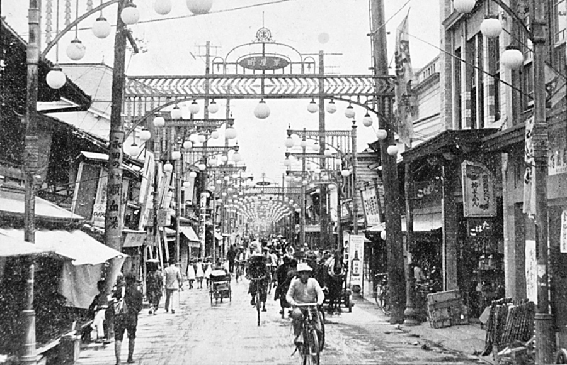 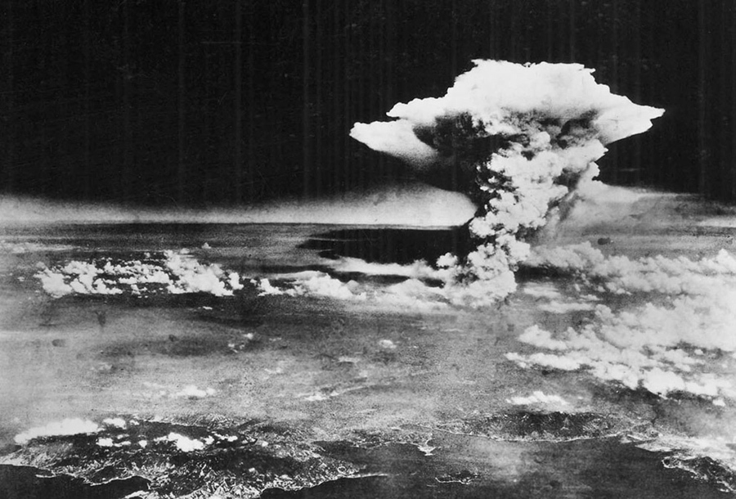

**BEFORE THE EXPLOSION THE EXPLOSION**

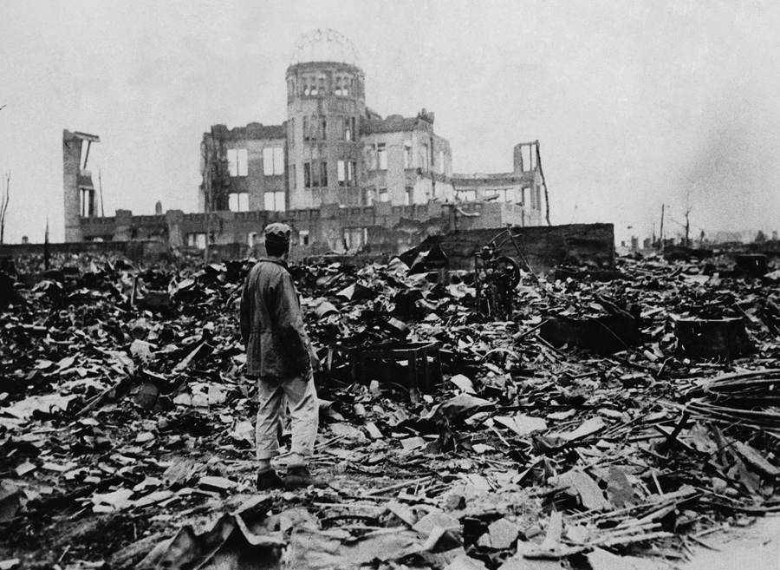

**AFTER THE EXPLOSION**

THE COLD WAR

Despite being allies throughout the war, Russia and the Americans were to embark on a new kind of war after 1945: the so-called Cold War lasted up until very recent times and was characterized by American attempts to contain the advancing threat of communism throughout the world. America provided countries threatened with communism with both financial and military aid up until the official collapse of the Eastern Bloc in the late 80s. Both the wars in Korea (1950-53) and Vietnam (1957-75) saw American troops deployed in an effort to crush the communist threat in these two countries. If the Korean War ended in a truce between pro and anti-communist forces, the war in Vietnam proved a costly enterprise in terms of both human lives lost and national morale. Indeed, President Nixon’s decision to withdraw ground troops from Vietnam in 1973 was a formal recognition of defeat at hands of the better organized Northern Vietnamese Communist troops. The Americans looked many years to recover from the effects of this war.

Nixon’s visits to China and the USSR in 1972 gave room for hope that diplomatic relations between Communist and Western Bloc countries would improve and despite the continued growth of ever more sophisticated nuclear arms on both sides, and the implicit threat of nuclear war, relations between East and West slowly improved. Ronal Reagan’s presidency (1980-88) was influential in reducing nuclear arms on both sides and the collapse of the Berlin Wall on 1989 further accelerated the end of the Cold War.

HOME AFFAIRS. THE AMERICAN SOCIETY.

* Increasing material wealth but continued division between rich and poor;
* Despite inflation and recession the American economy prospered after WW2;
* An ever-growing number of consumers (the population rose by 28 million between 1950 and 1960) provided a ready market for the wealth of goods available – cars, televisions, dishwashers, etc.;
* A general move from the cities to the suburbs during the post war period and the automobile became an indispensable aspect of modern American life;
* Not everybody shared in the growing prosperity: large minority groups of blacks and Hispanic Americans lived in the poverty stricken areas of urban America;
* In the 1950s - a chorus of organized protests;
* This was to culminate in the Civil Rights movement of the 1960s: Martin Luther King (assassinated in 1968) and Malcolm X became the active voices of Black American protest, and, although measures were taken to improve the lot of blacks in America during the 1960s, minority groups continued to be discriminated against through the 1970s and 1980s.

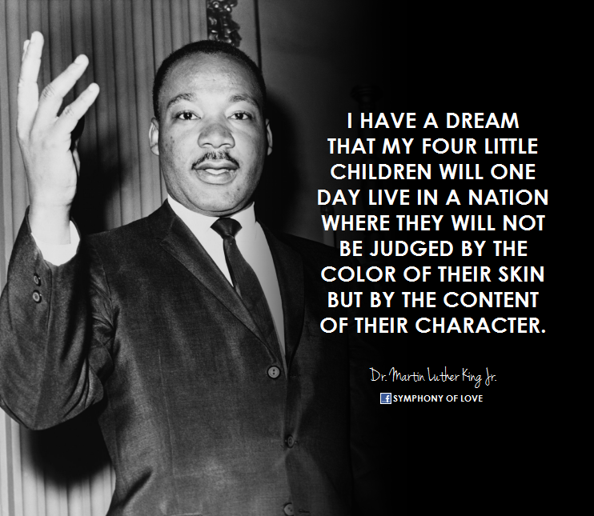

* The gap between rich and poor became increasingly evident during the Reagan administration.

**LITERARY CONTEXT**

After the Second World War American literature continued to flourish but not in any one distinct direction: it would be difficult to say what its mainstream works are. Instead, other sections of the variegated patchwork that is American society began to produce important writings including Jews, African-Americans, Native-Americans, Hispanics, Asian-Americans, homosexuals and so on. Many of these groups came to the fore during the 1960s and 1970s. Perhaps the only theme that links together these various groups is their interest in America’s theme par excellence: individuality.

THE BEAT GENERATION

* Included prose writers and poets centered in **San Francisco** and **NYC** in the 1940s and 1950s;
* **BEAT** = ‘beaten down’ or ‘beatific’;
* Celebrated freedom and stood against middle-class values, commercialism and conformity;
* Enthusiasm for the visionary states produced by religious meditation, sexual experience, jazz, or drugs;
* Drew their inspiration from quintessential American artists (Walt Whitman) and the jazz composer and musician Charlie Parker, as well as from Zen Buddhism.
* MAIN REPRESENTATIVES: **Jack Kerouac** (1922 – 1969) - ***On the Road***;

**Allen Ginsberg** (1926 - 1997) – ***Howl*** (the manifesto of the Beat Movement); **William S. Burroughs** (1914–1997) - ***Junky*** and ***Naked Lunch***; **Lawrence Ferlinghetti, Gregory Corso, Gary Snyder** - poets who also took Walt Whitman as their spiritual and literary father.

***Holy! Holy! Holy! Holy! Holy! Holy! Holy! Holy! Holy! Holy! Holy! Holy! Holy! Holy! Holy!***

***The world is holy! The soul is holy! The skin is holy! The nose is holy! The tongue and cock and hand and asshole holy!***

***Everything is holy! everybody’s holy! everywhere is holy! everyday is in eternity! Everyman’s an angel!***

***The bum’s as holy as the seraphim! the madman is holy as you my soul are holy!***

***The typewriter is holy the poem is holy the voice is holy the hearers are holy the ecstasy is holy!***

***Holy Peter holy Allen holy Solomon holy Lucien holy Kerouac holy Huncke holy Burroughs holy Cassady holy the unknown buggered and suffering beggars holy the hideous human angels!* […]**

(Footnote to *Howl* by Allen Ginsberg)

It is obvious that the extract above sounds quite different in tone. Poetic inspiration is no longer found in an archive. Poetry is that holy, lived experience, the ecstatic. A new use of language – mirroring the speed of experience. You might have felt embarrassed while reading it! Embarrassment is something that the beats wanted and valued.

**Jack Kerouac** (1922 – 1969)

* A novelist recognized for his method of spontaneous prose;
* *On the Road* (1957) – a semiautobiographical novel, which documents pretty closely the actual road trips that Kerouac took with his friends;
* Language – aiming to reproduce experience;
* A new kind of language – elimination of small words (*the, and* …); syntax can be set aside; language needs to move at the speed of experience and at the speed of ecstasy. Language – imitating experience.

PROSE

* Flourishing American literature but not a distinct direction of it;
* Different sections of the American society started to produce important writings;
* Jewish novelists – continued to some degree the Yiddish tradition and blended it into American writing (Saul Bellow, Bernard Malamud, Philip Roth);
* African-American writers – Tony Morrison wrote about the black experience in America from the times of slavery to this day; her writing is highly poetic but never ignores the horrors and tragedies of life;

AMERICAN POST WW2 FICTION

- **Norman Mailer** - *The Naked and the Dead* (1948)

- **James Jones -** *From Here to Eternity* (1951

SATIRE AND DARK HUMOR

* **J. D. Salinger** (1919- 2010) - *The Catcher in the Rye*(1951) – a classical portrayal of rebellious youth;
* **Joseph Heller** (1923 – 1999) –*Catch-22* (1961) – a humorous madness about the madness of war.

COMPLEX PLOTS

* **Thomas Pynchon** (1937 -) – *V* (1963)
* **Kurt Vonnegut** (1922 – 2007) ***- Slaughterhouse-Five*** (1969
* Both authors shared the same belief that human beings are trapped in a meaningless world and neither God nor man can make sense of the human condition.

**Vladimir Nabokov (1899 – 1977)**

* A Russian-born American novelist and critic;
* Wrote both in Russian and English;
* Refined prose and complex literary structures;
* Being an outsider made him particularly aware of the manias of modern America;
* *Lolita* (1955) – the satirical tale of a college professor who falls in love with a young girl.

POETRY

CONFESSIONAL POETS

* **Robert Lowell, Randall Jarrell, John Berryman, Theodore Roethke, … -** impersonal, hard-edged poetry for intense personal confessions, often presented in finely crafted poems in traditional forms;
* **Sylvia Plath** used this confessional style to give a poetic portrayal of her psychological breakdown.

OTHER GROUPS

* BLACK POETS – inspired by the Beats; (**Gwendolyn Brooks**, **Amiri Baraka)**;
* NATIVE AMERICANS – towards the end of the last century large numbers of Native American poets begin to write in English;
* CHICANO (MEXICAN-AMERICAN) poetry: **Rudolfo Anaya, Cherrie Moraga** and **Gary Soto.** They write in both Spanish and English, often blending poetry and prose.

DRAMA

**Eugene O’Neill** (1888 – 1953)

* Introduced psychological and social realism to the American stage; (techniques earlier associated with Russian playwright Anton Chekhov and Henrik Ibsen);
* The first to include speeches in American vernacular and involve characters on the fringes of society;
* Experimental and emotionally probing dramas; deep psychological complexity**.**

**Arthur Miller** (1915 – 2005)

* *Death of a Salesman* (1949) – a modern tragedy that tells of the life and death of a travelling salesman;
* *The Crucible* (1953) – Miller wrote indirectly about the hunt of communists of Senator Joseph McCarthy during the 1950s. The play deals with the witch trials held in Salem, Massachusetts.

**Tennessee Williams** (1911 – 1983)

* Wrote moving and poetic plays about outsiders.
* *A Streetcar Named Desire* (1947) – tells the story of a woman whose illusions of being Southern gentlewoman are shattered by her tough, working-class husband.
* *Cat on a Hot Tin Roof* (1955)