**THE PERIOD OF ROMANTICISM**

(1820s – 1860s)

HISTORICAL AND SOCIAL CONTEXT

THE DRIVE WESTWARDS

The early to mid 1800s are characterized by a geographical expansion westwards on the part of the American people. Attracted by the prospect of good farmland, rich mineral and forest resources, and, in some cases, by greater religious freedom, thousands of settlers moved over the Appalachian Mountains into unknown territories, continually pushing the frontier westwards. By the 1830s settlers were moving west beyond the Mississippi river into eastern Texas, Iowa, Missouri and Arkansas. The next decade witnessed still further movement west across the Great Plains to the rich farmland and forests of the Far West. Most of these courageous and resilient pioneers became farmers and landowners, although this movement of the population inevitably led to urban development too: towns and cities sprang up along the trails, providing opportunities for trade and commercial expansion.

In ever greater numbers, Americans came to believe in what had been termed ‘Manifest Destiny’, a doctrine which held that the United States should control the whole of North America. During the 1840s the pioneers settled in lands as far west as California and Oregon Country, which belonged to Mexico and Britain respectively. Texas was annexed in 1845 following appeals on the part of its inhabitants for intervention against its corrupt and tyrannical Mexican government. American forces defeated the Mexicans in the brief war which followed and in 1848 Texas, together with California and a vast area of land known as New Mexico, became part of the United States.

The decimation of Indian tribes at the hands of both pioneers and American soldiers was an unfortunate consequence of this expansion westwards. Those who survived were moved west of the Mississippi river. By 1854 an unprecedented influx of immigrants from Europe helped to swell the number of people living in the thirty-one states which then made up America to as many as 22.5 million.

EARLY- MID-CENURY ECONOMIC GROWTH

Territorial expansion was accompanied by growing economic prosperity during these formative years for American society, and before the end of the century the United States was to become the world’s leading agricultural nation. Agricultural surpluses – especially cotton – were exported abroad to Europe at high prices. Farmers grew tobacco, wheat, corn and fruit in huge quantities on the rich farmlands and took advantage of new farming methods and machines. Transport was expanded and improved in the form of canals (the Erie canal was opened in 1825) and roads (the National Road in the east and Oregon and Santa Fe trails in the west). Both the steamboat and, later, the steam powered railroad were to prove decisive in America’s commercial success: by 1850, 14 500 km of railroad were in operation, thus assisting the speedy delivery of industrial goods and merchandise all over the nation.

Improvements in agriculture were matched by those in industry. Manual labour continued to predominate for some time, although developments in large scale manufacturing – particularly in the East – were beginning to take place. An expanded postal system combined with the new telegraph to provide a quick and efficient means of communication. Information became more widely available to people as improvements were made to printing methods, and an ever increasing reading public gladly took to a steadily growing and more self-confident national literature.

SOCIAL CONCERNS

* Social reform - a pressing issue;
* Improvements in prison and asylum conditions took place;
* Tentative efforts were made to reduce the working day (from 14 to 10 hours);
* Education - a major concern;
* Women’s rights became an important issue;
* The most significant issue - SLAVERY.

HOME AFFAIRS

The period was dominated by Andrew Jackson, leader of the newly founded Democratic Party and champion of the common man. Whereas all preceding Presidents of the United States had come from wealthy eastern families, Jackson had grown up as a poor child in a log cabin, and his election as President in 1828 and 1832 was largely made possible by the support of western farmers and settlers and members of the manual laboring classes in the city. His promises to eliminate privileged politics and establish a more equal distribution of political power became known as ‘Jacksonian democracy’.

LITERARY CONTEXT

A CONTRAST BETWEEN NORTH AND SOUTH - most writers of the period were working in **New England** (despite the English influence some authors succeeded in producing some of America’s finest and most memorable literature). Few signs of a ‘**Southern School**’ developing; (English Romantic models were more closely adhered to in the South).

BASIC NOTIONS

* Romanticism is considered by many the real beginning of American literature;
* Emphasis upon the imaginative and emotional qualities of literature;
* Nature – a refuge from the constraints of society;
* A liking for the picturesque, the exotic, the sensuous, and the supernatural;
* A strong tendency to exalt the individual and the common man.

The aesthetic vision of the Hudson River School of painters is believed to have been influenced by Romanticism.

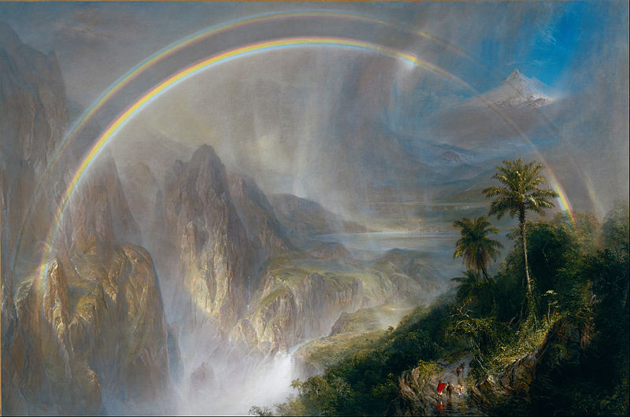

Frederic Edwin Church - *Rainy Season in the Tropics*

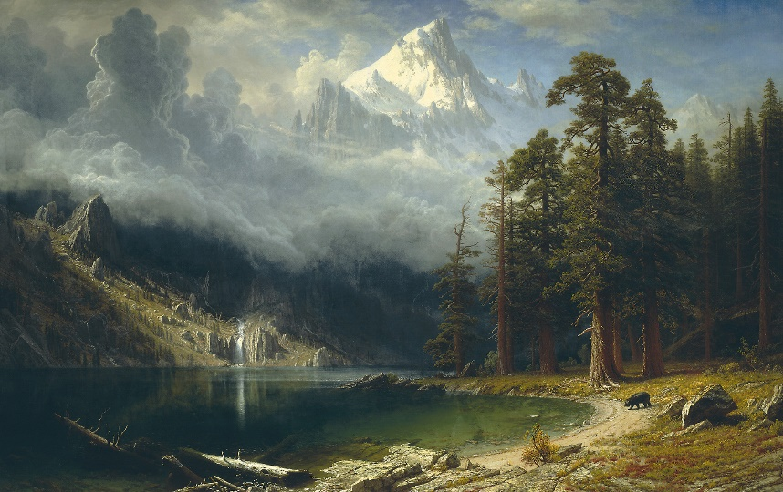

[Albert Bierstadt](https://www.nga.gov/collection/artist-info.6707.html) - *Mount Corcoran*

**NEW ENGLAND TRANSCENDENTALISM**

* Romanticism on Puritan soil;
* Flourished in New England (1830s – The Civil War);
* Transcendentalists took their ideas from European Romantic literature, German Idealistic philosophy, Oriental mysticism…
* A fresh perception of nature as symbolic of the spirit or God;
* **Feeling** over **reason**;
* Individual expression over the restraints of law and custom;
* The stress of the importance of the individual as the most important element of society;
* Against the materialism of American society;
* They believed in the transcendence of the ***Oversoul***, an all pervading power for goodness from which all things come and of which all things are part.

Ralph Waldo Emerson (1803–1882)

* The central figure of the American Transcendentalists;
* Key belief - each individual could transcend, or move beyond, the physical world of the senses into deeper spiritual experience through free will and intuition.
* God is not remote and unknowable; believers understood God and themselves by looking into their own souls and by feeling their own connection to nature.
* Man is a part of absolute good.
* In the 1840s Emerson founded and co-edited the literary magazine *The Dial*, and he published two volumes of essays.
* "The Over-Soul" (1841) - an essay.
* “Self-Reliance” (1841) - his most well-known essays (the reader is asked to examine his relationship with Nature and God and to trust his own judgment).
* “Nature" (1836) and “Experience”. (1844) – other essays.

Henry David Thoreau (1817–1862)

* Philosopher, Journalist, Poet
* A basic representative of Transcendentalism and a close friend of Ralph Waldo Emerson (1803–1882)
* "Walden“, subtitled "Life in the Woods"(1854) - his most famous work, an account of the two years he spent living the simple life in the woods at Walden Pond;
* “Resistance to Civil Government“, often reprinted with the title "Civil Disobedience“(1849) - his most influential essay, in which he recommended disobeying unjust laws;
* "The Maine Woods" and "Excursions“ - travel books (published after his death);
* His huge "Journal", accumulated over 24 years, was published in 14 volumes in 1906.

From *"*Civil Disobedience“ (1849):

***I have paid no poll-tax for six years. I was put into a jail once on this account, for one night; and, as I stood considering the walls of solid stone, two or three feet thick, the door of wood and iron, a foot thick, and the iron grating which strained the light, I could not help being struck with the foolishness of that institution which treated me as if I were mere flesh and blood and bones, to be locked up… I did not for a moment feel confined, and the walls seemed a great waste of stone and mortar. I felt as if I alone of all my townsmen had paid my tax… I saw that the State was half-witted, that it was timid as a lone woman with her silver spoons, and that it did not know its friends from its foes, and I lost all my remaining respect for it, and pitied it. Thus the State never intentionally confronts a man's sense, intellectual or moral, but only his body, his senses. It is not armed with superior wit or honesty, but with superior physical strength.***

***\*\*\*\*\*\*\*\****

***There will never be a really free and enlightened State until the State comes to recognize the individual as a higher and independent power, from which all its own power and authority are derived, and treats him accordingly.***