COLONIAL LITERATURE
The majority of settlements, which made up Britain’s Thirteen Colonies (later to become the United States of America) were well established by the middle of the eighteenth century, and, although each of these colonies had a Governor, they were ultimately answerable to the British crown. Mounting prosperity and an expanding – and increasingly self-confident – population led to Virginia and Maryland making an appeal to the London Company (an organization of English merchants) for larger measures of self-government. In an effort to attract more newcomers to the colonies, the London Company agreed and in 1619 Virginia established the House of Burgesses, the first representative legislature in America.

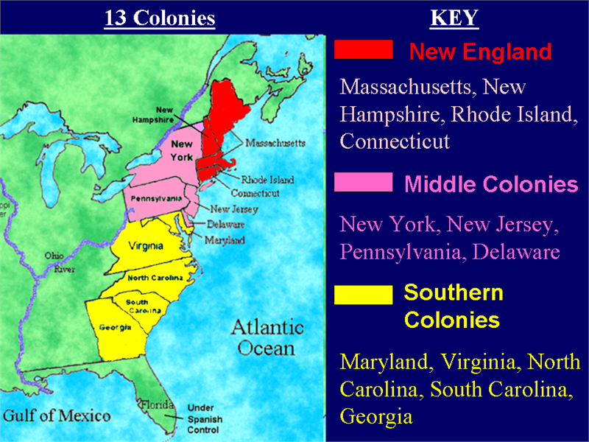

THE NORTHERN COLONIES

The New England colonies in the north were populated mainly by newly arrived Puritans, English Protestants who had initially emigrated from England to Holland because of disagreements with the Orthodox Church of England. They succeeded in establishing a thriving and diversified economy in the north and made a substantial contribution to the development of political practices and social beliefs. Indeed, their belief in government by contract from the governed was to prove decisive in influencing New England principles concerning the value of individual freedom and democracy. They also believed strongly in the importance of hard work (which conveyed dignity on man and ensured him of a place in God’s favour) and education (Harvard and Yale colleges were established in 1636 and 1701 respectively). They were particularly strict on matters concerning morality and religion. Indeed, the society they built up in the northern colonies was highly theocratic: civil government officials were chosen from among those members of the church who most ardently adhered to the principles of the Old Testament, and who were regular churchgoers. Religious intolerance and persecution were not unknown in Massachusetts, as the hanging of nineteen people suspected of witchcraft in 1692 in Salem demonstrated. New and less severe ideas took root slowly, and by the time Massachusetts became a royal colony in 1691, Puritan rigor was already in decline.

THE MIDDLE COLONIES

Such was the strength of the English presence in the colonies that other nations were frustrated in their efforts to establish permanent settlements of their own. In 1664 England took over the middle colonies of Dutch-controlled New Netherland (later New York) and Swede-dominated New Sweden. Another settlement in what is now Pennsylvania was chartered to William Penn in 1681. Penn was a member of a much persecuted religious group called the Quakers, and other settlers seeking freedom from persecution to come to his colony. Pennsylvania flourished and its capital city, Philadelphia, rapidly became America’s largest city.

THE SOUTHERN COLONIES

Further south, Carolina was chartered out to eight proprietors in 1663: British settlers and French Protestants, called Huguenots, combined with other Americans to populate the colony, which in 1712 was divided into two – North and South. The well established rice and indigo plantations in South Carolina required a substantial work force, and many African-Americans were imported to work as slaves by the growing number of wealthy landowners.
The southernmost part of Carolina became known as Georgia in 1733. Plantations and African slaves made up an essential part of what was to become a flourishing economy. In contrast to life in the north, the country – as opposed to the town – was the main unit of government, largely because life was more rural. Large and self-sufficient estates, plantations and mansions formed the social backbone of southern life. The southern middle classes also gained a reputation for being more fun-loving and tolerant in religious matters than their northern counterparts.

THE POPULATION OF AMERICA

By the 1750s the population in the colonies had risen from the lowly figure of one hundred in 1607 to 360, 000: roughly 20 percent of the population consisted of blacks imported from Africa to work as slaves. By the 1750s colonial America had become a ‘melting pot’ in terms of both religion and race. In addition to Puritans, Quakers and Huguenots, there were Roman Catholics, Jews and members of other German Protestant sects who sought freedom from religious persecution in the new land.
Africans, who had been captured during the course of tribal warfare and imported by unscrupulous trading merchants, initially possessed the same rights as the newly arrived white prisoners from overcrowded English jails. In the beginning both were passed into servitude – or ‘indentured’ – for a limited number of years, but by the 1660s owners of the Africans (especially in the southern colonies) extended these periods of ‘service’ indefinitely. Hence the beginning of true slavery in America.
By the early 1700s there were signs of a growing sense of national identity among the colonists, and although they were still ultimately under British rule, crown regulations and law were frequently ignored. An increasingly clear conflict of interests was to come to a head during the mid 1700s when relations between the Thirteen Colonies and Britain began to break down definitively.
Indeed, Americans had to wait until the mid-nineteenth century for a rich and imaginative national literature to rival that of the English. Although there were significant exceptions, most Americans were concerned with the day to day business of living and the struggle to achieve some form of national identity.
Early American literature varies greatly in quality. Most New England colonists were, like their southern counterparts, chiefly engaged in making a home of the wilderness they had discovered on America’s shores. The literature of this period is of more historical than literary interest to the modern reader. It is largely made up of historical and religious journals, letters, speeches, sermons and public documents.
Prose in the colonial period was dominated by the work of New Englanders whose religious writings formed the great bulk of early American literature. The quest for spiritual identity in the New World persuaded them to write serious and responsible works which often contained some kind of moral purpose. Indeed, most of the prose written during this period was devoid of entertainment value. Its declared function was to instruct, and readers – or listeners – were more often than not to be found in the pulpit. Sermons and religious pamphlets dealt with the themes of religious tolerance (or intolerance), and other ecclesiastical controversies. A strong Puritanical or Calvinistic strain ran through much of these works.
The literature of the Colonial period can be roughly divided into prose connected with history and geography, religious writing and colonial poetry.

PROSE CONNECTED WITH HISTORY AND GEOGRAPHY

The other main concern of prose writers was to describe the history and geography of the newly settled territories. Accounts of the first pioneers and their various activities took the form of newsletters, journals, practical handbooks and ordinary letters, and they provide us with an interesting picture of early colonial life. The first English writer in America was Captain John Smith (1580 – 1631) whose A True Relation of Such Occurrences and Accidents of Noate as Hath Hapned in Virginia Since the First Planting of that Collony (1608) is a straightforward and precise historical account of the Jamestown settlement. He also wrote an interesting account of early settlement life in Virginia in The General History of Virginia (1624).
Other writers producing early historical accounts include John Winthrop (1588 – 1649), William Bradford (1589 – 1657), William Penn (1644 – 1718) and William Byrd (1674 – 1744). Winthrop’s Journal described life in the Massachusetts Bay colony from 1630 to 1649, and his advocating of theocratic state was echoed by Bradford in his The History of Plymouth Plantation (1646), an account of the Pilgrim Fathers and their foundation of the Plymouth colony. Penn’s Some Account of the Province of Pennsylvania (1681) was in part an attempt to publicize the opportunities offered by life in Pennsylvania. Byrd was a Virginia planter and agent for the colony: his History of the Dividing Line: Run in the Year 1728 was a witty and satirical account of the boundary survey between Virginia and North Carolina.

RELIGIOUS WRITERS

Among the most important religious writers of this period were Cotton Mather (1663 – 1728), Jonathan Edwards (1703 – 1758) and John Woolman (1720 – 1772).
The Puritan Mather was the most versatile and prolific writer of the age; among the 450 he wrote are a number of writings dealing with theological issues. Wonders of the Invisible World (1693) defends Mather's role in the witch hunt conducted in Salem, Massachusetts, and espousing the belief that witchcraft was an evil magical power. Mather saw witches as tools of the devil in Satan's battle to "overturn this poor plantation, the Puritan colony", and prosecution of witches as a way to secure God's blessings for the colony. Mather’s most important work was Magnalia Christi Americana (1702), a two-volume ecclesiastical history of New England. His Christian Philosopher (1721) recognizes God in the wonders of the earth and the universe beyond; it is both philosophical and scientific and, ironically, anticipates 18th-century Deism, despite his clinging to the old order.
Jonathan Edwards was a Calvinist preacher in Massachusetts. As a leader of the religious revival movement known as the Great Awakening, he struck the fear of God into the hearts of his congregation with fiery sermons. His most famous work was Freedom of Will (1754), an influential philosophical treatise written in defence of Calvinistic doctrine.
The Journal (1774) of John Woolman (1720 – 1772), a Quaker leader and early abolitionist, is a classic record of the spiritual inner life.

COLONIAL POETRY

Colonial poetry was mainly of a religious nature and was mostly written for friends and relatives. The first book to be published in the colonies was the Bay Psalm Book (1640), a collection of psalms in verse from intended for group singing in the churches. The New England Primer, America’s first text book, was used in schools to help people to read. Most Puritans were thoroughly familiar with these two volumes. Despite Puritan doubts and suspicions about the value of poetry (it was too sensuous and lacked a true instructional element), heavily Puritanical elegies and epitaphs were composed to honour the dead.
The Puritan poet thinks of himself as fallen from Adam, as an individual, that distinctness that individuality, is all contaminated with the story of self-assertion and corruption he inherited from Adam. And so a poet who thinks himself in this way, thinks of himself as sinful.
While often influenced by English poets of the sixteenth and seventeenth centuries, Anne Bradstreet (1612 – 1672), Michael Wigglesworth (1631–1705) and Edward Taylor (1642 – 1729) provided American literature with its first poetic voices. Anne Bradstreet included simple lyrics and poems on nature in her The Tenth Muse, a collection of mainly religious poems published in England in 1650. Wigglesworth’s heavily Calvinistic ballad style in The Day of Doom (1662) was the most popular literary work of colonial times and took its place on most Puritan bookshelves beside the Bible and Bunyan’s Pilgrim’s Progress. The most important poet of the period was, however, Edward Taylor whose poems were only discovered in 1937. A fierce Puritan, Taylor spent most of his life as a minister in a Massachusetts town. His poems show the influence of the English Metaphysicals (especially Herbert and Donne) and many of his finest ‘meditations’ were composed to be performed in church as a prelude to his sermons.

