Proiect DAFI

Unelte software folosite(\*- necesare): Python\*, Django\*, Django-Jazzmin\*, Django-cors-headers,

Crispy-bootstrap5 ,SQLite3, Bootstrap, Git

Instructiuni rulare:

- cd proiect

- pipenv shell

- python manage.py runserver

Posibile erori:

1. Pentru eroare lipsa pachete:

* Pip install pipenv
* Pipenv install django django-jazzmin

1. Pentru eroare la recunoasterea pachetelor

* Trebuie selectat interpetorul pentru mediul virtual

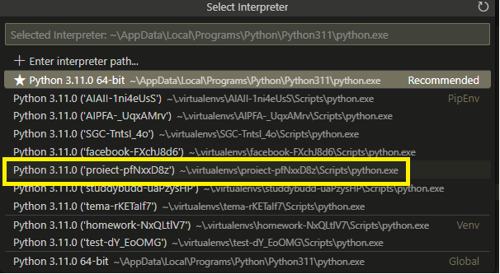

Link proiect github: <https://github.com/alextassy24/ProiectDAFI>



