**NSSA-220 Project 1: Application Performance Monitoring**

**Andrew Apollo, Alex Tedesco, Carsen Terwilliger**

**Introduction**

The purpose of this project was to create a script to monitor performance of application processes. To do this we will run six executable programs that were provided, these C binary programs create a load on the system that can be measured using sysstat tools and Linux commands. We will use these to gather system information and store the information is csv files for interpretation.

**Process Level Metrics**

The CPU utilization plot shows the CPU % that each process is took up at a specific time. APM3 took up the most CPU % while APM2, AMP4, and APM6 used little to no CPU%.

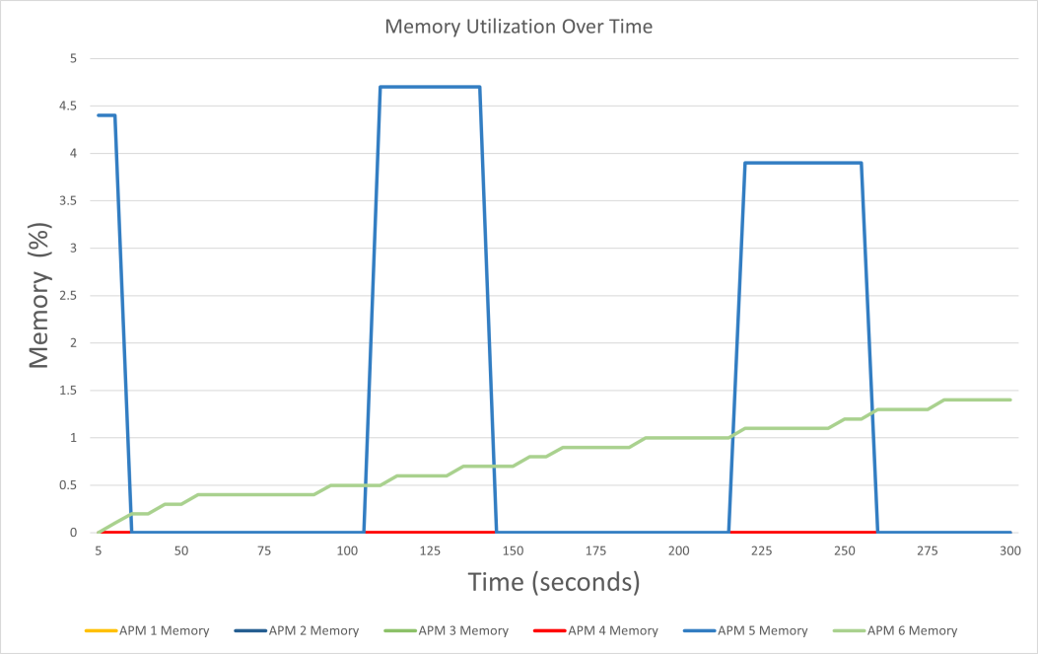

The memory utilization plot shows the memory% that each process took up at a specific time. The APM3 executable suffered with memory leak as over time its use gradually increased to 1.5% after 5 minutes. APM5 consistently used around 4.5% of the memory about every 75 seconds. The rest of the APMs used no memory at all.

**System Level Metrics**

The network bandwidth utilization plot showed the receive and transmit data rates. It can be observed that over the 5 minutes no data was transmitted whereas roughly every 60 seconds data was received by the disk.

The hard disk access rate plot showed how often data was wrote to the disk. Within the first 30 seconds there was a slight increase in disk writes per KB/s but for the remainder of time the disk writes decreased to around 1200 at the end of the 5 minutes.

The hard disk utilization plot shows how much capacity was remaining on the disk. It can be observed that the capacity took massive declines throughout the 5 minutes up until 255 seconds where it reached near 0.

**Summary and Lessons Learned**

The VM we used was able to handle the processes in terms of memory and network capacity but not for the CPU and disk. After our 5-minute runs we consistently saw the CPU usage hover between 40 and 60 percent for APMs 5 and 3 respectively. The rest of the APMs used little to no CPU%. As for the disk, near the end of our 5-minute tests we received a low disk warning. The VM likely does not have enough disk space to run these applications for extended periods of times.