* K-fold CV (Cross-Validation) –
  + Fold k is validation set, fit method on (k-1) remaining folds
  + Repeat k times incrementing k each time
  + 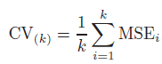
* LOOCV (Leave One Out Cross-Validation) vs. K-fold CV:
  + Lower bias – training set is (n-1)
  + Higher variance – only one element in validation set
    - Fit varies highly between different validation set
* Cross-Validation (Qualitative)
  + 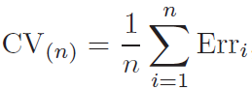
    - 
* K-fold cross validation vs. (1) validation set and (2) LOOCV:
  + (1) Validation set:
    - Pros:
      * Simple 🡪 partition training data into two sets
    - Cons:
      * Test error rate highly variable 🡪 depends on which observations included in training and validation set
      * Validation set may overestimate test error rate
  + (2) LOOCV:
    - Higher variance, lower bias
    - Most computationally expensive