Kanaloa API — Smart Oceanic Restoration

1. Topic Selection
A new API app named Kanaloa that helps users monitor, protect, and restore oceanic sites.
- I’m documenting how to use the Kanaloa API web-based application. The target audience includes Marine Biologists, Marine Roboticists, Marine Robotics Engineers, Ocean Robotic Software Developers, and student interns.
- The documentation instructs the user(s) on how to create and run specific data reports. The documentation teaches users how to get started, use specific features, and troubleshoot.
- Prerequisites: API license, username and password credentials, and an internet connection.

2. Sample Documentation
Five sample (.md) documentation files for the Kanaloa web-based (API) application.
1. Kanaloa_Quick_Start_Guide.md
2. Kanaloa_How_to_Create_a_Data_Report.md
3. Kanaloa_Interactive_API_Reference.md
4. Kanaloa_Whats_New_Changelog.md
5. Kanaloa_FAQs.md

3. Documentation Structure & Information Architecture
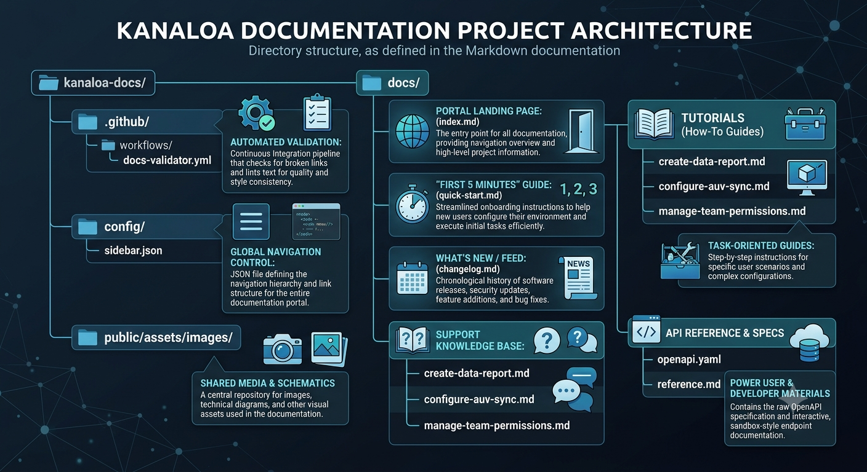
● Navigation logic (e.g., sidebar mapping or table of contents hierarchy).
● Quick start guide, how to doc, power user API reference, and a what’s new changelog.
● This repository architecture cleanly separates potential concerns: automated workflows in .github/ to ensure quality, global config manages navigation, docs/ groups the index landing page, guides, and API specs logically. Isolating public` assets prevents clutter, giving developers and writers an intuitive, scalable, and easy-to-maintain structure.

4. AI-Assisted Workflow Design
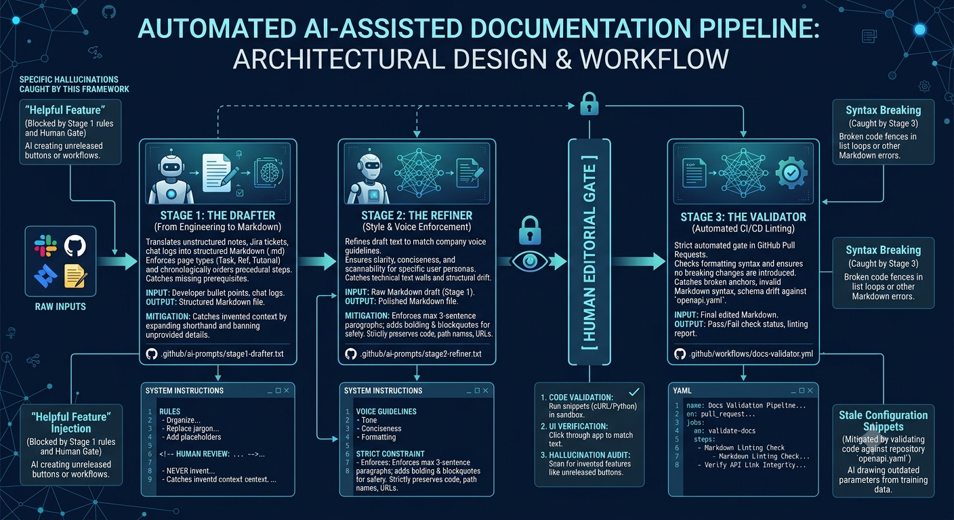

5. Technical Documentation End-to-End Lifecyle Process
Here is the operational breakdown of how our documentation lifecycle moves from a raw engineering change to a fully published and validated release.
Phase 1: Triggers & Information Gathering
Operational Triggers:
Code Trigger: Opening a Pull Request in the core application repository that alters UI schemas or files in `/api/v1/`.
Product Trigger: Moving a tracking ticket to the **"Ready for Docs"** column in Jira or GitHub Projects.
Context Gathering: A GitHub Action automatically extracts the PR description, aggregates developer branch notes, and detects structural diffs in `openapi.yaml`.
Phase 2: Creation, Refinement, & Evolution
New Files: Stage 1 AI identifies the target directory, scaffolding a new file, e.g. docs/tutorials/new-feature.md with standardized Markdown templates.
Updates & Diffs: For existing files, a diff engine feeds existing content and new technical notes into the AI workspace to surgically update obsolete steps or append new parameters.
Voice Alignment: The draft moves to Stage 2 (The Refiner) to enforce Kanaloa's scannable, empathetic and concise brand tone.
Phase 3: Quality Gates & Automated Validation
Gate A: Continuous Integration (CI/CD)
Syntax & Structure: Automated GitHub Actions ensure balanced Markdown syntax, unbroken anchor links, and clean code fences.
Schema Drift: Compares code samples directly against `openapi.yaml` to prevent stale endpoint parameters.
Gate B: The Human in the Loop (HITL) Editorial Gate.
Validation: A Technical Writer manually tests cURL/Python snippets in a sandbox and verifies UI step accuracy against the live web app.
Hallucination Prevention: Flags and removes unreleased UI features or "helpful" assumptions generated by AI models.
Definition of Done (DoD)
A documentation task is Done and ready for automatic production deployment via Vercel/Netlify webhooks only when it fulfills all five criteria:
100% UI Accuracy: Every button label, screen name, and navigation path matches production screens exactly.
Verified Code Snippets: All cURL, JS, or Python code examples return a successful `2xx` HTTP response when executed in the sandbox environment.
Scannability Standards: Paragraphs do not exceed three lines, bolding is used on key terms, and task-oriented headers structure the page.
Passing CI Pipeline: Markdown linter and link-checking workflows return zero errors or warnings.
Dual Sign-Off: The PR holds explicit approvals from both the Lead Feature Engineer for technical validity and the Technical Writer for style, clarity, and safety.

6. Dynamic Update Scenarios
Here’s how our documentation pipeline automatically detects, routes, and resolves product drift across three real-world scenarios:
Scenario 1: Minor UI Element Rename & Terminology Change
What Changes: A UI button label is renamed, e.g. from `"Generate Report"` to `"Compile Ecosystem Insights"` alongside an API variable update, e.g. `water_temp_celsius` to `sea_surface_temp_c`
Which Docs Are Hit:
- `docs/tutorials/create-data-report.md` (updates UI procedural steps)
- `docs/api/reference.md` (updates parameter tables and code blocks)
- `docs/quick-start.md` (updates sample request payloads)
Which AI Steps Run:
Trigger: An automated regex sweep fires upon changes to `openapi.yaml` or code commit edits to UI label strings.
Stage 1 - Drafter: Bypassed for simple text tutorials, but generates updated OpenAPI parameter schema tables and updates code snippets.
Stage 2 - Refiner: Replaces button string references across tutorials while ensuring sentence structure remains smooth and concise.
Approval & Quality Gate: Fast-Track Gate.The CI/CD pipeline validates that `sea_surface_temp_c` matches `openapi.yaml`. The Technical Writer completes a visual diff check in the PR and merges.
Scenario 2: Major Feature Launch & Workflow Restructure
What Changes: A linear configuration process is expanded into a multi-step sequence requiring an **Operations Plan** and a **Pre-Dive Safety Check** prior to AUV sync.
Which Docs Are Hit:
- `docs/tutorials/configure-auv-sync.md` (complete architectural rewrite)
- `docs/changelog.md` (new feature release entry)
- `docs/index.md` (navigation and landing page adjustments)
Which AI Steps Run:
Trigger: Jira ticket moved to Ready for Docs with attached engineering specs and workflow diagrams.
Stage 1 - Drafter: Scraps the old sequential steps, builds a new multi-step Markdown structure, and inserts a placeholder: `<!-- HUMAN REVIEW: Verify pre-dive telemetry bounds -->`.
Stage 2 - Refiner: Polishes tone and clarity, applying task-oriented headers and scannable formatting for complex procedures.
Approval & Quality Gate: High-Risk Gate. The Technical Writer executes the flow in a staging environment. The Lead Robotics Engineer gives technical peer review approval on the PR.
Scenario 3: Outdated, Incomplete, or Conflicting Information Cleanup
What Changes: Documentation explicitly states offline caching is unsupported, but a backend patch quietly enabled offline AUV log caching.
Which Docs Are Hit:
- `docs/faq.md` (inverts logical statement to accurately reflect feature support)
- `docs/changelog.md` (documents new capability)
Which AI Steps Run:
Trigger: A nightly semantic repository audit cross-references documentation against feature flag manifests.
Stage 1 - Drafter: Identifies the conflicting block in `faq.md` and rewrites the paragraph using context from the developer's merged PR.
Stage 2 - Refiner: Rewrites the answer in Kanaloa's brand voice, encouraging helpful, concise, and collaborative language.
Approval & Quality Gate: Standard Gate. Markdown linters verify syntax. The Technical Writer clears the `<!-- HUMAN REVIEW -->` comment, verifies the fix against official release notes, and merges.

7. Walkthrough Documentation
I completed the goal by designing a repeatable documentation workflow that combines docs-as-code practices, and generative AI with robust human review gates. I’m ready to develop the repository + record a video walkthrough, but as a paid Technical Writer at KODE Labs. Please review my Kanaloa API sample docs and let me know of any questions. Thank you.

