**CICD**

**Introduction**

CI/CD stands for continuous integration, continuous deployment and continuous delivery

Continuous integration is the act of merging developers working copies to a shared mainline several times a day.

Continuous deployment is a software engineering approach in which the value is delivered frequently through automated deployments. Automated build-and-test steps triggered by CI ensure that code changes being merged into the repository are reliable

Continuous delivery is a producing and releasing value in short cycles.

The CI/CD pipeline refers to the automation that enables incremental code changes from developers’ desktops to be delivered quickly and reliably to production.

CI/CD initiate an effective process for pushing products to market faster than ever before without any delay. Continuously delivering code into production, and ensuring an ongoing flow of new features and bug fixes via the most efficient delivery method.

Continuous Integration makes use of job in the CI/CD. This are the various job used

• Create Infrastructure

• Configure Infrastructure

• Deploy Production Artifacts

• Smoke Testing

• Rollback

• Promoting to Production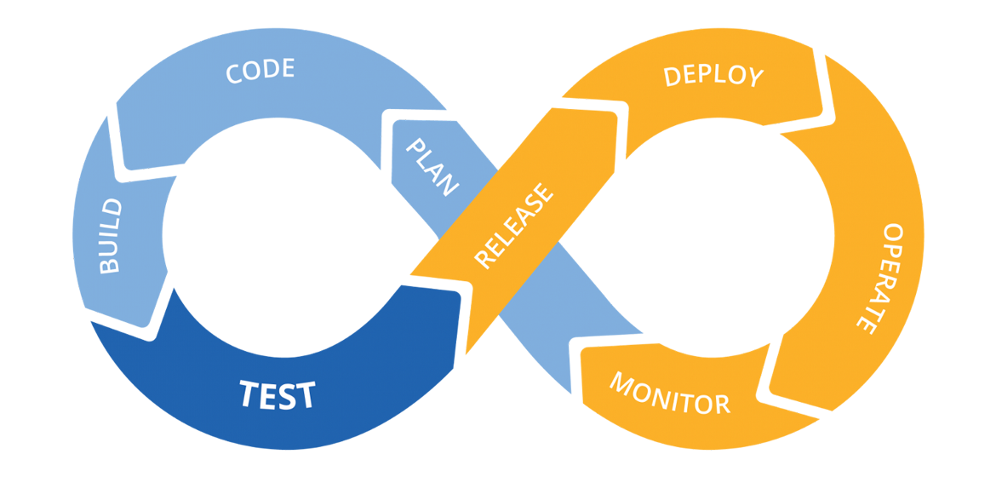

**Importance of CI/CD**

CI/CD will result in faster builds and deliver quicker results. With deployments running in continuous cycles, this will enable you to track the project and provide feedback in real-time, as well as fix shortcomings with your team whenever necessary. With consistent reviews, the product will see more refinement, and be more in tandem with the end-users expectations.

Below are the list of the CI/CD benefits

* CI/CD promote faster and more frequent production deployments which increase Revenue by new value-generating features released more quickly.
* It ensures automate Infrastructure creation which avoid cost by less human error and faster deployments.
* It automated rollback triggered by job failure translating to quick undo to return production to working state.
* CI/CD carried out automated smoke tests which protects revenue by reducing downtime from a deploy-related crash or major bug.

**Conclusion**

CI/CD helps different engineers to collaborate and merge their code to a share line. It takes out the gruesome part of integration and delivery and helps to manage compute resources