Ref | Year | Grid | 1.Propagation  2. Distance to “responsible” asset | Geography | Tech. | Trigger | f (Hz) | Duration | Waveform | 1.Line Trip?  2. Gen Trip? | 1.Source of data  2. Processing of data  3. Analysis | 1. Causes  2.Mitigation
Gautam2024 | 2023/01 | India, Rajasthan | 1. 300 km Approx.  2. 176 km | 26°07'36.9"N 75°01'54.5"E | PV | ~ | 3.5 | Hours | 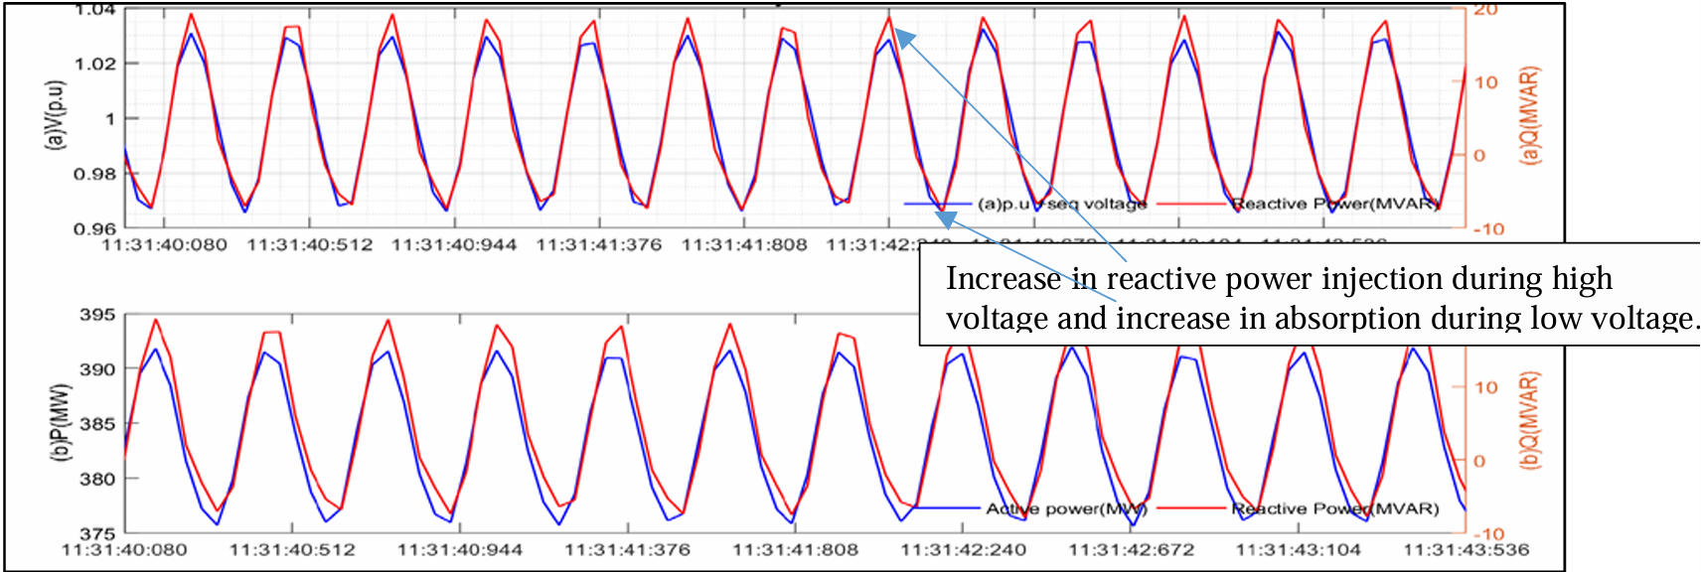 | 1.No  2.No | 1.PMU  2. Signal normalization  3.Time-response simulations with EMT models. | 1.Different PPC technologies; slow polling rates of PQ measurement;  Interactions of PI controls; small dead-band of voltage ride-through.  2.Retuning
ESO2024 | 2021/08 | GB, Scotland | 1.Contained in Scotland  2. ~ | 57°25'30.8"N 4°15'47.8"W | WF | ~ | 8 | 25 s | 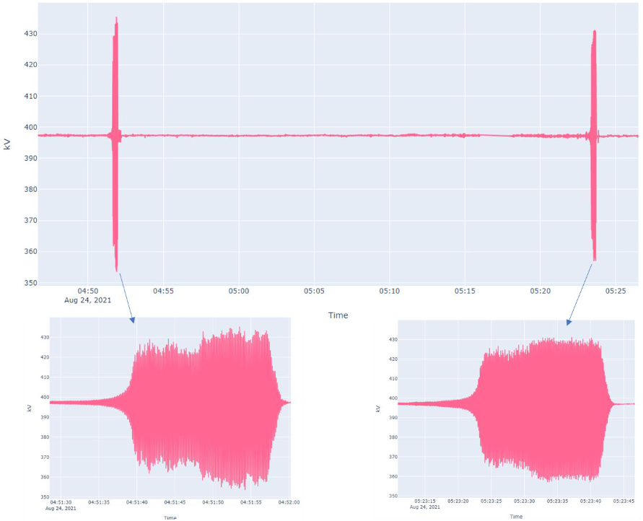 | 1.No  2.Yes | 1. PMU  2. ~  3.Time response simulations with EMT models (TOTEM Project) | 1. A particular asset was the major contributor.  2.Mitigation measures in the asset. Retuning of voltage controllers in other assets and changes to protection settings.
Wang2022 | 2020/07 | Virginia,  USA | 1.~  2.~ | 37°31'32.7"N 77°26'54.1"W | PV | Daylight hours | 22 | Minutes | 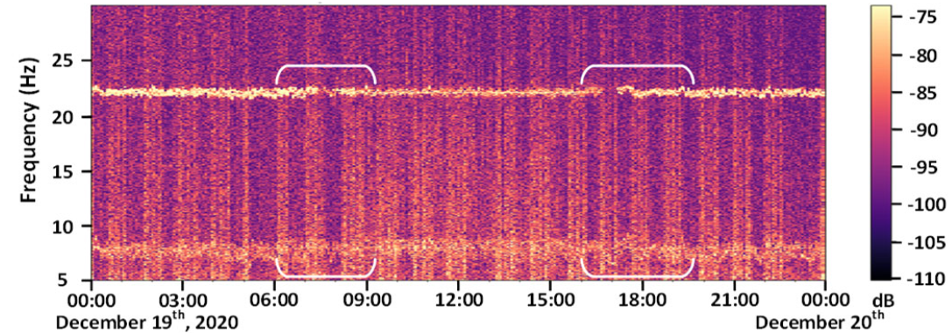 | 1.No  2.No | 1.PMU; synchrophasor.  2.Spectogram; power spectral density. | 1.Active power-power factor control.  2.~
Sun2025 | 2019/08 | UK | 1.Propagated across England, Wales, and some parts of Scotland.  2.120 km approx | 53°53′6″ N  1°47′27.6″ E | WF,  CC | Lightning | 9 | 30 ms | 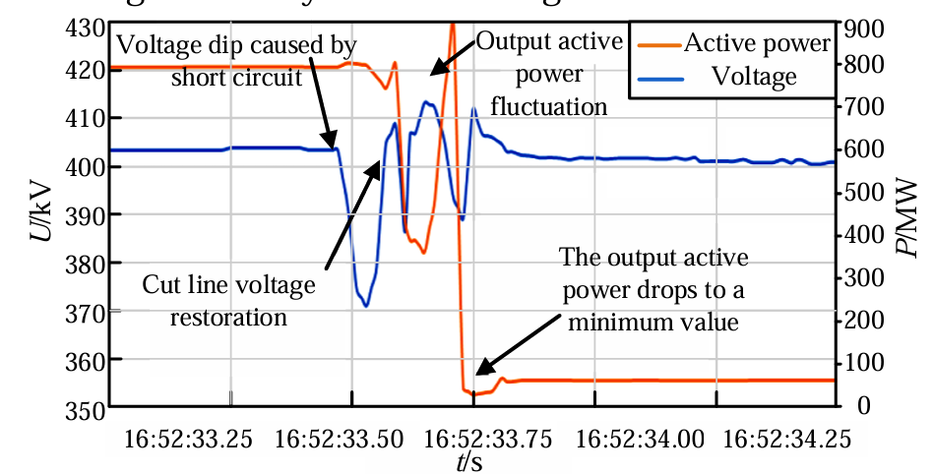 | 1.Yes  2.Yes | 1.PMU Data

