Gautam2024:  https://www.e-cigre.org/publications/detail/c4-11521-2024-strategies-for-mitigation-of-oscillations-in-ibr-penetrated-network-in-india.html | 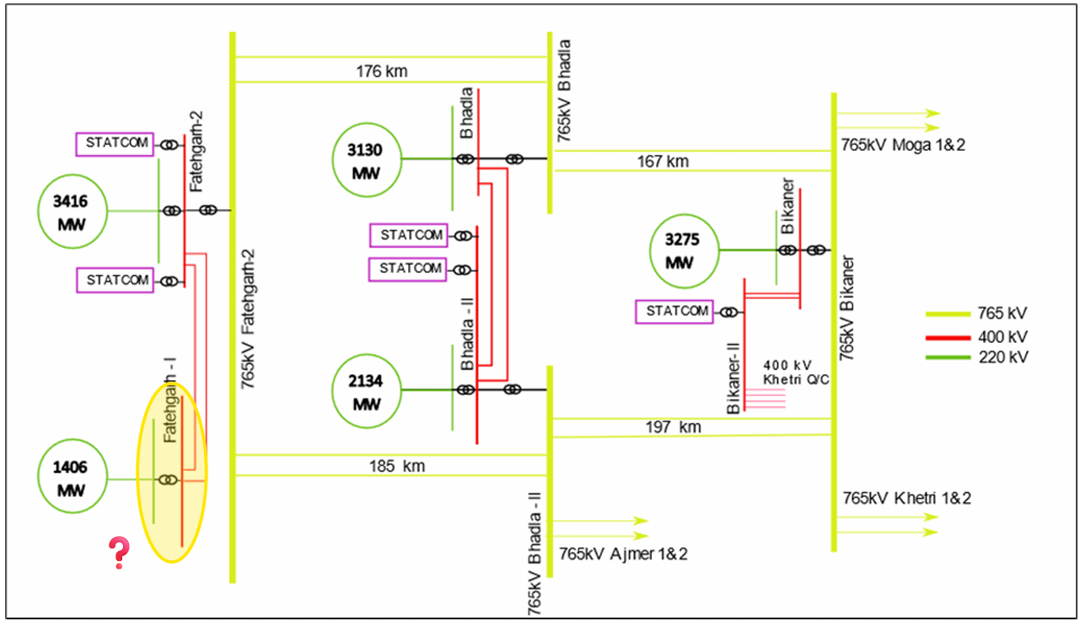
ESO2024:  https://www.neso.energy/document/319056/download  Leslie2022  https://www.esig.energy/download/managing-grid-stability-in-a-high-ibr-network-julian-leslie/?wpdmdl=8504&refresh=61f14353799ba1643201363 | 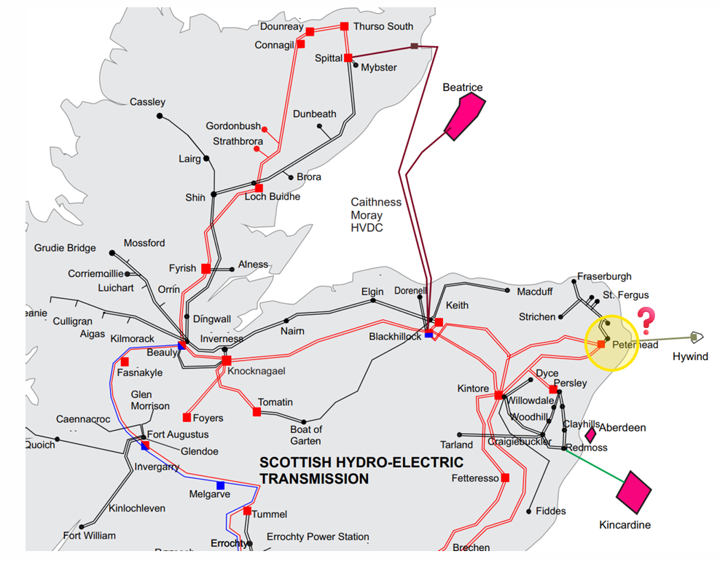
Wang2022  https://ieeexplore.ieee.org/abstract/document/9916830 | 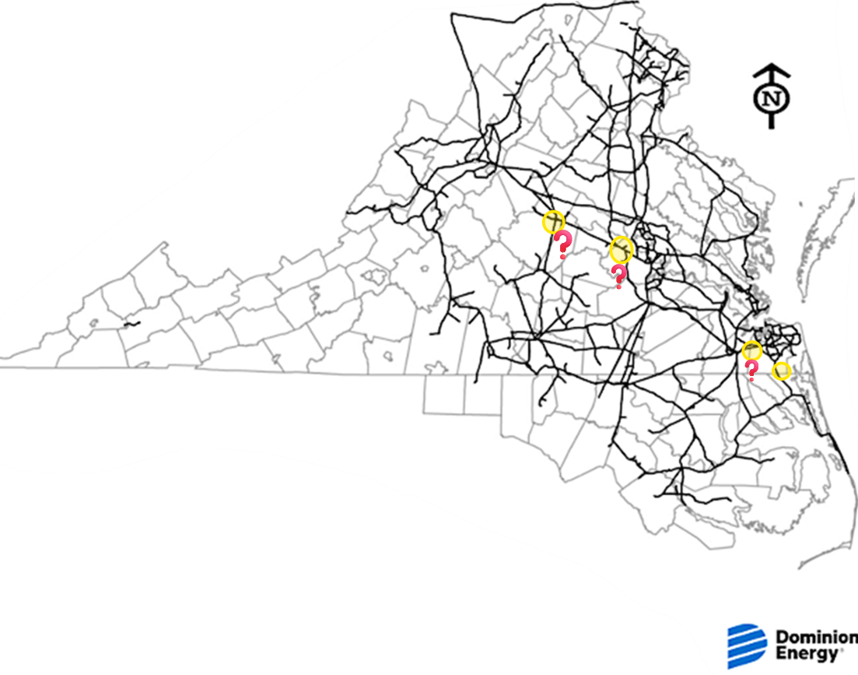
Sun2025  https://ieeexplore.ieee.org/document/10859154  NESO2019  https://www.neso.energy/document/152346/download | 