Some integrals with Gaussian wavepackets

1. Definition
The normalized Gaussian wavepacket is defined as:
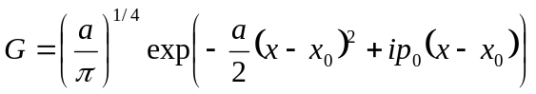. (1)
Here, is the width parameter, 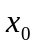is the center of wavepacket, 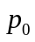is the momentum of wavepacket.

2. Overlap integral

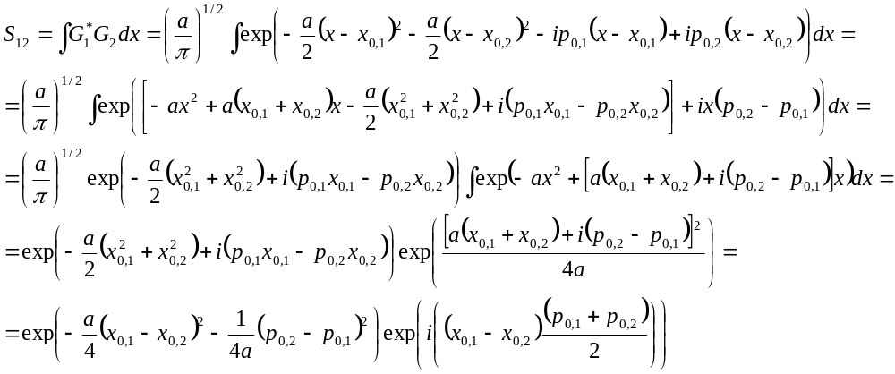 (2)
Here, we have used the integral
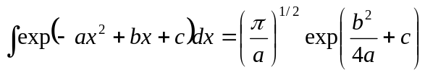 (3)

3. Position expectation value
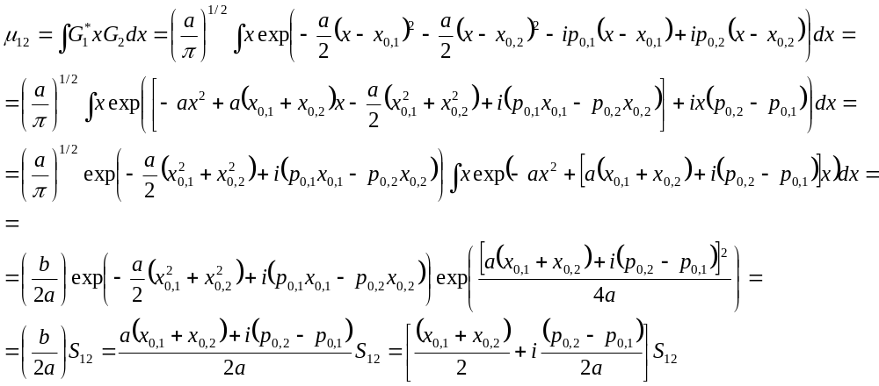

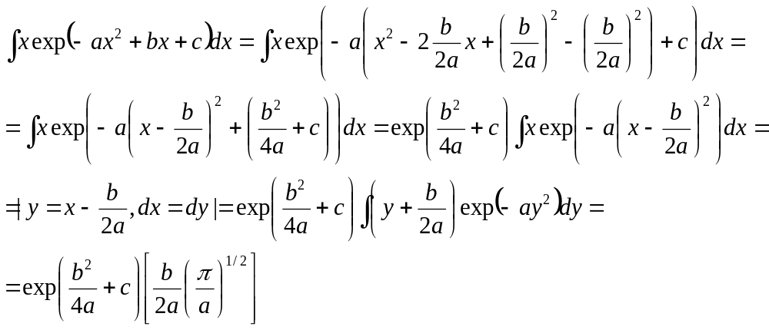

4. Derivative coupling integral

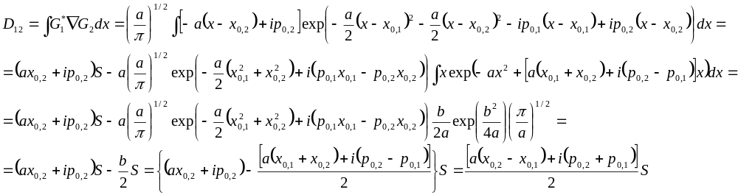 (4)

Check:
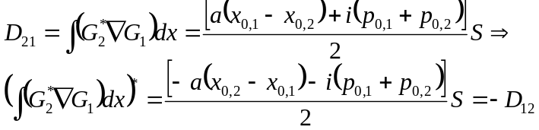 (5)
So:
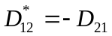. (6)

5. Kinetic energy integral

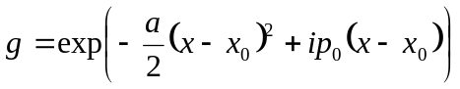 (7)
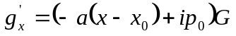 (8)
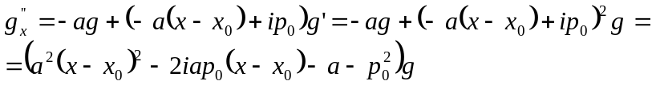 (9)

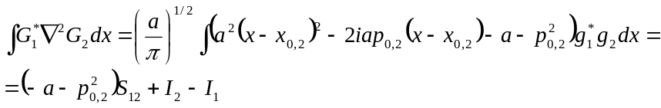 (10)

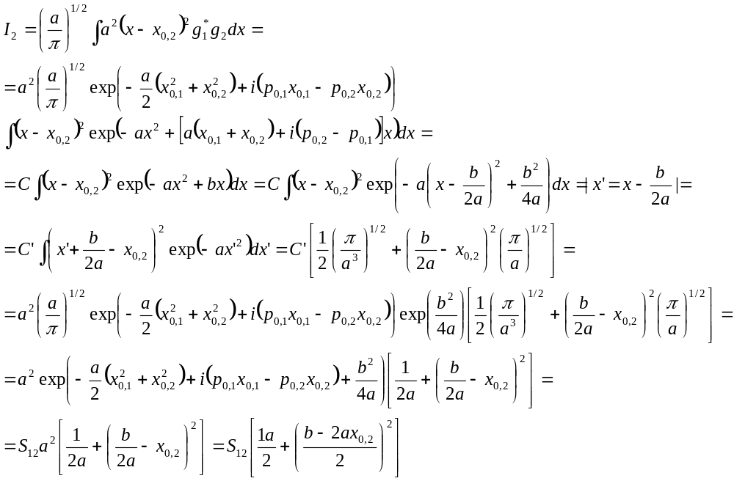(11)
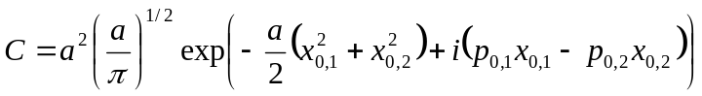 (12)
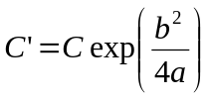 (13)
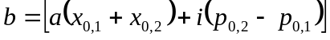 (14)

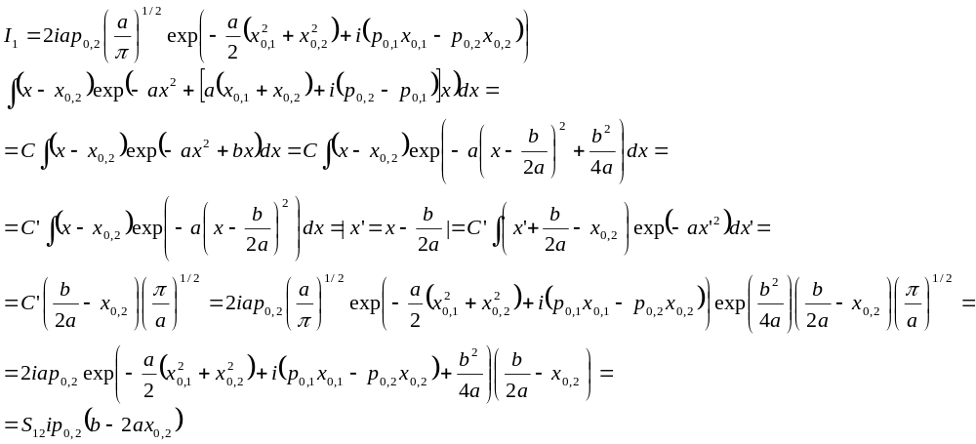 (15)
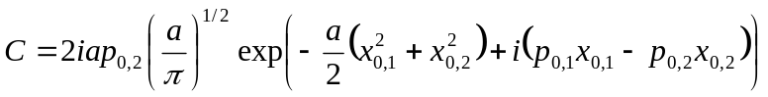 (16)
(17)
(18)
So:
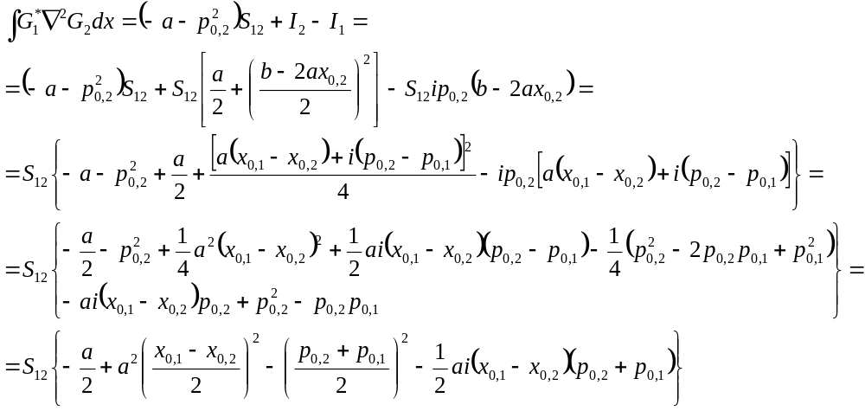 (19)
6. Summary
, (20)
(21)
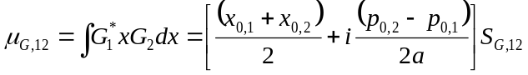
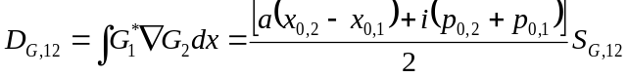 (22)

(23)

6. Generalization
The form of the Gaussian, Eq. 1, is not general – the momentum term should have the denominator. In addition, the complex phase factor is often present. So the more appropriate form is
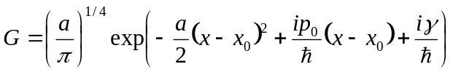 (24)
Let also denote 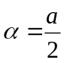, so:
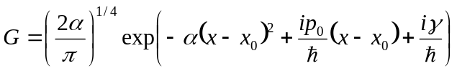 (25)
This form, for instance, is present in the paper of Makhov et al. [ Makhov, D. V.; Glover, W. J.; Martinez, T. J.; Shalashilin, D. V. Ab Initio Multiple Cloning Algorithm for Quantum Nonadiabatic Molecular Dynamics. The Journal of Chemical Physics 2014, 141 (5), 54110.]

The results Eqs. 21-23 derived for the form Eq. 1 will transform to:
(26)
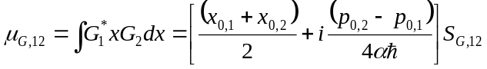
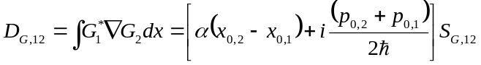 (27)
(28)

Introducing variables
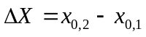, 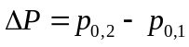, 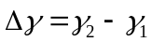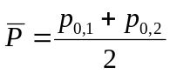, 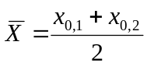. (29)
The above equations simplify to:

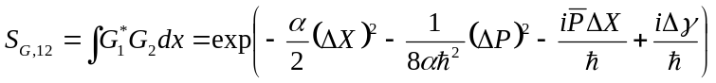 (30)
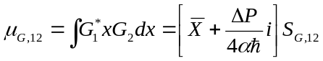
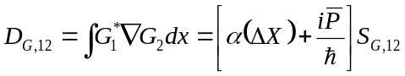 (31)
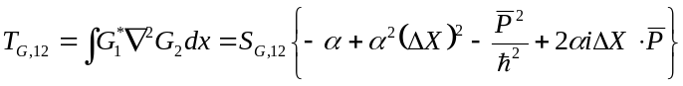 (32)

The equations for the overlap and for the kinetic energy are consistent with those of Makhov et al. However, the equation for the derivative coupling is not – they attribute similar equation to a different type of the derivative coupling.
To show consistency of the overlap, consider
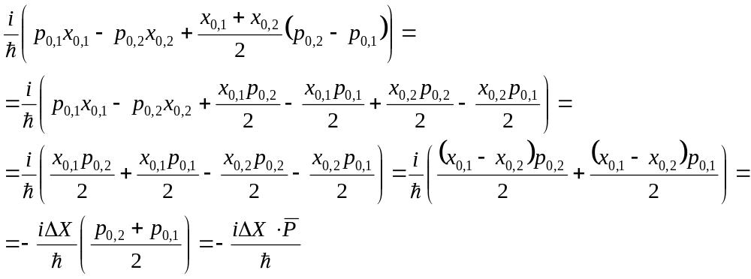
So, their expression coincides with our term 