Let’s start with a simple case:
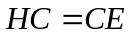, (1a)
or
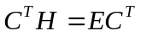. (1b)
with orthonormality condition:
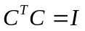. (2)

We then get:
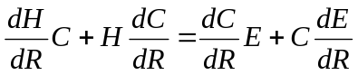, (3)
and
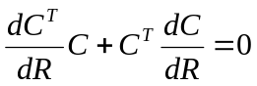. (4)

The derivative coupling is
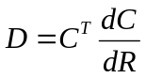. (5)
From Eq. 4 and 5 we can see that:
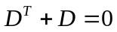. (6)
Multiplying Eq. 3 by 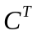from the left, we obtain:
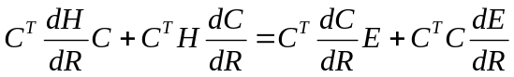. (7)
Using Eq. 1b, we get:
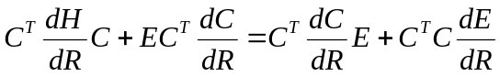. (8)

Using definition Eq. 5 and orthonormality condition Eq. 2, the Eq. 8 simplifies:
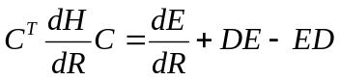. (9)

The matrix 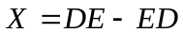is symmetric with zero diagonal elements. Moreover, it has the following structure:
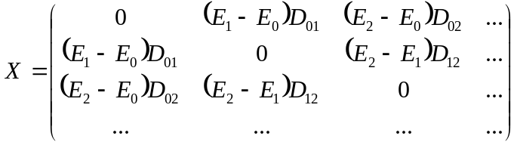. (10)
On the contrary, the matrix 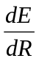is diagonal.
Therefore, one can split the matrix 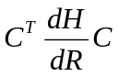into diagonal matrix and symmetric matrix with all diagonal elements zero. In this way we can compute gradients and NACs as:
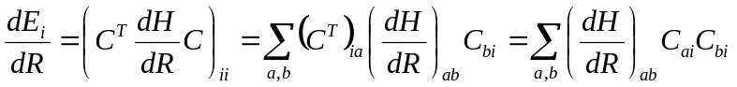, (11)
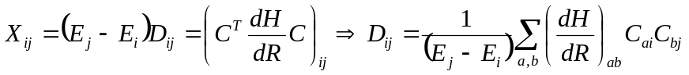. (12)

Now let us consider more general case – non-orthogonal basis:
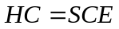, (13a)
or
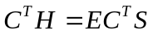. (13b)
with orthonormality condition:
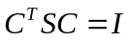. (14)

We then get:
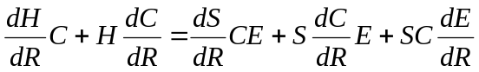, (15)
and
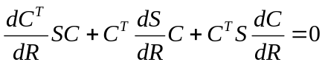. (16)

The derivative coupling is
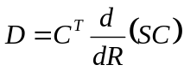. (17)
From Eq. 16 and 17 we can see that:
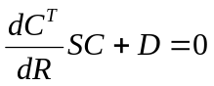, (18a)
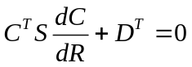. (18b)
Summing Eq. 18a and 18b and using Eq. 16, we get:
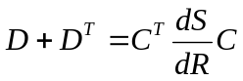. (19)
Multiplying Eq. 15 by from the left, we obtain:
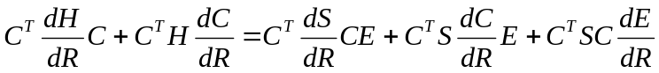. (20)
Using 13b and 14
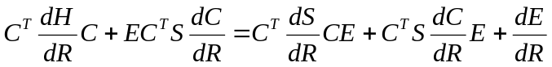. (21)
Using Eq. 17:
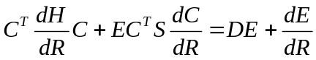. (22)
Using Eq. 18b:
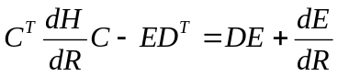. (23a)
or
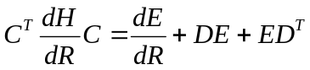. (23b)

Using Eq. 19, we get:
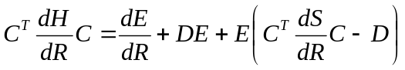, (24a)
or
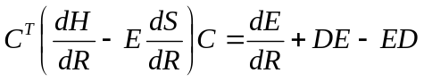. (25)
The structure of the matrixes on the right-hand side is the same as in the orthogonal case, Eq. 9. The only difference is that one now has additional term in effective Hamiltonian matrix, due to non-orthogonality of the basis functions. Apparently, the Eq. 9 is recovered as the special case of Eq. 25, when 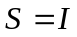.

Second order NAC and the derivatives of the first order NAC

Consider the case of orthogonal states first. Also, we are only interested in kinetic-energy-like terms, so we have only 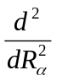and no cross-terms like 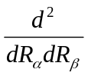. In the present case, we have generalized the theory to the complex-valued coefficients C.
From the definition, Eq. 5, we obtain:
, (26)
The symmetry of T:
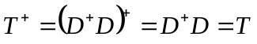, (27)
as it should be

