Two state system

Consider the TD-SE for two level system:
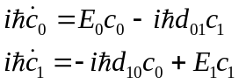. (1)
Introduce new variables:
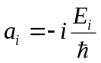, (2)
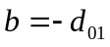. (3)
The Eqs. (1) then turn to:
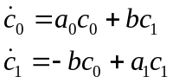. (4)

Assuming that and are constant (do not depend on time), by taking second time-derivative we obtain:
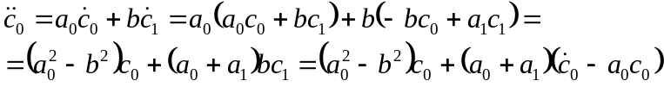, (5)
or
, (6)
or, finally
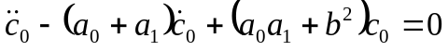. (7)

To solve the second-order ODE Eq. (7) we assume the following ansatz:
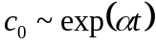. (8)

Substitution of Eq. (8) into Eq. (7) gives the quadratic equation:
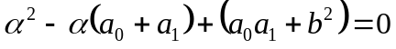. (9)
with the roots
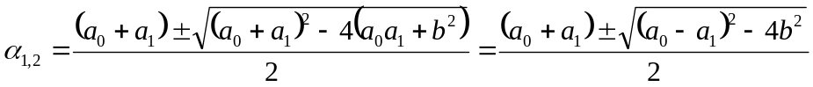. (10)
Each of the roots gives the specific solution of the ODE Eq. (7). The general solution is obtained by summing specific solutions with some coefficients:
, (11)
where
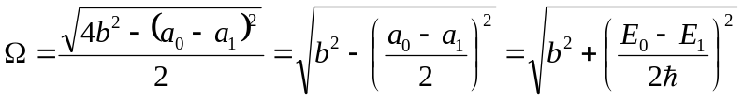. (12)
The coefficients are determined by the initial conditions. For example
If 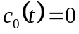, then 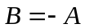and solution Eq. (11) takes the form:

. (13)
The population of the considered state (0) is then given by:
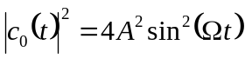. (14)
The exponent disappears because are the pure imaginary quantities.
The transition rate can be obtained as:
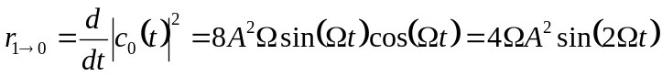. (15)
This shows that the population oscillates with some frequency, depending on the energy difference of two levels 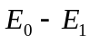and the coupling between them. For the degenerate case 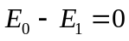the rate is determined only by the coupling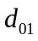. Alternatively, if the states are not coupled 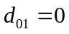the rate of population transfer is determined only by the energy difference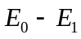 - this is a qualitatively incorrect result, because the derivation scheme does not work under such conditions – see the paradox and its solution.
Some asymptotic analysis: using 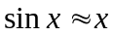we can find that at short times 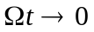:
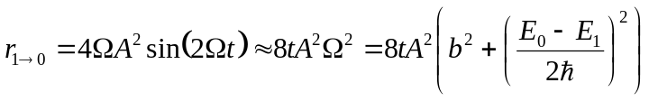. (16)

A paradox:
If we assume the states are not coupled () in the very beginning of the derivation, the equation (1) will read:
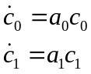, (17)
leading straight to the solution:
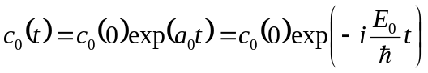, (18)
so the population is conserved over time:
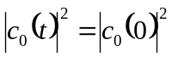. (19)

Solving the paradox:
If 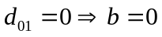, then the substitution in Eq. (5) is invalid, that is the 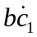and 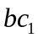should be set to zero, leading to
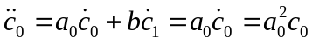. (20)
The equation Eq. (20) has the same solution as Eqs. (17), what solves the paradox.

