The rotational invariance means that a matrix A whose elements depend on the selected basis, 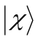, transforms consistently with the transformation of the basis. More specifically, the condition of the rotational invariance can be expressed as:
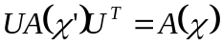, (1)
where 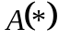is the matrix A with its elements expressed in the given basis *, 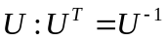is the unitary transformation matrix, and
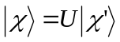. (2)

Examples:
1) Overlap matrix:
The overlap matrix can be expressed in terms of the scalar product of the basis vectors, so:
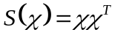, (3)
Now, using Eq. 2, we get:
, (4)
which satisfies Eq. 1. Thus, the overlap matrix is rotationally-invariant.

2) Density matrix:
The density matrix is defined as:
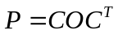, (5)
where O – is the diagonal occupation matrix in MO basis, C – is the matrix of MO-LCAO coefficients such that:
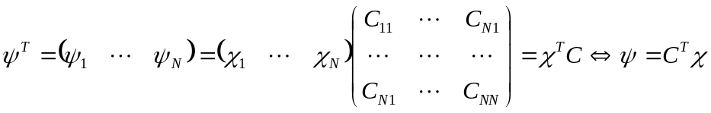. (6)
So:
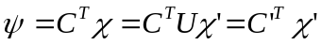, (7)
meaning that the MO-LCAO coefficients transform according to:
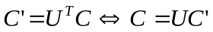. (8)

So Eq. 5 transforms:
. (9)
Hence, the density matrix is also rotationally-invariant.

3) Products of any powers of density and overlap matrices
Indeed, since 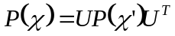and 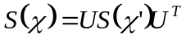, we get:
, (10a)
and
, (10b)
and
. (10c)

Now, lets show that the extended Hückel theory (EHT) Hamiltonian is not rotationally-invariant.
The matrix elements of the Hamiltonian can be represented as:
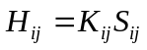
The elements of the transformed Hamiltonian are:
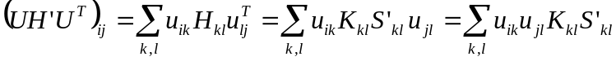, (11a)
The elements depending on transformed orbitals:
. (11b)

One of the ways to satisfy the rotational invariance is via:
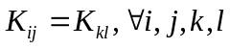
In other words, the coefficient must be constant.

In the weaker rotationally-invariant version, when the matrix U is composed of blocks acting only on the atomic-centered orbitals – independently for each atoms – the coefficient K is allowed to depend on atom type (or pair of atom types).

