Meyer-Miller-Thoss-Stock (MMTS) formulation revised

1. Statement 1
In variables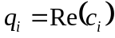 and 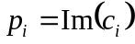, the TD-SE:
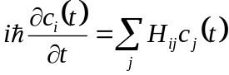, (1.1)
can be written as:
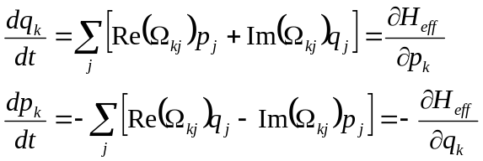, (1.2)
with
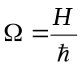. (1.3)
Proof:
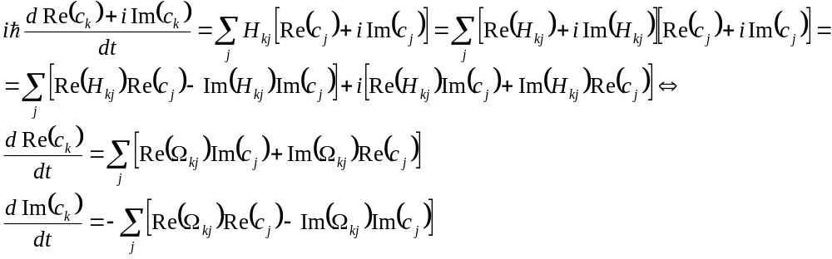 (1.4)
QED
Note that the leftmost equalities in Eqs. 1.2 are exact and true for a general Hamiltonian, Hermitian or non-Hermitian. The rightmost equalities in Eq. 1.2 are desired, but are not always possible – they are only possible if the Hamiltonian  is Hermitian (classical analog: Hamiltonian dynamics). If is non-Hermitian, the rightmost equalities can not be met, additional terms are needed (classical analog: non-Hamiltonian dynamics).
2. Statement 2
For a Hermitian Hamiltonian,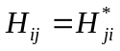, Eqs. 1.2 are Hamiltonian (proof of the rightmost equalities), with the effective Hamiltonian, 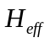, given by:
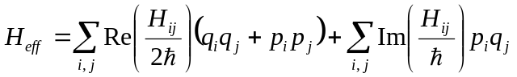. (2.1)
Proof:
First, assume a very general quadratic form of the effective Hamiltonian:
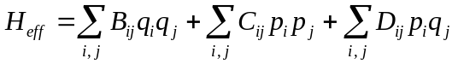. (2.2)
Then
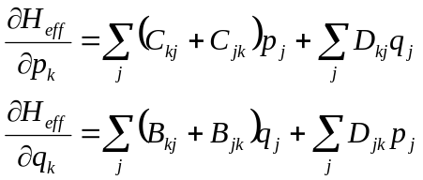, (2.3)
and
. (2.4)
We want the rightmost sides of Eq. 2.4 be satisfied:
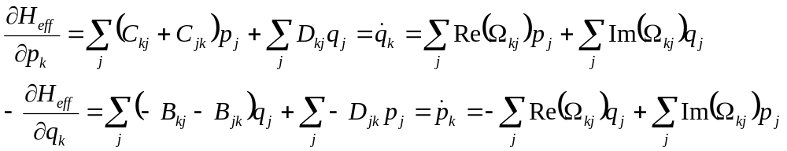. (2.5)
These equations are equivalent to:
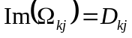, (2.6a)
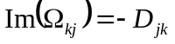. (2.6b)
Equations 2.6a and 2.6b imply:
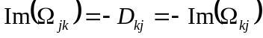. (2.7c)
From Eq. 2.5, we find that:
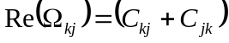, (2.8a)
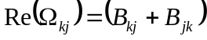. (2.8b)
Equations 2.8a and 2.9b imply:
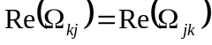. (2.8c)
To see that:
. (2.9)
The matrices C and B can be related to each other as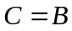 or 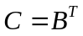. These two conditions can be satisfied simultaneously, if the matrices are symmetric. There is little physical meaning in requiring either of matrices C or B to be non-symmetric, so this condition is met practically always.
In summary, we have shown that:
, (2.10a)
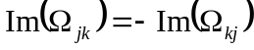. (2.10b)
In other words, the Hamiltonian equations of motion, Eq. 2.4, are held only when the quantum Hamiltonian, H, is Hermitian. The form of the effective Hamiltonian can be derived as follows.
Using the relationship, , we can simplify Eq. 2.2 to:
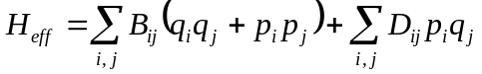. (2.11)
Using the fact that, and 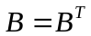, we obtain:
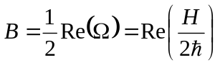. (2.12)
From the above definitions, it follows that:
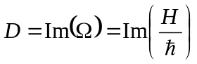. (2.13)
Combining Eqs. 2.11-2.13, we finally obtain:
. (2.14)
QED
3. Statement 3
If the electronic Hamiltonian is Hermitian, then the total electronic energy, , is related to the effective mapped Hamiltonian, , as:
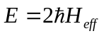. (3.1)
Proof:
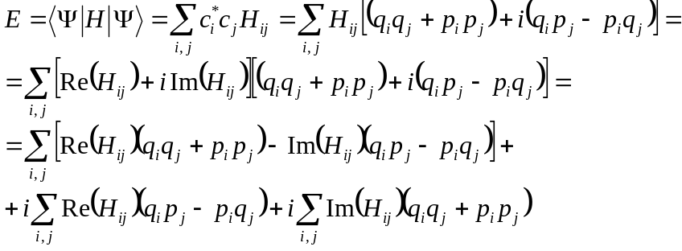. (3.2)
Then, using the hermiticity of the vibronic Hamiltonian, :
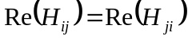, (3.2a)
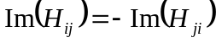, (3.2b)
and re-summing the resulting terms, we obtain:
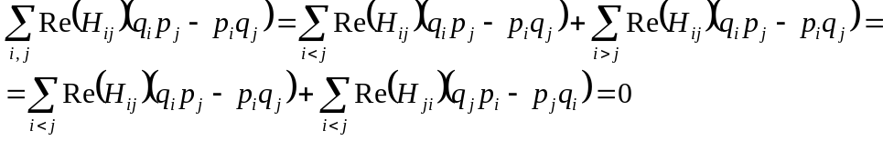. (3.3)
and
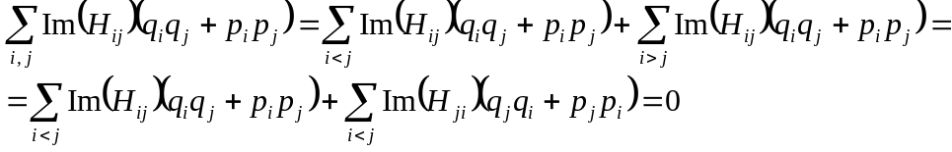. (3.4)
So, the imaginary term is zero, as it should be, and the energy is:
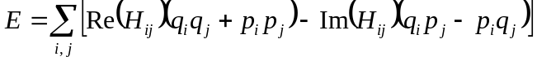. (3.5)
The last term is:
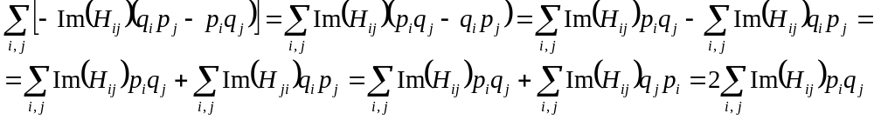. (3.6)
Thus, the energy is:
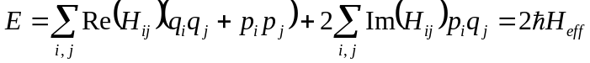. (3.7)
QED

