Some integrals with Gaussian wavepackets

1. Definition
According to Heller’s notation, the normalized Gaussian wavepacket is defined as:
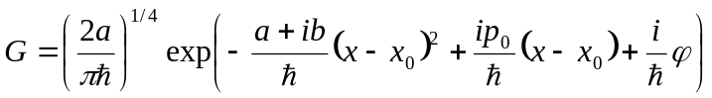, (1)
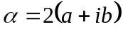
Here, is the width parameter, is the position-momentum correlation, 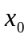is the center of the wavepacket, 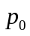is the momentum of the wavepacket, is the phase.

2. Derivatives
Now, assume all the parameters , , , , and depend on time explicitly.
Compute the time derivative of the Gaussian:

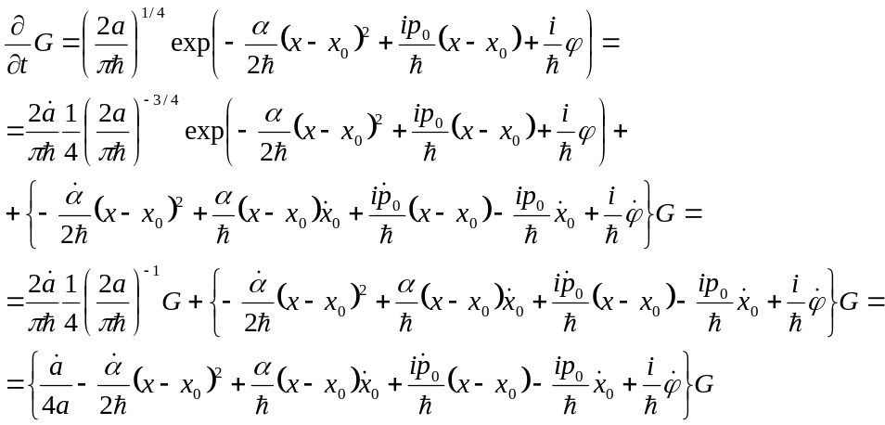 (2)

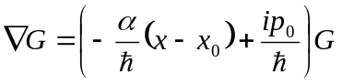, (3)
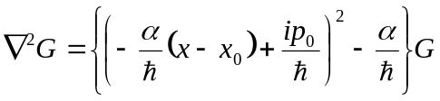, (4)

3. Time-dependent Schrodinger equation

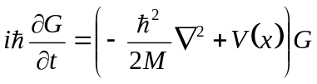 (5)
Substitute derivatives and simplify

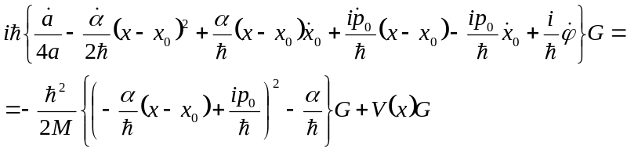 (6a)
or
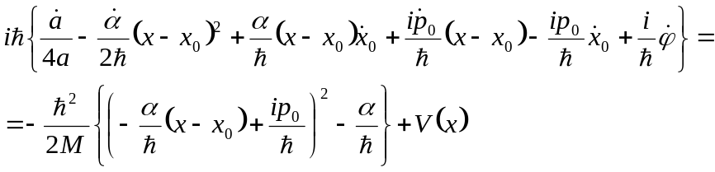 (6b)
This is exact propagation!!!

Simplify:
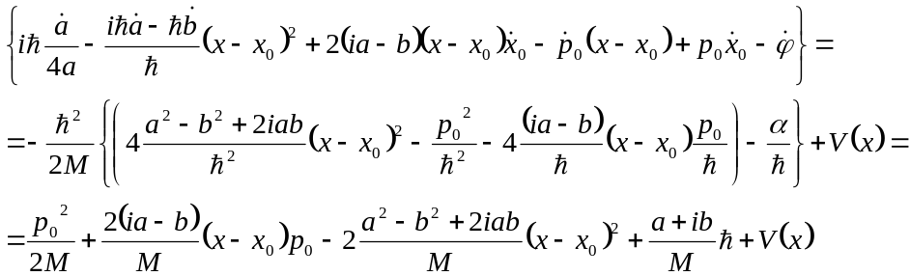 (7)

Separate real and imaginary parts:
Real:
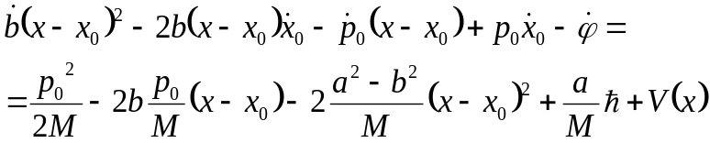 (8a)

Imaginary:
(8b)

From Eq. 8b, comparing the powers of 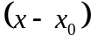, we get:
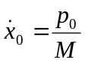 (9a)
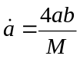 (9b)
Eq. 8a then simplifies:
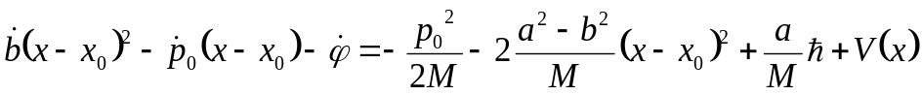 (9c)

Lets use the 2-nd order expansion of 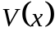:
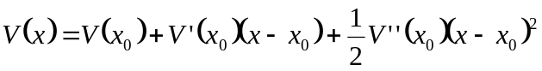 (10)

Then
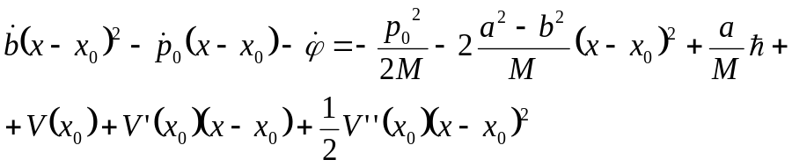 (11)
Comparing the same powers of yields:
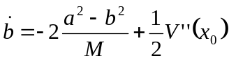, (12a)
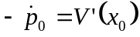, (12b)
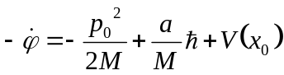. (12c)

4. Equations of motion

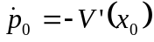, (13a)
, (13b)
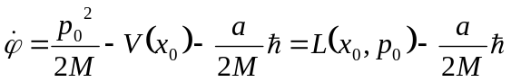, (13c)
, (13d)
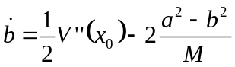. (13e)

