Time-dependent variational principle (TDVP)

1. Basic definitions

Quantum-mechanical action:
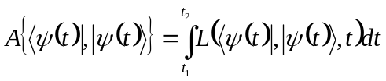, (1)
where 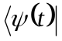 and 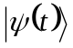are the left (bra) and right (ket) states. They are not necessarily related to each other by the Hermitian conjugation (transpose and complex conjugate). This is only true for Hermitian Hamiltonians. Also note that these states act as independent variational variables (for the above reason).

The variational principle requires the action to be stationary and the variational parameters to satisfy the boundary conditions:
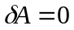, (2a)
. (2b)
The Lagrangian, 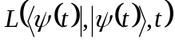, in Eq. 1 is defined as:
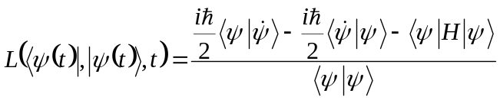. (3)

2. Derive the TD-SE

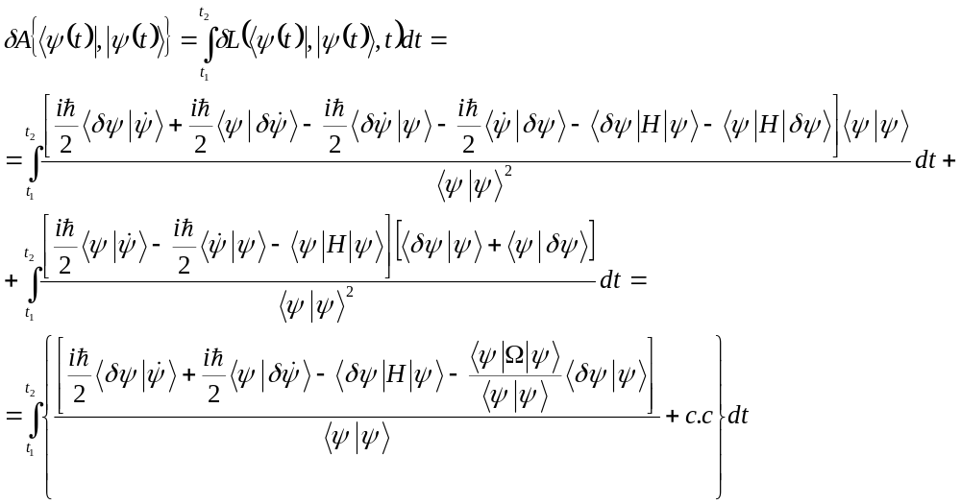, (4)
where
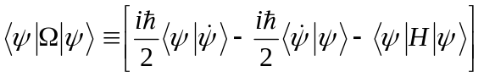. (5)
Using integration by parts, transform 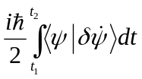:
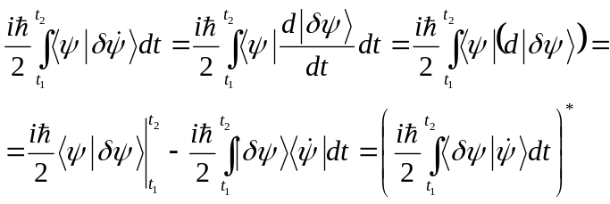. (6)
One can note that one such term is already present in the “c.c” part. Analogously, the 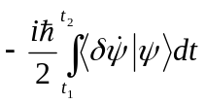term from the “c.c” part will yield the 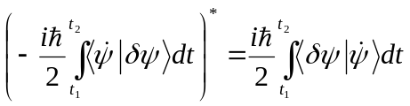term, contributing to the present direct term. Thus, the RHS of Eq. 4 simplifies to:

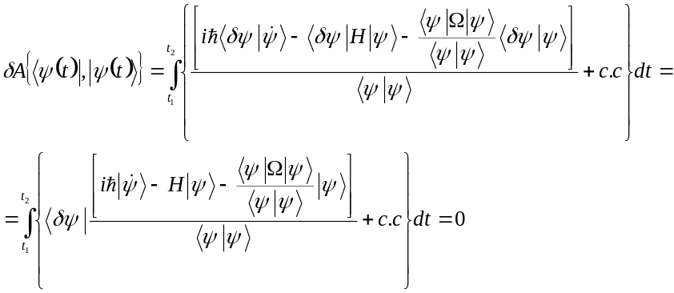. (7)
Since the variations 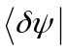and 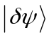are independent and are arbitrary, Eq. 2a combined with Eq. 7 lead to:
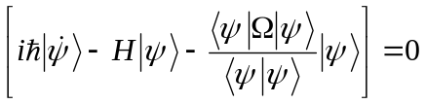. (8)
and a corresponding conjugate equation. In the most common case of a Hermitian Hamiltonian, the bra and ket vectors are related to each other, so it is sufficient to solve only Eq. 8. The conjugate equation is not independent.

One can recognize that Eq. 8 becomes a TD-SE,
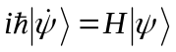, (9)
if
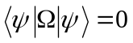. (10)
The condition Eq. 10 can be satisfied by choosing an appropriate phase factor:
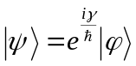. (11)
Such that:
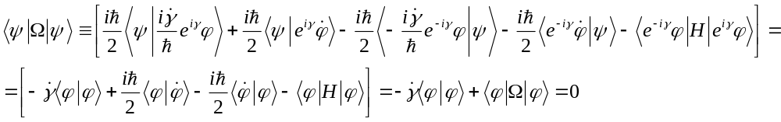 (12a)
So that:
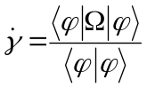, (12b)

3. Derive the classical mapping (Coherent state dynamics)

In the following derivations, omit the time dependence in wavefunctions. Also, now consider the Hermitian case, so use the complex conjugate variables.

Introduce
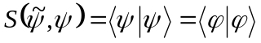, (13a)
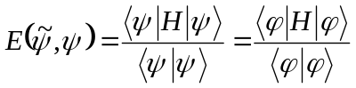. (13b)
Now, lets say the ket state,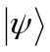, is parameterized by:
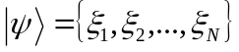. (14a)
and the bra state, 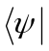, is parameterized by:
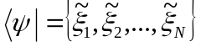. (14b)
The action is then:
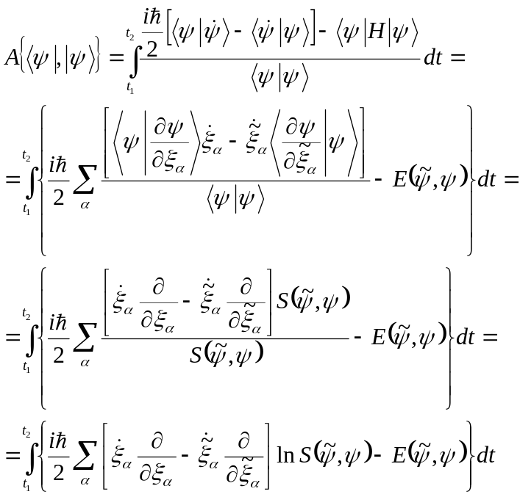. (15)

Here, we have used the fact that bra-vectors do not depend on 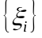and, vice versa, that ket vectors do not depend on variables 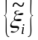, so one can write:
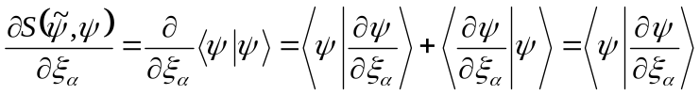, (16a)
and
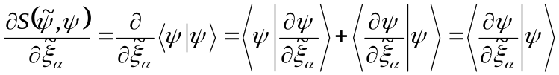. (16b)
The variation of the action, Eq. 15, with respect to all parameters yields:
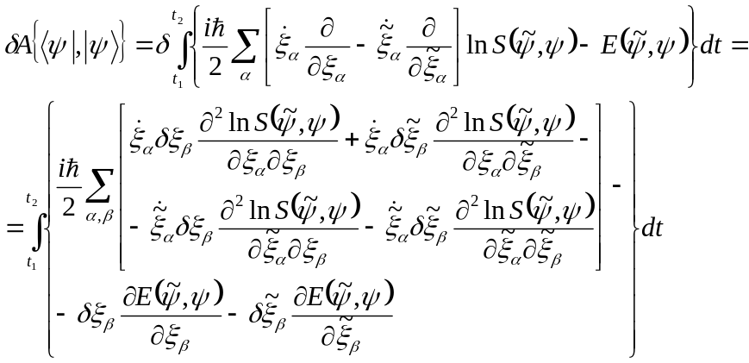. (17)
Consider
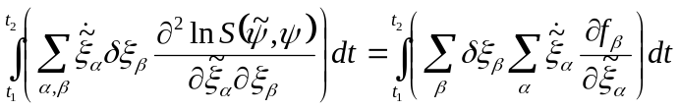, (18)
where 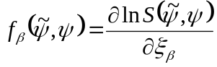.
Recall that (assuming there is no explicit time dependence of 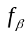)
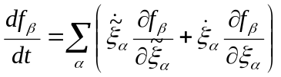. (19)
So, Eq. 18 simplifies:
(20a)
in a similar way we can show that:
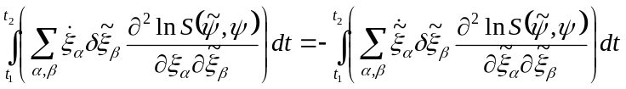. (20b)
Inserting the results Eqs. 20 into Eq. 17, we obtain:
(21)

Applying the variational principle, we obtain the equations of motion for the parameters:

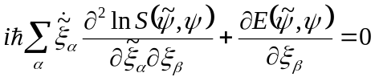. (22a)
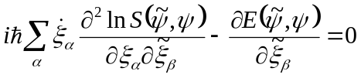. (22b)
Now, remember that 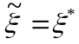, so one equation is just a complex conjugate of the other.

Introduce
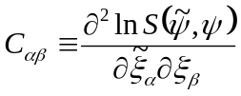. (23)
Then Eqs. 22 can be simplified:
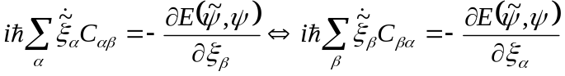, (24)
complex conjugate both parts of Eq. 24:
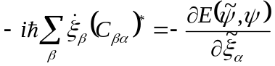, (25)
By definition, Eq. 23, the coefficient 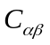has the property:
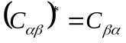. (26)
So, eventually, Eq. 25 becomes:
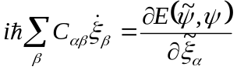. (27a)
analogously, we obtain:
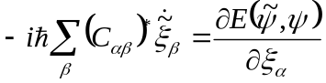. (27b)

So, the set of equations 27 are the resulting equations of motion.

In the matrix notation, they can be written as:
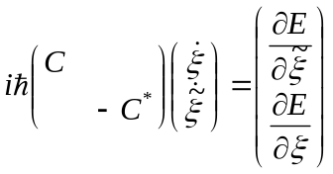. (28)

