Consider the TD-SE for two level system:
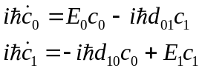. (1)
Introduce new variables:
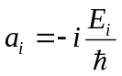, (2)
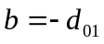. (3)
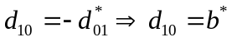
The Eqs. (1) then turn to:
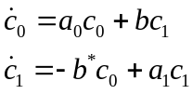. (4)
but we use purely real , so 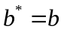.

The Liouvillian of this system of first order ODE (ordinary differential equations) can be written as:
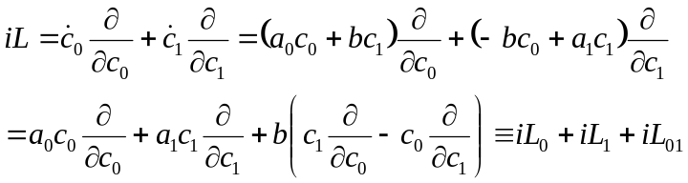. (5)
The solution of the system Eq. (4) with initial conditions 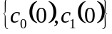for time is equivalent to propagation of the variables 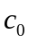and by evolution operator 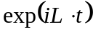for such time:
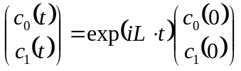. (6)
The evolution operator (propagator) can be factorized using the second-order Trotter formula, which for general non-commuting operators and can be written as:
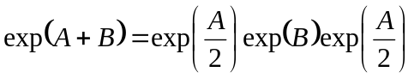. (7)
If the operatorsand commute, the factorization (7) is exact and can be simplified:
. (8)

Using Eqs. (7) and then (8) and the definition of the sub-Liouvillian operators in Eq. (5), the evolution operator in Eq. (6) can be factorized as:
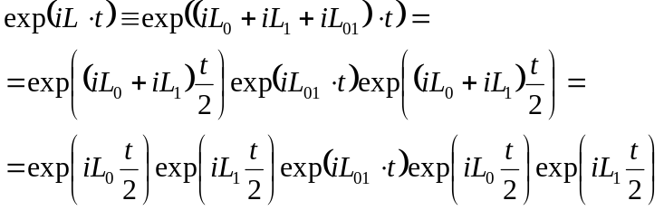. (9)

To obtain explicit solution to the Eq. (6) we need to know the action of operators in the RHS of Eq. (9). It can be shown that the action of operators of type 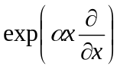on variable is equivalent to multiplication of variable by the constant 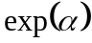:
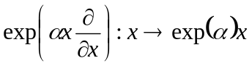. (10)

Thus,
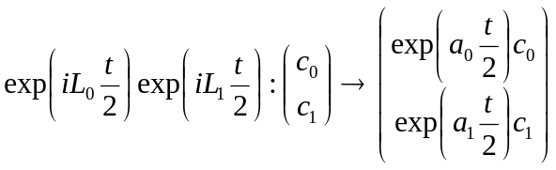, (11)
or, equivalently:
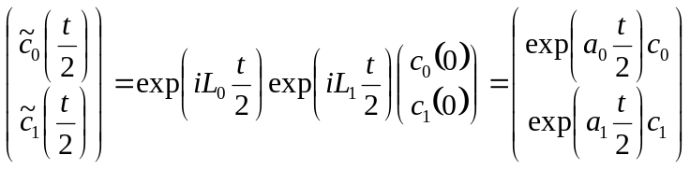, (12)

The action of the operator of type 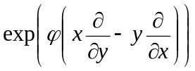is equivalent to rotation of the phase space point 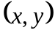by the angle:
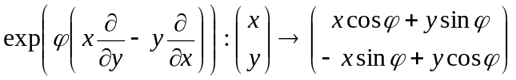. (13)
Thus,
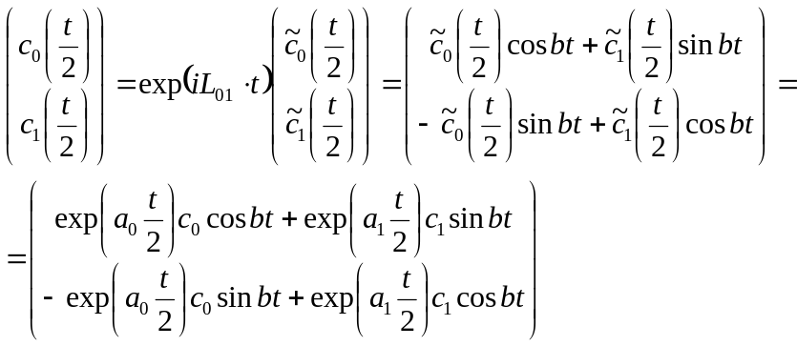 (14)
Finally, applying the operator in Eq. (11) one more time we get the answer:
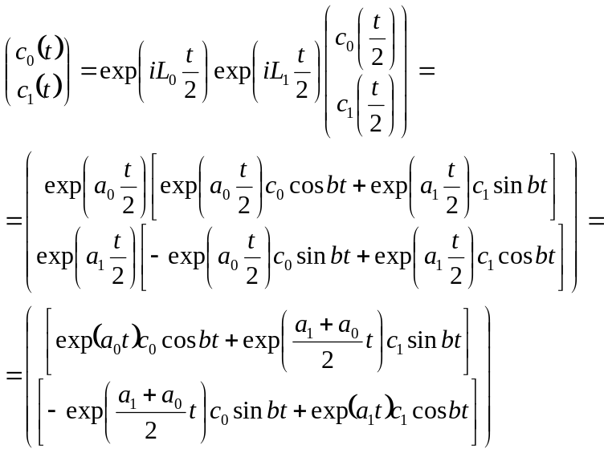. (15)

Then,
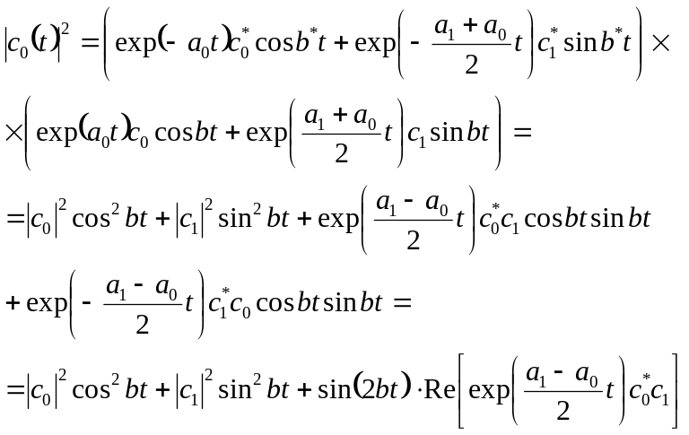 (16)

In case when we started with pure state 0 (so 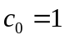 and 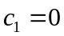), the Eq. (16) simplifies:
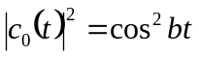.
Thus, the rate does not depend on the energy difference.

