The Hamiltonian is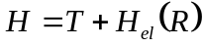, where 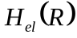is a Born-Oppenheimer (adiabatic) electronic Hamiltonian, parameterized by slow degrees of freedom,. Assume 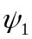and 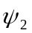are two adiabatic states:
, (1)

The adiabatic surfaces are defined as such that diagonalize the Hamiltonian (we focus only on the electronic one, since the kinetic Hamiltonian is a constant)
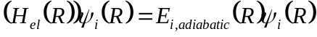. (2)

Now 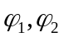- diabatic states, that is they are almost independent (or weak dependence on R):
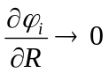. (3)
There is an angle , which is a function of the slow degree of freedom R : 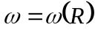, such that there is a transformation:
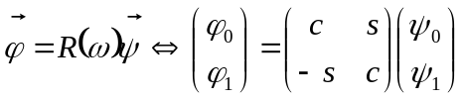, (4a)
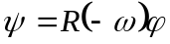, (4b)
where
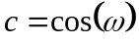, (5a)
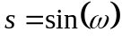. (5b)

Because of (3), the action on nuclear kinetic energy operator on diabatic states is zero, so:
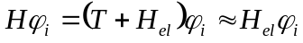. (6)
In the diabatic basis, the Hamiltonian takes the form:
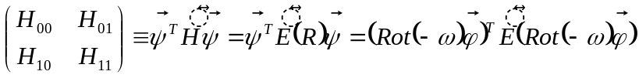, (7)
where
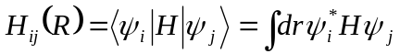. (8)
The 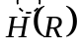is a [diabatic] electronic Hamiltonian matrix (provided by quantum chemistry)
Since the diabatic stated are also orthonormalized and only slightly depend (or do not depend at all) on slow degrees of freedom, the integration over fast degrees of freedom may be performed separately and yields: 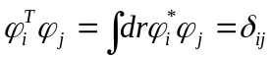. Finally we get:
(9)

Comparing left and right sides we get:
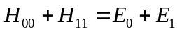, (10a)
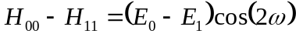, (10b)
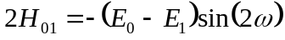. (10c)
The angle that transforms one representation into the other is:
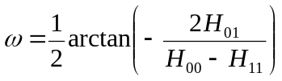. (11)

Now, we want to compute the nonadiabatic couplings. From the transformation Eq. 4b, we obtain:
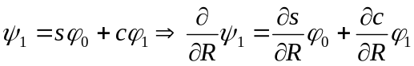 (12)
Using the definition of nonadiabatic coupling and the orthonormality of diabatic states,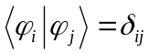, we obtain:
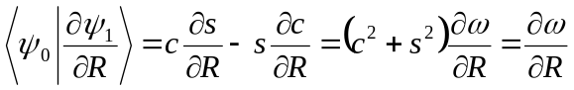. (13)
Using the results Eq. 11 and Eq. 13, we can further obtain:
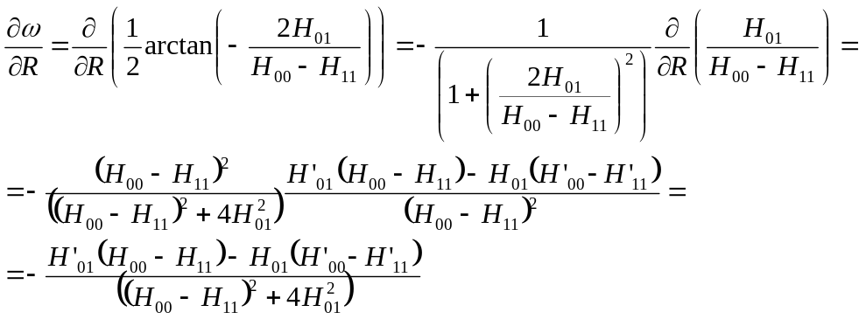. (14)

In the explicit form, the adiabatic surfaces and nonadiabatic coupling are given by:
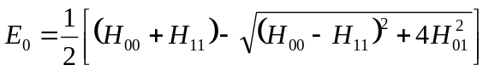, (15a)
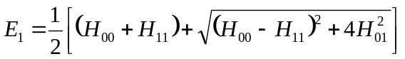, (15b)
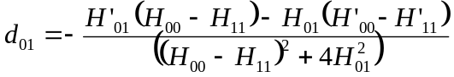. (15c)

