**4. Chemical kinetics**

**4.1. Basic concepts and definitions**

Definition: **Chemical kinetics** – is a branch of physical chemistry that studies rates of chemical reactions.

Comparison: Even though we haven’t discussed thermodynamics, it is useful to make the comparison.

|  |  |  |
| --- | --- | --- |
|  | kinetics | thermodynamics |
| **Object** (is something that is studied by the given discipline) | Transformation of substances:  **How fast** will it happen? | Transformation of substances:  What will be in the **end**? |
|  | 2H2 + O2 = 2H2O has , so it is allowed thermodynamically, but  It will take 1017 years for the reaction to finish under no special conditions  with Pt (as a catalyst) – it will take seconds/minutes to complete  with heating – it will tame milliseconds to complete | |
| **Time** | Is the main variable | No time |
| **Path** | Reaction doesn’t proceed as written (only stoichiometry)  In reality, there are **intermediates**  Main **subject**: mechanisms of chemical reactions (what happens in the “black box”)  Example:  H2 + O2 🡪 2OH*  OH* + H2 🡪 H2O + H*  H* + O2 🡪 OH* + O*  O* + H2O 🡪 H2O2  Or:  H + H 🡪 H2 (no good)  H + H + M 🡪 H2 + M* (better) | Path is not important |

Definition: **Mechanism of chemical reaction** is a series of **elementary reactions** that can be physically realized in the *reactive mixture* of reagents and products *under given conditions.*

Note: Mechanism may involve not only reactants, but also products

Mechanism may be different under different conditions

**Elementary reaction** can be defined in several ways

Definition #1 (simple): The reaction in which only one bond is broken or formed

Definition #2 (Tolmen): The reaction which has 1 potential barrier. The problem with this definition is: a) there are under-barrier reactions (tunneling); b) there can be other barriers, which are not crossed over the course of the reaction; c) there are barrier-less reactions

Definition #3 (IUPAC): In which one or more chemical species react directly to form products in a single *reaction step* and with a single *transition state*.

Notation:

🡪 (arrow sign) Denotes elementary reactions

= (equation sign) Denotes only mass conservation law (stoichiometry)

Examples:

2NOI 🡪 2NO + I2 (1 step, 1 barrier)



H2 + I2 🡪 2HI (no! this is only an apparent reaction scheme)

Definition: **Molecularity** – minimal number of particle necessary to accomplish reaction (usually 1, 2, 3 – no more!). 1 = uni(mono)molecular reactions, 2 = bimolecular, 3 = threemolecular.

Reactions can be classified as:

1. **Simple** (elementary)
2. **Complex** (involve many steps)

**4.2. Rates of chemical reactions**

Definition: **Rate** of chemical reaction – the number of elementary acts happening per unit time per unit volume of reaction space.

For instance, for j-th reaction (assuming there are many channels) aA + bB + … = cC + dD the rates are:

, (1)

where

, (2a)

describe how fast A or B disappear and

, (2b)

describe how fast C or D are formed.

**Dimensionality** of rate is: 

The speed of reactant disappearance or product formation is given by:

, (3)

where K is the number of reactions (channels) and are the stoichiometric coefficients of the component in the reaction *j*.

Definition: **Kinetic mass action law** is given by the expression:

 (4)

Using the dimensionality of the rate, we can find out the **dimensionality of rate constants**, , for different types of reactions:

Monomolecular: 

Bimolecular: 

Definition: **Kinetic rate equation** – equation that connects rate of chemical reaction and concentrations of substances that participate in the reaction. (Participate is understood in a broad sense: e.g. catalysts).

There are two types of kinetic rate equations:

|  |  |
| --- | --- |
| Model | Experimental |
| aA + bB 🡪 zZ     1. a, b, etc. – are integers, are called **model** reaction **orders** 2. only reactants’ concentrations are involved in the kinetic rate equation   a+b+.. – reaction molecularity | aA +bB = zZ     1. nA, nB, nZ – can be fractional, are called **apparent** reaction **orders** 2. both reactants and products’ concentrations are involved in the kinetic rate equation. |

Definition: **Order of reaction** – empirical parameter that is taken as the power with which concentration of a given component enters the kinetic rate equation.

**Independence principle**: k – does not depend on concentrations, and depends only on temperature.

Apparent order – **diagnostic tool**:

1. if integer
2. if no dependence on products

Then: the reaction is elementary

**4.3. Machinery of chemical kinetics**

|  |  |
| --- | --- |
| Direct kinetic problem | Inverse kinetic problem |
| Given:  - all kinetic rates, initial concentrations, and mechanism of reaction  Find:  - the dependence of concentrations of all components on time and spatial parameters. | Given:  - usually from the experiment, mechanism is also given (e.g. assumed)  Find: - the best set |

The general mass transport (and including chemical transformations) equation is:

 (5)

The first term on the RHS describes chemical transformations

The second term on the RHS describes diffusion

is a stoichiometric coefficient of the component *i* in the reaction *j*.

reactants

products

The inclusion of gradients is especially important in crowded environments (e.g. reactions in proteins, etc.), when viscosity is high, and in large-scale systems (e.g. in industrial systems – this may be essential!).

In many typical chemical setups, gradients can be neglected, then we obtain an automonous system of differential equations:

 (6)

This system of equations is linearly-dependent (e.g. due to material balance), so we need to reduce it to an irreducible representation (**stoichiometric basis**).

For instance, consider the set of reactions (Bodenstein) for H2 + Br2 = 2HBr:

Br2 🡪 2Br HBr + H 🡪 H2 + Br

Br + H2 🡪 HBr + H H2 🡪 2H

H + Br2 🡪 HBr + Br 2H 🡪 H2

Br2 + H2 🡪 2HBr 2Br 🡪 Br2

H + Br 🡪 HBr HBr + Br 🡪 H + Br2

There are only 3 linearly-independent reactions, for instance:



Methods of solution:

* Exact
* Numerical
* Approximate (e.g. some k are much larger other ks)

**4.4. Kinetics of elementary and complex reactions**

**A. 1-st order reaction (simple)**: 

, so the solution is straightforward:



The initial concentration of A is usually known: , so:



The **half-reaction time** of the first-order reaction, , is the time, when the initial concentration of the reactant has decreased by half. That is:



**Decay (relaxation) timescale** is defined as an inverse of the rate constant: . If we plug this definition into the expression for the time-evolving concentrations, we obtain: . From here, we can see: . That is the relaxation time for the first-order process is defined as the time when the initial concentration by 2/3.

**B. n-th order reaction (simple)**: 

, so the solution is straightforward:



The half-reaction time:



As you can see, the half-reaction time depends on the initial concentration!

**C. Parallel reaction (complex)**: 



The solution is trivial – same as for the first-order reaction, but with the effective rate constant .

**D. Reversible reaction (complex)**: 



The concentration of B can be expressed via the initial concentrations and the current concentration of A:

.

Combining the two equations, we get:

.

We solve the equation first. The indefinite integral is: , so the solution is:

, from where:



Now, if we use the coefficients we got in our earlier kinetic model, we get:



The equilibrium concentration is defined as:

, then:



**E. Consecutive reaction**: 

The rate equations are:





The solution of the first equation is straightforward, .

To solve the second equation, let us first solve the homogeneous equation:

, now we assume is the function of time, so we can solve the inhomogeneous equation:

, so



So, the final solution is:



Using the initial condition:

, we get:



Finally,



**4.5. Approximate methods of chemical kinetics: steady-state and quasi-equilibrium approximations.**

A general sheme:



Kinetic equations:

,





There are two major types of approximations, as summarized in the table:

|  |  |
| --- | --- |
| **Steady-state**  (joke: also known as a steady-steak approximation) | **Quasi-equilibrium** |
| Conditions:  This means that the component B is consumed very fast – it is an unstable **intermediate**.  Typically, this could be a radical.  As a consequence, the instantaneous concentration of the component B is very small (close to zero), and therefore, its temporal change is also close to zero: | Conditions:  The component B is consume very slowly. So, one can assume the components A and B are in equilibrium with each other.  Thus: |

**A. Solution for the steady-state case:**

,



So,

,

The solution is the same as for the first-order rate:

 and



One can solve the problem exactly, to obtain:



The analysis of the limiting behavior. Under the conditions of the validity of the steady-state approximation, , , and . On the other hand, and . So both exact and approximate solutions become: .

**B. Solution for the quasi-equilibrium case:**

.

So, the

,

which makes sense since A is in equilibrium



Again, we obtain an effective first-order equation for B consumption.

Note: to solve the overall problem, one will need also to use the conservation of mass law.

Example 1: Conversion of para-hydrogen to ortho-hydrogen.





is an intermediate, so:

, so

the rate of ortho-hydrogen production is:



Example 2: Bodenstein-Lind, 1907. Studied the reaction.

The rate for HBr formation was experimentally found to be: , which was a challenge to theory.

The proposed mechanism was:



In this case, both H and Br are the intermediates, so:





From these equations, we find that  and 

From  we obtain: 

From we obtain: , so



Thus, the final rate of HBr production is then



with and .

Consider an alternative mechanism, like:



This would lead to .

Principle: **Kinetic discrimination of mechanisms**. Based on a proposed mechanism obtain an expression for the reaction rates. Compare with experimental results. Assess the feasibility of the mechanism.

But: Different mechanisms may lead to similar rate expression – **kinetically indistinguishable mechanisms**.

**4.6. Enzymatic catalysis.**

One of the most important examples where the approximate methods discussed above are utilized is the kinetics of enzymatic catalysis reactions.

The **Michaelis-Menten** scheme is:



where S – substrate, E – enzyme, SE – substrate-enzyme complex (this is an intermediate), P – product.

The **main assumptions** are:

1. Steady-state in SE
2. Excess of substrate: . This means that 

We are looking for the rate of product formation:



We use the mass balance equation: 

From the steady-state in SE, 

, so



Rate: 

 - **Michaelis constant**

Dimensional analysis: - units of concentration

Analysis of the rate equation:

1)  - maximal rate value

2) what if ? then 

**Physical meaning of the Michaelis constant**: It is equal numerically to the concentration of substrate at which the rate is equal to half of the maximal rate.

**4.7. Elementary act theory: Theory of active collisions (TAC).**

Assume there are two particles, A and B, colliding. The velocities are: and , the masses are: and . The particles are in quantum states *i* and *j*, respectively.

Then, collisions can be classified into 3 groups:

1. **Elastic**:  (kinetic energy transfer)
2. **Inelstic**: (kinetic and internal energy exchange)
3. **Reactive**: (same as above + reactions)

We consider only reactive collisions.

Separation of motion of the center of the mass and relative motion: effectively treat one of the particles (B) as fixed. Consider the particle A moving w.r.t. the particle B with the **relative velocity** (Figure 1).

The kinetic energy of internal translation is , where is the **reduced mass**: .

Figure 1 introduces 3 parameters: d – **minimal distance** (a sum of atomic radii) between two particles, b – is the **aiming parameter**,  is the **approaching angle**.

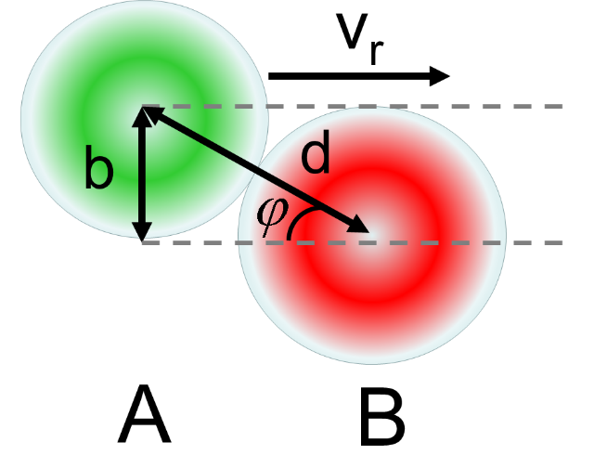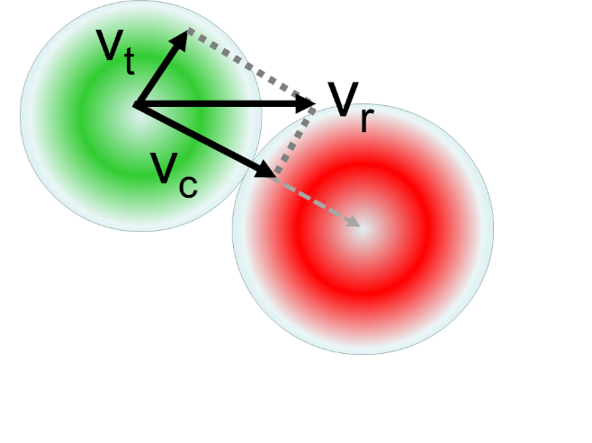

**Figure 1.** Schematics showing the geometry of a reactive collision act and the relative velocity decomposition onto along-center and tangential components.

The relative velocity can be decomposed into two components. Only the component that is parallel to the line connecting centers, , of the colliding particles will contribute energy toward the activation of reaction. The magnitudes of all velocities are found from simple geometrical considerations:

,

where .

From the main trigonometric identity we obtain: .

Since kinetic energy is quadratic in velocities, we obtain:



This is the fraction of total kinetic energy that goes into reaction.

 - heads-on collision

- no collision

 - that is for given value of the aiming parameter, the energy channeled into the reactive process is sufficient – at least the activation energy.

Thus,



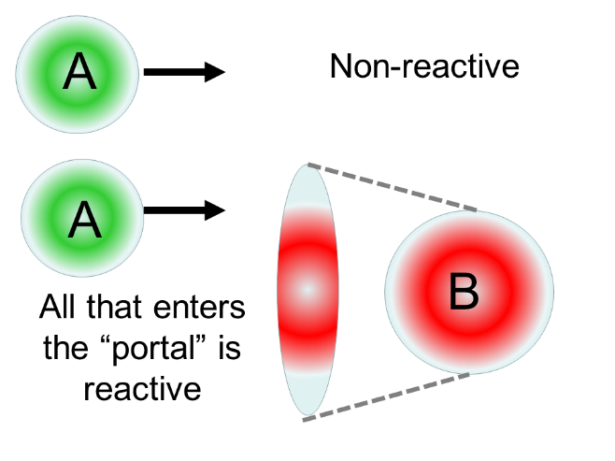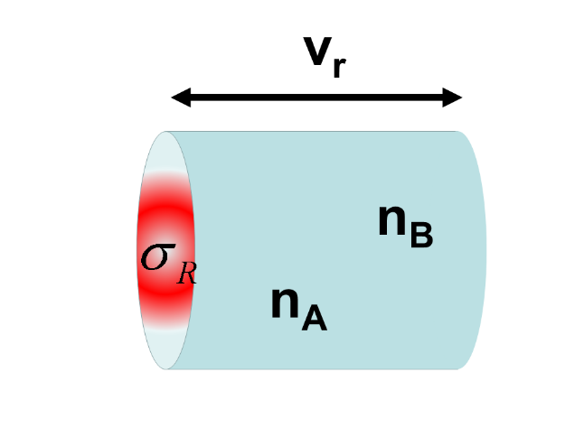

**Figure 2**. Schematics showing the reaction cross section

Now, all the particles that enter the area of the radius have sufficient energy for the reaction to occur and lead to reaction. These are reactive collisions. All other collisions (or misses) do not lead to reaction. The area is called the **reaction cross section**. It is convenient to think of it as a “portal” to another world – the world of reactants.

Apparently, the area of the reaction cross section is: .

The dimensionality of reaction cross section is that of area [m2].

Since molecules move with the velocity , they can be found anywhere in the reactive volume per unit time:

.Assuming the concentration of particles A in state *i* is and that of particles B in state *j* is , we can count the total number of particles meeting in this reaction volume as: . Since all particles that enter this volume react, the computed quantity is nothing but the rate of chemical reaction:



The dimensional analysis shows that this quantity has the units of reaction rate: .

Introducing the fraction of particles in a given vibronic state, , we obtain:

 and



So:

, or:

 - the expression for **microscopic, state-resolved rate constant**

In fact, this value of rate constant is really defined for a narrow interval of velocities .

One has to take the distribution of velocities into account. The distribution function will be: .

So:



**Integral state-resolved rate** **constant**:



Remove state-resolution, get the **macroscopic rate constant** (averaging over all quantum states):



with:



Here:

1. we introduced full reaction cross section: 
2. assumed the velocity distribution function doesn’t depend on quantum state: 

Thus, the fundamental TAC equation for the rate constant is: 

**Now, we need to know: and .**

**Component # 1**

Velocity distribution: - from Maxwell-Boltzmann

Using the substitution: , we can simplify the expression.

Also, note that - average relative velocity.

**Component # 2**

According to TAC derivations, we assume:



Summarizing all components together, and integrating the result, we obtain the final equation, called **Trautz-Lewis** equation:



**Physical meaning of**  - the number of collisions per unit of volume

**Significance**:

1. 1-st equation that suggested a way of obtaining the reaction rate constant
2. The experimentally-found Arrhenius equation,, is recovered
3. The dependence of pre-exponent on temperature is found.

**But**:

1. No prescription to compute 
2. Lewis: for the reaction 2HI 🡪 H2 + I2 found:

,



but this turned out to be an exception

**Physical meaning**:  a hard spheres model, but the spheres are not hard; collisions are not elastic

So, the more the particles deviate from the hard spheres, the more dramatic the error will be:



Problem for TAC: transformation of a single molecule (monomolecular reaction)

1919 Perren proposed a radiation theory, for instance for reactions:



But, a nasty fact: at high P – go as monomolecular, at low P – as bimolecular

**1921, Lindemann**:



A* - is an intermediate, so: ,

so:



Then:

High P 🡺  (monomolecular)

Low P 🡺 

One can see that , so that .

From here, we see: - concentration of A when the order of reaction changes. This can be determined experimentally.

**Found**: , meaning that 

**Problem**: model of structureless spheres.

**Solution** (new model): f oscillators

If there are s quadratic terms in the Hamiltonian, then:

,

Here 2f – corresponds to internal degrees of freedom (oscillators)

2*1 – translational degrees of freedom

The multiplier 2 appears because we have kinetic and potential energy terms.

We now consider the activation process:



The probability to activate  oscillators is given from the stat. mech. by:

