**5. Thermodynamics**

**5.1. Basic concepts and definitions**

Definition: Thermodynamics (TD) – science about transformation of heat into work (E. Fermi)

Definition: Thermodynamics –science that studies exchange of energy between macroscopic objects and the consequences of this exchange.

**Object of thermodynamics**: any system of *macroscopic* objects bound by the “dividing surface”

Note: macroscopic – is important. Don’t apply TD to molecular systems!

Classification of TD systems:

* **Isolated** – exchange of energy and mass is prohibited
* **Closed** – exchange of energy is allowed, exchange of mass is prohibited
* **Open** – exchange of both energy and mass is allowed

Definition: **TD state** is defined is:

1. all parameters of state are given
2. the function (equation) of state is given

Definition: **TD variables** – the variables that characterize a system in its equilibrium

Note: we only work with TD variables!!!

TD parameters (variables) can be:

* **Extensive** = depend on size (volume, mass, etc.)
* **Intensive** = do not depend on size (temperature, pressure, etc)

1. **External** = depend on the position of external objects
2. **Internal =** depend on the internal properties of a system

Definition: **TD process** – a sequence of equilibrium states

Note: There is no time!

Mathematically, a TD process can be defined by the condition: , where is the rate of change of a TD variable a, is a characteristic relaxation time.

If the relaxation time is very small, then after each infinitesimal perturbation, the system returns to its equilibrium state very rapidly (e.g. Fig. 1).

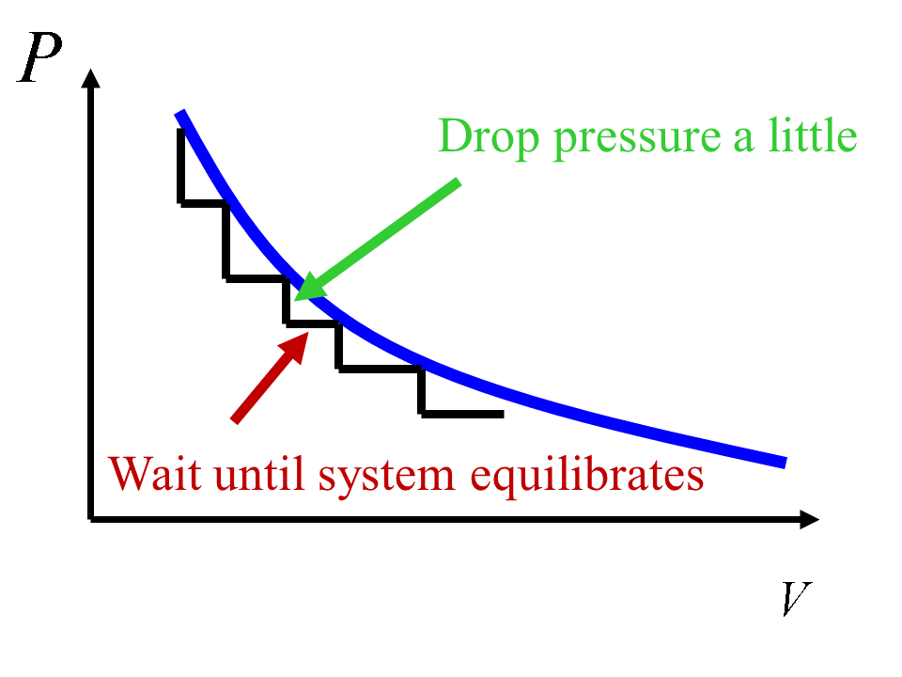

**Figure 1**. An isothermal process (T = const) for the ideal gas (PV = nRT). TD process is a sequence of equilibrium states.

**5.2. Postulate of TD # 1 (we all will die ☺ )**

In any **isolated** system, after a certain time, the state of **thermodynamic equilibrium** will be reached, from which the system can not escape spontaneously.

Definition: **Equilibrium state** is the state in which TD parameters do not change in time, and there are no fluxes through any element of the dividing surface.

Note: If there are fluxes, one has a **steady-state**.

**5.3. Postulate of TD #2 (existence of T)**

There exists a function of state – temperature – which has the same value for all parts of a system that are in thermal equilibrium with each other.

In practice: Defined by an empirical scale for ideal gases: , where .

Convention: Triple point of water corresponds to 

**5.4. 0-th law of TD (transitivity of thermal equilibrium)**



In words: If the system A is in thermal equilibrium with the system B, and the system B is in thermal equilibrium with the system C, then the system A is also in thermal equilibrium with the system C

**5.5. Equation of state**

A general approach. Lets say, we have a function of TD variables: . Assume, volume can be expressed explicitly, , then:



If V = const, then , so: 

Recall that , so we obtain:



Introduce **thermal coefficients**:

; and , we then obtain:

 - **thermal equation of state**

Examples of equations of state for gases:

**Ideal gas**: 

1873, **van der Walls** ,

- molar volume.

1898, **Diterichi** 

1900, **Bertlo** 

1901, **virial** (Kamerling-Onnes) 

Here, and  are called **virial coefficients**.

**5.6. 1-st law of TD**

**A. Formulation**



In words: Heat transferred to the system () is utilized to change the internal energy of the system and to perform work by the system against external forces.

**Essentially**: It is the law of energy conservation

**Sign convention**:

**Heat** is **positive** if it is transferred **to the system**

**Work** is **positive** if it is made **by the system**

Notation: Symbol signifies that the quantity is not a full differential.

**B. Work and generalized forces**

A – stands for German “Arbeit” = “work”

Here, the term stands for the work system performs on its environment.

The term corresponds to the work gas expansion performs on the environment

The term accounts for other ways to perform work (e.g. charging, magnetization, etc.)

 are called **generalized forces**

are called **generalized coordinates**

Main examples:

|  |  |  |
| --- | --- | --- |
| **Table 1.** Generalized forces and coordinates. | | |
| Coordinate (extensive) | Force (intensive) | Description |
| V | P | Volume and pressure |
| q |  | Charge and electric potential |
|  |  | Surface area and surface tension |
| n |  | Number of moles and chemical potential – for each component separately |
| D | E | Electrostatic induction and electric field intensity |
| B | H | Magnetic induction and magnetic field intensity |
| dS | T | Entropy and temperature |

**C. Alternative formulation of the 1-st law of TD. Functions of state:**



In words: internal energy is the function of state (mathematically, a potential function).

Definition: **Function of state** - its change in a TD process going from point A to point B does not depend on the path chosen, only on the initial and final states.

A consequence: Potential function is assumed to be additive.

This is applicable if:

1. for macrosystems (mole of a substance)
2. short-range interatomic forces.

**C. Work of the gas expansion**

Unlike potential energy, work is not a function of state. It depends on a selected path. For instance, Fig. 2 (left panel) shows two possible paths for gas expansion. Path **1** consists of an isobaric expansion (horizontal line) followed by a sudden change of the pressure (which is, by the way, not a process allowed in TD). According to (change to a full differential, since all other parameters are kept fixed), we obtain:



The isochoric drop of the pressure (vertical line) contributes 0 to work (also using the same integral expression)

Alternatively, (assume) the path **2** describes isothermal expansion of the ideal gas. Then:



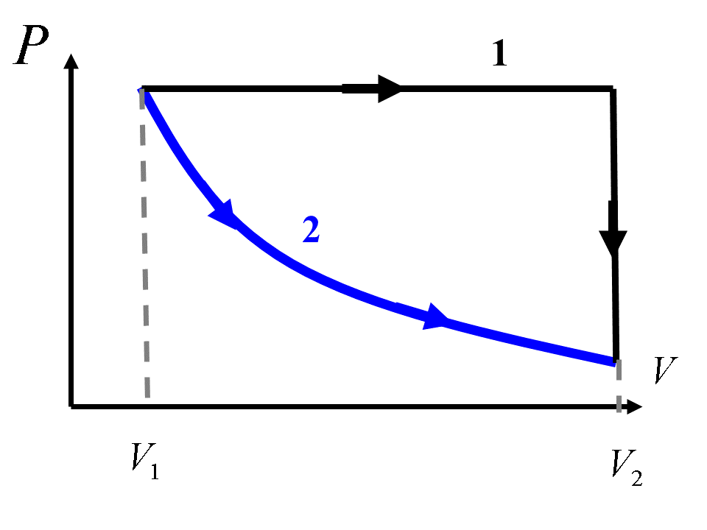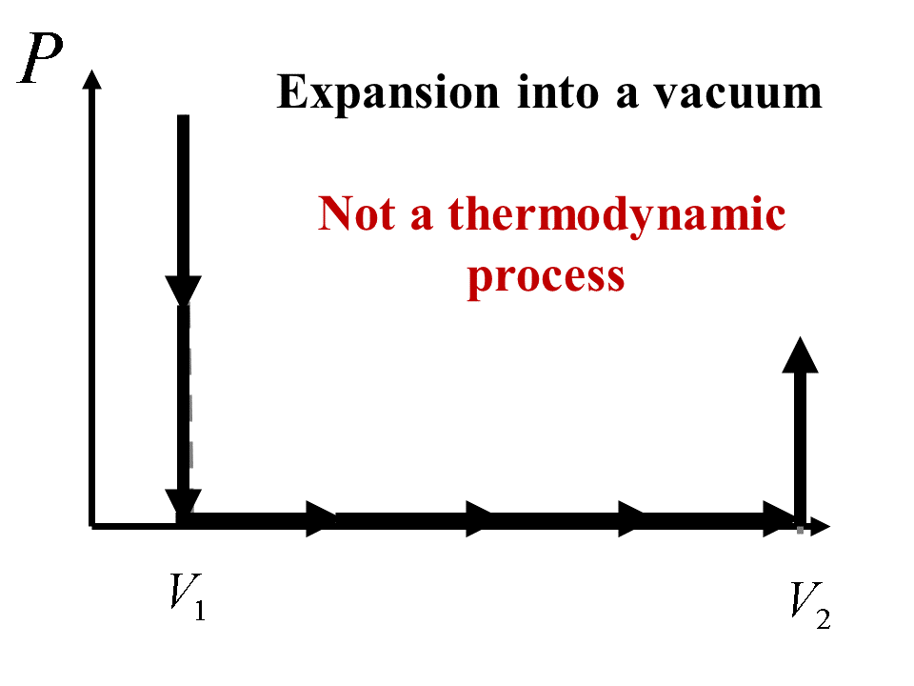

**Figure 2.** To the discussion of a work produced by an expanding gas.

Finally, the right panel in Fig. 2 shows the path corresponding to a free expansion of a gas into a vacuum. Since there is no pressure against which the gas makes some efforts on changing the environment, the gas does not produce any work, .

**5.7. Enthalpy and thermochemistry**

**A. General:**

Definition:  is called **enthalpy**



From the 1-st law we have:



So: 

**B. Natural variables**:

 - T, V, and generalized coordinates are said to be natural variables for U. This means, one usually use U if T, V and the corresponding generalized coordinates are fixed. For instance, it is typical to compute the internal energy (potential energy) in the MD calculations, since the simulation cell is usually fixed (e.g. NVE ensemble).

 - T, P, and generalized coordinates are said to be natural variables for H. Again, if we work under constant temperature and pressure conditions (and all other generalized variables, I’m saying this for the last time here), the use of H will be the most natural choice. Most of the experiments are performed under constant temperature and pressure (atmospheric) conditions. To maintain volume fixed is very difficult in experiment. Thus, H is the quantity one gets directly from the experiments. In the modeling: if you are running MD simulations under the conditions of NPT ensemble (the volume of your simulation cell may fluctuate), the potential energy you compute corresponds to enthalpy!

**C. Heat capacity**:

From , we obtain:



Then:





Definition: - **isochoric heat capacity**

Definition: - **isobaric heat capacity**

From the above derivations, we see:



, or



For the ideal gas:

 and , so:



Working with enthalpy:





Now:



So:





Note: Enthalpy is related to as internal energy is related to 

**D. Major types of TD processes**

Consider a **simple system** = no external forces



For the **ideal gas**!!! (note – for other types of systems, this may be not true): , so:



Condition defines an **adiabatic process** (slow, so all internal energy is converted to work)

Condition defines a **polythermal process** (slow, so all internal energy is converted to work)

Adiabatic:

,

where 

Polythermal:



so, analogously, one obtains:

, but with .

Isothermal process:



in this case: 

Isobaric process:





**E. Thermochemistry. Hess law.**

Heat of reaction,, is determined by the conditions under which the reaction takes place:

If under constant volume – use internal energy: 

If under constant pressure – use enthalpy: 

**Hess law:**

The amount of heat released or adsorbed during chemical reaction (thermal effect of chemical reaction) that takes place under constant volume or pressure does not depend on the reaction path. It depends only on the initial (reactants) and final (product) states.

Note: in thermochemistry, heat is taken as positive if it is released into the environment, that is when and .

Relationships between and :

**In solution or solid phase**: 

**In gas phase**: 

Definition: **Standard state** – a state of a pure substance at pressure of 1 bar (= 105 Pa) and given temperature.

|  |  |
| --- | --- |
| **Reaction**  - enthalpy of reaction between substances in standard states at temperature T | **Formation/Combustion**  - enthalpy of **formation** at given temperature T of 1 mole of a substance from elements, in their most stable state  Reference point:  (H+ in water solution)  Tabulated for T = 298 K. For other temperatures use:    - enthalpy of **combustion** at given temperature T – is the enthalpy of reaction of oxidation of 1 mole of a substance |
| For the reaction  Enthalpy of formation = Formation Products – Formation Reactant  Enthalpy of formation = Combustion Reactants – Combustion Products | |
|  |  |