2. Laws of dialectics. Mathematical notation. Sets.

2.1 Hegel’s/Engels’ dialectics.

There are 3 main laws:
- “Quantity to quality”
- “Negation of negation”
- “Unity of conflicting parts” (internal conflict)

Significance: These are the laws of evolution in a broader sense (development, progress). They are very general, and are applicable to a wide variety of situations: both in science and in real life.

More detailed explanation and examples:

#1 Quantity to quality: Quantity can lead to qualitative transformations.

Example 1: amount of time you study and the level of understanding you gain. This change happens instantaneously, discontinuously, during a “click” moment. One has to be sufficiently focused, of course, although the idea could come up via a random “diffusion of mind” process.

Example 2: heat a solid (ice) it will transform into a liquid (water), heat liquid even more – it will transform into a gas (water vapor).

More examples:
- critical mass of radioactive elements.
- periodic table of elements
- phase transitions (e.g. precipitation)

#2 Negation of negation: Evolution occurs by negating old things by the new things, but the new things will be negated themselves, eventually.

Example 1: children and parents – each generation has something of its own, next generation may have different values, different picture of the world, etc. As an observable result, new generation negates the older one. But it is with the necessity that something of the older generation will be taken in the newer ones. And this is what leads to the evolution (progress). Without this synthesis, there would be just an alternation of effectively two generations, without any progress.

Example 2: evolution of scientific concepts (analogously to the children & parents example) – new scientific generations find new, more general, and more universal theories and tools (e.g. quantum mechanics vs. classical mechanics, or modern organic/inorganic synthesis vs. ancient alchemical methods). So, in some sense, they negate previous experience. But, without inheriting older concepts and practices there would be no progress.

More examples:
- changes in political or socioeconomic models;
- history (historic process) itself – either within any local period/culture/geography or as a whole process;
- evolution of arms and weapons, etc.

#3 Unity of conflicting parts (internal conflict)
Be careful here, it is not enough to find opposite/conflicting entities. They have to be un-separable, meaning one does not exist without the other.

Example 1: All biological systems: if organs are separated apart, the body (life) as a whole stops existing. Organs work together, but they exert opposite forces, so they can “conflict” – a homeostasis. The absence of the “conflict” means the system has reached equilibrium = it is dead and cannot evolve any more. So, both unity and constant conflict are needed for the system to evolve.

Example 2: more abstract form – the thinking itself. The process of thinking is impossible without constant flow of questions and answers. The questions and answers are the two sides of the same coin, so to say. They constantly “conflict” with each other, competing to let us say “yes” or “no” to certain statements. Questions undermine our certainty in something, answers compensate for that, but the answers may create new questions, and so on. The two components do not exist without each other: there is no question without an answer, and there is no answer without a question. Only by keeping this dialogue in one’s mind one can stay intellectually alive and evolve to new levels. Related example: a dialogue – any form of constructive dialogue: it doesn’t have to happen in one’s mind all the time. It can happen across minds (classroom setups, seminars, scientific community in general, etc.).

More examples, only without detalization: light-and-darkeness: there is no shadow without light; good-and-evil: many things are good and bad at the same time; relationships in families (the “conflict” is sometimes needed to resolve problems and move on – to evolve; the unity – is a way to constrain the system from finding alternative pathways for resolution); the wave-particle dualism: particles have wave nature and waves can behave as particles, inheritance and genetic variability; me-and-“it” (Freud): two parts of human unconscious; internal(thing in itself) and external (accessible to experimental investigations).

2.2. Sets

A. Common mathematical notation

Belongs: 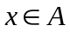. Here, - is an element, is a set
Does not belong: 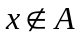.
Any (All):  - this symbol is just a reversed letter A
Exists: - this is just a reversed letter E
Set: - define the set by providing info in the curly brackets
 - conjunction (and)
- disjunction (or)

B. Ways to define sets
- Enumeration: 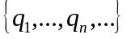
Example: 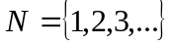- integer numbers, 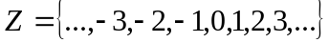- whole numbers, 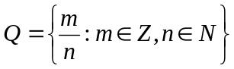- rational numbers, - real numbers (not defined here)

- Indexation: 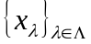.
Example: 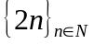- a set of even numbers

- 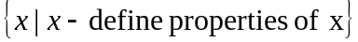
Example: 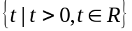- a set of all positive real numbers; 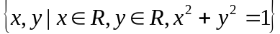- a set of all points on the circle of a unit radius.

C. Definitions

Definition: Set – (cannot be rigorously defined) – a collection of some objects, sharing a common property. The objects are called elements of the set.

Definition: 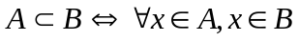 Then, is called a sub-set of a set .

Definition: The setwhich doesn’t contain any element is called an empty set

Note: The symbol denotes an operation between two sets (inclusion)
The symbol denoted an operation between a set and an element
So: but 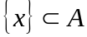

Definition: Set intersection 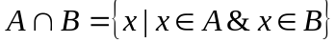
Definition: Set union 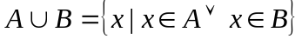
Example: 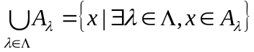
Definition: Set difference 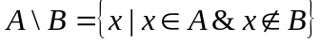

D. de Morgan laws and Venn diagrams

For any sets and 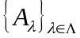
1. 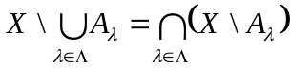
2. 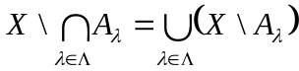

Proof:
Part 1.
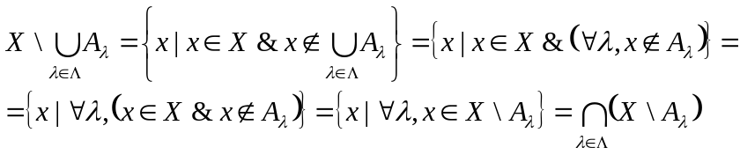
Part 2.
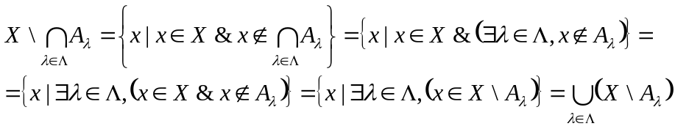

Operations on sets can be conveniently described by the Venn diagrams:

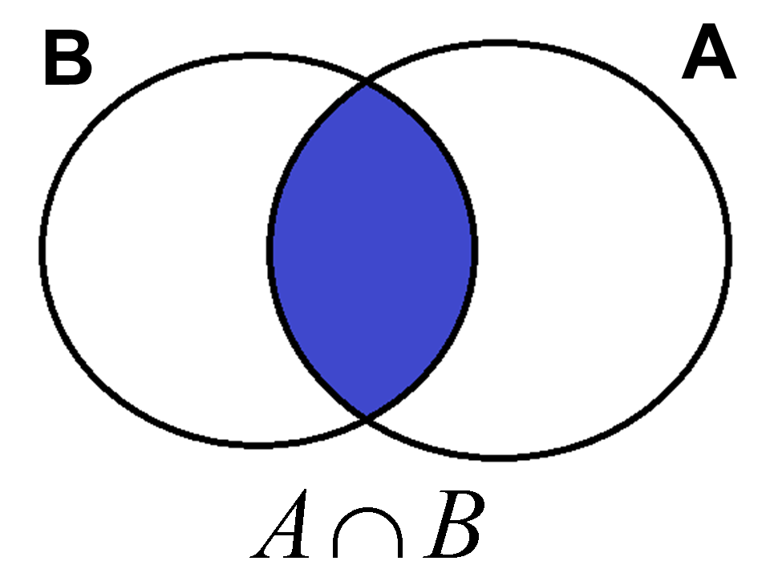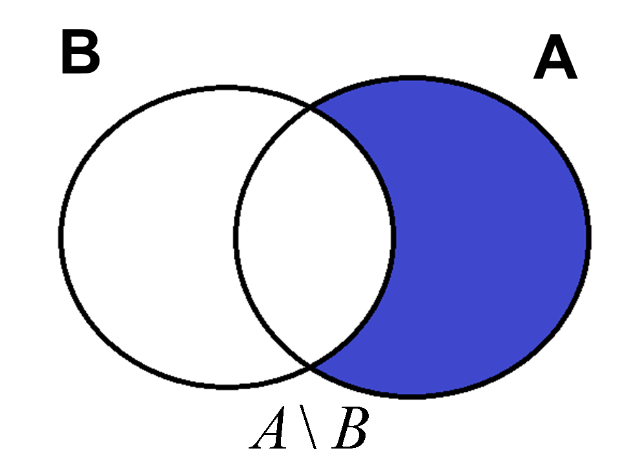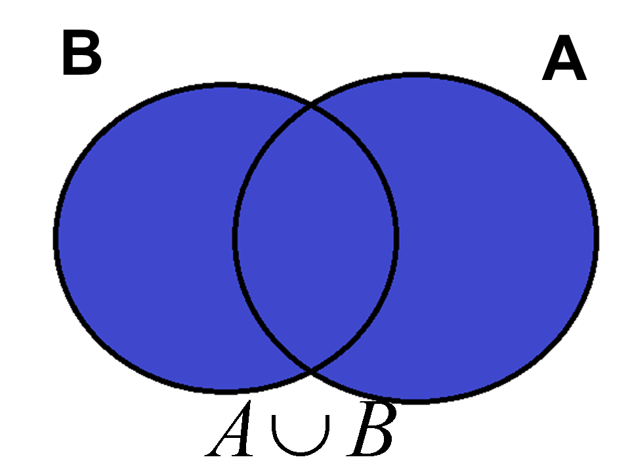
(a) (b) (c)
Figure 1. Venn diagrams for: (a) intersection; (b) difference, and (c) union of sets A and B.

